Project: Moffat Bay Lodge | Members:  Jacob Achenbach  Tabari Harvey  Zachariah King  Ryan Monnier
Course: CSD 460 Capstone
Description: Module 9 Testing
Date: 2025/11/30
To complete the test case plan, fill out the information for Project, Course, Description and Date in the header below.
.
TABLE OF CONTENTS
Reservation Look-up Page loads properly 3
Reservation Look-up functionality for historical/future reservations 4
Contact Us / About Us page loads from link on main page properly 7
About Us page has a way to contact the company 9

For each test, the developer should: provide a test description, a test objective, the developer name and date tested. For each step, fill out the actions to be taken and describe the expected results, and indicate yes or no for each step depending upon the result. The peer tester should provide their name, date tested, indicate yes or no for each step depending upon the result, and a screenshot (thumbnail) of the result.

Test 1 | Reservation Look-up Page loads properly
 | Test Objective: Verify that user can navigate to a page to view their past/upcoming reservations | Developer: Zach  Date tested: 2025/11/30 | Peer tester: Ryan  Date tested: 2025/11/30
Step | Action | Expected results: | Developer pass/fail | Tester pass/fail  + Screenshot
1 | Login | Be redirected to a user’s dashboard page | Yes | Yes  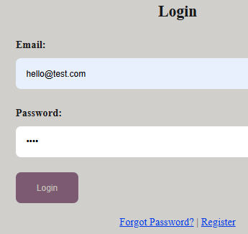
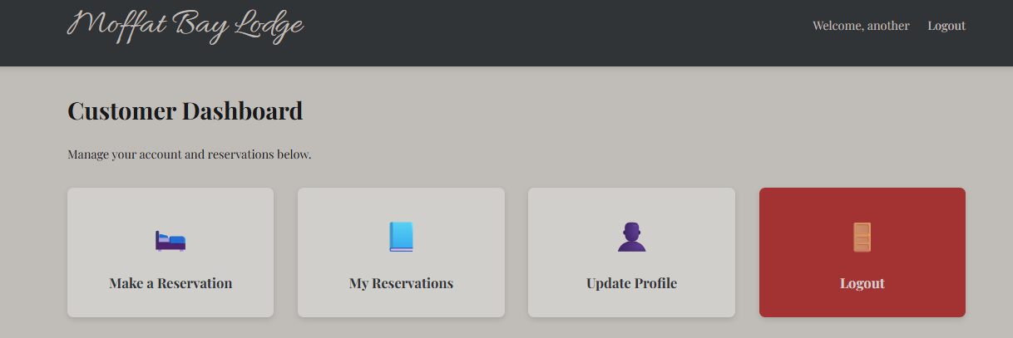
2 | Click ‘My Reservations’ | Be redirected to a functional page to review user’s reservations | Yes | Yes
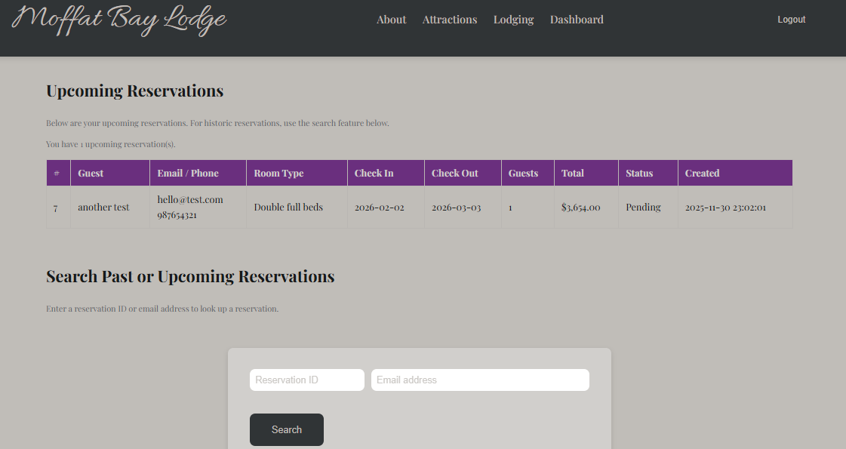
3 | Reviews listed reservations | Be able to view only upcoming reservations and only for the current user | Yes | Yes
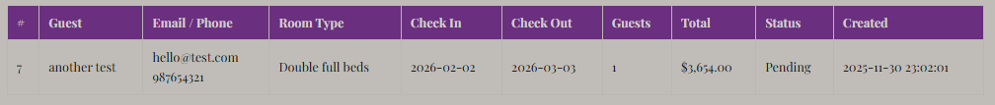
Comments | The reservation_summary.php page loads properly and maintains the style and format of the rest of the site. Upon loading, user is presented with their upcoming reservations. It appears that they’re only shown reservations associated with their email/customer_id as expected.

Test 2 | Reservation Look-up functionality for historical/future reservations
 | Test Objective: User should be able to search for reservations by Reservation ID or email. They should only be able to see their own reservations | Developer: Zach  Date tested: 2025/11/30 | Peer tester: Ryan  Date tested: 2025/11/30
Step | Action | Expected results: | Developer pass/fail | Tester pass/fail
1 | Enter in a reservation ID for a historic reservation for the associated user | Have the intended results returned from search | Yes | Yes
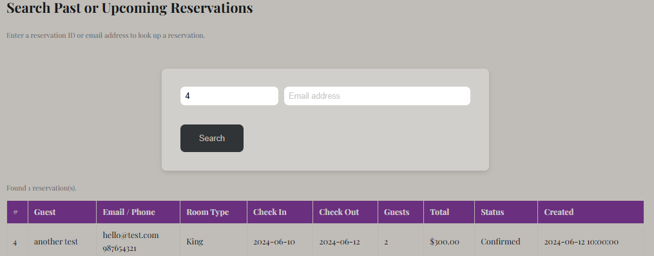

2 | Enter email for associated account | See all past/present reservations for user | Yes | Yes
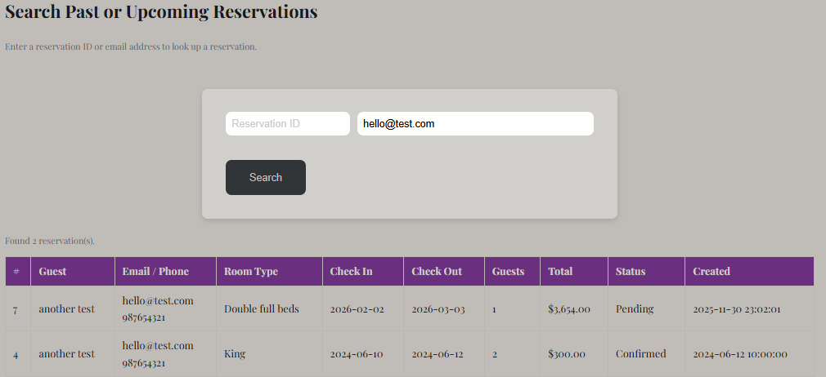
3 | Enter reservation number associated with reservations that do NOT belong to current user | Search should not return results for other users | Yes | Yes  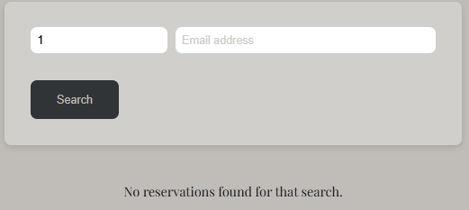
4 | Enter email associated with reservations that do NOT belong to current user | Search should not return results for other users | Yes | Yes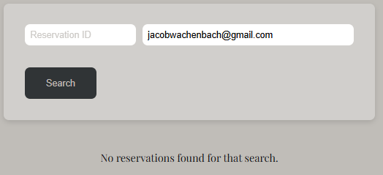
Comments | The reservation lookup functionality seems to work as expected. Users are able to query by reservation ID or by their own email, but they cannot access other user’s reservations.

Test 7 | Contact Us / About Us page loads from link on main page properly  Note: Client requested that the functionality of the Contact Us page be merged in with the About Us page. Contact Us page is no longer necessary
 | Test Objective: Ensure that the About Us page loads properly with relevant data | Developer: Zach  Date tested: 2025/11/30 | Peer tester: Ryan  Date tested: 2025/11/30
Step | Action | Expected results: | Developer pass/fail | Tester pass/fail
1 | Click the link on the main page | Page loads properly | Yes | Yes  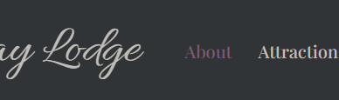  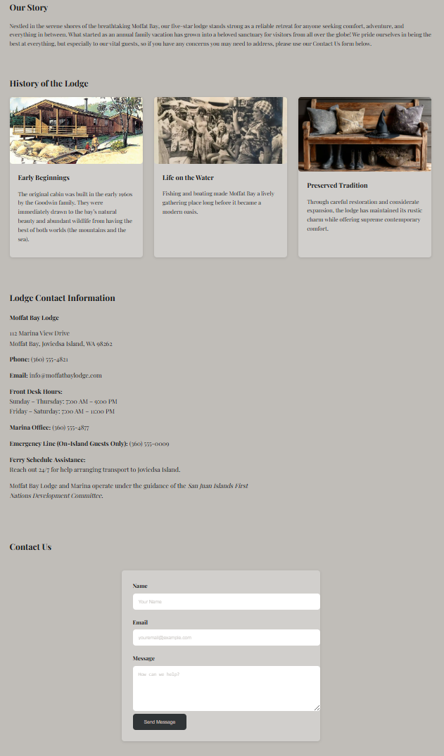
2 | Read the information present on the page | Information is relevant and explains a little bit about the lodge | Yes | Yes  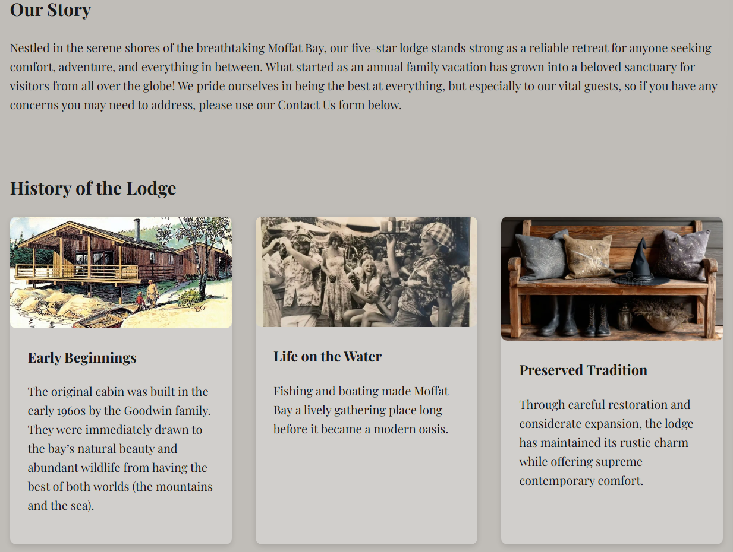
Comments | The About Us page loads properly and is consistent in format with the landing page. The page has relevant information that one seeking to stay at the lodge might like to read, including some history, contact information, and a form to submit an inquiry.

Test 8 | About Us page has a way to contact the company
 | Test Objective: Test functionality of contact us on the about us page | Developer: Zach  Date tested: 2025/11/30 | Peer tester: Ryan  Date tested: 2025/11/30
Step | Action | Expected results: | Developer pass/fail | Tester pass/fail
1 | Enter information in the Contact Us field | Fields should be fillable | Yes | Yes  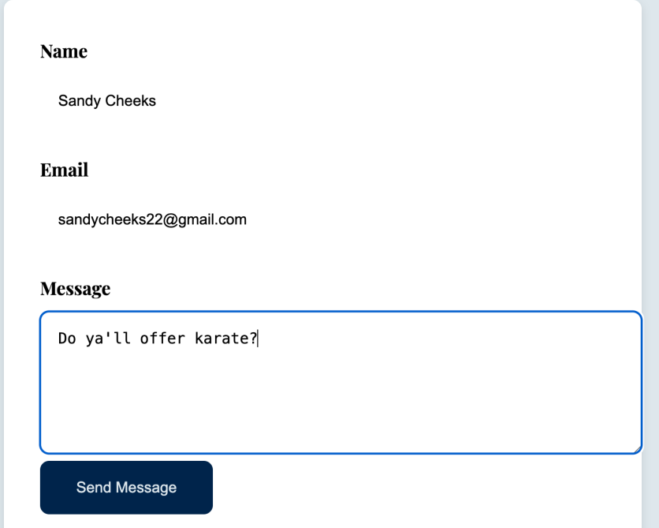
2 | Click Send Message | Receive some verification of message being sent | Yes | Yes
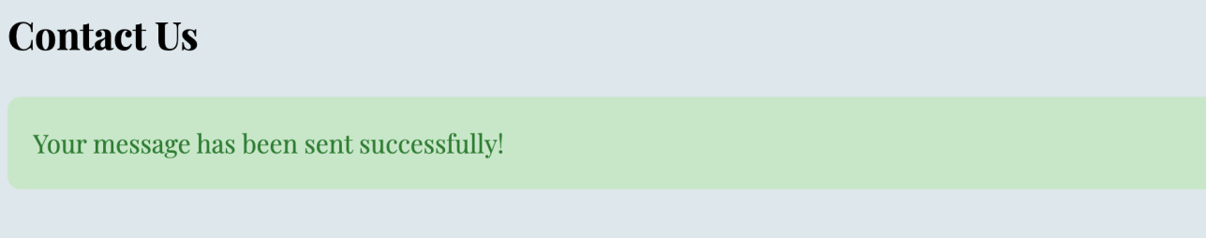
3 | Ensure that data is properly stored | Name, Email and Message should be present in a table | Yes | Yes
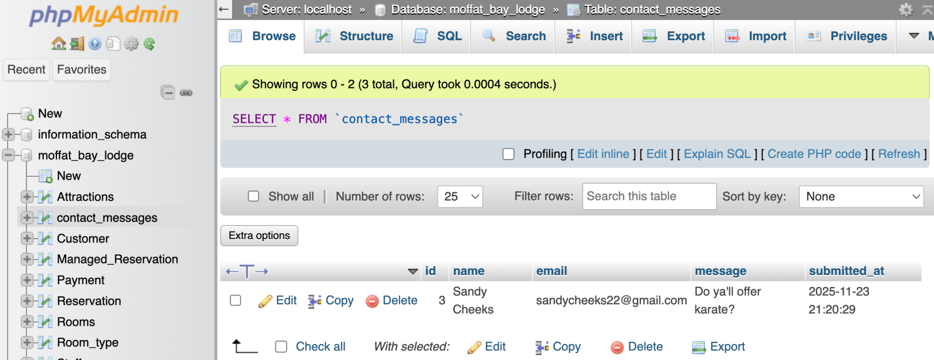
Comments | Contact Us form properly displays and allows for user input. Users can enter their Name Email and a Message which are then stored in a contact_messages table. The page is available to anyone who navigates to the site, there is no requirement to be logged in.

