**CSD 310**

**Milestone 3**

**Red Team:**

Ryan Monnier

Zachariah King

Jacob Achenbach

**Report List**

1. Supplier Report:
   1. A monthly report that shows whether suppliers are delivering on time or not by including the expected delivery time and actual delivery time.
2. Wine Sales Report:
   1. Shows how each wine is selling (or not) within each distributor.
3. Employee Hours Worked Report:
   1. A quarterly report showing how many hours each employee worked per week.

**Report 1: Supplier Report**

* This report shows each month with each supplier and their total amount of deliveries for that month as well the average delay (in days) of those deliveries, if any. This shows whether suppliers are delivering on time and displays any problematic gaps within expected delivery time and actual delivery time.

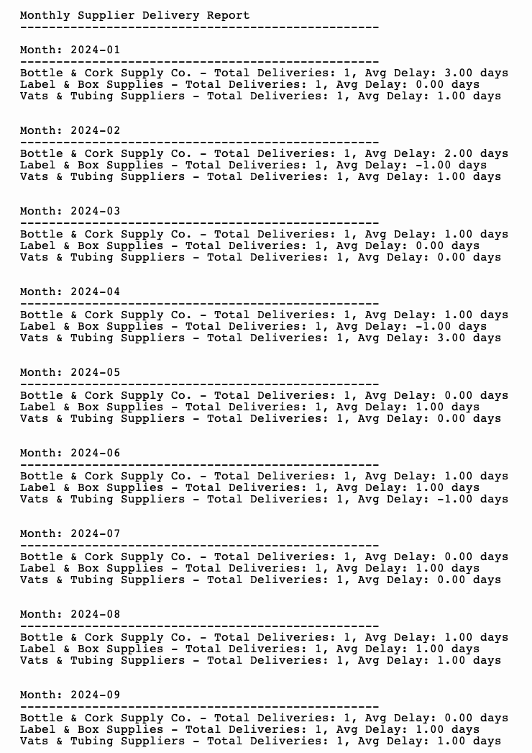

**Report 2: Wine Sales Report**

* This report displays wine bottle sales according to type of wine and its distributor using a bar graph to visually show where certain wines aren’t selling and where other ones are doing well.

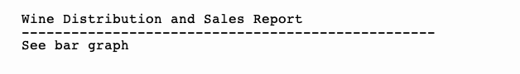

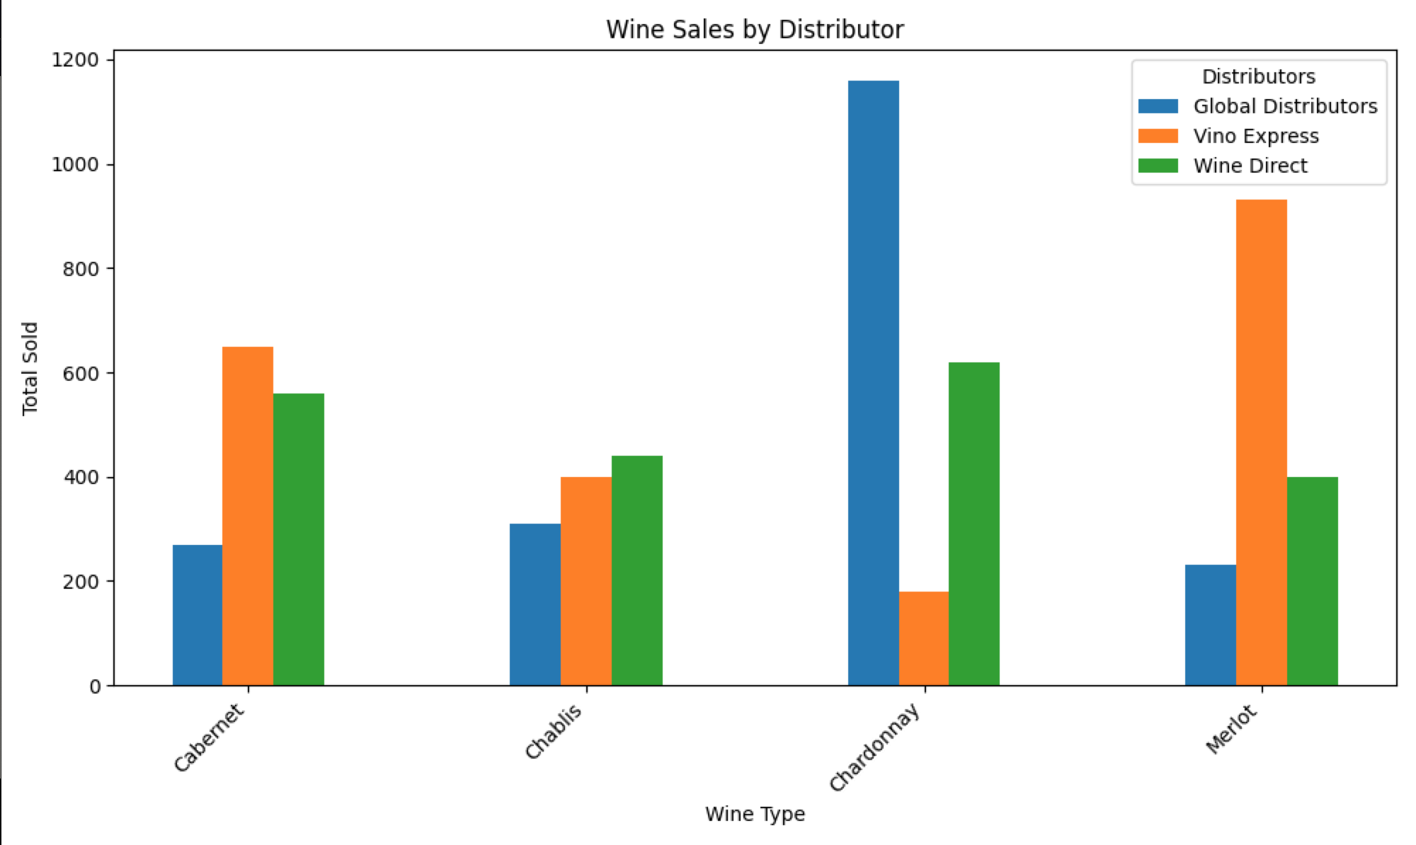

**Report 3: Employee Hours Report**

* This report generates a list of employees in alphabetical order showing how many hours they worked in the past four quarters, by quarter and the total of their hours worked in those past 4 quarters.

