Zachariah King

Assignment 5.2

* RAND() Function: For when you need to generate a random number between 0 and 1 and possibly for a specified amount of times.
  + alias: ‘Random Number’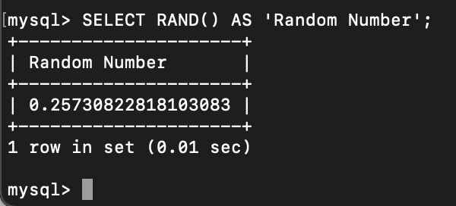
* SQRT() Function: For when you need to return the square root of a number.
  + alias: ‘Square Root of 64’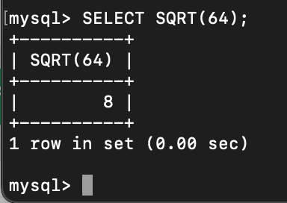

• DEGREES() Function: For when you need to turn a radian value into degrees.

• alias: ‘1.4 in Degrees’