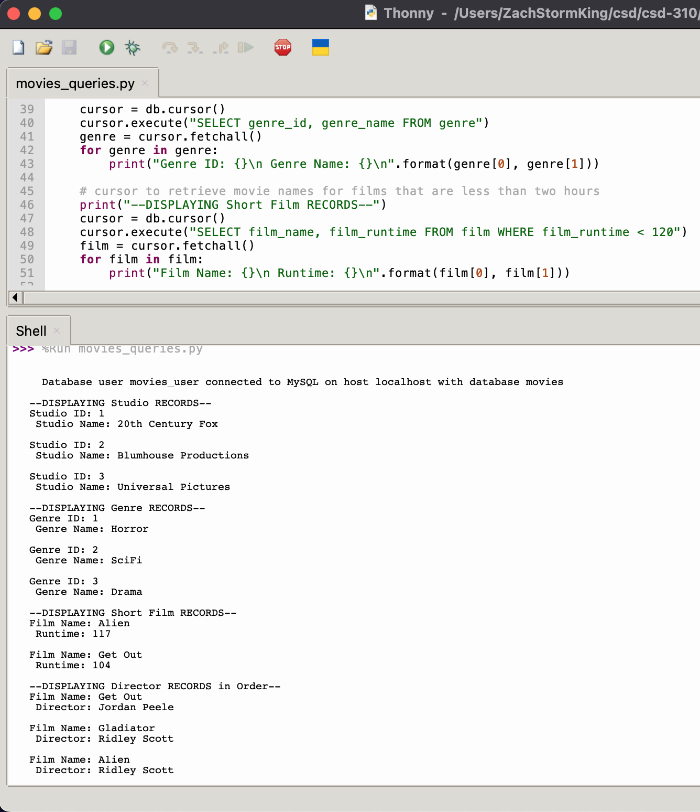

<https://github.com/zachxxking/csd-310.git>