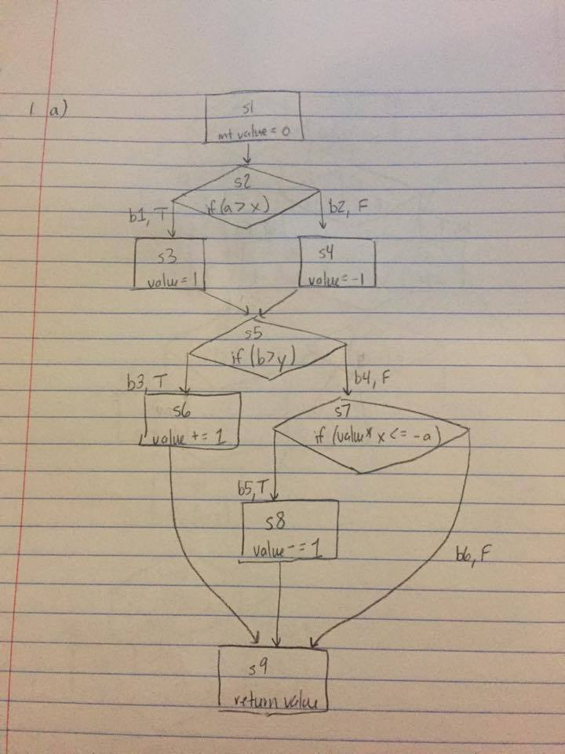

/\* 1b - We want our tests to have full statement coverage, which means that

\* s1, s2, ..., s9 have to be executed

\*/

/\* This test should enter both if statements and should

\* cover s1, s2, s3, s5, s6, s9.

\* In order for it to enter these statements, a>x and b>y

\* The return value will be 1 + 1 = 2

\* This test covers the path b1,b3

\*/

@Test

public void test1() {

assertEquals(2, coverage(1, 1, 0, 0));

}

/\* This test should enter the else then else-if statements and should

\* cover s1, s2, s4, s5, s7, s8, s9

\* In order for it to eter these statements a<=x, b<=y, and

\* value (which should be -1 based on these assumptions) \* x <= -a

\* The return value will be -1 - 1 = -2

\* This path covers the path b2,b4,b5

\*/

@Test

public void test2() {

assertEquals(-2, coverage(0, 0, 0, 0));

}

/\* 1c - We want our tests to achieve full branch coverage, which means

\* that, in our diagram, b1, ..., b6 should all be executed.

\* Looking at the above tests, we see that the following branches have already

\* been tested: b1, b2, b3, b4, b5.

\* This means that we need to test b6: the case where the second if/else-if staement

\* isn't satisfied. Therefore, we need a test where b<=y and value\*x > -a.

\* For this test, we will also use a>x so value will be 1.

\* This path covers the path b1,b4,b6

\*/

@Test

public void test3() {

assertEquals(1, coverage(1, 0, 0, 0));

}

/\* 1d - We want our tests to achieve full feasible path coverage. There are a

\* couple of places where our code branches off. Our code can take b1 or b2.

\* In addition, it can take b3 or [b4,b5] or [b4,b6].

\* This means that all possible paths include:

\* 1. b1,b3 - covered by test1

\* 2. b1,b4,b5

\* 3. b1,b4,b6 - covered by test3

\* 4. b2,b3

\* 5. b2,b4,b5 - covered by test2

\* 6. b2,b4,b6

\* We will then attempt to create tests to cover the remaining paths

\* starting from the top of the list and moving to the bottom.

\*/

/\* We need a test that covers b1,b4,b5, which means that we need

\* a>x (implies value=1) as well as (value\*x <= -a) and b<=y. This path makes

\* value=1 so (value\*x) will simplify to just x. The second condition then

\* becomes x<=-a

\*/

@Test

public void test4() {

assertEquals(0, coverage(-1, 0, -2, 1));

}

/\* We need atest that covers b2,b3, which means that we need

\* a<=x and b>y.

\*/

@Test

public void test5() {

assertEquals(0, coverage(0, 1, 1, 0));

}

/\* 1d and 1e

\* We need a test that covers b2,b4,b6, which means that we need

\* a<=x, b<=y, (value\*x > -a). From these assumptions, we see that

\* value at the point of the second condition will be equal to -1.

\* Therefore the condition will become (-x > -a). Multiplying the

\* inequality by -1 yields (x<a). However, the first condition states

\* that (x>=a). We see there is no way to fulfill both of these conditions

\* so this is an infeasible path.

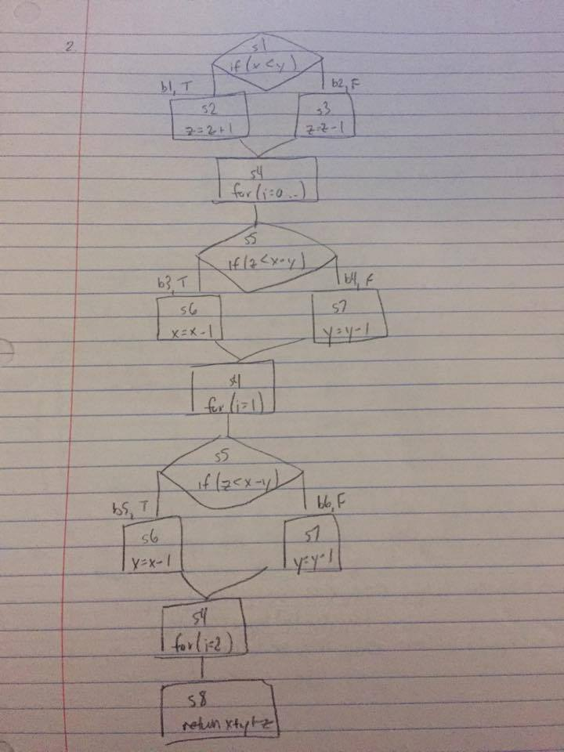

public static int compute(int x, int y, int z) {

if (x < y) { // S1, B1

z = z + 1; // S2

}

else { // B2

z = z - 1; // S3

}

// Loop unrolled (repeats twice)

/\* Enter loop \*/ // S4

if (z < x - y) { // S5, B3

x = x - 1; // S6

}

else { // B4

y = y - 1; // S7

}

/\* Next iteration \*/ // S4

if (z < x - y) { // S5, B5

x = x - 1; // S6

}

else { // B6

y = y - 1; // S7

}

return x + y + z; // S8

}

/\* First we will come up with the symbolic execution after S3 executes.

\* To do this, we will come up with the effect of S2 executing which becomes

\* (x<y) AND (z=z+1). Next, the effect of S3 executing is (x>=y) AND (z=z-1).

\* Therefore, the symbolic execution is simply the OR of these two possibilieis:

\* ((x<y) AND (z=z+1)) OR ((x>=y) AND (z=z-1)).

\*

\* Next we need the symbolic execution of each iteration of the loop.

\* We do the same process as above. The effect of S6 executing becomes

\* (z<x-y) AND (x=x-1). The effect of S7 executing becomes (z>=x-y) AND (y=y-1).

\* Therefore, the symbolic execution becomes the OR of these:

\* ((z<x-y) AND (x=x-1)) OR ((z>=x-y) AND (y=y-1))

\*

\* The next iteration will have the same symbolic execution.

\*

\* We should note, however, that later branch conditions are affected

\* by prior assignments.

\*/

/\* Next, we need to come up with different paths of execution.

\* Each path of exeuction can take (B1 OR B2) AND (B3 OR B4) AND (B5 OR B6).

\* We will note here that S4 will be always be executed at the beginning

\* of a loop iteration and S8 will always be executed at the end of the function.

\* S1 is always executed because the expression needs to be evaluated.

\* If B1 is taken, then S2 executes. Otherwise B2 is taken and S3 executes.

\* This logic follows for the other branches.

\* S5 is always executed at the beginning of an iteration.

\* If B3 or B5 is taken, then S6 is executed.

\* Otherwise, B4 or B6 is taken and S7 is executed.

\*

\* Next we will list the possible branches that can be taken:

\* 1. B1,B3,B5 (TTT)

\* 2. B1,B3,B6 (TTF)

\* 3. B1,B4,B5 (TFT)

\* 4. B1,B4,B6 (TFF)

\* 5. B2,B3,B5 (FTT)

\* 6. B2,B3,B6 (FTF)

\* 7. B2,B4,B5 (FFT)

\* 8. B2,B4,B6 (FFF)

\*

\* Associating each of the branches with the exeuctions we get the

\* following statement executions:

\* 1. S1,S2,S4,S5,S6,S4,S5,S6,S4,S8

\* 2. S1,S2,S4,S5,S6,S4,S5,S7,S4,S8

\* 3. S1,S2,S4,S5,S7,S4,S5,S6,S4,S8

\* 4. S1,S2,S4,S5,S7,S4,S5,S7,S4,S8

\* 5. S1,S3,S4,S5,S6,S4,S5,S6,S4,S8

\* 6. S1,S3,S4,S5,S6,S4,S5,S7,S4,S8

\* 7. S1,S3,S4,S5,S7,S4,S5,S6,S4,S8

\* 8. S1,S4,S4,S5,S7,S4,S5,S7,S4,S8

\* | | |

\*

\* Now let's look at the te test cases given in Part A.

\*

\* 1. x = 1 AND y = 2 AND z = -4

\* First branch: (x<y) -> (1<2) TRUE

\* z incremented to -3 -> x=1, y=2, z=-3

\* Second branch: (z<x-y) -> (-3<1-2=-1) TRUE

\* x decremented to 0 -> x=0, y=2, z=-3

\* Third branch: (z<x-y) -> (-3<0-2=-2) TRUE

\* x decremented to -1 -> x=-1, y=2, z=-3

\* Return -1 + 2 + -3

\* TTT -> Path 1 executed.

\*

\* 2. x = 2 AND y = 3 AND z = -1

\* First branch: (x<y) -> (2<3) TRUE

\* z incremented to 0 -> x=2, y=3, z=0

\* Second branch: (z<x-y) -> (0<2-3=-1) FALSE

\* y decremented to 2 -> x=2, y=2, z=0

\* Third branch: (z<x-y) -> (0<2-2=0) FALSE

\* y decremented to 1 -> x=2, y=1, z=0

\* Return 2 + 1 + 0

\* TFF -> Path 4 executed

\*

\* 3. x = 4 AND y = 6 AND z = -3

\* First branch: (x<y) -> (4<6) TRUE

\* z incremented to -2 -> x=4, y=6, z=-2

\* Second branch: (z<x-y) -> (-2<4-6=-2) FALSE

\* y decremented to 5 -> x=4, y=5, z=-2

\* Third branch: (z<x-y) -> (-2<4-5=-1) TRUE

\* x decremented to 3 -> x=3, y=5, z=-2

\* Return 3 + 5 + -2

\* TFT -> Path 3 executed

\*

\* 4. x = 3 AND y = 1 AND z = 2

\* First branch: (x<y) -> (3<1) FALSE

\* z decremented to 1 -> x=3, y=1, z=1

\* Second branch (z<x-y) -> (1<3-1=2) TRUE

\* x decremented to 2 -> x=2, y=1, z=1

\* Third branch (z<x-y) -> (1<2-1=1) FALSE

\* y decremented to 0 -> x=2, y=0, z=1

\* Return 2 + 0 + 1

\* FTF -> Path 6 executed

\*

\* 5. x = 2 AND y = 5 AND z = -5

\* First branch: (x<y) -> (2<5) TRUE

\* z incremented to -4 -> x=2, y=5, z=-4

\* Second branch: (z<x-y) -> (-4<2-5=3) TRUE

\* x decremented to 1 -> x=1, y=5, z=-4

\* Third branch: (z<x-y) -> (-4<1-5=-4) FALSE

\* y decremented to 4 -> x=1, y=4, z=-4

\* Return 1 + 4 + -4

\* TTF -> Path 2 executed

\*

\* 6. x = 3 AND y = 2 AND z = 2

\* First branch: (x<y) -> (3<2) FALSE

\* z decremented to 1 -> x=3, y=2, z=1

\* Second branch: (z<x-y) -> (1<3-2=1) FALSE

\* y decremented to 1 -> x=3, y=1, z=1

\* Third branch: (z<x-y) -> (1<3-1=2) TRUE

\* x decremented -> x=2, y=1, z=1

\* Return 2 + 1 + 1

\* FFT -> Path 7 executed

\*

\* 7. x = 1 AND y = 2 AND z = -2

\* First branch: (x<y) -> (1<2) TRUE

\* z incremented to -1 -> x=1, y=2, z=-1

\* Second branch: (z<x-y) -> (-1<1-2=-1) FALSE

\* y decremented to 1 -> x=1, y=1, z=-1

\* Third branch: (z<x-y) -> (-1<1-1=0) TRUE

\* x decremented to 0 -> x=0, y=1, z=-1

\* Return 0 + 1 + -1

\* TFT -> Path 3 executed

\*

\* 8. x = 1 AND y = 2 AND z = -3

\* First branch: (x<y) -> (1<2) TRUE

\* z incremented to -2 -> x=1, y=2, z=-2

\* Second branch: (z<x-y) -> (-2<1-2=-1) TRUE

\* x decremented to 0 -> x=0, y=2, z=-2

\* Third branch: (z<x-y) -> (-2<0-2=-2) FALSE

\* y decremented to 1 -> x=0, y=1, z=-2

\* Return 0 + 1 + -2

\* TTF -> Path 2 executed

\*

\* 9. x = 1 AND y = 2 AND z = 0

\* First branch: (x<y) -> (1<2) TRUE

\* z incremented to 1 -> x=1, y=2, z=1

\* Second branch: (z<x-y) -> (1<1-2=-1) FALSE

\* y decremented to 1 -> x=1, y=1, z=1

\* Third branch: (z<x-y) -> (1<1-1=0) FALSE

\* y decremented to 0 -> x=1, y=0, z=1

\* Return 1 + 0 + 1

\* TFF -> Path 4 executed

\*

\* 10. x = 2 AND y = 1 AND z = 1

\* First branch (x<y) -> (2<1) FALSE

\* z decremented to 0 -> x=2, y=1, z=0

\* Second branch (z<x-y) -> (0<2-1=1) TRUE

\* x decremented to 1 -> x=1, y=1, z=0

\* Third branch (z<x-y) -> (0<1-1=0) FALSE

\* y decremented to 0 -> x=1, y=0, z=0

\* Return 1 + 0 + 0

\* FTF -> Path 6 executed

\*

\* Paths 5 and 8 are not executed by the test cases.

\*

\* Path 5 (FTT) - (x>=y) AND (z=z-1) AND (z<x-y) AND (x=x-1)

\* AND (z<x-y) AND (x=x-1) =>

\* (x>=y) AND (z-1<x-y) AND (z-1<(x-1)-y) =>

\* (x>=y) AND (z-1<x-y) AND (z<x-y) =>

\* (x>=y) AND (z<x-y) => C

\*

\* Path 8 (FFF) - (x>=y) AND (z=z-1) AND (z>=x-y) AND (y=y-1)

\* AND (z>=x-y) AND (y=y-1) =>

\* (x>=y) AND (z-1>=x-y) AND (z-1>=x-(y-1)) =>

\* (x>=y) AND (z-1>=x-y) AND (z-2>=x-y) =>

\* (x>=y) AND (z>=x-y+2) => B

