|  |  |  |  |  |  |  |  |  |
| --- | --- | --- | --- | --- | --- | --- | --- | --- |
| [Home](http://users.ece.utexas.edu/~miryung/index.html) | [Research](http://users.ece.utexas.edu/~miryung/research.html) | [Publications](http://users.ece.utexas.edu/~miryung/publications.html) | [Teaching](http://users.ece.utexas.edu/~miryung/teaching.html) | [Students](http://users.ece.utexas.edu/~miryung/students.html) | [CV](http://users.ece.utexas.edu/~miryung/miryungkim_cv.pdf) | [Software](http://users.ece.utexas.edu/~miryung/software.html) | [Funding](http://users.ece.utexas.edu/~miryung/funding.html) | [Activities](http://users.ece.utexas.edu/~miryung/activities.html) |

**UML**

Software engineers often have to communicate properties of the systems they develop with other stakeholders who may or may not be familiar with the technical details of the system that is being examined.  UML provides a unified, consistent way to communicate information about software systems in a way designed to be intuitive for both technical and non-technical individuals.  Many tools exist that support working with UML that serve to support the development of a UML model and expressing that model by generating graphical artifacts as specified by the UML standard.  
  
This laboratory exercise will introduce you to one such tool, ArgoUML.  We'll use ArgoUML to develop four commonly encountered UML artifacts:

* use case diagram
* state diagram
* class model diagram
* sequence diagram

The diagrams you create will model aspects of a simple case study wherein you've been contracted to create a new computer system for a university library.  The system you are to develop will replace the library's antiquated card catalog and their manual, paper-based method for keeping track of what has been lent out to library members.  For each diagram, we'll introduce the basics of working with ArgoUML to create that diagram and then you will be charged with translating a description of the system to be developed into the desired UML artifact.

**Software**

This lab requires an installation of [ArgoUML](http://argouml.tigris.org/).  The following screenshots and procedures were developed using ArgoUML version  0.32.

**Use case diagram**

A use case diagram is a simple drawing which documents the behavior of a system from the user's point-of-view.  It identifies the external entities (known as actors) that will work with your system as well as what they will be doing with your system (the "use cases" for those actors).  When you start ArgoUML, it will create a default model called "untitledModel".  This is the root node of your model and will contain all the artifacts that we will be creating.  If you expand this root node, you will see that it has already been pre-populated with a class diagram and a use case diagram.  We'll return to the class diagram later, but for now we'll focus on the use case diagram.  Clicking on the pre-populated use case diagram entry in the model will display the (currently empty) use case diagram in the main edit window.

**Actors**

Actors can be added to the use case diagram by selecting the "New Actor" tool from the main edit window's toolbar.  Once the tool has been selected, click anywhere in the diagram window to place an actor in that location.  Each actor in your system should have a short descriptive name.  Add this information by filling in the "Name" field in the "Properties" tab located below the diagram.  All these features are shown below:  
  
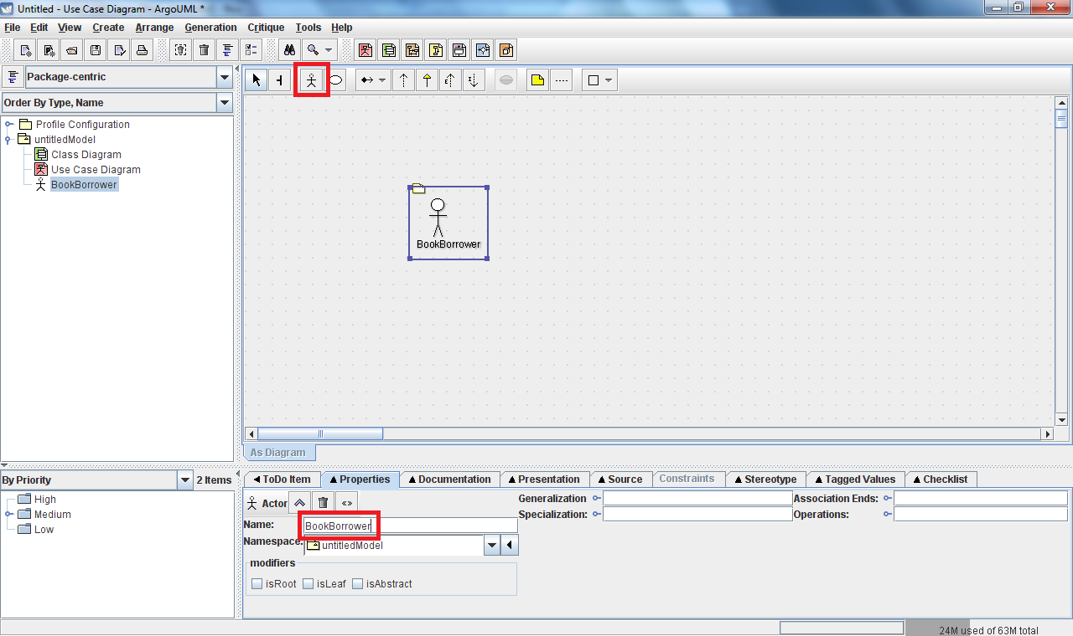

**Use cases**

Use cases can be added to the use case diagram by selecting the "New Use Case" tool from the main edit window's toolbar.  Once the tool has been selected, click anywhere in the diagram window to place a use case in that location.  Each use case in your system should also have a short descriptive name.  Add this information by filling in the "Name" field in the "Properties" tab located below the diagram.  Again, all these features are shown below:  
  
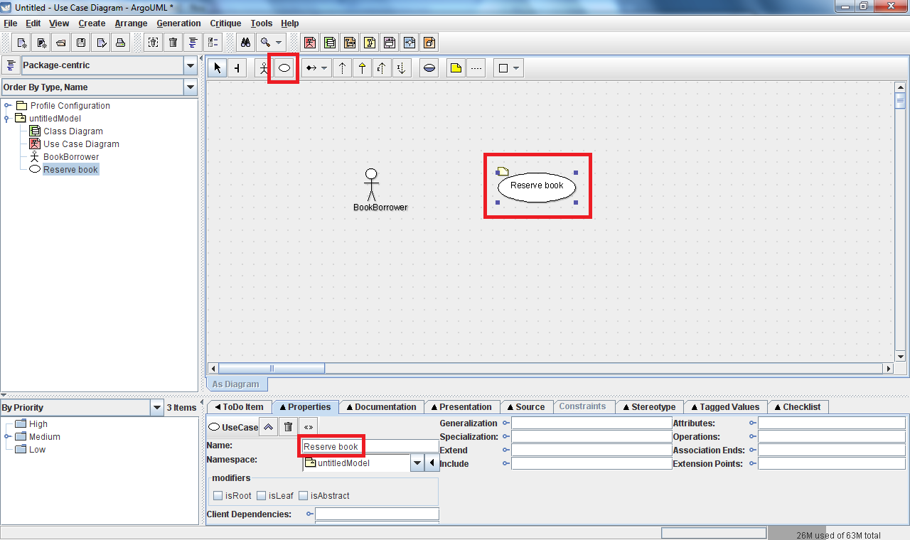

**Associations**

Use cases and actors are linked by an "association" which indicates that a particular actor is expected to need to use the system in a given way.  To notate these association between actors and use cases you'll need to draw a line representing this association.  This can be added to the diagram by selecting the "New Association" from the edit toolbar.  You may need to use the dropdown button next to the toolbar item group in order to select the appropriate tool.  Once this association tool has been selected, click and hold on an actor and drag the mouse over to the use case with which you want them to be associated.  You can associated multiple actors with a given use case, or multiple use cases with a single actor.  You can name your associations if you like, but this is not required.  An example of a simple associated actor/use case is given below:  
  
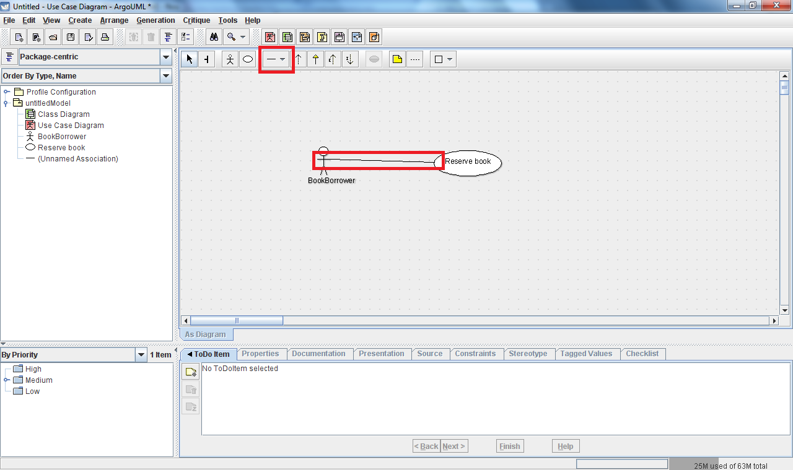

**Exercise**  
Translate the following English statements into a representative use case diagram:

The system shall have the following four types of actors: BookBorrower, JournalBorrower, Browser, and Librarian.  A user playing the role of a BookBorrower shall be able to reserve a book, borrow a copy of a book, return a copy of a book, and extend the loan of a book.  A JournalBorrower shall be able to borrow a journal and return a journal.  A Browser shall be able to browse, and a librarian shall be able to update the catalog.

**State diagrams**

Perhaps the most familiar of the UML diagram types, state diagrams are used to communicate how parts of a software system react to specific stimuli.  To create a state diagram in ArgoUML, right-click on the top-level model node on the left-hand side of the tool and select the "Create Diagram -> New Statechart Diagram" menu item.  This will add a new state machine, "(Unnamed State Machine)", as a child node in the model tree.  Expand this node and you'll find the statechart diagram we just created.  The "state machine"-> "state diagram" hierarchy we see here is provided by UML in order to allow one state machine to span across multiple state diagrams.  By default the state diagram created will be named "untitledModel 0" - feel free to rename this to something more descriptive using the "Properties" tab below the edit window.  Click on the state diagram entry in the model tree and the empty state diagram will be presented in the edit window.

**States**

States can be added by clicking on the "New Simple State" toolbar button and then clicking somewhere within the edit window to indicate where you would like the state to be placed.  Each state should be given a short descriptive name, which can be entered in the "Name" field within the "Properties" tab.  The essential user interface elements you'll need are called out below.  
  
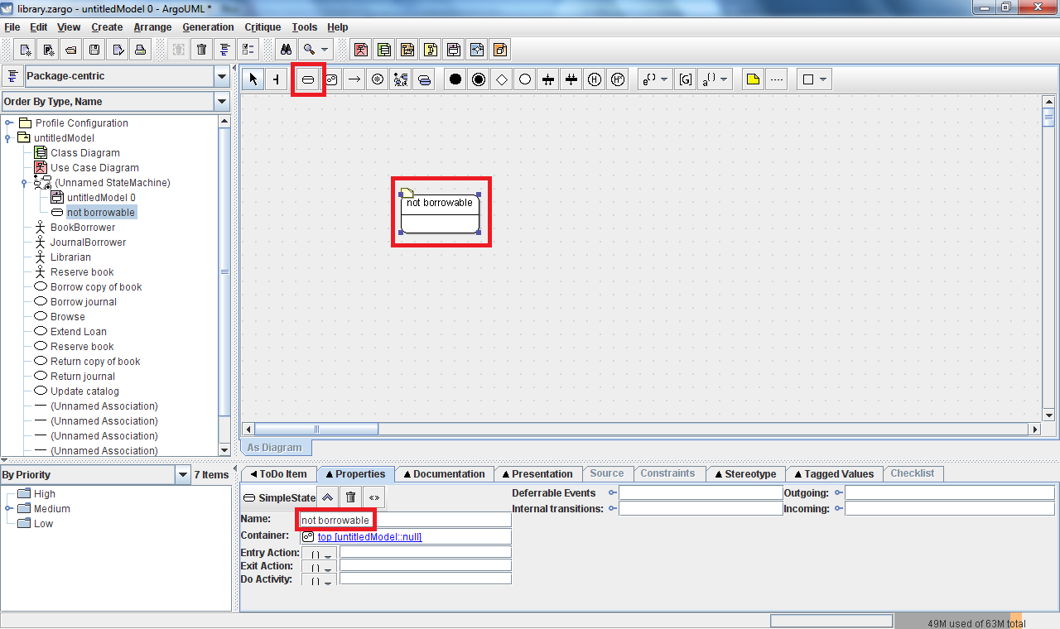

**Transitions**

Movement by the system from one state to another is indicated by adding a "Transition" from one state to another.  To add a transition between states, click on the "New Transition" tool from the edit toolbar.  Then click and hold on the state in which the transition begins and drag the mouse to the state to which the transition ends.

**Annotations**

Transitions are almost always annotated with additional information regarding actions that cause the transition to occur (triggers) and things that will happen when the transition occurs (effects).  Additionally, a transition's triggers can be specified to only be valid under certain conditions (guards).  ArgoUML supports all of these constructs, and the appropriate annotations can be added within the "Properties" tab.  To add a trigger, effect, or guard click on the tool button located adjacent to the respective annotation you wish to add (where different sub-types of actions are available, we will almost always use the "Call" type as this corresponds to the familiar action of calling an object's method).  See the figure below for an example showing two transitions:

* "not borrowable" transitioning to "borrowable": this transition represents a transition triggered by a call to "returned"
* "borrowable" transitioning to "borrowable": this self-transition represents a transition triggered by a call to "borrowed", but it is guarded (i.e.: won't happen unless) it is not the last copy

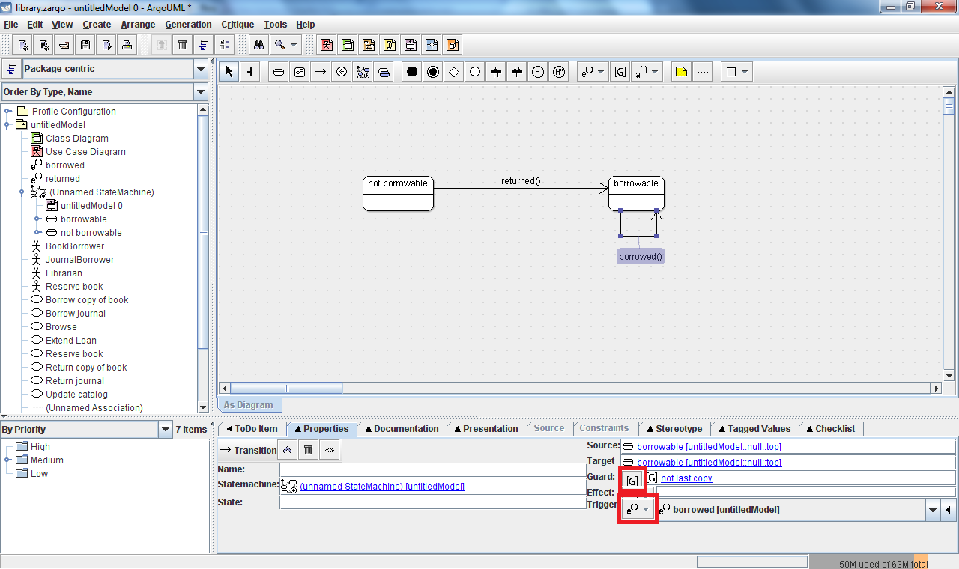Note: Creating a transition from a state to itself (a so-called "self transition") is not intuitive in ArgoUML.  To enter such a transition use a "u-turn" when drawing the transition - namely click on the state and drag out a distance from the state, release the mouse, move the mouse slightly, click again, and then finally click back on the state.  This will create the desired self transition.  
  
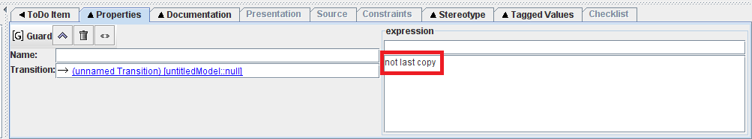  
  
Note: To define a guard, the desired expression should be entered in the large text box at the bottom right (as seen above), not the name field or the small textbox directly under "expression".  The small text box can be used to specify a language for the expression (and there are tooltips to indicate this), but it is not immediately apparent from the user interface.

**Exercise**  
During the process of designing the new library system it was discovered that one class of the library system objects would be a "Book".  Perhaps not as obvious is that an additional (but closely related) object class would be one for specific copies of a book.  For this exercise you will be designing a simple subset of the state machine that is implemented as part of the "Book" class.  Translate the following English statements into a representative state diagram which models the behavior of the "Book" class of objects:

A Book should either be borrowable or not borrowable.  If a Book is currently borrowable, it should accept notifications that it was returned unconditionally.  Additionally, if the book is borrowable and it is notified that a copy of it has been borrowed, then it should transition to not being borrowable only if it was the last copy that was just borrowed - otherwise it should remain borrowable.  Conversely, if the book is not currently borrowable, then it should transition back to being borrowable whenever it is notified that a copy of the book is returned.

**Class diagrams**

Class diagrams provide a way to document the structure of a system by defining what classes there are within it and how they are related.  ArgoUML automatically includes a class diagram in all of the models it creates.  The default class diagram name is "Class Diagram", click on it to open the blank class diagram canvas in the edit window.

**Classes**

As you would expect, the basic building block of a class diagram is the class.  To add a new class to your class diagram, click on the "New Class" tool in the class diagram's edit toolbar and click anywhere in the edit window where you would like the class to be placed.  At a minimum, each class should have a name, which can be supplied using the "Name" field in the "Properties" tab for a given class.

**Operations**

Classes can contain additional information about the operations they support.  Operations define the ways in which objects interact with each other (these operations are often analogous to methods in many programming languages).  Operations can be added to a class by selecting the desired class in the edit window and clicking the "New Operation" tool from the edit window's toolbar.  This will add a new operation to the class that can be modified using the "Properties" tab as seen below.  
  
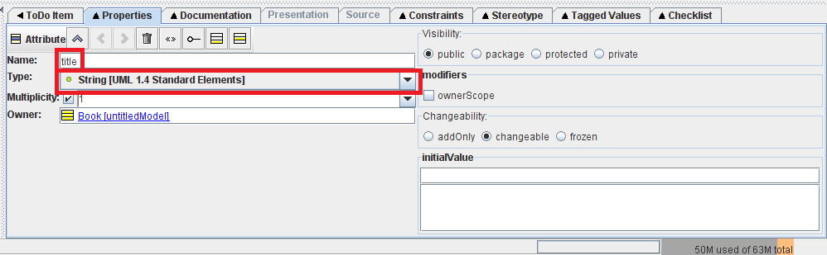  
  
The most common properties that you'll want to modify will be to give the operation a name and to specify information about the parameters it uses.  Parameters are often used to record the arguments the operation/method is expected to take and the type (if any) it uses to return information. Expanding the parameter list box by clicking on "Parameter" in the "Properties" tab will give you access to additional parameter related tools such as "New Parameter" that allow you to add parameters for the operation.  By default, all operations have a "return" parameter with type <none> that serves as a placeholder for the return type.  Double-clicking on a parameter in the parameter list will will open an additional edit screen for the selected parameter in the "Properties" tab.  This edit screen allows you to modify parameter properties such as its name and type.  A sample parameter edit screen showing the "return" parameter modified to return an Integer is shown below.  
  
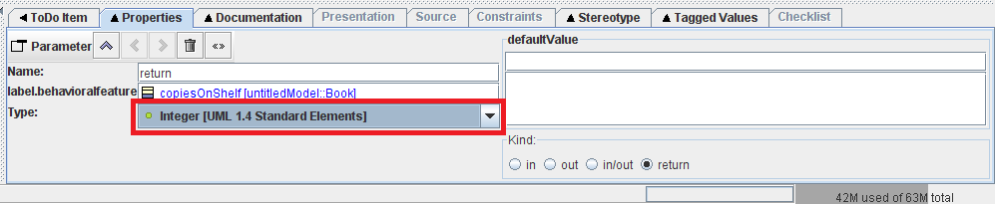  
  
Note: UML provides standard primitive types for you.  You can also specify the type to be a class that you've added to your model (such as the Book class) as well.

**Attributes**

In addition to operations, classes will also often have attributes which are used to describe the data contained in an object of the class (these attributes are often analogous to fields in many programming languages).  Attributes can be added to a class by selecting the desired class in the edit window and clicking the "New Attribute" tool from the edit window's toolbar.  This will add a new operation to the class and will open a new edit screen in the "Properties" tab.  In this edit screen you can modify the attribute properties such as its name and type.  A sample attribute edit screen is shown below.  
  
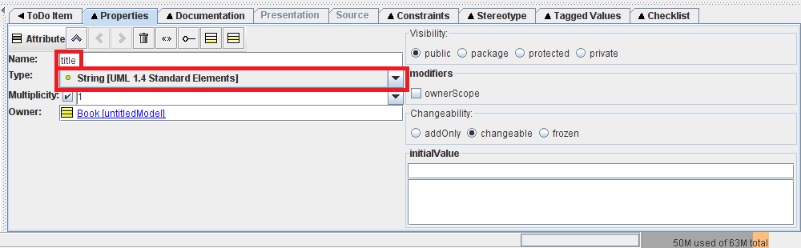  
  
A sample class diagram using a class with attributes and properties is shown below.  
  
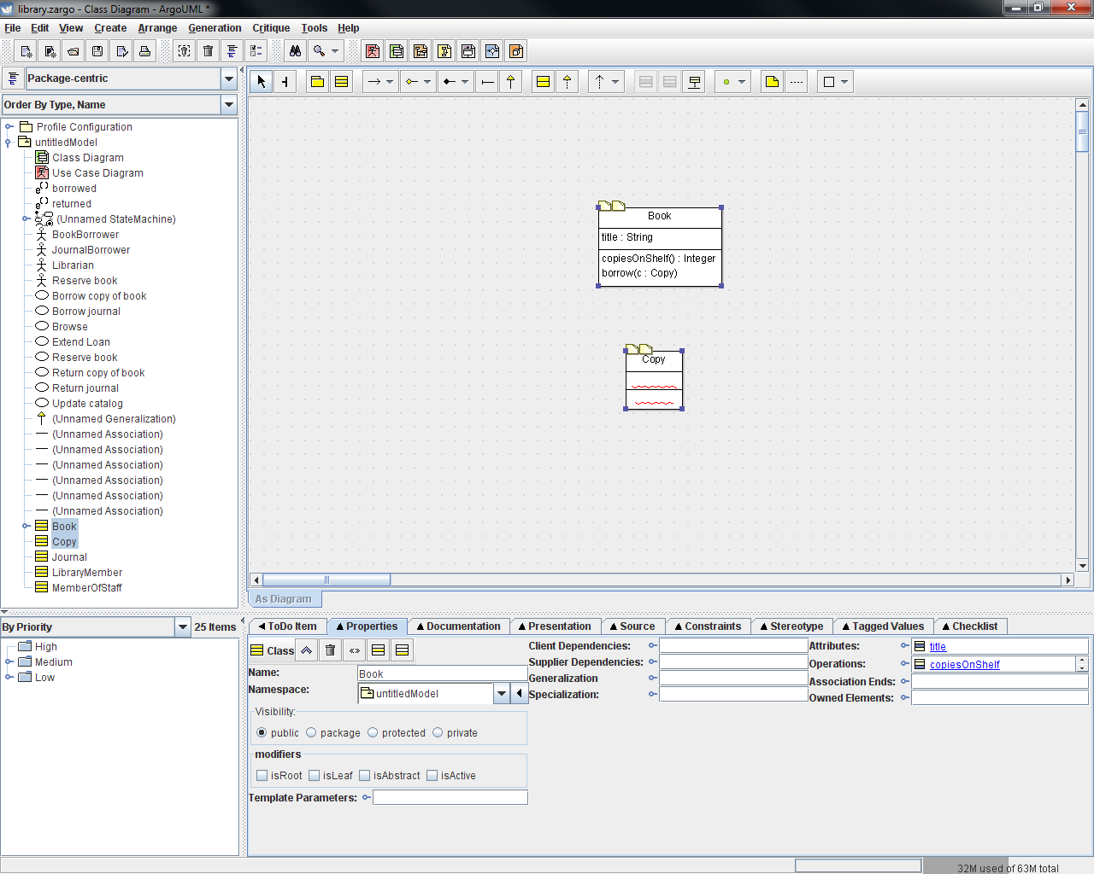

**Associations and Generalizations**

The relationships between classes are often described using associations and generalizations.  While classes often correspond the "nouns" in a system, associations correspond to the "verbs".  They describe relationships such as "is a copy of" and "borrows/returns".  Associations can be added between classes in ArgoUML by selecting the "New UniAssociation" tool in the edit toolbar and then clicking and holding on one class in the diagram and dragging the mouse to the class to which you want to create the association.  You'll generally want to give names to your associations, and this can be done using the "Properties" tab edit screen for the association.  A sample class association is shown below.  
  
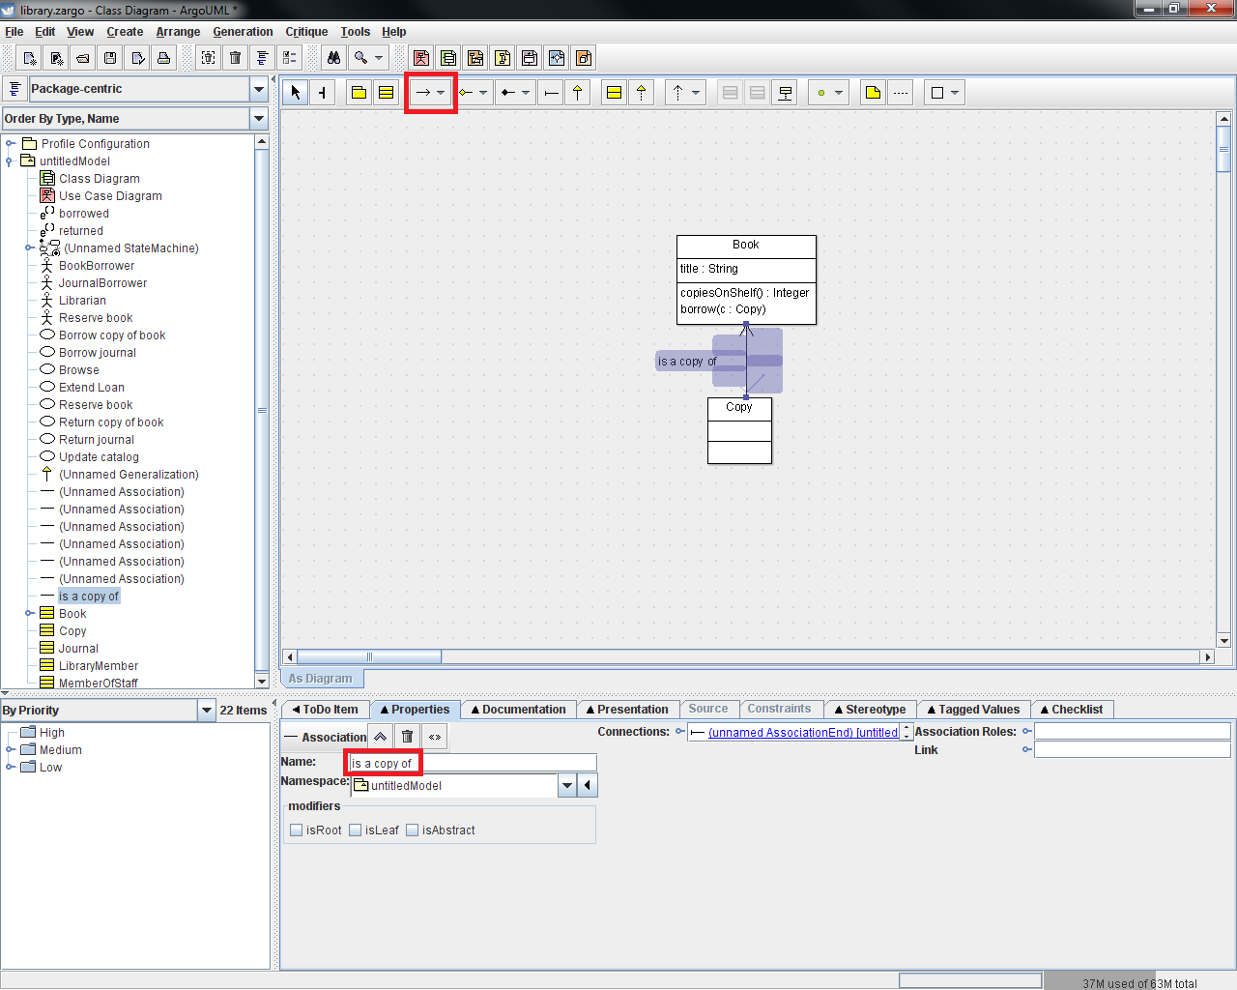  
  
Another important relationship between classes is a "generalization".  Generalizations describe relationships that are often analogous to inheritance in programming languages.  Generalizations can be added by clicking on the "New Generalization" tool in the edit toolbar and then clicking and holding on the more specific class and then dragging the mouse to the class which is a generalization of it.  A sample showing a generalization relationship between two classes is shown below.  
  
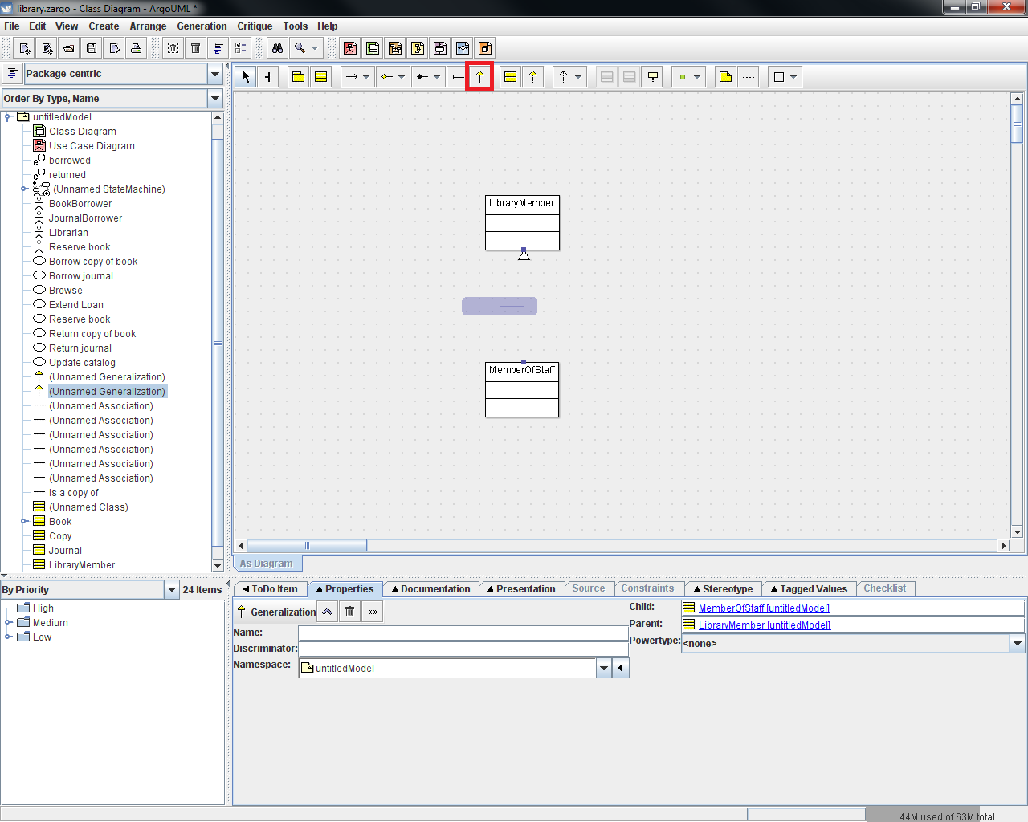

**Exercise**  
Translate the following English statements into a representative class diagram which models the structure the library system:

The library system should allow for the representation of the following roles: LibraryMember, MemberOfStaff, Journal, Book, Copy.  LibraryMembers can interact with Copy objects in that they can borrow/return them.  Likewise, MemberOfStaff objects can borrow/return Journals.  It's also important that we have a relationship between Book and Copy where Copy is a copy of a Book.  Also, note that MemberOfStaff objects will always be LibraryMembers as well and should be able to do everything a LibraryMember can do.  
  
Lastly, let's add some additional details to the Book class: every Book will keep track of its title, which is a string.  It should respond to a copiesOnShelf message with an integer, and it should accept a borrow message that has an input parameter of type Copy.

**Sequence Diagrams**

The last UML diagram type we'll be working with is a sequence diagram.  A sequence diagram is sub-type of a more broad category of UML diagrams called interaction diagrams.  A sequence diagram shows how actors and/or objects interact with each other by providing a timeline of messages being passed from one to the other.  Each object/actor has a representation of its own timeline (known as a lifeline) in which time is assumed to pass as we move from top to bottom of the diagram.  To create a sequence diagram in ArgoUML, right-click on the root node of your model and select "Create Diagram -> "New Sequence Diagram".  This will add a new sequence diagram (nested in a collaboration node) to the model and open a blank sequence diagram canvas in the edit window.

**Actors/Objects**

The first step in defining the sequence diagram is to add the actors/objects that are involved in the interaction to be displayed.  You can add generic objects, but in general it is best to associate the lifeline with a type that we've already defined in the model.  For this, search the model tree on the left of the screen to find a class (which was defined in your class diagram) or an actor (which was defined in your use case diagram) that represents the type of the object/actor you wish to add to the diagram.  Click and hold on this entry and drag it onto the sequence diagram canvas.  This will create a lifeline (referred to as a "Classifier Role" in ArgoUML) that is associated with the selected type in your diagram.  As usual, properties of this model member can be modified using the "Properties" tab - in general at least a name should be provided.  The screenshot below shows a sequence diagram that has been populated with two lifelines: on the left is an instance ("aMember") of an actor ("BookBorrow"), on the right there is an instance ("theLibraryMember") of a class ("LibraryMember").  
  
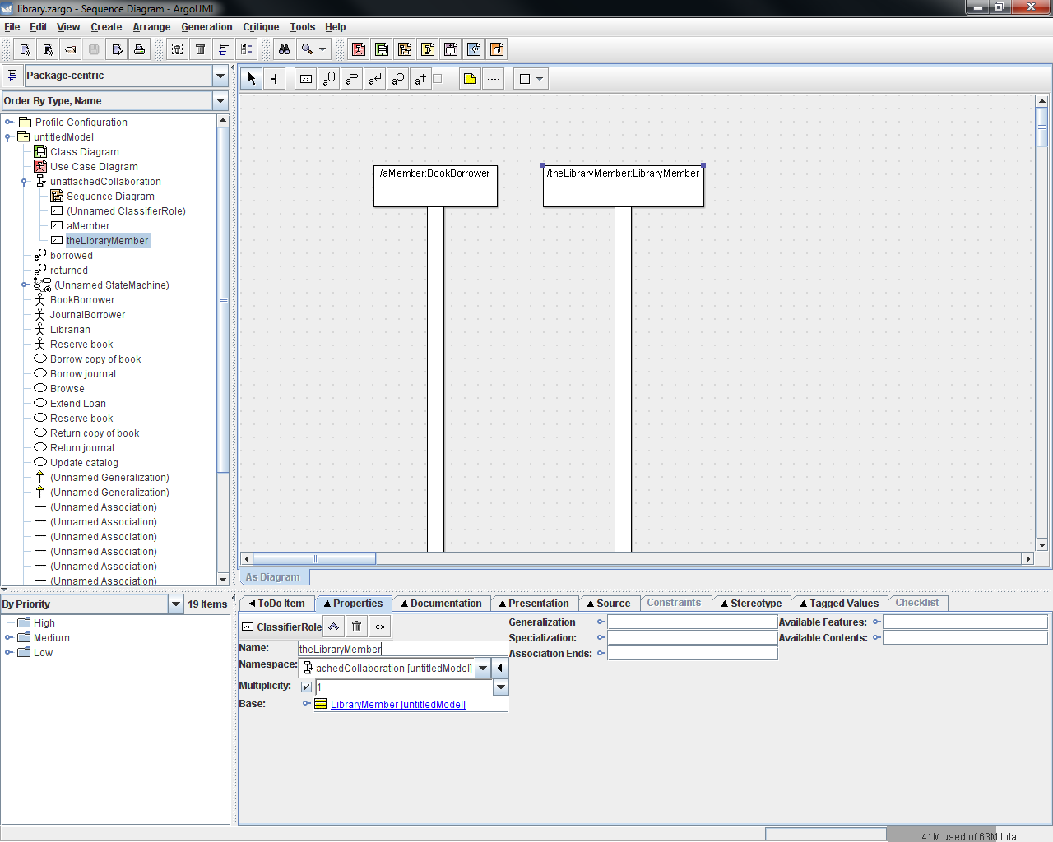

**Messages**

With the actor and object instances placed in the diagram, the next step is to depict the sequence of messages that are passed between each instance. Most often these message will represent the calling of a method, so to add these messages you'll select the "New Call Action" tool from the edit toolbar and then click-and-hold on the instance which will be generating the message and drag it to the instance which will be receiving it.  This will create a message call and return action in the sequence diagram.  As usual, you will need to edit the properties for this message using the "Properties" tab where you can use the "Name" field to record information about the message.  The snapshot below shows the sequence diagram from above updated with two messages: one from "aMember" to "theLibraryMember" requesting to borrow a specific copy, and another showing that "theLibararyMember" will send a message to itself to see if it's alright for the member to borrow the copy.  The second diagram has also been updated to include a third lifeline for "theCopy", an instance of the "Copy" class,  since "theCopy" is involved in the interaction between "BookBorrower" and "theLibraryMember".  
  
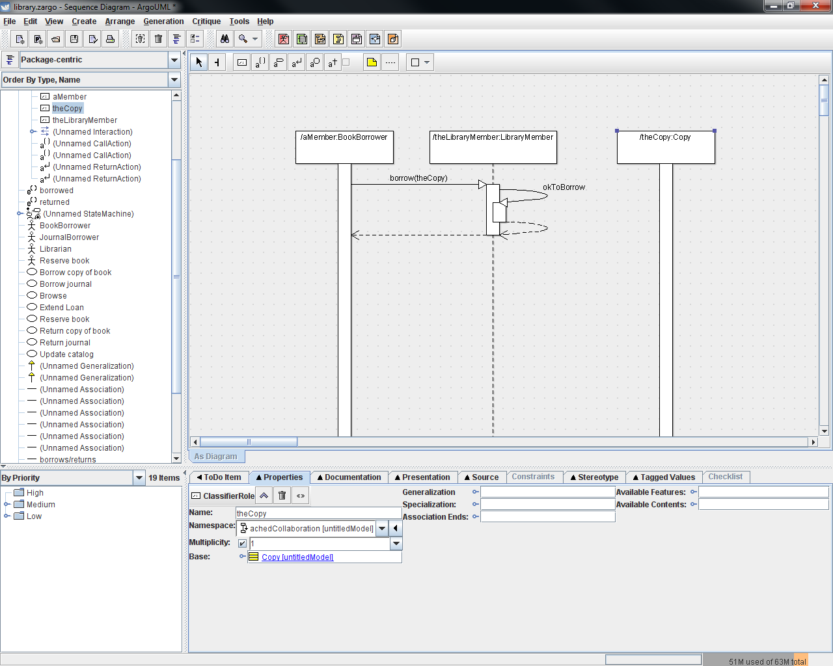  
  
Note: As we've seen before, getting ArgoUML to allow a message to be passed to the same object that is generating it is not initially intuitive.  To create this message-to-self you'll need to use the "U-turn" method discussed earlier for state diagrams.  Click-and-hold on the instance you wish the message to be generated by and drag away, release the mouse, click in yet another location away from the instance, and finally click back on the instance.  Note that your second and third clicks must be far sufficiently far away from the lifeline for this to work - specifically, they must be further away than the bounding box for the box at the top of the lifeline.  See below for an example of the sequence of clicks that will successfully generate a message-to-self.  
  
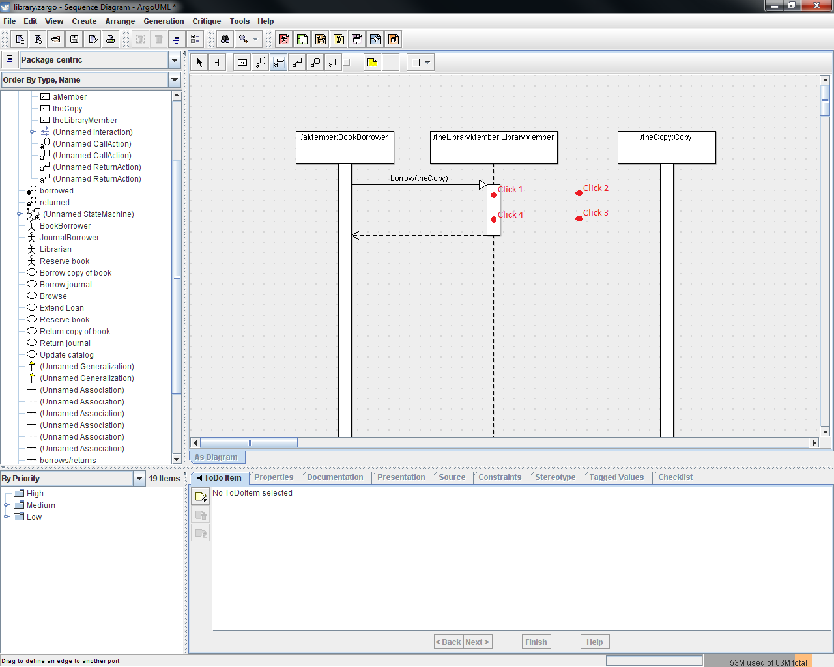

**Exercise**  
Translate the following English statements into a representative sequence diagram which models the interaction necessary for a member to borrow a book:

Four actors/objects will be involved in a book borrowing interaction: a BookBorrower named aMember, a LibraryMember named theLibraryMember, a Copy named theCopy and a Book named theBook.  aMember will request to borrow theCopy by sending a message to theLibraryMember.  theLibraryMember will then check with itself to make sure it's ok for the borrowing to occur and then notify theCopy that it is going to be borrowed.  theCopy will then in turn notify theBook that it has been borrowed.  Once all of these nested operations are complete, aMember is now borrowing the book!

Reference materials:

* Perdita Stevens with Rob Pooley, *Using UML: Software Engineering with Objects and Components*,*Updated Edition*, ISBN 0-201-64860-1

Developed with guidance from Miryung Kim  
  
[Copyright (c) 2011 Professor Miryung Kim and a course development TA Evan Grim](mailto:evan@mirgnave.com)  
  
Permission is granted to copy, distribute and/or modify this document under the terms of the GNU Free Documentation License, Version 1.1 or any later version published by the Free Software Foundation; with no Invariant Sections, no Front-Cover Texts, and no Back-Cover Texts.  A copy of the license can be found on the GNU web site [here](http://www.gnu.org/copyleft/fdl.html).