- Exit function.
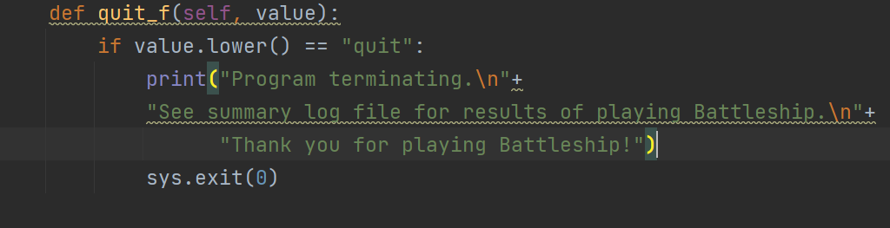

We call this method every time the use try to enter an input
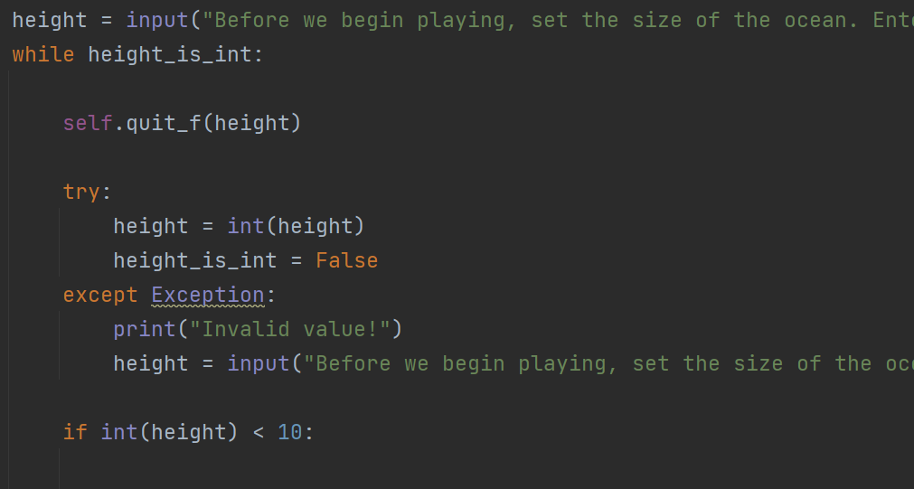
After the player input the height, we see if the player input “quit” or “exit” (don’t worry about the “while” right now, we will discuss that in a minute)
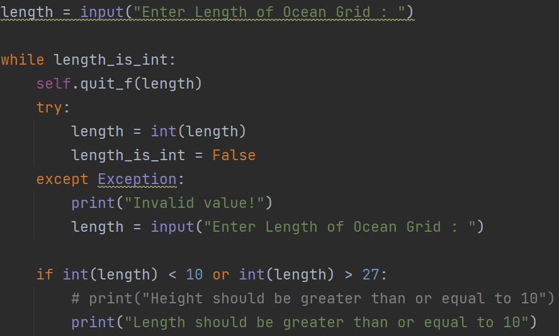
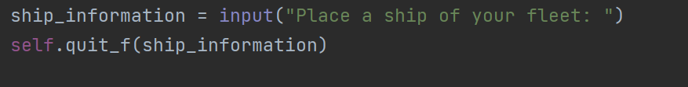
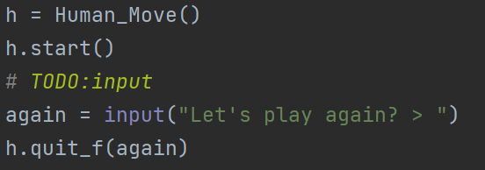
In the previous three inputs we use “self” to call the method because we were inside the class where the method “quit_f” is implemented, but in the last one we use “h.quit_f”, “h” is an object of the class Human_Move.

- the summary log
at the beginning when the player input the height and the length we open the file “Summary_Log” and we append the values entered by the player.
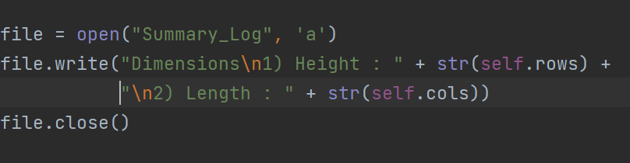
And each time when the player make a guess we add them to the file and the computer guesses as well.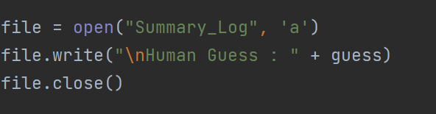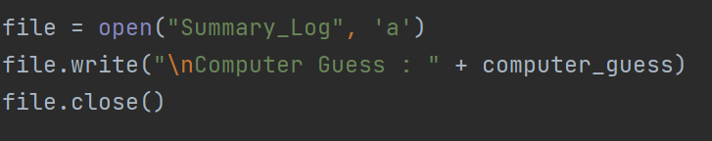
In the end of the game the following code will add to the file Which ships fully sank for each player if any, The winner (if any) of the match. And it will print the grids (player grids and computer grids) in the console.
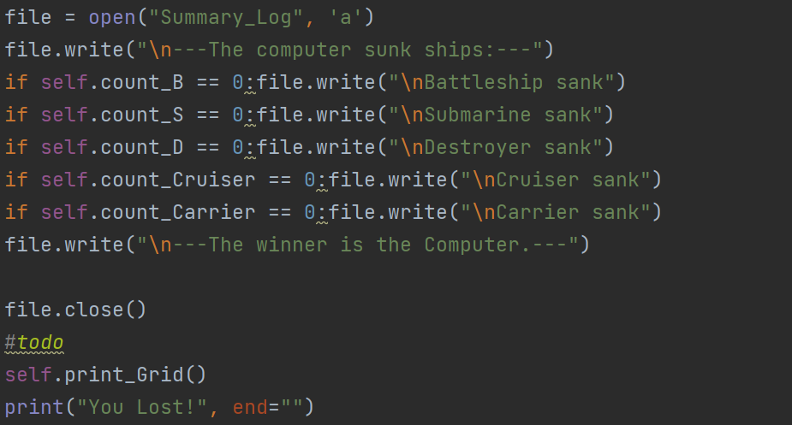
IN THE COMPUTER CLASS
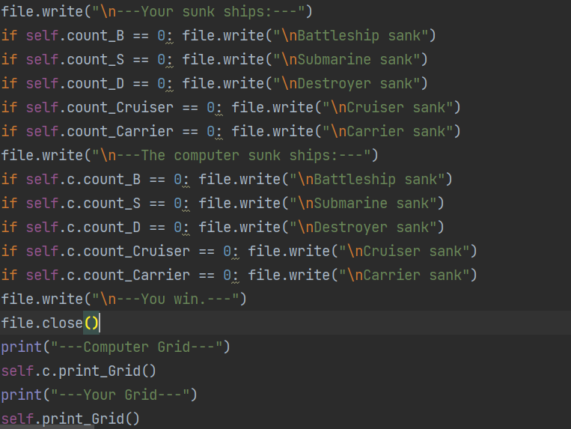
IN THE HUMAN CLASS
- add function that when enter invalid value for any input it need to display "Invalid value!"
Now we will tackle the benefit of the use of the “while” mentioned before.
In the following 2 images we have two similar functionalities applied on the two input statements (height = input(….) and length = input(….)).
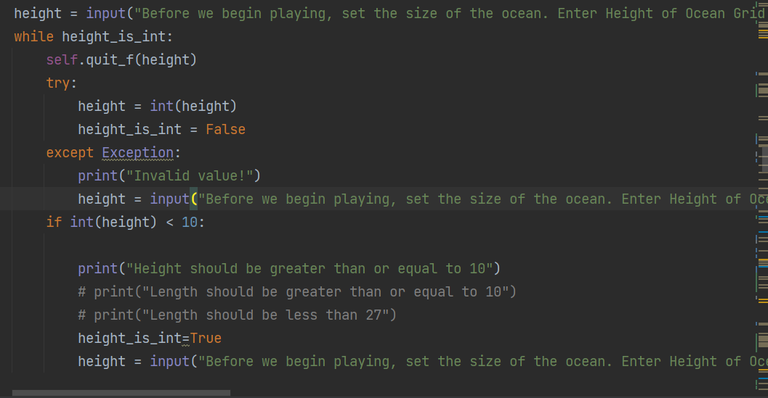
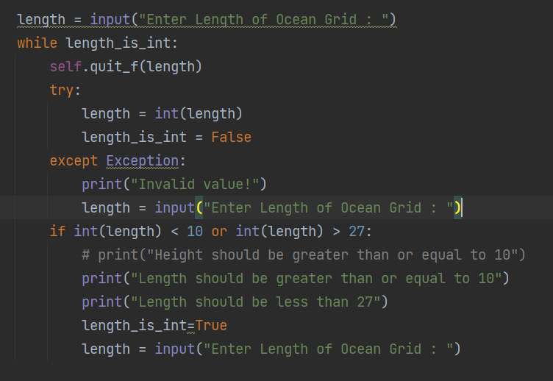
So what we are doing here is that after the use input a value we dive into the while loop first we call the “quit_f” function discussed earlier to see if the player enter a “quit” word, after that we use try/except in case the player enter a string other than “quit” to avoid having errors. The block try actually try to convert the input to int if it works, the program knows the player enter a valid input which is an int and that’s what we want in this case and that will proceed by changing the value to false to stop the loop otherwise the except will catch an Exception and handle it with printing “invalid value!” and give the player the change to input a correct value. After all that we check if the length is < than 10 and grater than 27, if it is the case, we print a hint give the player another change to input a correct value.
The same logic is applied for the guess input
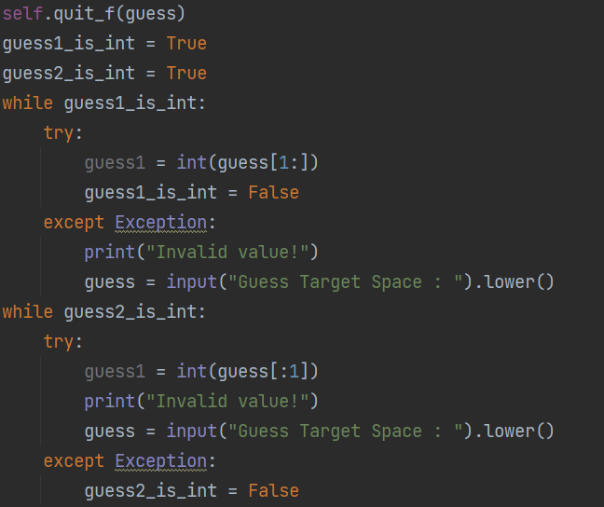
The only difference is that we split the guess because the guesses are contracted of a number and a letter (like “A13” “G4”..).
In the following input the things are slightly different. We call the method inside itself, so we the player enter an invalid value he will have a change to input a correct value. This method is seminar to a loop but it takes fewer time.
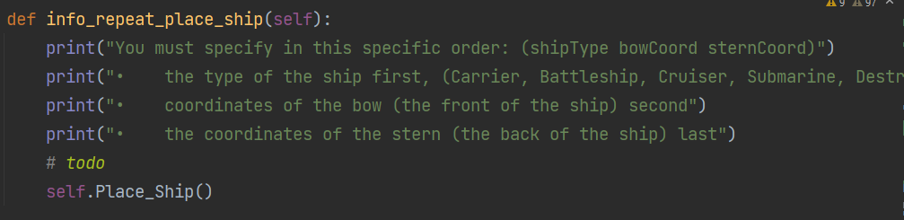
We create a method that prints what the player should enter which call “self.Place_Ship” and we call it inside “Place_Ship”
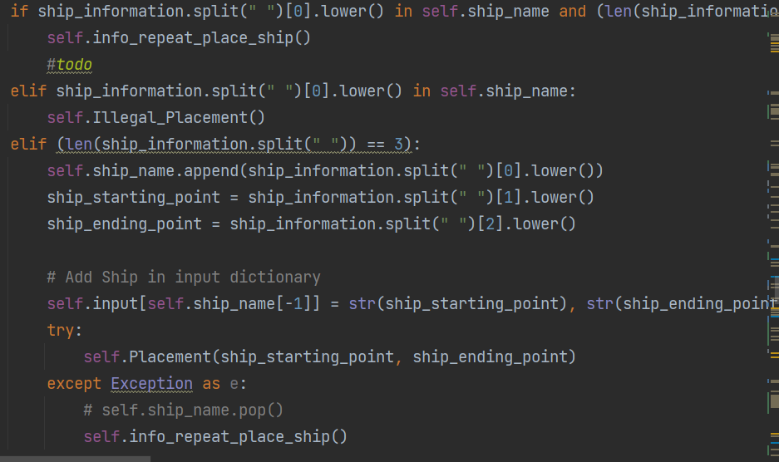
- when putting lower case it need to display the correct output as well not just uppercase:
to overcame this problem we use the predefined function upper().
