15.093 Project Proposal

*Names of team members and emails:*

Zachary Horton ([zhhorton@mit.edu](mailto:zhhorton@mit.edu)) and Tanner Street ([street24@mit.edu](mailto:street24@mit.edu))

*Problem Description:*

Epichlorohydrin (ECH) is a key intermediate in the production of epoxy resins, which are used in a large variety of products such as adhesives, electronics, and protective coatings. ECH has historically been produced using petroleum-derived byproducts, but recent research has demonstrated that ECH can also be produced using a glycerol-derived pathway. Glycerol is a major byproduct of the rapidly growing biodiesel industry, so processes that use glycerol are considered more environmentally friendly. We therefore want to create a plant that produces glycerol-derived ECH for financial and environmental benefits. The general pathway is:

$$Glycerol\underset{→}{1}Dichlorohydrin (DCH)\underset{→}{2}Epichlorohydrin (ECH)$$

For simplicity, we will only build our plant around the second step of the pathway (DCH→ECH). We will assume that our suppliers for DCH produced it using glycerol. The reaction that produces ECH (with byproducts NaCl(aq) + H2O) is:



We have a set of k customers. Each customer requires a certain amount of ECH at a specified purity. For example, customer 1 could require 100 kg of ECH at a purity of 99.8%. To meet these demands, we will build a plant with the following general outline:

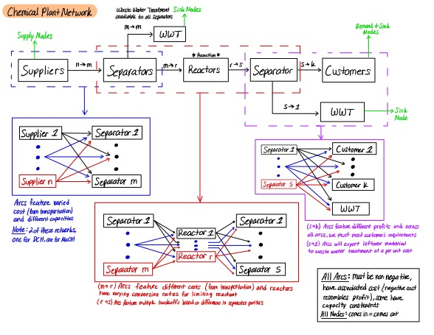

We begin by purchasing DCH and NaOH from two sets of suppliers, considering their price, availability, and impurity levels. The feed streams are then purified using separators, each with varying capacities and transportation costs. The impurities removed from the feed streams are treated in wastewater treatment facilities. The purified reactants are then sent to reactors with varying costs and conversions (percentage of limiting reactant converted into products) to produce ECH. The outlet streams from the reactors contain unreacted reactants, byproducts, and the desired product ECH. Thus, we need to purify these streams for customer standards using separators with varying costs and efficiencies.

The decision variables will be the amount of DCH and NaOH to purchase from the suppliers, as well as the flow through each path. The overall objective is to maximize profit. The revenue corresponds to ECH sold to customers. The costs correspond to reactant purchases, separators, reactors, and wastewater treatment.

*Data & Methods Used:*

We will implement linear and network flow optimization modeling techniques. There are aspects of our system that could involve mixed-integer optimization. Specifically, we are most heavily considering incorporating a binary variable to select if NaOH or DCH is the limiting reactant since that would affect our mass balance around the reactor. We will use concepts from duality to analyze our solution and system constraints. Finally, we will use basic chemical engineering principles to ensure that mass is conserved in our system.

Data:

* Physical and chemical properties (molecular weights, stoichiometric coefficients, etc.)
* Estimated costs of separators, reactors, and wastewater treatment
* Estimated prices for DCH, NaOH, and ECH
* Synthetic data for transportation costs, separator specifications, reactor specifications
* Synthetic constraint values for wastewater treatment, capacities

*Expected Results:*

We expect our solution to be moderate in terms of how much material to purchase and produce since our system includes many tradeoffs/alternatives. Additionally, we can see which constraints are the most restrictive to our objective function based on dual prices.

*Practical Applications:*

This model will help us fully characterize a hypothetical ECH plant. Indeed, the model is determining and optimizing the mass flow of each stream. Building an optimal ECH plant is beneficial both financially and environmentally.