

A
Mini Project Report on

Automatic Water Dispenser via Dashboard
Submitted in partial fulfillment of the requirements for the degree

Bachelor of Engineering – Information Technology
by

Zahra Surve | 23204002
Tharani Velar | 22104075
Urvija Sawant | 22104016
Saim Ghori | 23204009

Under the guidance of

Ms. Charul Singh

DEPARTMENT OF INFORMATION TECHNOLOGY
A.P. SHAH INSTITUTE OF TECHNOLOGY
G.B. Road, Kasarvadavali, Thane (W)-400615 UNIVERSITY OF MUMBAI

Academic year: 2025-26

CERTIFICATE

This is to certify that the Mini Project report on “Automatic Water Dispenser via Dashboard” has been submitted by Zahra Surve(23204002), Tharani Velar(22104075), Urvija Sawant (22104016) and Saim Ghori(23204009) are Bonafide students of A. P. Shah Institute of Technology, Thane as a partial fulfillment of the requirement for the degree in Information Technology, during the second half of academic year 2025-2026 in the satisfactory manner as per the curriculum laid down by University of Mumbai.

Ms. Charul Singh Guide

Internal Examiner: External Examiner:
1. 1.

Place: A. P. Shah Institute of Technology, Thane
Date:

ACKNOWLEDGEMENT

This project would not have come to fruition without the invaluable help of our guide Ms. Charul Singh. Expressing gratitude towards our HoD, Dr. Kiran Deshpande, and the Department of Information Technology for providing us with the opportunity as well as the support required to pursue this project.

TABLE OF CONTENTS
- Introduction. 1
- Review of Literature 2
- Problem statement 3
  - Motivation 3
  - Objective 3
- System Architecture 4
  - State Diagram/Workflow
  - Circuit Diagram
- Project Timeline 6
- Implementation 7
  - Hardware and Software requirements
  - Principle and working of project
- Conclusion 11
- Future Scope 12
- References

CHAPTER 1

Introduction
The Automatic Water Dispenser via Dashboard is a comprehensive, smart system that leverages the Internet of Things (IoT) to revolutionize water access, placing high priority on hygiene, operational efficiency, and user convenience. This project serves as a crucial replacement for unhygienic, traditional manual tap systems, offering an intelligent, automated, and remote-controlled solution. It ensures a seamless user experience through two primary modes of operation: Automated Touchless Dispensing and Remote Control.
In the touchless mode, an Ultrasonic Sensor is utilized for reliable, hands-free proximity detection; when a cup or hand is detected beneath the outlet, the system automatically dispenses water. For remote control, a robust manual control option is provided via a web- based dashboard (e.g., Blynk or Node-RED), allowing users to remotely start or stop water flow and monitor the system. At the heart of the system is the ESP8266 microcontroller, which acts as the control unit and provides essential Wi-Fi connectivity. This connectivity is what enables the system to communicate with the cloud-based dashboard. The physical dispensing mechanism is controlled by a 5V Relay, which safely switches the power to the Water Pump. The relay is essential for isolating the low-voltage microcontroller from the higher voltage/current required to run the pump. The combined use of these components ensures Contamination Reduction, as the Ultrasonic Sensor allows for a truly touchless interaction, significantly reducing the potential spread of germs in high-traffic or shared environments.
Furthermore, it promotes Water Conservation by automating the shut-off process, actively working to prevent water wastage caused by human error or misjudgement. Finally, the design, built upon the readily available and cost-effective ESP8266, enhances Accessibility, making smart dispensing technology suitable for deployment in various settings, including homes, offices, and public spaces.

CHAPTER 2
Review of Literature

Sr.no | Title | Author(s) | Year | Outcomes | Methodology | Result
1 | Automatic Water Dispenser Machine | A. Kumar | 2021 | Improved hygiene and hands-free access | Ultrasonic Sensor + Arduino + Servo Motor | Achieved real-time, contactless dispensing by using the servo to control the valve based on ultrasonic detection, successfully reducing  water wastage by up to 30% in tested  setups.
2 | IoT Automatic Water Dispenser With RFID | R. Patel | 2022 | Remote monitoring and control | ESP8266 +  Ultrasonic Sensor + Blynk Dashboard | Successfully integrated ESP8266 Wi-Fi  connectivity to enable real-time monitoring of system status and water level, and allowed for remote ON/OFF control of the pump via the  cloud dashboard.

CHAPTER 3

Problem Statement

Traditional water dispensing systems are flawed because they rely on manual switches or taps, necessitating physical contact, which significantly increases the risk of contamination and compromises hygiene in shared environments. Furthermore, the lack of automation inherent in manual dispensing frequently leads to water wastage when users forget to turn off the tap or misjudge0020the volume required, thereby increasing utility costs and harming resource efficiency. While various smart dispensing solutions exist, they are often prohibitively expensive, utilize proprietary hardware, and lack the customizable, open-source platform needed for widespread accessibility and remote monitoring. To address these critical limitations, this project develops an affordable, IoT-enabled automatic water dispenser using an ESP8266 and an ultrasonic sensor to provide a robust, contactless, and remotely manageable solution.

Motivation
The primary motivation for this project is driven by three essential modern demands. First, there is a clear and growing need for hygienic and contactless interaction in shared environments, compelling the shift toward automated systems to minimize the spread of germs. Second, users demand convenience and centralized control; the integration of IoT systems satisfies this by allowing the dispenser to be remotely monitored and managed from any location, enhancing overall user experience. Finally, there is a fundamental necessity for water conservation; by replacing manual operation with precise, sensor-based automation, the system effectively prevents accidental spills and unnecessary power consumption, ensuring more responsible and efficient resource utilization.

Objectives

- To design an automatic water dispensing system using an Ultrasonic Sensor for reliable, contactless cup/hand detection.
- To utilize the 5V Relay and water pump to control water flow, eliminating the need for a manual tap.
- To integrate the system with the ESP8266 for Wi-Fi connectivity and remote control/monitoring via a dashboard.
- To create a cost-effective and energy-efficient solution.

- To minimize water wastage and improve hygiene by ensuring water is only dispensed when needed.

CHAPTER 4

System Architecture

State Diagram/Workflow

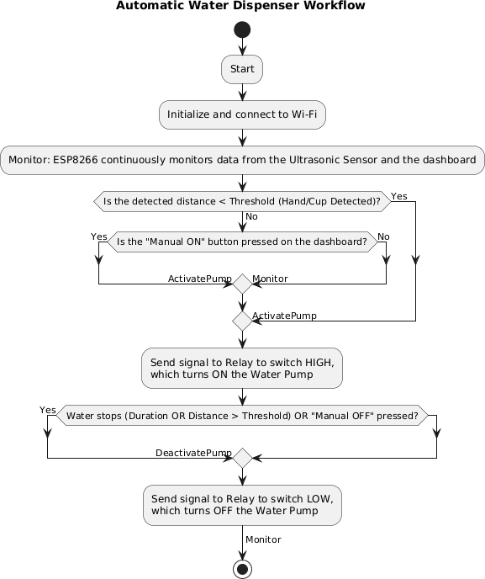

Circuit Diagram

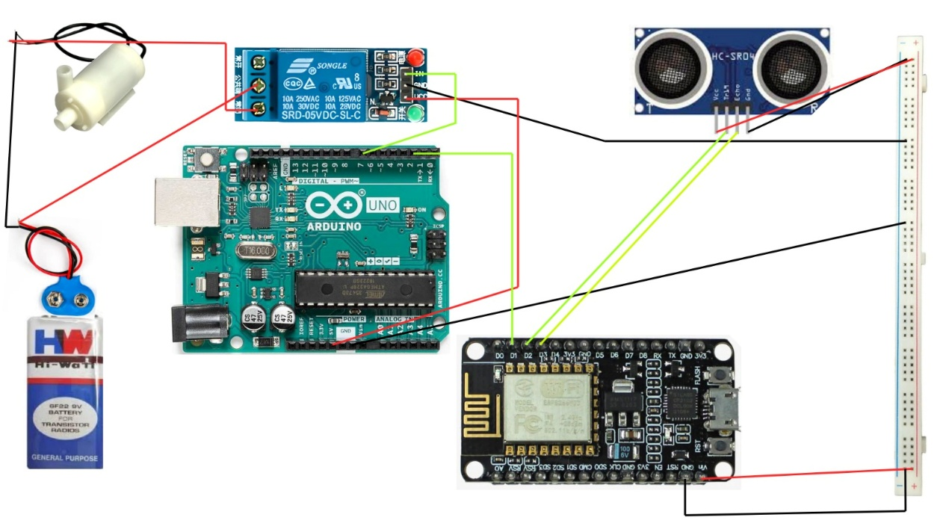

CHAPTER 5
Project Timeline

Sr.no | Group members | Time Duration | Work to be done
1 | Zahra Surve Urvija Sawant Tharani Velar Saim Ghori | 3rd and 4th week of July. | Topic finalization and requirements gathering.
2 | Zahra Surve Urvija Sawant Tharani Velar Saim Ghori | 1st and 2nd week of August. | Implementing the circuit design on software.
3 | Zahra Surve Urvija Sawant Tharani Velar Saim Ghori | End of August and 1st week of September. | Connecting the components.
4 | Zahra Surve Urvija Sawant Tharani Velar Saim Ghori | By the end of September. | Final testing and resolving issues if any.

CHAPTER 6

Implementation

Hardware and Software Requirements
- ESP8266 or NodeMCU:
This is the central processing unit and the project's Wi-Fi module. It reads data from the Ultrasonic Sensor, runs the control logic, and connects to the internet to communicate status and receive commands from the remote dashboard.
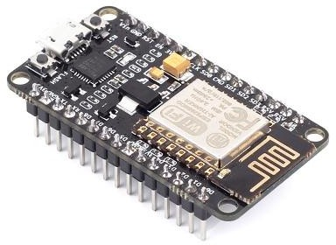

- Ultrasonic Sensor:
A key input component that emits sound waves to measure the distance to the nearest object. It provides the necessary data for touchless proximity detection, activating the dispenser when a cup or hand is placed within the set threshold.
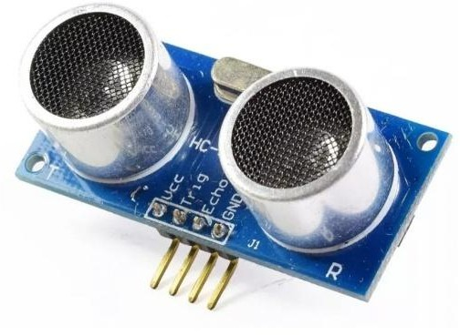

- Jumper wires (M-F, M-M each 10 pcs).
Jumper cables is a smaller and more bendable corrugated cable which is used to connect antennas and other components to network cabling.
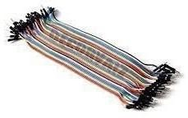

- Relay 5V:
An electrically controlled switch that is essential for safety. It uses the low-voltage signal from the ESP8266 to switch the separate, higher-voltage circuit required to run the water pump, safely isolating the microcontroller.
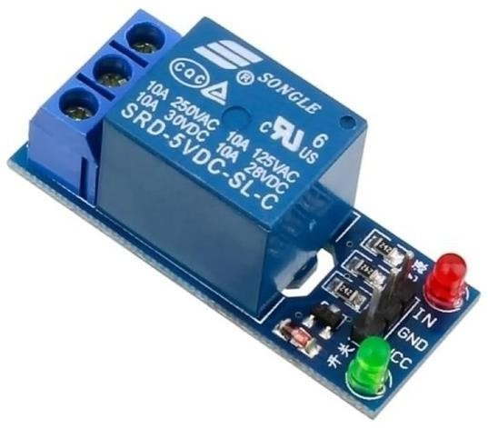

- DC Water Pump (Submersible):
The project's actuator. This motor-driven pump draws water from the reservoir and dispenses it through the pipe when the relay is activated.
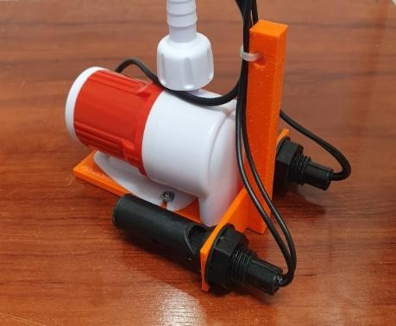

- 9V Battery & Connector:
Provides the necessary power to run the pump and/or the ESP8266 circuit, ensuring portability and operation of the higher-current load (the pump).
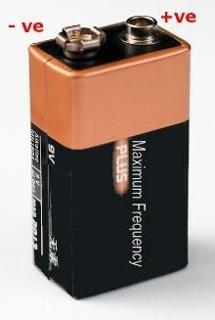
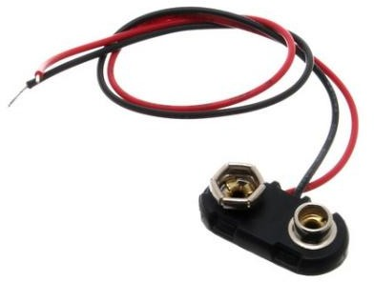

- Arduino IDE (Software Requirements):
The Arduino Integrated Development Environment - or Arduino Software (IDE) - contains a text editor for writing code, a message area, a text console, a toolbar with buttons for common functions and a series of menus. It connects to the Arduino hardware to upload programs and communicate with them.

- Blynk Platform:

A cloud-based IoT dashboard platform required to create the remote web interface. It allows the ESP8266 to send real-time status data (monitoring) and receive remote commands (control) via Wi-Fi.
Hardware | Quantity | Price
ESP8266 NodeMCU | 1 | Rs.300 /-
Ultrasonic Sensor | 1 | Rs.70 /-
5V Relay Module (Single Channel) | 1 | Rs.40 /-
DC Water Pump (Submersible) | 1 | Rs.50 /-
9V Battery & Connector | 1 | Rs.30/-
Breadboard | 1 | Rs.50/-
Jumper wires | As required | Rs.50 /-
Total |  | Rs.590 /-

Software | Function
Arduino IDE | Programming the ESP8266
Blynk Platform | Creating the IoT Dashboard

Principle and Working of project

Step 1: Sensing (Ultrasonic Detection)

The process begins with the Ultrasonic Sensor (HC-SR04) acting as the primary input device. The sensor continuously emits high-frequency sound waves from its transducer (Trig pin). It then measures the time taken for these sound waves to reflect off an object (like a hand or cup) and return to its receiver (Echo pin). By calculating this time-of-flight, the sensor accurately determines the distance between itself and the object below the dispenser. This method provides reliable, touchless proximity detection.

Step 2: Processing & IoT (Decision Making)

The distance data from the sensor is fed into the ESP8266 microcontroller, which acts as the central processing unit and maintains a Wi-Fi connection to the IoT Dashboard (e.g., Blynk). The ESP8266 is programmed to trigger the dispensing sequence under two conditions: if the measured distance drops below a pre-defined threshold (Contactless Mode) or if a virtual 'ON' button is pressed on the web-based Dashboard (Remote Control Mode).

Step 3: Actuation (Relay Control)

Once either of the two triggering conditions is met, the ESP8266 initiates the dispensing sequence by sending a low-voltage (5V) control signal to the 5V Relay Module. The relay is an essential safety component that safely isolates the low-voltage ESP8266 circuit from the potentially higher-voltage/current circuit required to run the Water Pump. When the relay receives the signal, its internal switch closes, completing the power circuit and switching the Water Pump ON. The pump then draws and dispenses the water through the pipe.

Step 4: Control (Flow Management and Feedback)
The ESP8266 manages the duration of the water flow based on programmed logic: dispensing continues for a pre-programmed duration (e.g., 5 seconds for a standard cup), or until the object is removed (the distance increases above the threshold). For remote control, the dispensing stops when a manual 'OFF' signal is received from the dashboard. After dispensing is complete, the ESP8266 deactivates the relay by sending an 'OFF' signal, which safely turns off the Water Pump. The ESP8266 continuously sends status data back to the dashboard, allowing the user to remotely monitor the system's operational status and potentially the remaining water level.

Code:
const int RELAY = 3; const int soundSensor = 2; const int REDLED = 4; const int GREENLED = 5;

bool LED_STATE = false; void setup() {
// put your setup code here, to run once:

Serial.begin(9600); // Initialize serial communication for debugging pinMode(RELAY, OUTPUT);
pinMode(soundSensor, INPUT); // Set the sensor pin as an input pinMode(REDLED, OUTPUT);
pinMode(GREENLED, OUTPUT);
digitalWrite(RELAY, LOW); digitalWrite(GREENLED, LOW); digitalWrite(REDLED, HIGH);
}

void loop() {
int sensorValue = digitalRead(soundSensor); Serial.println(sensorValue);
if ( LED_STATE == false) { if (sensorValue == LOW) {
Serial.println("LED OFF!"); // Print a message when an obstacle is detected
LED_STATE = true; digitalWrite(RELAY, HIGH); digitalWrite(GREENLED, LOW); digitalWrite(REDLED, HIGH); delay(70);
}
} else if (LED_STATE = true) { if (sensorValue == LOW) {
Serial.println("LED ON!"); // Print a message when no obstacle is detected
LED_STATE = false; digitalWrite(RELAY, LOW); digitalWrite(GREENLED, HIGH); digitalWrite(REDLED, LOW); delay(70);
}
}
// put your main code here, to run repeatedly: delay(3);

CHAPTER 7

Conclusion

The Automatic Water Dispenser project achieved a successful implementation by seamlessly integrating IoT technology with a contactless sensing mechanism, resulting in a highly hygienic and operationally efficient water management system. The fundamental breakthrough lies in transcending simple automation by incorporating internet connectivity. By leveraging the ESP8266's built-in Wi-Fi capability, the system is seamlessly integrated with a cloud-based dashboard, effectively elevating it beyond a basic proximity device to a true IoT appliance capable of two-way communication and centralized management.

This innovative approach delivers a significant improvement over conventional dispensing methods through its dual control capabilities, offering substantial benefits in both public health and resource management. The first major advantage is Superior Hygiene and Safety: the reliance on the Ultrasonic Sensor for touchless dispensing completely eliminates the need for physical contact with taps or buttons. This elimination of contact is paramount for reducing contamination risks and promoting better public health standards in shared environments.

The second key benefit is Enhanced Efficiency and Conservation. The system's inherent intelligence ensures precise control over water output, regardless of whether it's activated by the sensor or a remote command. This crucial ability to accurately manage flow and automate the shut-off process effectively prevents water wastage caused by spills or human error, leading to better resource conservation compared to traditional manual systems. In conclusion, the project successfully merges cost-effective hardware with smart software to provide both automated, touchless dispensing and full remote control/monitoring via a dashboard, ultimately fulfilling the core objective of developing a modern, accessible, and resource-conscious dispensing solution.

CHAPTER 8

Future Scope

The Automatic Water Dispenser via Dashboard has significant potential for future development, with various enhancements that can improve its functionality and accessibility. Here are some possible advancements:

- Water Level Monitoring: Incorporate a second ultrasonic sensor to monitor the water level in the source tank, sending an alert to the dashboard when the level is low.
- Custom Volume Dispensing: Implement a flow sensor to dispense precise, user-defined volumes via the dashboard interface.
- Battery Management: Add a system to monitor the 9V Battery level and send a low-power notification to the user.
- Voice Control Integration: Integrate with services like Alexa or Google Home for voice- activated dispensing.

Overall, the Automatic Water Dispenser via Dashboard has the potential to evolve into a comprehensive smart control hub, significantly improving hygiene, energy efficiency, and accessibility in both residential and commercial environments.

References
[1 A. Kumar and R. Sharma, "Infrared-based contactless control systems for hygienic electrical switching," IEEE Transactions on Consumer Electronics, vol. 67, no. 3, pp. 245-250, 2021.

[2 S. Patel and M. Gupta, "Design and implementation of touch-free relay switches for public health applications," Springer Journal of Medical Systems, vol. 46, no. 4, pp. 112-125, 2022.

- L. Wang and C. Zhang, "Energy-efficient Arduino-based automation systems for smart buildings," Elsevier Sustainable Energy Technologies, vol. 15, pp. 78-89, 2023.

- T. Nguyen and H. Yamamoto, "Comparative analysis of sensor technologies for contactless human-machine interfaces," ACM Transactions on Interactive Systems, vol. 8, no. 2, pp. 1-18, 2023.

