**Coursera Capstone**

**The Battle of Neighborhoods**

**Isaac Shahar**

**Business Problem**

London real estate market is under unprecedented changes these years. The high prices and the talks about brexit, led to many speculations trying to forecast what the future holds.

Along the speculations, there are also many opportunities. Investors from all over the world are looking for assets to buy and they are willing to make good and smart decisions. The value of an asset is affected by many factors and therefor potential investors are looking for capabilities to perform data analytics in order to extract actionable insights.

**Target Audience and Stakeholders**

|  |  |
| --- | --- |
| Audience | Interest |
| UK Government | Identify areas that can attract investors |
| Investors | Identify valuable investments |
| Sellers | Evaluate their assets |
| Real estate agents | Identify areas that can attract investors |

**Data Section**

|  |  |  |  |
| --- | --- | --- | --- |
| Data | Type | Description | Data source |
| Foursquare | JSON | Location data of relevant places | https://foursquare.com/ |
| HM Land Registry: Price Paid Data | CSV | Property sales in UK | http://landregistry.data.gov.uk/ |
| Google Maps Geocoding API | JSON | Location coordinates | Google |

**Methodology**

HM Land Registry: Price Paid Data contains the prices paid for assets in UK. The data is being updated on a regular basis.

The aim of this project is to provide the user (as detailed above) with tool by which he can explore potential assets based on his budget and based on interesting venues. In addition the algorithm may be used as a tool to get or provide recommendations to investors.

The following is the description of the process beyond this project:

1. Parse and create dataset from the price paid data
2. Clean the data
3. Scope the data to only include London
4. Filter streets in which transactions have made with average rice that is in the budget range
5. Get location coordinates of the streets by Google API requests
6. The recommended locations are being shown on a map
7. The locations are being explored by Forsquare to look for venues around their area

**Results**

After analyzing the data as described, we managed to create a list of streets in London that meet the budget (according to average transaction price), along with their location coordinates.

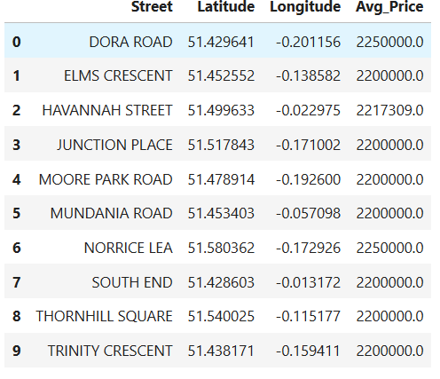

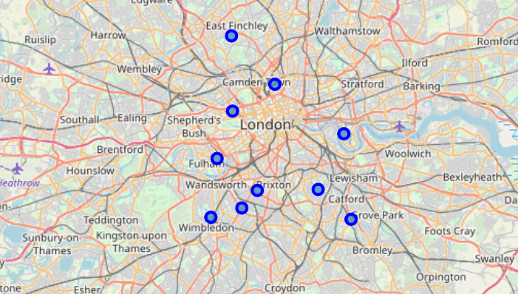

We are now able to easily explore these areas with foursquare