**Problem 1:**

Figure - y=x, x^2, x^3

**Problem 2:**

Figure - sin(x) vs x with 'n' amounts of terms

**Explanation:** With n=3 and all values ranging from 0 to 2pi, to make them equally spaced only 3 values for x would be possible: 0, pi, and 2pi. Sin is zero at all these values, making the response a constant line with a value of zero.

**Observation:** The response when N=21 is the average for the response when n=201.

**Problem 3:**

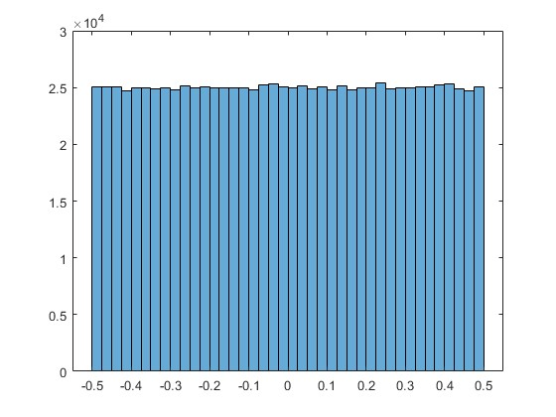

Figure - N = 1

Figure - N=2

Figure - N=3

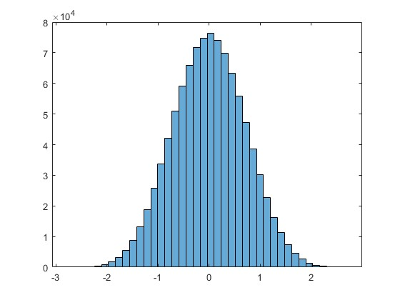

Figure - N=6

**Observation:**

As N increases the distribution converges to 0 and diverges from values in its neighborhood.