TinyTales
A simple memory journal for parents to record and revisit their child's moments.
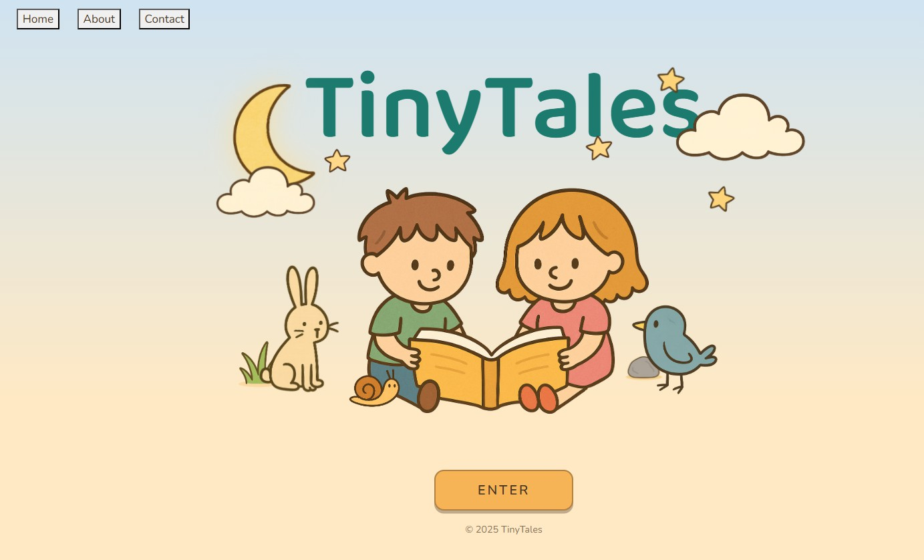

Project type | Web application (React + Vite, Node.js + Express)
Primary users | Parents with young children
Core value | Private journaling with photos, easy browsing via carousel and calendar

Problem Statement
Parents capture many photos and videos, but meaningful moments get scattered across phone galleries and chat apps. It becomes difficult to locate memories by date and keep short written notes together with images.

Proposed Solution
TinyTales provides a private account-based journal where a parent can quickly write a short entry, attach photos, and revisit past entries through a carousel and calendar view.

Target Users
  - Parents with young children who want a simple, low-friction memory journal.
  - Families who prefer a private space for memories instead of scattered albums.

MVP Features (In Scope)

Authentication
  - Login for existing users
  - Basic session handling

Journaling
  - Create entry (title, content, date)
  - Upload multiple photos per entry
  - View entries (carousel and entry popup)
  - Calendar-based navigation

Out of Scope
  - Registration and email-based password reset
  - Full admin dashboard and advanced user management
  - Social sharing, comments, and AI features

Tech Stack

Frontend | React (Vite) + external CSS
Backend | Node.js + Express
Database | MySQL
Storage | Supabase (image storage)

- Data Model (Overview)
User: id, username, passwordHash, createdAt Entry: id, userId, entryDate, title, content, createdAt EntryPhoto: id, entryId, imageUrl, createdAt

- Website Navigation Map
Enter Page
Login Modal
YourTales Page
New Entry Popup
Entry View Popup
Calendar Page
Story Time Page

- Database Schema & Constraints Table: Sheet1
Unnamed: 0 | Unnamed: 1 | Unnamed: 2 | Unnamed: 3 | Unnamed: 4 | Unnamed: 5 | Unnamed: 6 | Unnamed: 7
 |  | Data type & constraint
 | PARENT
 | ParentID | INT | PRIMARY KEY
 | Username | VARCHAR(20) | NOT NULL
 | Password | VARCHAR(20) | NOT NULL
 | Email | VARCHAR(20) | NOT NULL
 | DateOfBirth | DATE | NOT NULL
 | Gender | VARCHAR(6)
 | Created_at | DATE | NOT NULL
 | CHILD
 | ChildID | INT | PRIMARY KEY
 | Username | VARCHAR(20) | NOT NULL
 | Password | VARCHAR(20) | NOT NULL
 | DateOfBirth | DATE | NOT NULL
 | Gender | VARCHAR(6) | NOT NULL
 | Created_at | DATE | NOT NULL
 | ENTRY
 | EntryID | INT | PRIMARY KEY
 | Title | VARCHAR(50) | NOT NULL
 | Content | TEXT | NOT NULL
 | EntryDate | DATE | NOT NULL
 | Created_at | DATE | NOT NULL
 | UserID | INT | NOT NULL
 | PHOTO
 | PhotoID | INT | PRIMARY KEY
 | Description | TEXT
 | Created_at | DATE | NOT NULL
 | EntryID | INT | NOT NULL
 | EVENT
 | EventID | INT | PRIMARY KEY
 | Title | VARCHAR(50) | NOT NULL

Unnamed: 0 | Unnamed: 1 | Unnamed: 2 | Unnamed: 3 | Unnamed: 4 | Unnamed: 5 | Unnamed: 6 | Unnamed: 7
 | Note | TEXT
 | EventType | VARCHAR(10) | NOT NULL |  | task | event
 | Status | VARCHAR(10) | NOT NULL |  | pending | done | cancelled
 | Created_at | DATE | NOT NULL
 | UserID | INT | NOT NULL
 | VIDEO
 | VideoID | INT | PRIMARY KEY
 | Title | DATE | NOT NULL
 | ViewCount | INT | NOT NULL
 | WatchLog | DATETIME | NOT NULL
 | Duration | DATETIME | NOT NULL
 | UrlLink | VARCHAR(255) | NOT NULL
 | Created_at | DATE | NOT NULL
 | UserID | INT | NOT NULL

