**Chapter 9 Hands-On Test**

Web Development Technologies - horizontal line

* Develop a **page** to sell a widget(s) or product(s) of your choice.
  + <header> includes logo and navbar
    - Include the company name, with brand logo, and make this a link to the home page **- 5pts**
    - Include a single-tiered navbar with 5 links (href=”#”) using appropriate semantic tags **- 5pts**
  + <section> includes a Call to Action
    - Include a heading, a smaller heading, and a link styled as a button to “BUY NOW” **- 5pts**
    - Include a Featured Image to the right of the text and button **- 5pts**
  + <main> includes two sections of content:
    - Top section with 3 div’s of content
      * Each div has [rounded image](https://www.w3schools.com/howto/howto_css_rounded_images.asp), a heading, a short description **- 5pts**
    - Bottom section of with a heading and 4 div’s of content
      * Each div has a square images, a heading, and paragraph **- 5pts**
  + <footer> includes copyright line. Such as "© 2021 Company Name" Must use copyright HTML entity**- 5pts**

***Note** Footer not shown in Mock Up***

***(Desktop View)***

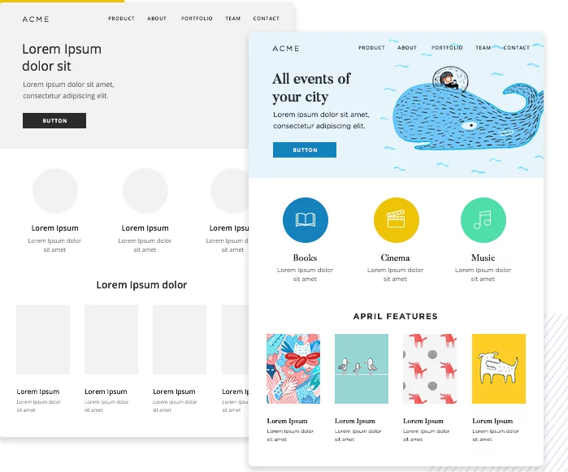

* Use **CSS** to responsively implement the page layout.
  + **Use FlexBox for all parts of the layout. - 10pts**
  + Use **mobile-first** techniques to implement the page layout.
  + Use the following media query breakpoints **- 10pts**
    - Default is phone
    - 600px for tablet portrait
    - 1200px for desktop
  + The Feature Image should go above the Text and Buy Now button on mobile and be to the right of it on desktop. - **10pts**
  + The **navbar** must appear **vertical** on mobile devices, and **horizontal** on desktop. - **10pts**
  + The 4 div’s should be in a **row** in desktop, **2x2** in tablet view and **vertical** in mobile - **10pts**
  + The 3 div’s should be in a row in desktop and vertical in mobile - **10pts**

100%