CT Thermometry with Image Registration and Filtering
Zachary DeStefanoa, Jack Yaoa, Nadine Abi-Jaoudeha, Ming Lia aNational Institutes of Health, Clinical Center Bethesda, MD 20814
ABSTRACT
Monitoring temperature during a cone-beam CT (CBCT) guided ablation procedure is important for prevention of over-treatment and under-treatment. In order to accomplish ideal temperature monitoring, a thermometry map must be generated. Previously, this was attempted using CBCT scans of a pig shoulder undergoing ablation.1 We are extending this work by using CBCT scans of real patients and incorporating more processing steps. We register the scans before comparing them due to the movement of organs. We also employ a robust change metric due to image noise and artifacts. In order to achieve an automated system in the future, we use PCA to select the Region of Interest (ROI) where the needle tip is located and thus where the ablation occurred. Once we have generated a change map in the ROI, we correlate change data with temperature data at points in the region to transform our change map into a thermal map. This thermal map is then able to provide an estimate as to the size of the ablation zone. We repeated our procedure on a data set of 12 patients who had a total of 24 ablation procedures performed. We were able to generate reasonable thermal maps with varying degrees of accuracy. In addition to providing estimates of the size of the ablation zone, these maps were used to produce 3D visualizations of the ablation zone and needle.
Keywords: Cone-beam CT, CBCT, Thermometry, Radiofrequency Ablation, Time Delay Analysis
1. INTRODUCTION
The possibility of generating a thermal map from CBCT scans has been explored before.1 We decided to extend the work to real patients and incorporate more processing steps to enhance the maps. For the procedures analyzed in this work, there was a baseline CBCT scan taken after the ablation needle was inserted but before it was heated. There were then 1-4 scans taken as the needle was heated and cooled.
These scans were taken a few minutes apart on live patients, thus there was movement of the organs. In order to account for this, we kept the baseline scan static and registered the subsequent scans to the baseline scan. This allowed us to have 3D CBCT scans that were reasonably aligned. However there was still noise, needle artifacts, and small registration errors. We thus needed a change metric that was robust to these issues.
Computing the pixel by pixel diﬀerence between scans is a poor metric that is not robust enough for our needs. Using the Wronskian Change Detector was explored previously1 but it is not well suited for the regression calculation we need to perform. Using the values in a window around a pixel proved to be eﬀective though.
We compared windows around a pixel in the baseline scan and comparison scan using two diﬀerent methods: Mean Diﬀerence and Spatial Oﬀset RMSE. The mean diﬀerence method is equivalent to performing a convolution using an averaging ﬁlter on both images and then computing the diﬀerence image. The Spatial Oﬀset RMSE method is equivalent to ﬁnding the ideal spatial oﬀset between the windows and then computing the RMSE of the pixel values in the shifted signal.
Because the relationship between HU change and temperature change varies depending on which organ is being aﬀected,2 it makes sense to only compute the thermal map for the ROI where the ablation occurred. Because the needle has distinct HU values from tissue and the ablation occurred at the tip of the needle, we were able to automate the process of ﬁnding the ROI.
The Spatial Oﬀset RMSE method is more computationally intensive than the Mean Diﬀerence method but it produces a much smoother change map. We thus use the Mean Diﬀerence to give us an estimate of the thermal map in order to verify that our ROI contains the ablation. We then use the Spatial Oﬀset RMSE to compute a more accurate thermal map.
Author Emails: zdestefa@uci.edu
2. RELATED WORK
2.1 CT Thermometry
CT Thermometry has been explored since the late 1970’s with some success.2 Using linear regression, various attempts have shown relationships between HU unit value and temperature. Due to the varying thermal properties of diﬀerent tissues, the exact calibration curve varies depending on which organ is being aﬀected. It thus makes sense for us to only focus on the ROI around the ablation needle when generating a thermal map.
Many of the attempts focused on correlating individual HU unit values with temperature. These values can be heavily inﬂuenced by image noise and metal artifacts. We thus decided to use a more robust change metric when correlating our HU unit change values with temperature change.
2.2 Image Registration
Medical Image Registration has been researched extensively.3, 4 For our purposes, we needed to align temporal sequences of CBCT scans. In particular, we performed an aﬃne registration in order to account for movement of the organs during the ablation procedure. The organs can deform thus we also incorporated non-rigid registration. There is now an open source tool known as NiftyReg5, 6 that was able to perform both the aﬃne5 and deformable6 registration.
2.3 Wronskian Change Metric
Previously, the Wronskian Change Detector7 was proposed as a metric that would be robust to noise.1 This particular change detector has been shown to perform well for classiﬁcation problems7–10 in image analysis. The formula however computes the ratios between intensity values. Because the relationship between HU unit value and temperature is roughly linear,2 we need a function that increases linearly as the change in HU unit increases. Because the Wronskian function does not, we decided not to use it for our purposes.
2.4 Time Delay Analysis
It is a common problem in signal processing to have two nearly identical signals that are oﬀset by a delay. In order to calculate the most likely delay, cross-correlations are used.11 The cross-correlation of two real-valued discrete signals f and g is deﬁned as follows:
∞
n
(f *g)[n]= f[m]g[m + n]
m=−∞
The most likely delay tdelay occurs when the correlation is the highest thus
tdelay = arg maxt(f *g)[t]
For our purposes, we will take two square small images U and V and interpret them as periodic 2D signals that continuously repeat horizontally and vertically. Extrapolating from time delay analysis, the ideal spatial oﬀset between the images occurs when the correlation is highest. Thus our ideal oﬀset (r, c) is as follows:
n−1n−1
nn
(r, c)offset = arg maxr,c Uk+r,l+c · Vk,l l=0 k=0
Our change metric calculates the RMSE of the two images with this oﬀset incorporated.
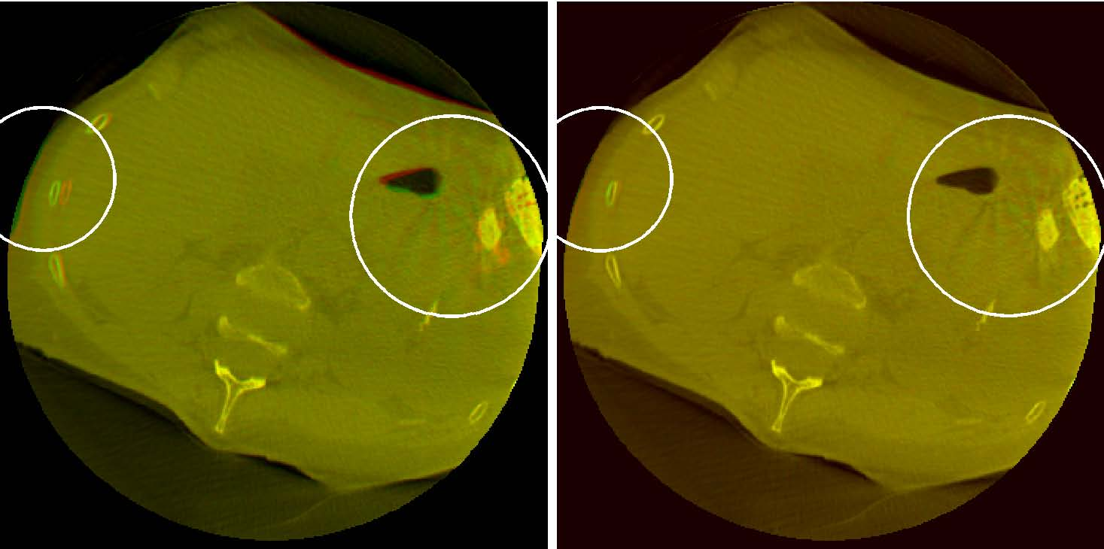
(a) Before Registration (b) After Registration Figure 1: Baseline (green channel) and Comparison (red channel) Image superimposed in one image before and after registration
3. PIPELINE
For each ablation procedure, there was a baseline CBCT scan as well as 1-4 comparison CBCT scans. The comparison scans were taken at various stages of heating and cooling the needle. For each comparison scan, a corresponding thermal map was generated via the following procedure:
- Register the comparison scan to the baseline scan
- Use Connected Component Analysis and PCA to detect the Needle tips
- Use the result to ﬁnd the ROI regions
- Take the ROI regions found, ﬁlter the images, and calculate the diﬀerence
- Use the result to ﬁnd the ROI regions where the ablation likely occurred
- Calculate the Spatial Oﬀset RMSE value for the ROI regions found
- Correlate Spatial Oﬀset RMSE values from in the temperature zones with the temperature data
- Use the regression model from the correlation calculated to generate a thermal map for the entire ROI

3.1 Image Registration
For the registration step, the 3D comparison scan was registered to the 3D baseline scan using the software package NiftyReg. We used the reg aladin command to perform an aﬃne registration.5 This was used to try to account for movement of the organs between diﬀerent scans. We then used the reg f3d command to perform non-rigid registration.6 This was an attempt to align the organs in such a way that accounted for changes in their shape between scans. Figure 1 shows an example of image slices before and after registration.
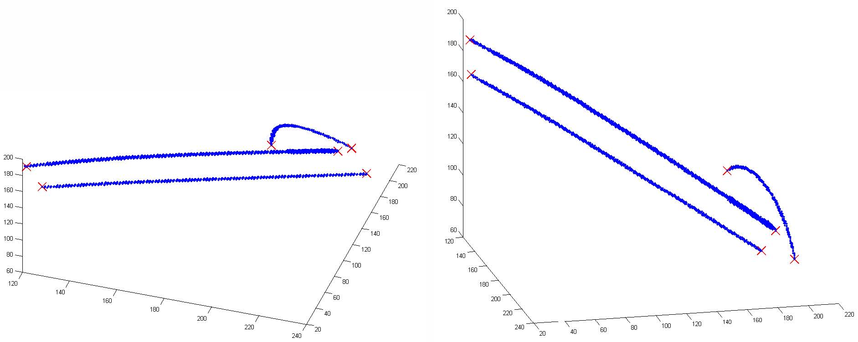
Figure 2: Needles and Thermocouple (blue) and their endpoints (red) detected using PCA
3.2 Needle Detection
The HU values for the needle and thermocouple are signiﬁcantly higher than the values for normal tissue. Thus after thresholding the values in the CBCT scan high enough, the points remaining are the ones in the needle and thermocouple. Doing connected component analysis with bwconncomp12 in Matlab let us ﬁnd the clusters which contain the needles and thermocouples. For each component, pca13 in Matlab was done to ﬁnd the needle vector and endpoints. Figure 2 shows the result after performing this procedure for one of our patients.
3.3 Change Detection
These images have a low signal to noise ratio as well as beam hardening artifacts. We thus decided to use a window around each pixel in order to have a more robust change value. Initially we calculated the mean diﬀerence between the baseline image window and the comparison image window and used that as the value of the pixel in the result image. This is equivalent to performing a convolution on both images with an averaging ﬁlter and then taking the diﬀerence between the ﬁltered images. The result images were used to provide an estimate of how the thermal map will appear. They are still too noisy to be used for the thermal map though.
In order to ﬁnd a better result image, for each pixel, we calculated the minimum RMSE between the baseline and comparison windows assuming that there is a spatial oﬀset between them. For each pixel, let U be the n by n window around it in the baseline image and let V be the n by n window around it in the comparison image. We made the matrix U' which is U repeated in the following manner:
∀(k, l, i ∈ Z) U'= Uk,l
k+i·n,l+i·n
Afterward the following was calculated and the value was stored as the pixel value in the result image:
n−1n−1
nn
min (U' − Vk,l)2
k+r,l+c
r,c l=0 k=0
Figure 3 shows the result image after applying the methods to an example slice in the baseline and comparison CBCT scan. As can be observed, raw subtraction gives us the noisiest result hence the need for a better metric. Filtered Diﬀerence gives us a much better result but there is still much noise and many artifacts. Spatial Oﬀset RMSE gives us the smoothest map.
3.4 Regression
After generating the Spatial Oﬀset RMSE result image, we ﬁnd the coordinates where the measured temperature zones are located. We correlate the result image values with the measured temperature changes at those zones using linear regression. We then take the regression equation found and compute its output across the result image. This gives us the thermal map. Figure 4 shows the plot of Spatial Oﬀset RMSE versus Temperature Change as well as the regression curve calculated from it. Figure 5 shows the resulting thermal map.
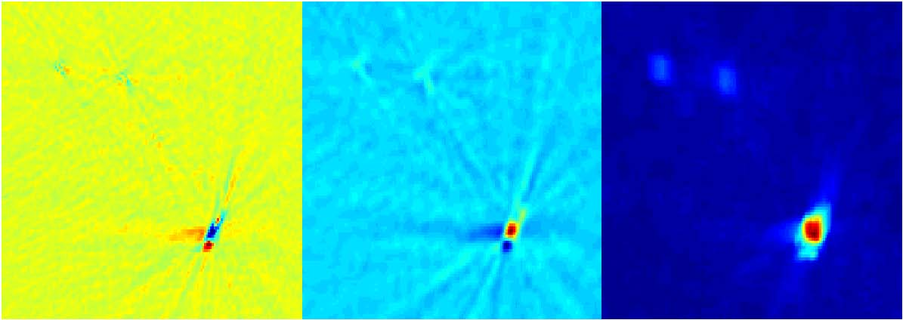
Figure 3: Results of diﬀerent change metrics in the ROI. Raw subtraction (left), Filtered Diﬀerence (center), and Spatial Oﬀset RMSE (right)
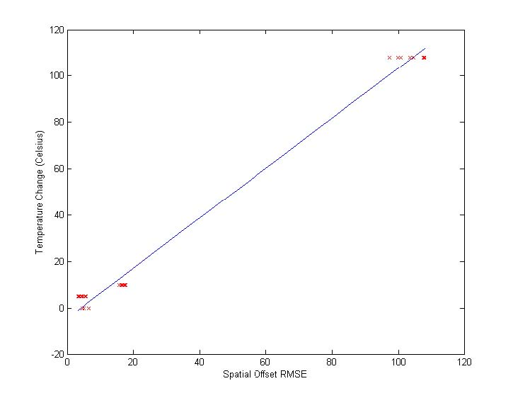
Figure 4: Regression Curve Calculated Figure 5: Thermal Map generated from Regression curve
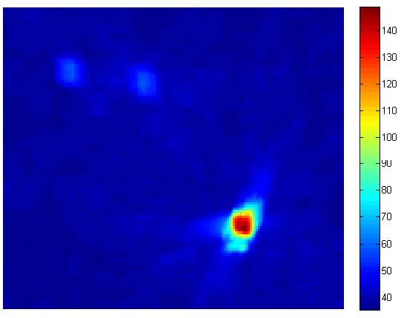
4. RESULTS
We used a data set of CBCT scans taken for 13 patients whose procedures were performed between September 2013 and June 2015. For each patient, there were between 1 and 4 ablations done. With each ablation, a baseline scan was taken followed by 1-4 comparison scans at diﬀerent time points. Each of these time points had the ablation needle at diﬀerent temperatures. We generated a thermal map at each of these time points in order to estimate the amount of tissue aﬀected.
4.1 Finding Error Rates
We decided to take the thermal maps generated from regression and see the average temperature in the zones that we were testing. We then did an RMSE of those temperatures with the measured temperatures. We divided this RMSE by the temperature range in order to obtain an error ratio. The results are in the table below. In that table, temperatures are in Celsius and Temps (From Regression) is the average temperature in the neighborhood around the needle or thermocouple (with radius speciﬁed by Neighborhood Radius) in the thermal map calculated from regression.
Pt Num | 4 | 5 | 5 | 6 | 8 | 9
Pt Sex | M | M | M | F | F | F
Pt Age | 54 | 48 | 48 | 65 | 59 | 61
Baseline Scan Number | 5007 | 5012 | 5021 | 5009 | 5002 | 5005
Baseline Temps | 36/36 | 35/35 | 38/36 | 31/31/30 | 36/37 | 37/37
Pixel size (mm) | 0.9823 | 0.9823 | 0.9823 | 0.9823 | 0.6549 | 0.6549
Neighborhood Radius (mm) | 1.9646 | 1.9646 | 1.9646 | 1.9646 | 1.3098 | 1.3098
Comparison 1
Scan Number | 5008 | 5013 | 5022 | 5010 | 5003 | 5006
Temps (Given) | 64/56 | 58/38 | 48/83 | 132/124/45 | 100/37 | 145/42
Temps (From Regression) | 67.2/59.6 | 64.2/45.4 | 50.9/62.2 | 128.4/108.9/81.0 | 111.0/36.6 | 142.6/56.5
Time Since Baseline (min) | 14 | 10 | 10 | 7 | 5 | 55
Comparison 2
Scan Number | 5009 | 5014 | 5023 | 5011 | 5004 | 5007
Temps (Given) | 67/57 | 66/58 | 52/95 | 126/107/98 | 52/38 | 47/37
Temps (From Regression) | 65.5/59.2 | 66.0/46 | 66.8/94.7 | 126.7/110.0/103.1 | 65.2/36.5 | 50.7/55.6
Time Since Baseline (min) | 70 | 22 | 23 | 13 | 13 | 62
Given & Regression Temp RMSE | 2.752 | 7.7 | 12.847 | 16.189 | 8.626 | 11.997
Error Ratio | 8.8774E-2 | 0.2484 | 0.2177 | 0.1587 | 0.2396 | 0.1110

4.2 Approximating Ablation Zone Area
After generating a thermal map, we identiﬁed the point with the highest temperature as being the likely center of ablation. We then made a graph showing the average temperature in a region around that point as a function of the radius of the region. In the future, the values of this function can be used to approximate the radius of the ablation zone. Figure 6 shows the values of that function for various patients in our study.
4.3 3D Visualization of Ablation Zone
We were able to produce a 3D visualization of the needle and the ablation zone. We thresholded the values of the 3D Thermal Map generated which produced a binarized 3D volume. We also thresholded the values of the original CBCT scan in order to produce a binarized 3D volume showing the needle. With both volumes, we ran a surface generation algorithm using ITK-SNAP.14 This created two 3D meshes. We overlayed them in 3D Slicer15 to show the needle and ablation zone together. Figure 7 displays the result.
5. CONCLUSIONS
The processing steps we performed seem to be good initial steps toward incorporating CT Thermometry in clinical practice. Aﬃne and Deformable Registration aligned the CBCT scans allowing us a much more accurate change map. Needle Detection provided a quick way of ﬁnding the ROI. The change metric we used provided smooth change maps that were able to generate reasonable thermal maps.
For some of the patients, these thermal maps were quite accurate while for others the error was higher. The higher error was the result of a high residual value in the linear regression. This was likely caused by image noise or registration error. In the cases where the error was low, the thermal maps have the potential to be quite useful during ablation procedures. They can be used to approximate the size of the ablation zone. Additionally, there is the potential to generate a 3D visual representation of the ablation zone.
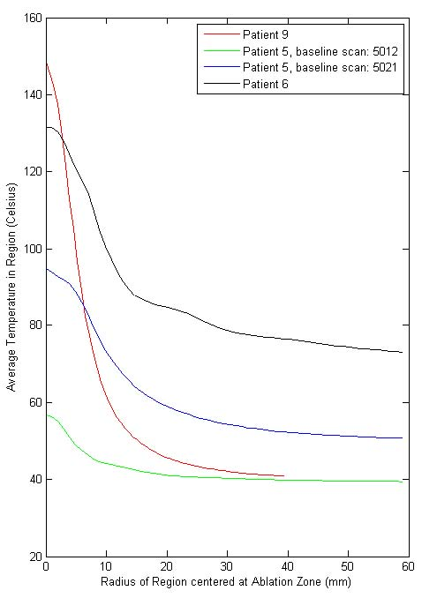
Figure 6: Graph of radius vs mean temperature
6. FUTURE WORK
6.1 Metal Deletion Technique
There are a myriad of medical image ﬁltering techniques that have been developed over the years. With regards to the metal artifacts in CT scans, a technique known as the Metal Deletion Technique16 has developed which has shown to be quite eﬀective. It reduces the artifacts quite well and has a relative low error in HU relative to the original image. In the future, we hope to incorporate this technique into the initial processing steps in order to produce an even smoother change map.
6.2 Further Testing
We hope these methods will continue to be tested and eventually incorporated into clinical practice. This will require testing on a lot more CBCT scans. Additionally, we will need a data set where multiple imaging modalities were employed. That way we can test our thermal map against one generated by a modality that is known to generate accurate thermal maps.
REFERENCES
1. M. Li, N. Abi-Jaoudeh, A. Kapoor, S. Kadoury, S. Xu, N. Noordhoek, A. Radaelli, B. Carelsen, and B. J. Wood, “Towards cone-beam ct thermometry,” Proc. SPIE 8671 , March 2013.
2. F. Fani, E. Schena, P. Saccomandi, and S. Silvestri, “Ct-based thermometry: An overview,” International Journal of Hyperthermia , June 2014.
3. F. P. M. Oliveira and J. M. R. S. Tavares, “Medical image registration: a review,” Computer Methods in Biomechanics and Biomedical Enginnering , 2014.
4. D. L. G. Hill, P. G. Batchelor, M. Holden, and D. J. Hawkes, “Medical image registration,” Physics in Medicine and Biology 46(3), 2001.
Figure 7: 3D Visualization of the Needle and Ablation Zone
5. S. Ourselin, A. Roche, G. Subsol, X. Pennec, and N. Ayache, “Reconstructing a 3d structure from serial histological sections,” Image and Vision Computing , January 2001.
6. M. Modat, G. G. Ridgway, Z. A. Taylor, M. Lehmann, J. Barnes, N. C. Fox, D. J. Hawkes, and
S. Ourselin, “Fast free-form deformation using graphics processing units,” Computer Methods and Programs in Biomedicine , June 2010.
7. E. Durucan and T. Ebrahimi, “Change detection and background extraction by linear algebra,” Proceedings of the IEEE 89, pp. 1368–1381, Oct 2001.
8. D. K. Panda and S. Meher, “Video object segmentation based on adaptive background and wronskian change detection model,” 2013 International Conference on Signal Processing and Communication , 2013.
9. L.-M. Ang, Visual Information Processing in Wireless Sensor Networks: Technology, Trends and Applications: Technology, Trends and Applications, ch. 5, pp. 102–103. IGI Global, 2011.
10. B. Subudhi, S. Ghosh, and A. Ghosh, “Change detection for moving object segmentation with robust background construction under wronskian framework,” Machine Vision and Applications 24(4), pp. 795– 809, 2013.
11. M. Rhudy, B. Bucci, J. Vipperman, J. Allanach, and B. Abraham, “Microphone array analysis methods using cross-correlations,” ASME Proceedings: Sound, Vibration and Design , November 2009.
12. MathWorks, “Find connected components in raw image,” 2015.
13. MathWorks, “Principal component analysis of raw data,” 2015.
14. P. A. Yushkevich, J. Piven, H. Cody Hazlett, R. Gimpel Smith, S. Ho, J. C. Gee, and G. Gerig, “User-guided 3D active contour segmentation of anatomical structures: Signiﬁcantly improved eﬃciency and reliability,” Neuroimage 31(3), pp. 1116–1128, 2006.
15. A. Fedorov, R. Beichel, J. Kalpathy-Cramer, J. Finet, J.-C. Fillion-Robin, S. Pujol, C. Bauer, D. Jennings,
F. Fennessy, M. Sonka, J. Buatti, S. Aylward, J. Miller, S. Pieper, and R. Kikinis, “3d slicer as an image computing platform for the quantitative imaging network,” Magnetic Resonance Imaging 30, pp. 1323–41, 11 2012.
16. F. E. Boas and D. Fleischmann, “Evaluation of two iterative techniques for reducing metal artifacts in computed tomography,” Radiology 259(3), pp. 894–902, 2011.

