# Abstract:

Social distancing and lockdown policies do not provide the same benefits to poor as they do to rich countries. A younger population, less susceptible to the disease, and less willing to exchange economic well-being for risk reduction, means that lockdown measures are likely to be less valuable in poorer countries. [At Y-RISE](http://yrise.yale.edu/covid-19/) we are conducting the rapid data collection necessary to combat the spread of COVID-19 and implementing harm-reduction strategies to reduce the transmission of the coronavirus while permitting economic activity.

The Value of Social Distancing is Not Equally Distributed

Zachary Barnett-Howell and Ahmed Mushfiq Mobarak

In the past months governments around the world have implemented social distancing and lockdown policies designed to inhibit the spread of the coronavirus by restricting the movement and everyday activity of billions of people. Despite the uniformity of this policy prescription, the expected benefit to widespread restrictions on mobility varies significantly from country to country.

In our study “[The Benefits and Costs of Social Distancing in Rich and Poor Countries](http://yrise.yale.edu/wp-content/uploads/2020/04/covid19_in_low_income_countries.pdf)” we used the Imperial College London COVID-19 Response Team’s [epidemiological model](https://www.imperial.ac.uk/media/imperial-college/medicine/sph/ide/gida-fellowships/Imperial-College-COVID19-Global-Impact-26-03-2020v2.pdf) to estimate the benefit to a set of social distancing and suppression policies in different countries (Walker et al. 2020; Barnett-Howell and Mobarak 2020). We find that the value of lockdowns and other social distancing policies is heavily tilted towards richer countries. Moreover, the marginal value of an increasing policy stance—moving from social distancing to full lockdown and suppression—is relatively small in poorer countries. Our conclusion is that the benefit of lockdowns does not support their ubiquity, and that each government should carefully consider how social distancing and lockdown policies will benefit their citizens. Instead, we recommend the immediate deployment of harm-reduction measures that reduce the spread of COVID-19 while allowing permitting economic activity to continue.

Using the current best understanding of COVID-19, the value of social distancing and lockdown policies varies widely across countries based primarily on two factors:

1. Demographics: the fraction of the population that is elderly within a society
2. Risk valuation: how each society might trade economic for health security

# Demographics

The fatality risk of COVID-19 increases sharply with age. The predicted case fatality ratio from COVID-19 for a sixty year old person is approximately 30 times greater than that of a thirty year old, and 60 times greater for a seventy year old (Verity et al. 2020; Ruan 2020). While there should be no debate about the absolute risk that COVID-19 presents—it is significantly more dangerous than the seasonal influenza—the majority of that risk is concentrated among the elderly.

Richer countries tend to have lower fertility rates, and therefore relatively older populations than poorer countries. For example, In Italy and the United States the percentage of the population above the age of 65 is 22.8 and 15.8, respectively. In Bangladesh only 5.2 percent of the population is above the age of 65. There are simply more people at greater risk in high- than low-income countries, which is borne out by the epidemiological model’s estimate that the unmitigated spread of the novel coronavirus would lead to the deaths of 0.21 percent of the sub-Saharan African population; for the United States and other OECD countries predicted mortality is 0.8 percent of the population.

# Valuing Risk

Lockdowns impose a tradeoff on their populations: lowering the mortality risk from COVID-19 while increasing economic deprivation. Yet individuals within each country have their own calculus over how they would exchange risk for money. One example is the proposed strike by workers for the Instacart service in the United States, who go to stores to shop and deliver goods for other people. These workers have demanded $5 in hazard pay per order in compensation for their increased risk to COVID-19 (Ghaffary 2020). Using individual preferences for compensation for increased exposure to mortality risk, the exchange between money and risk can be estimated for a population (Viscusi and Masterman 2017; Robinson et al. 2019). Poorer people are less willing to make economic sacrifices to reduce their risks. This is not a normative statement, rather it reflects the fact that people living closer to the margin, who require a daily wage feed their families and make ends meet, are willing to accept higher levels of risk for less compensation.

By accounting for the country-specific valuation of risk, we find that the difference between countries in the benefit afforded by suppression and lockdown measures is even more stark. The value of mortality risk reduction by moving from a scenario where COVID-19 is unmitigated to a social distancing policy that reduces interpersonal contact rates by approximately half, provides the United States with an estimated benefit equal to 59% of its GDP; in Germany the benefit is estimated at 85% of its GDP. In contrast, the marginal value of the same policy in Bangladesh and India is only 14% and 19% of their GDP, respectively.

# Capacity Constraints

The purpose of social distancing and lockdown policies is to “flatten the curve” of the pandemic, to buy time for healthcare systems to accommodate the number of people requiring medical attention (Gourinchas 2020). However, the capacity of healthcare systems varies widely between countries. If we consider estimates of the number of hospital and ICU beds as a proxy for the capacity of each country’s medical capacity, high-income countries have more than twice the per-capita capacity of low-income countries (Walker et al. 2020; Sussman 2020). Increasingly suppressive policies are necessary to stretch the number of people contracting COVID-19 so that it falls within the capacity of poor countries. In many countries such a flattening of the curve is impossible: Somalia’s Health Ministry claims no ventilators, the Central African Republic, South Sudan, and Liberia have less than six ventilators each, Nigeria has approximately one ventilator per 2 million people (Berak and Paquette 2020).

Another equally crucial difference between rich and poor countries is the government capacity to provide social welfare to its citizens. Even generous welfare schemes like in Denmark, which will pay workers 75% of their salaries during the lockdown period, are only apply to people working in the formal sector (Collington 2020; Hansen 2020). In Denmark only 5% of workers are outside the formal sector; by contrast, in Bangladesh 55% of workers are either informally or self-employed. This is more than a question of policy design: informal workers are do not always appear in government and bureaucratic records, it is uncertain how quickly such people could be located, if at all, to deliver relief aid to them.

# Immediate Suggestions

There is considerable space between doing nothing and enforcing strict lockdowns on a population. We estimate that the benefit of social distancing and suppression policies are significantly lower in poor countries. The costs in poor countries also stand to be higher for households that rely on a daily wage to feed themselves and their families. Already we see emerging healthcare crises as routine medical care and vaccinations fall in countries across the world (Nelson 2020). A tailored response to each country’s situation is necessary (Mehtar et al. 2020). To this end we recommend:

1. The public adoption of masks and home-made face coverings, which are comparatively cheap and feasible to implement.
2. Improving access to clean water, handwashing and sanitation, especially in public places and around transport hubs.
3. Widespread social influence and information campaigns to encourage behaviors that slow the spread of disease, but do not undermine economic livelihoods. This could include restrictions on the size of religious and social congregations, or programs to encourage community and religious leaders to endorse safer behaviors.

# Next Steps

At [Y-RISE](http://yrise.yale.edu/covid-19/) we are engaged in a number of projects to help better understand and address the pandemic. A team of epidemiologists and economists are working together on a model for how the coronavirus will spread within a low-income country, and how people will balance social distancing with their need to earn a wage. To generate real-time data on the dynamics of the disease as it progresses, we are building infrastructure in Bangladesh to conduct pharmacy-level point-of-contact identification of COVID-19 symptoms. Combining the data we collect with a series of nationally representative phone surveys that we are fielding across Bangladesh in collaboration with [IPA](https://www.poverty-action.org/), we can identify hotspots where the disease is growing rapidly.

To address the economic deprivation resulting from social distancing and lockdown orders, we are deploying machine learning tools to identify those households hardest hit by this crisis and most in need of immediate aid. We are designing a series of messaging strategies to raise COVID-19 awareness and promote harm-reducing behaviors, and are working with [a2i](https://a2i.gov.bd/) to scale up the circulation of these messages through local community and religious leaders. Our goal is to develop measures to alleviate suffering in Bangladesh and to serve as a model that other countries can replicate when dealing with the COVID-19 pandemic.

# References

Barnett-Howell, Zachary, and Ahmed Mushfiq Mobarak. “The Benefits and Costs of Social Distancing in Rich and Poor Countries.” *arXiv preprint arXiv:2004.04867v1*. April 10, 2020.

Bearak and Paquette. “Africa’s most vulnerable countries have few ventilators — or none at all.” *Washington Post*. April 18, 2020. <https://www.washingtonpost.com/world/africa/africa-coronavirus-ventilators/2020/04/17/903163a4-7f3e-11ea-84c2-0792d8591911_story.html>. (Accessed May 1, 2020)

Collington, Rosie. “Denmark is helping those who can't work due to coronavirus — why isn't the UK?” *The Guardian.* March 18, 2020. <https://www.theguardian.com/commentisfree/2020/mar/18/denmark-coronavirus-uk-government-workers-employees>. (Accessed May 1, 2020)

Ghaffary, Shirin. “The Instacart strike, explained.” *Vox*. March 30, 2020. <https://www.vox.com/recode/2020/3/30/21200495/instacart-strike-coronavirus-covid-19-working-conditions-amazon-whole-foods-gig-economy>. (Accessed May 1, 2020)

Gourinchas, Pierre-Olivier. “Flattening the pandemic and recession curves.” In *Mitigating the COVID Economic Crisis: Act Fast and Do Whatever It Takes*. Eds. Richard Baldwin and Beatrice Weder di Mauro. pp. 31-40. March 18, 2020.

Hansen, Bue Rübner. “Denmark’s Answer to the Coronavirus Recession.” *Tribune Magazine*. March 16, 2020. <https://tribunemag.co.uk/2020/03/denmarks-answer-to-the-coronavirus-recession>. (Accessed May 1, 2020)

Mehtar, Shaheen, Wolfgang Preiser, Ndèye Aissatou Lakhe, Abdoulaye Bousso, Jean-Jacques Muyembe TamFum, Oscar Kallay, et al. “Limiting the spread of COVID-19 in Africa: one size mitigation strategies do not fit all countries.” *The Lancet Global Health*. April 28, 2020. <https://doi.org/10.1016/S2214-109X(20)30212-6>

Nelson, Roxanne. “COVID-19 disrupts vaccine delivery.” *The Lancet Infectious Diseases*. Vol 20. April 17, 2020. <https://doi.org/10.1016/S1473-3099(20)30304-2>

Robinson, Lisa A., James K. Hammitt, and Lucy O’Keeffe. "Valuing mortality risk reductions in global benefit-cost analysis." *Journal of Benefit-Cost Analysis* 10, no. S1 (2019): 15-50. https://doi.org/10.1017/bca.2018.26

Ruan, Shigui. "Likelihood of survival of coronavirus disease 2019." *The Lancet Infectious Diseases*. March 30, 2020. https://doi.org/10.1016/S1473-3099(20)30257-7

Sussman, Nathan. “Time for bed(s): Hospital capacity and mortality from COVID-19.” *COVID Economics*. No 11, April 29, 2020.

Verity, Robert, Lucy C. Okell, Ilaria Dorigatti, Peter Winskill, Charles Whittaker, Natsuko Imai, Gina Cuomo-Dannenburg et al. "Estimates of the severity of coronavirus disease 2019: a model-based analysis." *The Lancet Infectious Diseases*. March 30, 2020. https://doi.org/10.1016/S1473-3099(20)30243-7

Viscusi, W. Kip, and Clayton J. Masterman. “Income elasticities and global values of a statistical life.” *Journal of Benefit-Cost Analysis* 8, no. 2 (2017): 226-250. https://doi.org/10.1017/bca.2017.12

Walker, P., C. Whittaker, O. Watson, M. Baguelin, K. Ainslie, S. Bhatia, S. Bhatt et al. “Report 12: The global impact of COVID-19 and strategies for mitigation and suppression.” March 26, 2020. https://doi.org/10.25561/77735

Differences in average VSL lost under different COVID-19 policy response scenarios.

Figure 1: Estimated Population-weighted average value of increasing mitigation policies using mortality estimates and policy scenarios from Walker et al. 2020 and VSL estimates from Viscusi and Masterman 2017. Income classifications given by the World Bank.

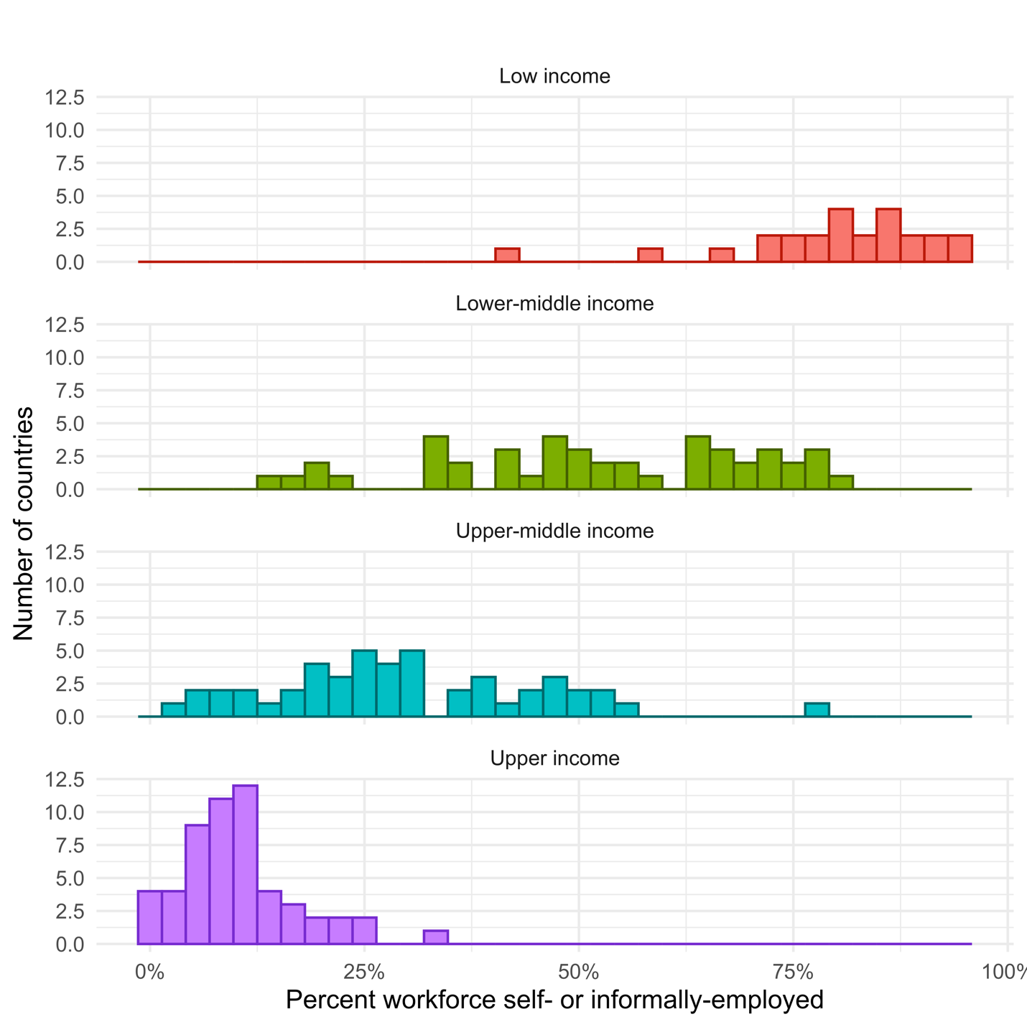

Figure 2: Distribution of percentage of the workforce either self-employed or in the informal sector by World Bank income classification.

Figure 3: distribution of percentage of the population over the age of 65 by World Bank income classification group.