“It's Time for Marriage”

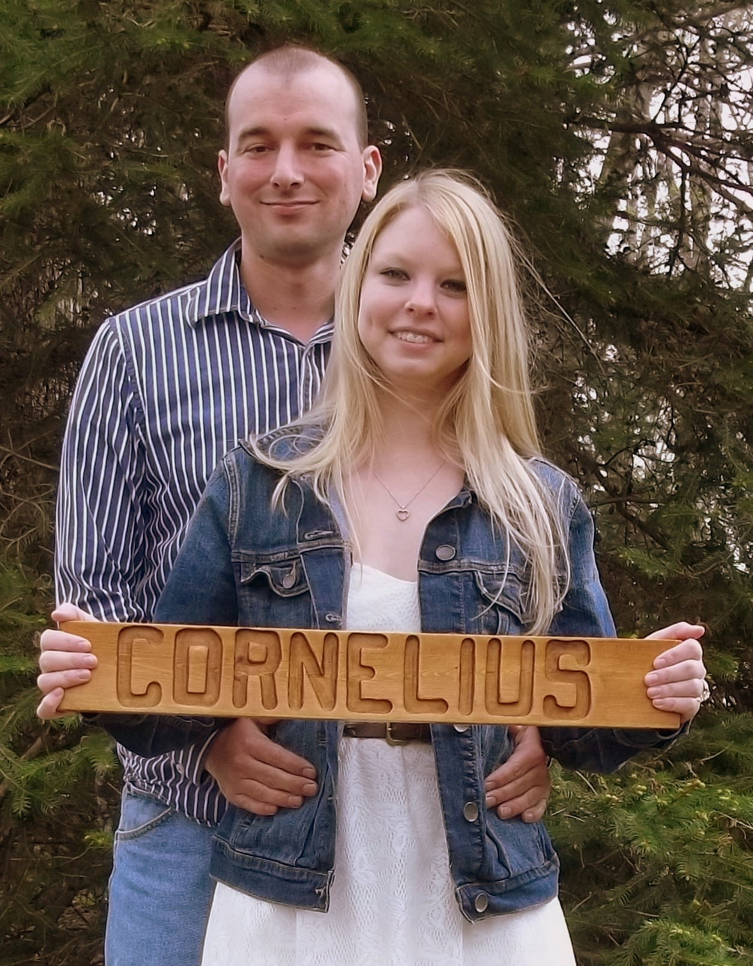

James Joseph Cornelius

and
Nicole Lynn Douglas

September 13, 2014
St. Peter Parish
Slippery Rock, Pennsylvania
2:00pm

