Beginning C++  
Using the Ngen Framework  
  
“Beginning C++ - Using the Ngen Framework” is a series of tutorials, examples, and lectures that will guide you through the beginning stages of writing C++ software. As you read through each chapter, you will slowly gain a strong level of understanding of software architecture and the C++ programming language. And don’t worry if you have never wrote code before, the book targets both professionals, and complete beginners.

Chapter 1 | A Programmer Programming

This book is literally two books compiled into one neatly structured document. The first part is for complete beginners to C++ and writing software in general, and the second part dives into advanced C++ with a complete introduction to the Ngen Framework. The Ngen Framework is a set of libraries that does a lot of work for the programmer, letting you write code more quickly, and safely. If you don’t know what a library is, don’t worry. For now, just know that a library is a tool programmers use to leverage some functionality without having to write all the leg work for it themselves.   
  
 Being a programmer does not only mean that you can write code. As a programmer, you will have to solve problems and critical thinking skills are necessary. While a programmer will typically write a lot of code when creating a new application, most the time spent will revolve around research and design. The biggest mistake programmers make when they first start a project is that they fail to properly draw a design. Even if the idea is researched extensively, certain details of the idea could easily be forgotten or missed, often giving rise to unexpected walls in development. Remember, your time is precious, and the less time you spend fixing broken code, or debugging your application, the more time you can spend on finishing your project or improving it.

**Research**

Let’s say that I want to make a game, something epic, like the next “Final Fantasy”. How would I go about getting started? Easy, welcome to the information age of the 21st century, where we have all the answers at our finger tips. Internet research is as easy as going to your favorite search engine and looking for websites that match a set of keywords. For instance, if I were to go to the Google Search Engine and query “how to make a game”, the Google servers will quickly respond with a massive collection of websites related to game development.



Typically, a search engine will be exact, with the first result as being the most related to your selected topic. Other times, the search engine could provide results that are confusing, or just plain wrong. Today, instead of only using a search engine to gather information, a programmer can utilize other websites, like search engines, that are made by programmers; for programmers. These websites are specifically designed for a programmer to ask programming related questions. Often the community that surrounds these kind of websites are extremely helpful and quick to respond to your specific needs.  
  
 One website in particular, the Q&A site Stack Overflow ([www.stackoverflow.com](http://www.stackoverflow.com)), is perfect to research helpful ways to get started on a new type of project. Here, a programmer will ask a question, and other interested and knowledgeable programmers will provide an answer. The programmer that asks the question, selects the best answer and the question is marked as being solved. Compared to the Google Search results, Stack Overflow looks more promising; remember that less is more.  
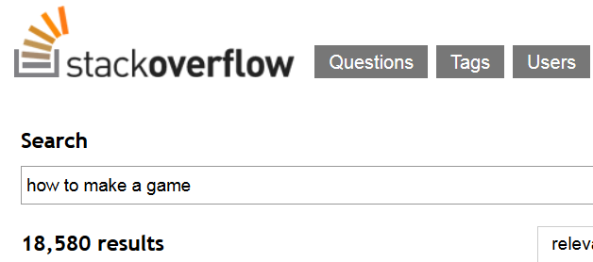  
  
 Another kind of website that helps with research are code-hosting websites, which host open source code projects, and useful code snippets. These kind of sites will help you tremendously when trying to write the actual code, as they often provide working examples of pre-written code that performs a needed task. Google Code (<http://code.google.com>), is a website service from Google that does just that, as they host thousands of coding projects and their accompanying source code.   
  
 Using the same set of keywords queried in the Google search engine, Google Code provides to us many results of related projects that most likely have working code samples for games.  


TODO end Research

**Design**

TODO: designing a code project

**Development**

**Marketing**

Chapter 2 | Writing In Code

Chapter 3 | Writing C++ De;;