Worksheet for lab 5

Haoyou Liu

1. **After running the cp command, what file(s) are now in your home directory? There should be at least two: a ".sh" file, and a ".py" file.**

spark-run.sh and ngram-job.py

1. **What is the name of the last file in the listing for HFS folder /var/si618w17?**

yelp_academic_dataset_review_updated.json

1. **What year was Einstein first mentioned (as a noun) in Google Books data?**

1921

1. **After the Spark job completes, what are the first three files listed in your Hadoop File System output directory ./output?**

part-00000, part-00001, part-00002

1. **What were the average word lengths observed in books from the years 1563, 1572, and 1575?**

(1563, 6.87824526311463),

(1572, 6.781863482544008),

(1575, 7.074171357961625)

cont’d

1. **Bonus Challenge**

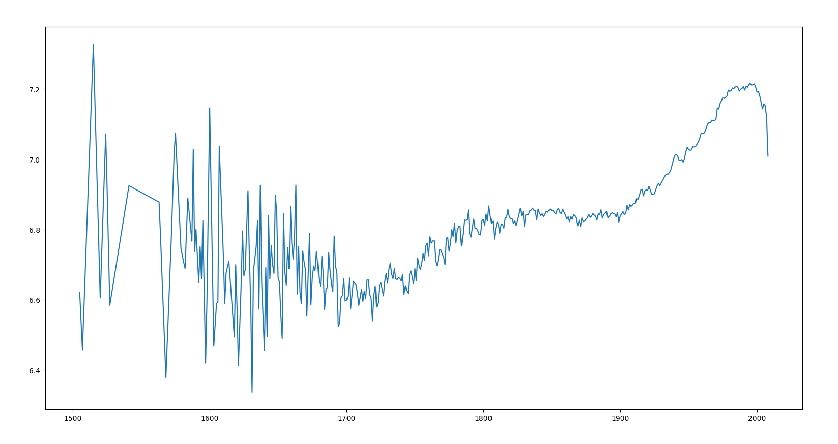

**Source code:**

**import** matplotlib.pyplot **as** plt  
  
**with** open ('ngrams-output.txt', 'r') **as** f:  
 dict = {}  
 **for** line **in** f:  
 line = line.strip().replace('(', '').replace(')', '').replace(' ', '').split(',')  
 dict[line[0]] = line[1]  
  
 tup = sorted(dict.items(), key= **lambda** x:x)  
 year, word_len = zip(*tup)  
  
 plt.plot(year, word_len)  
 plt.show()