**Nearest Neighbor Algorithm**

A naïve implementation of a fluid simulation using smoothed particle hydrodynamics takes into account interaction between all pairs of particles each time step, producing a runtime of O(n2), where n is the number of particles. To speed up the simulation, we used the nearest neighbor algorithm assumes that particles will only interact if they are within a certain distance of each other. This distance, called the radius of support, can be adjusted so that the fluid simulation produced looks nearly identical to the simulation produced by the naïve implementation. Using this algorithm, the runtime is reduced to O(nm), where m is the average number of neighbors of each particle.

Implementing the nearest neighbor algorithm allowed us to run real-time simulations with approximately 1200 particles at an average of 15 frames per second, rendering particles as spheres.

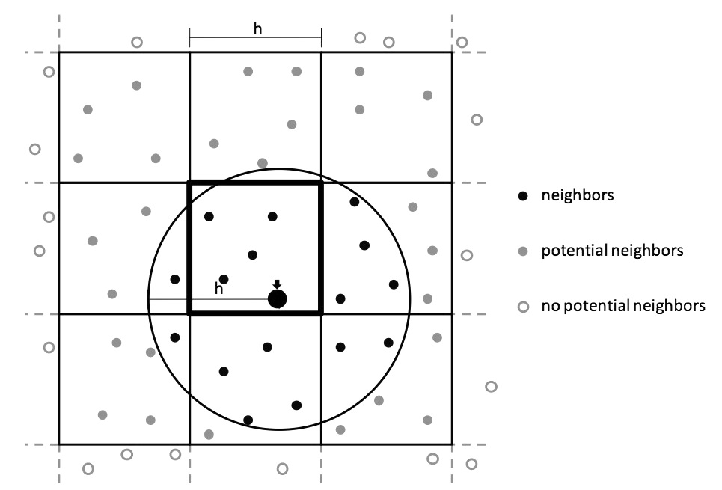

Image courtesy Stefan Auer.