Zack McGinnis
CS410 Winter 2016
Project 1 Report
Option 1: Color Transfer Between Images

Methods:
My color transfer program was developed using Visual Studio 2015 and written in C++. I also utilized the OpenCV library to implement the BGR to LAB, BGR to XYZ, and BGR to HSV color space tranfers.

The inputs and outputs for five separate images are displayed for three different color spaces (LAB, XYZ, and HSV).

The algorithm settings which produced these results are as follows:
- After creating the source and reference image structs, the cvCvtColor method is called to switch the color space of both the source and reference images (either CV_BGR2LAB, CV_BGR2XYZ, or CV_BGR2HSV).
- While operating in the LAB color space (or XYZ or HSV), we compute the mean and standard deviations for each of the three channels in both the source and reference image.
- The mean of each LAB channel is subtracted from each reference image channel.
- Both the source and reference images are scaled by the ratio of the standard deviation of source divided by the standard deviation of the reference, multiplied by each source channel.
- The mean values of the reference image in LAB are added to each channel.
- The image is converted back to BGR space by using either CV_LAB2BGR, CV_XYZ2BGR, or CV_HSV2BGR.

Image tests (taken from the "Color Transfer Between Images" paper):
Image 1:
BGR to LAB

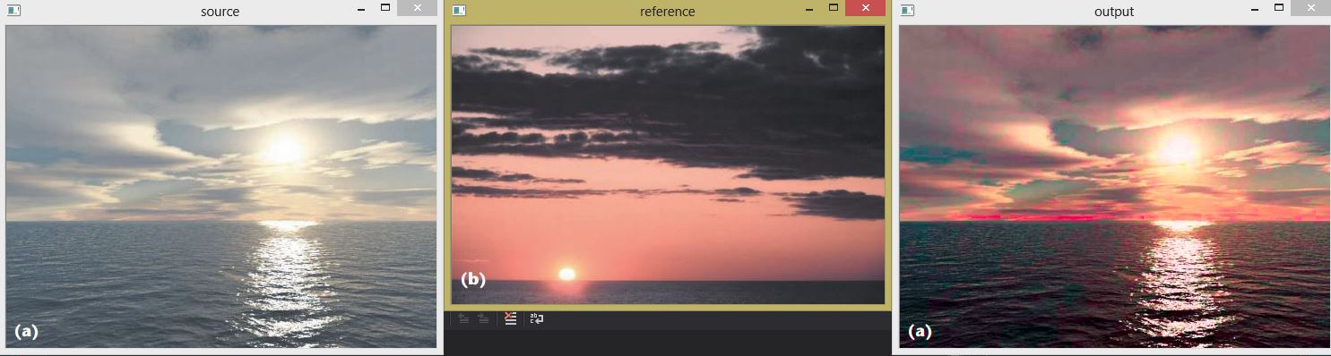

BGR to XYZ
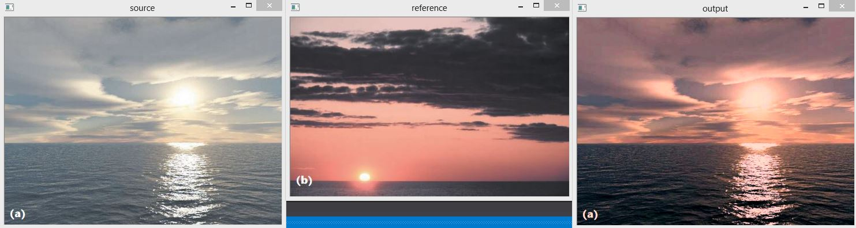

BGR to HSV
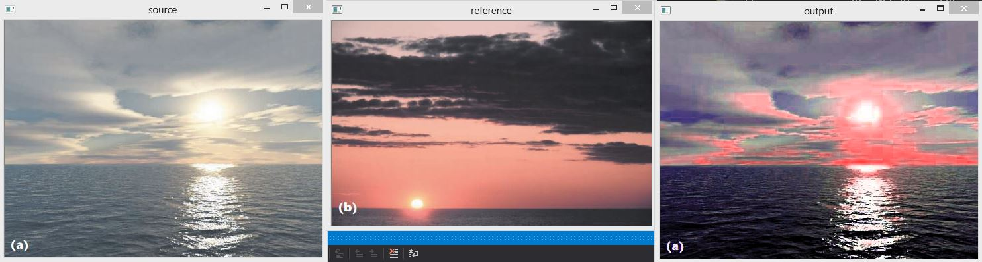

Image 2:
BGR to LAB
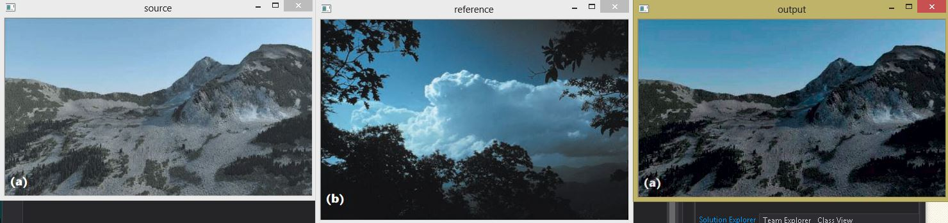
BGR to XYZ
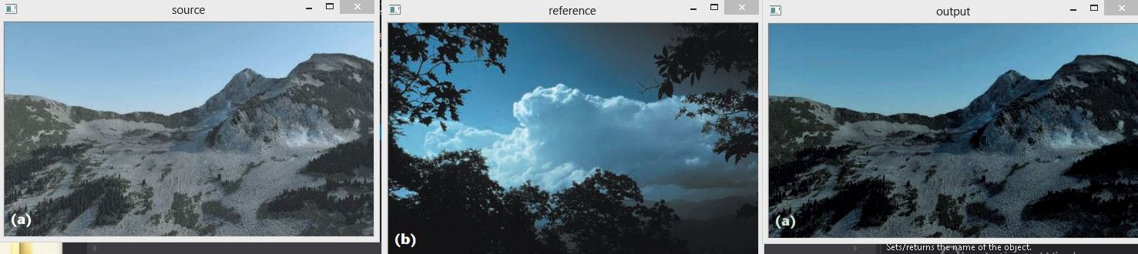

BGR to HSV
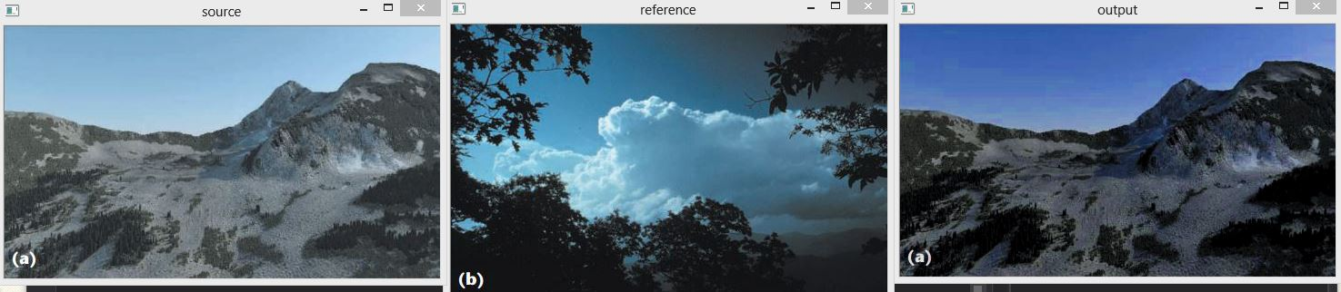

Image 3:
BGR to LAB
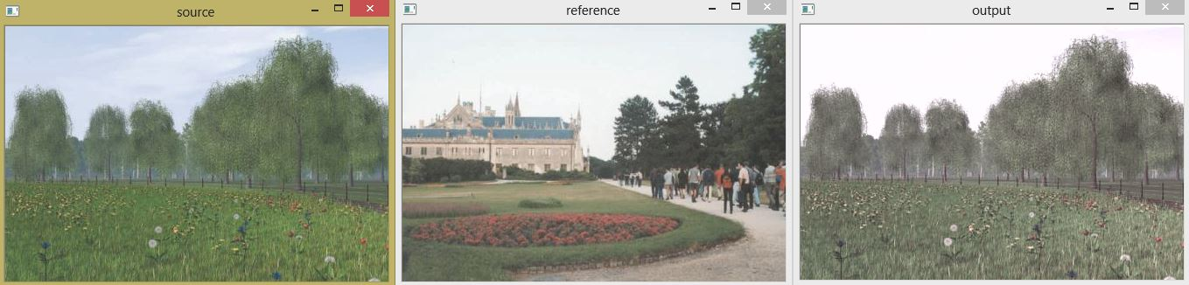
BGR to XYZ
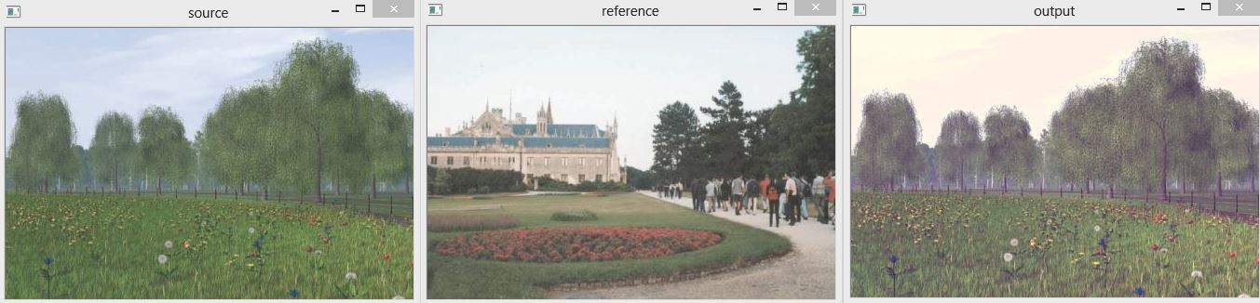
BGR to HSV
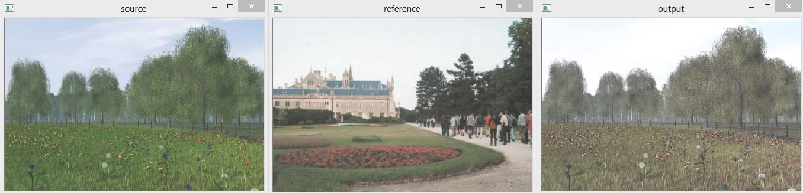

Image 4:
BGR to LAB
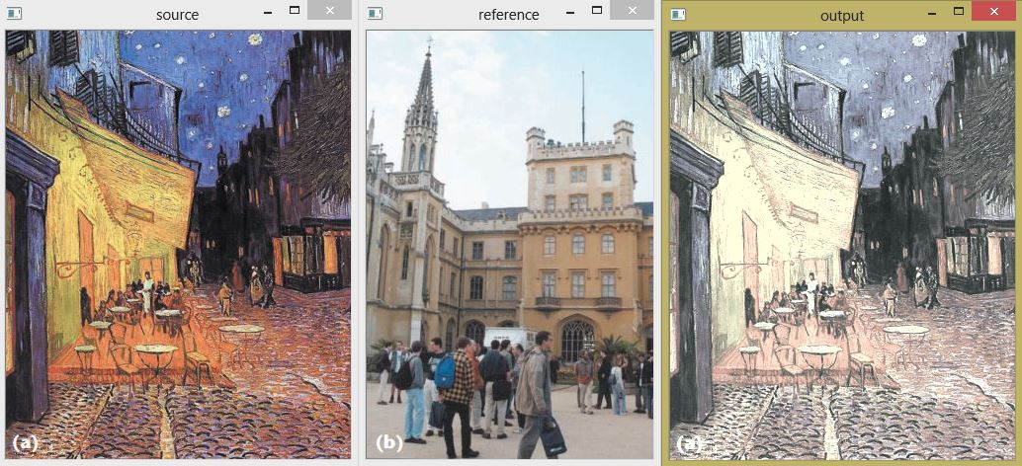
BGR to XYZ
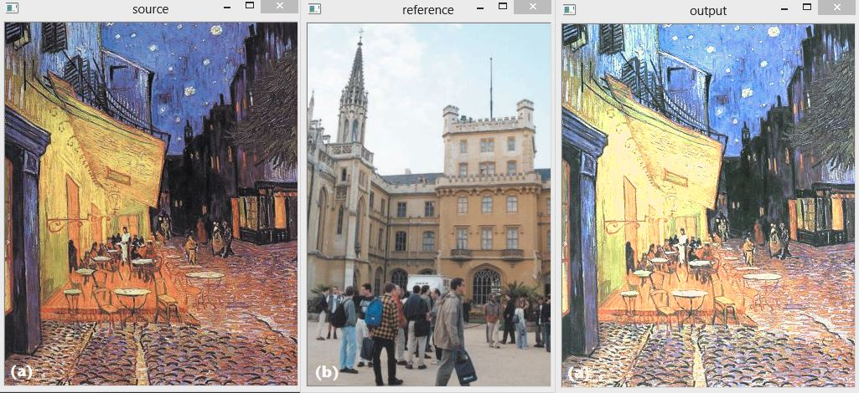

BGR to HSV
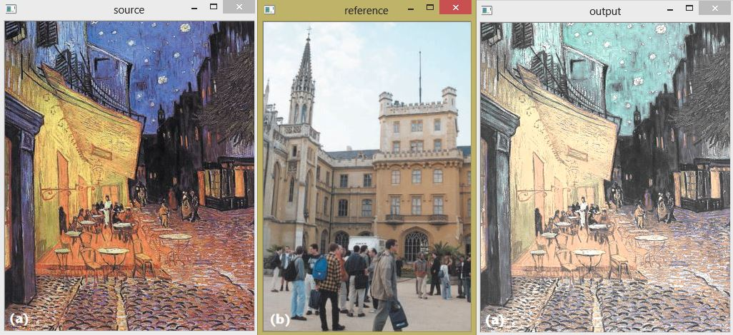

Image 5:
BGR to LAB
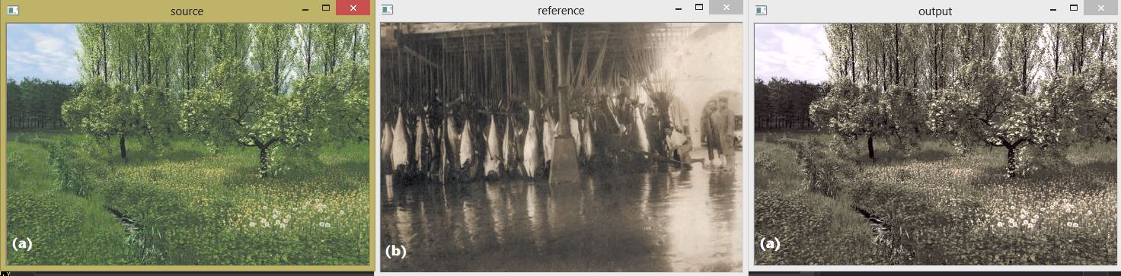
BGR to XYZ
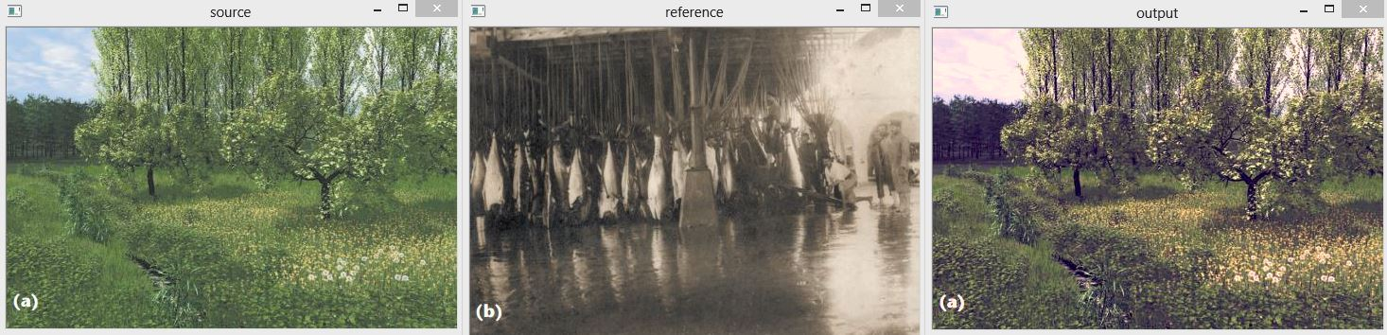

BGR to HSV
