Zack Mcginnis
CS441 Progress Report #1
11/2/2015

• Team Name – Team Z-Bot
o List of individual team members – Zack Mcginnis
• Project Title – Creating an Intelligent Poker Bot
• Project Summary – 100 words or less – In this project, I will attempt to create a poker bot which will utilize some of the sophisticated AI learning methods we have discussed in class (CS441). My bot will implement a neural net to make decisions based on learned history with other bot opponents. A genetic algorithm will be used to ensure the bot is making better decisions, measured in profit (bb/100) and EV. Using the Poker Genius GUI interface (from poker-genius.com), I will only need to create the appropriate classes, functions and algorithms in Java. I will compare results before and after the bot has had time to learn its opponents playing style.
• Project Description
o Goal – To create a poker bot which uses a neural net to learn about the playing style of its opponent, and uses that knowledge to make optimal decisions throughout future hands.
o Design Requirements – To import my bot into the Poker Genius GUI program, I need to javac my bots .java file, and package it into a .jar file. Separate .java files may need to be created to represent neural net and back propagation strategies.
o Implementation Plan
▪ Programming language to be used - Java
▪ Frameworks to be utilized – Meerkat API
▪ Additional technologies to be used
• The class website contains a list of approved software libraries and toolkits
▪ Development environment – Linux (Ubuntu), and Windows 8
▪ Borrowed code – I will likely draw inspiration from developers who have attempted to create a similar bot. David Moody is one such person who designed a Monte Carlo Tree Search poker bot with the Poker Genius software.
o Plan for Testing
▪ Sources for Data sets – Hand history data imported from previous playing sessions
▪ Experiments - I will compare the results of my bot playing vs another bot “SimpleBot”. I will note the difference in success my bot has from when it was relatively unintelligent, to when it has gained intelligence.
o PERT chart of project component dependencies


o Gantt chart or timeline for the project
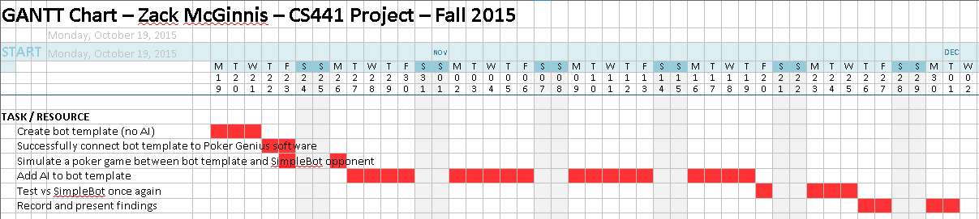

• Anticipated Obstacles – Designing a sophisticated, artificially intelligent poker bot is inherently more difficult than most people realize. This is due to the developer having to plan for unseen cards and unpredictable actions. This will most likely be my biggest challenge. Additionally, testing my bot in a precise manner may be problematic as well, since I must gain more familiarity with the Poker Genius software bundle.

