Zachary McNulty

CSE 373: HW 5

**Problem 1: Pseudo Code to Merge 2 Sorted Arrays**

**\*\*\* let “left” and “right” refer to the arrays with the sorted elements**

int leftCurr = 0; // current index we are looking at in left array

int rightCurr = 0; // current index we are looking at in right array

int index = 0; //current index we are storing elements in output

output = array of length right.length + left.length

while (leftCurr < left.length && rightCurr < right.length) { // neither left/right is fully traversed

If (left[leftCurr] <= right[rightCurr]) {

output[index] = left[leftCurr];

increment leftCurr;

} else {

output[index] = right[rightCurr];

Increment rightCurr;

}

Increment index;

}

// now we have completely traversed one of our arrays (left or right)

// but we might not have traversed all our elements; any remaining can just

// be added in order (they are already sorted, so just added left to right)

If (leftCurr < left.length) {

Add elements in indices leftCurr to the end of left to output (in order)

} else if (rightCurr < right.length) {

Add elements in indices rightCurr to the end of right to output (in order)

}

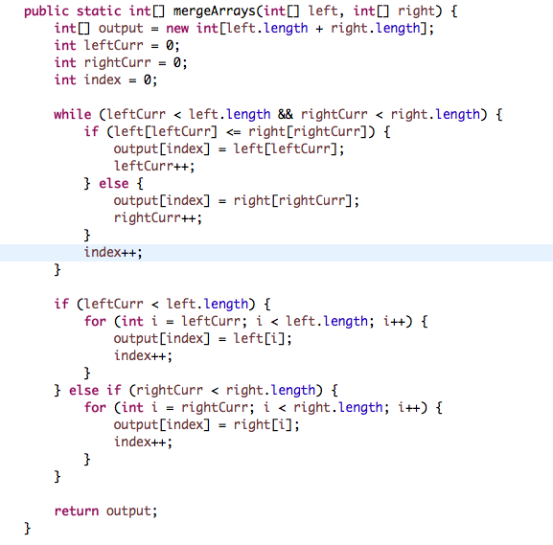

**Problem 2**

1. **Graph**

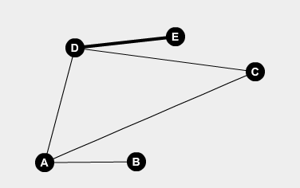

**b) Adjacency Matrix**

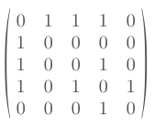

**c) Adjacency List**

A

B

C

D

E

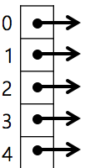

3

0 🡪 2 🡪 4

1 🡪 2 🡪 3

0 🡪 3

0

d) **Vertex** **Degrees**

Both Alice and Dan have a vertex degree of 3, the maximum.

Both Bob and Eve have a vertex degree of 1, the minimum.

The degree in this graph represents the number of friends you have at this given party.