Zachary Robinson Sonoma State University FALL 2022 CS470

All implemented features seem to work as intended.

Account sorted by market with search features.

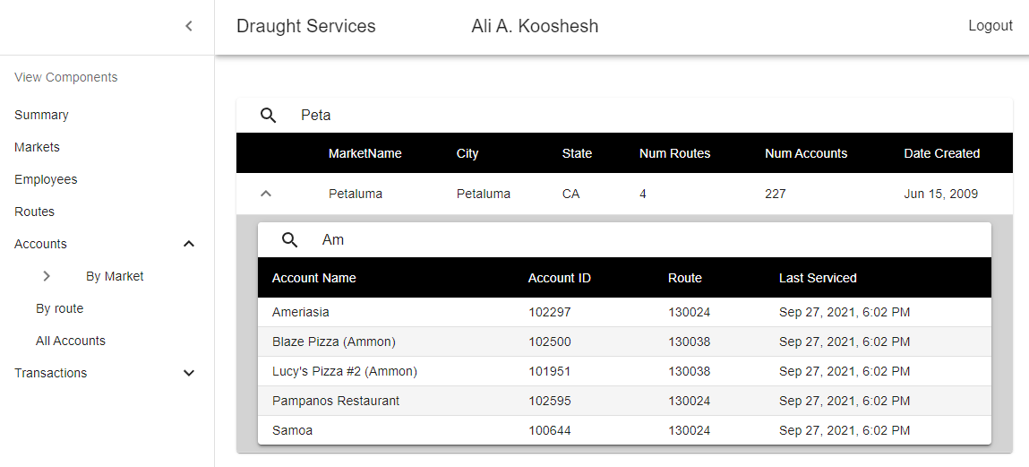

allAcounts with search features

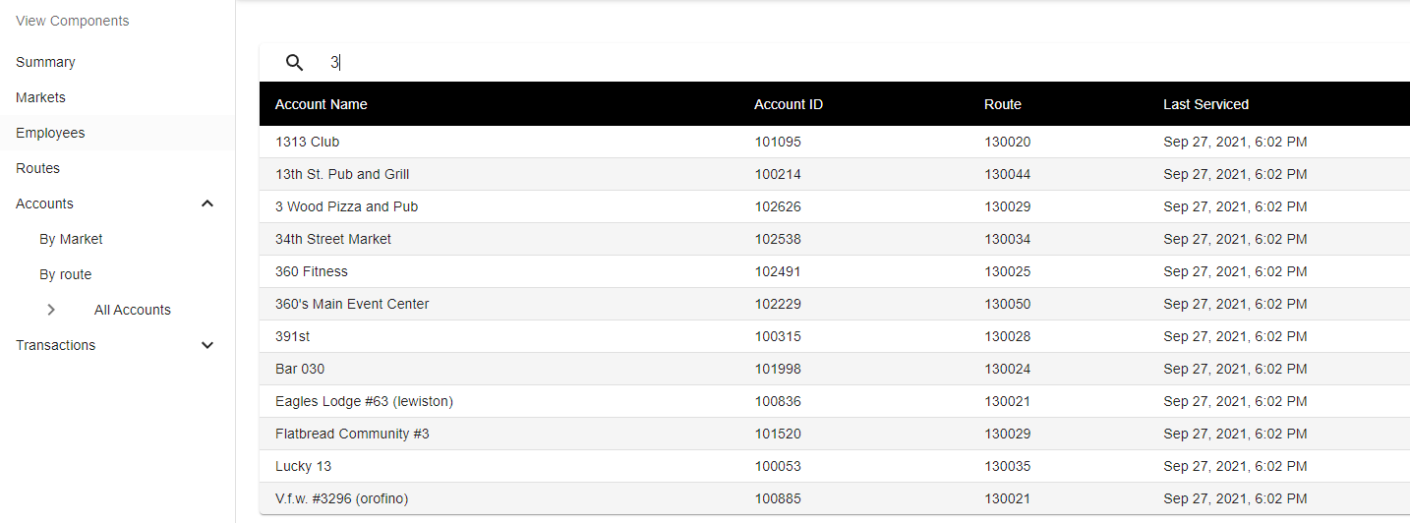

Summary Page

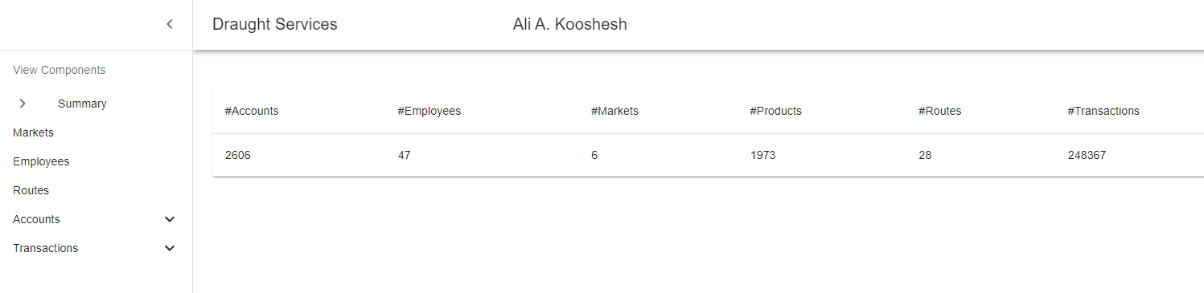

Unimplemented goals: Inserting and Removing from the database via API

TransactionByCycles

TransactionByEmployees

The summary page is obviously very weak