This help guide is based off of the below images, detailing what each item/area will do.

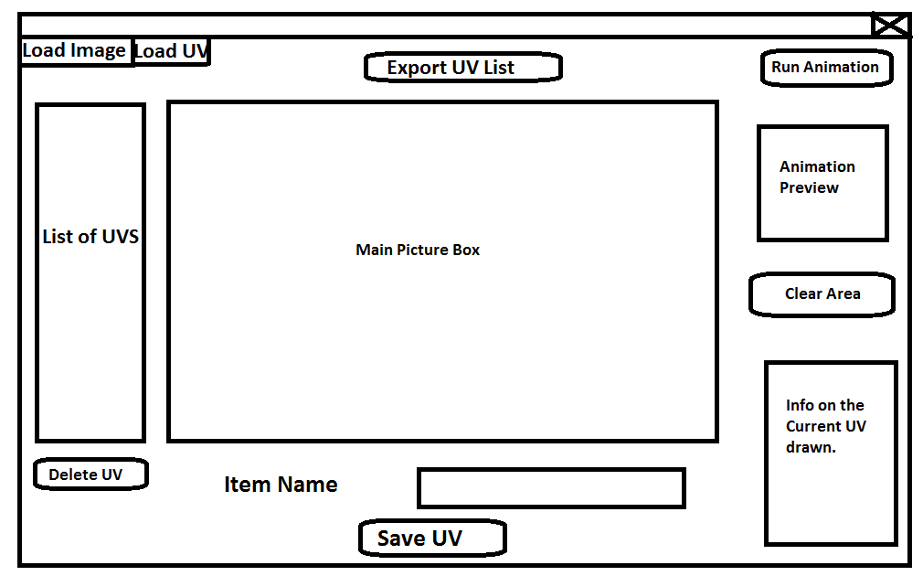

Load Image: This will load an image into the center picture box so that UV rectangles can be drawn upon it.

Load UV: This will load a list of UV’s and store them in the ‘List of UV’s’ list box.

Export UV List: This will allow the user to export the list of UV’s in the UV’s list box into a text file. Each UV contains a start and endpoint in pixel’s and UV’s, as well at the rectangles width and height.

Run Animation: This button will go through the list of UV’s in the list box and draw the first image in the list in the “Animation Preview” picture box, pause for a certain time frame, then proceed to the next image. This will continue to loop thought the list until the user clicks the button again. The button will be highlighted if it is selected, so that the user knows it is pressed down.

Clear Area: this will clear the any information fields, as well as any rectangles drawn in the main picture box.

Info of Current UV Drawn: This will display the information of the start and end point of the currently drawn or selected rectangle in pixels and UV coordinates, as well as the width and the height of the currently drawn/selected UV rectangle.

Save UV: This will save a drawn UV rectangle in the list box of UV’s under the name in the text field above. It should also be noted that a rectangle MUST be given a name.

Delete UV: This will delete a UV rectangle that has been selected in the “List of UV’s” list box. This button will only appear if you have selected a UV, thus making the user unable to delete from this list if there is no items there or if there is no UV’s selected. It is recommended if you want to delete the currently drawn UV, to use the Clear Area button instead.

List of UV’s: This is the current list of UV rectangles. This can be added onto via the Load UV button or by the Save UV button.

It should also be noted that if you wish to draw a rectangle, you must first click on an area within the main picture box, then drag your mouse to an area within the picture box, once you have let go of the left mouse button, the rectangle will be fully drawn and all the information of the current UV rectangle will be displayed. You can also right click drag the current UV you have drawn as long as you have your mouse within the drawn UV, but you are not allowed to right click drag a rectangle that has already been stored in the “List of UVs.”

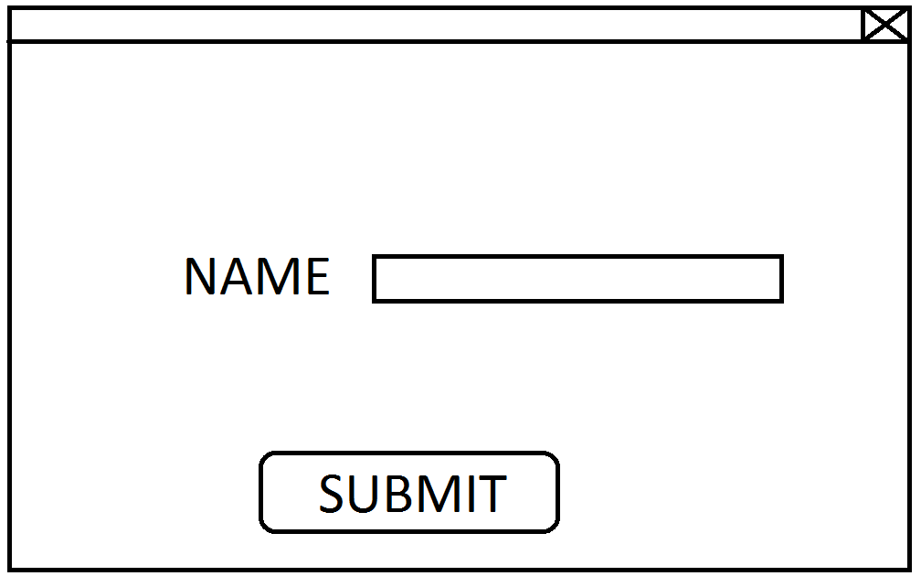This form is displayed when the user clicks on the Load UV button and has selected a valid text document containing the appropriate information.

The submit button will just grab the name from the txt box above the button and give the line of information in the text file a name that can then be added to the list of UV’s list box within the main form with the given name.