C# Tool Purposal

The tool I wish to create for my project is Spritesheet editor. This tool will allow for the ability to take a spiresheet image and to be able draw rectangles over the image in order to get the uv coordinates of a part of an image. The reason why this is important is for the use of game development software which sets a game objects material or image based off of a UV. A UV is a location on an image with a UV of 0.00, 0.00 being the top left and 1.00,1.00 being the bottom right of an image. Once we have two UV points, we can then make a rectangle out of these two points.

My tool will also allow for the importation of an image so that we can draw rectangles on to be able to calculate the UVs on, as well as for the importation of a text file that stores a list of information that features the start and end point of the rectangle, as well of the UV coordinates of the two points, as well as the width and the height of the each individual rectangle, which once imported, this list can have new UV rectangles drawn and added to the list, as well as UV rectangles deleted to the list.

My tool also allows for the saving of the list of made UV coordinates to a text file that stores the important information about each UV rectangle, such as the pixel location of the start and end point, the UV location of the two points and the width and height of each UV rectangle. This text file will be what the user accesses when they wish to incorporate the uv of an image file.

The final thing that my tool allows for is to play an animation of all the uv rectangles in the list, this is to show if all the uv images where in an animation what it would look like.

I originally had a layout of this as my design for my main page.

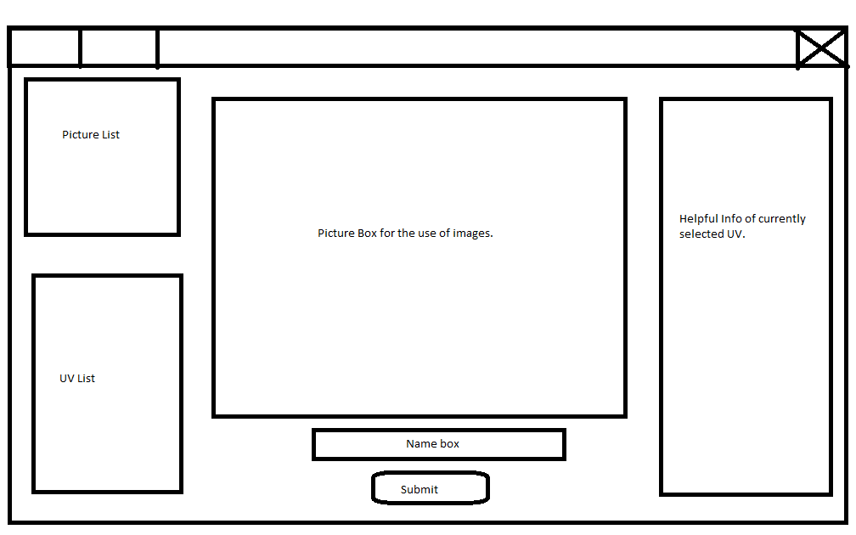

This is because I was going to have two separate lists, but I then decided that it would be easier to incorporate the image of the uv in a separate picture box, and that the image of the picture box would be that of whatever the image within the uv rectangle was.

This is the final sketch for my main page.

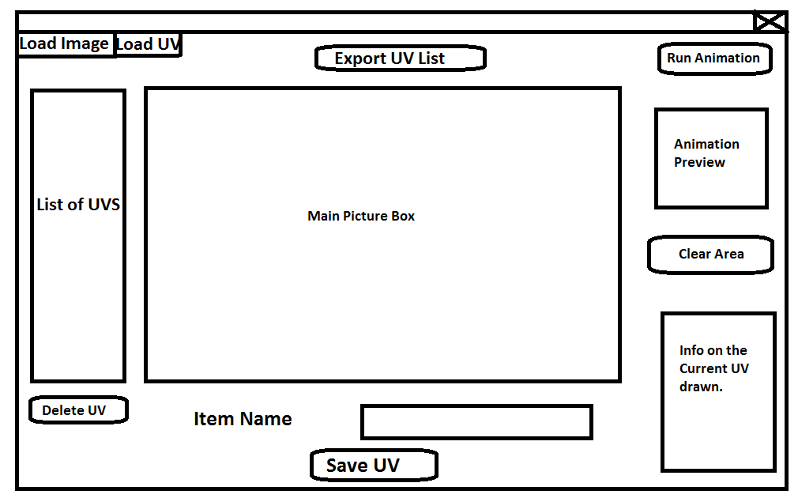

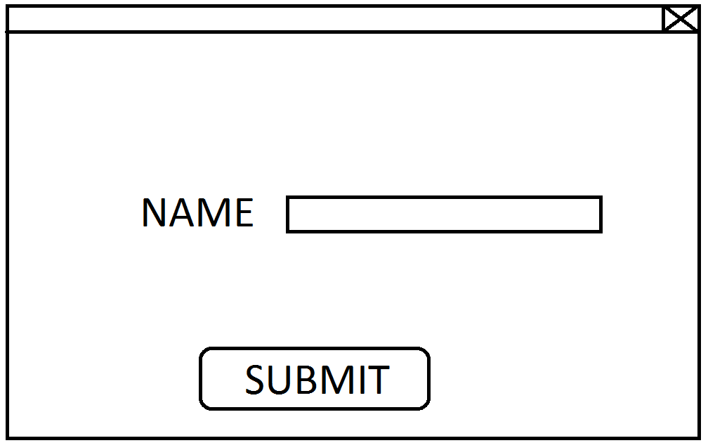And this is the final sketch for my name input if someone has chosen to import UV coordinates.