Q1.5

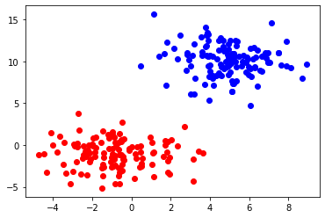

Number of wrong predictions is: 0

Q2.4

max_depth = 3:

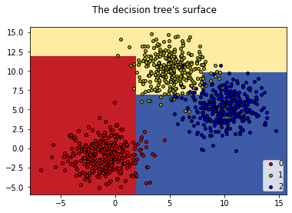

Number of wrong predictions is: 18

max_depth = 5

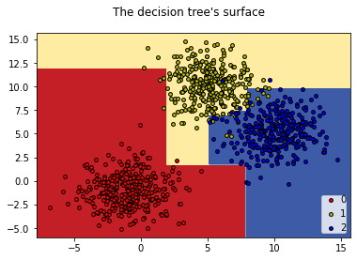

Number of wrong predictions is: 10

max_depth = 7

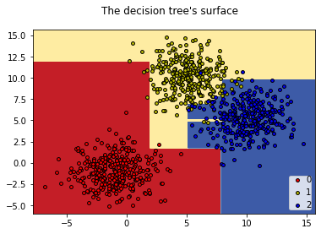

Number of wrong predictions is: 11

**The best model is max_depth = 5, while in max_depth = 3, the model have the most error due to the lack of complexity in the training process, not enough node and leaf for the model to identify all groups (0,1,2) and it is very naive.**

**At max_depth = 5, there is enough depth and nodes for the model to work on the data set and return with the lowest error result.**