* Constructor:

1. Should abstract for the SqlAgentStore and GoogleMapsDistanceCalculator.
2. Should inject dependencies for the SqlAgentStore and GoogleMapsDistanceCalculator.

* Function of CalculateAirlinePrices:

1. The function should be an asynchronous function.
2. Should use await keyword to handle GetItinaryAsync in order to avoid thread blocking.
3. Should use var for the definition of results for short.
4. If it’s possible, it should get a collection of quotes from all providers depending on itinerary once, rather than get quotes every time in a loop.
5. For adding items to a list we can use Concat method, rather than do a loop to add one for many times.

* Function of CalculateTotalTravelDistanceAsync:

1. If it’s possible, should get the total distance by the Waypoints once.
2. If it’s not, then should use Parallel.For to do the loop to request the distance in threads in order to decrease time consumption like below:

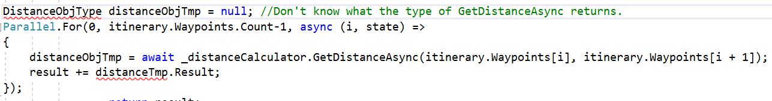

* Function of FindAgent:

1. The function should be an asynchronous function.
2. _dataStore.GetAgent should be awaitable and named as GetAgentAsync.
3. Should use await keyword to handle _dataStore. GetAgentAsync in order to avoid thread blocking.
4. _dataStore. UpdateAgent should be awaitable and named as UpdateAgentAsync.
5. Should use await keyword to handle _dataStore. UpdateAgentAsync in order to avoid thread blocking.
6. UpdateAgentAsync should return boolean value to indicate if the operation succeeded and if it’s not, should throw an exception.