[Title Here, up to 12 Words, on One to Two Lines]
Zachary Mclaurin
Southern New Hampshire University

Summary
This class was the first time I have ever used JUnit testing. After learning and using them I can see how important they are to building software. JUnit tests help to reduce the risk of program errors by easily finding the defects in the code and addressing it. The unit testing approach that I applied to each of the three features were all aligned with the software requirements. For example, here are some of the requirements that we asked for the contact class.
- The contact object shall have a required unique contact ID string that cannot be longer than 10 characters. The contact ID shall not be null and shall not be updatable.
- The contact object shall have a required firstName String field that cannot be longer than 10 characters. The firstName field shall not be null.
- The contact object shall have a required lastName String field that cannot be longer than 10 characters. The lastName field shall not be null.
- The contact object shall have a required phone String field that must be exactly 10 digits. The phone field shall not be null.
- The contact object shall have a required address field that must be no longer than 30 characters. The address field shall not be null.
All of the other features also had similar requirements so the software had to be able to meet those requirements in order to pass the JUnit tests. The quality of my JUnit tests was also good. I know this because all of them had a coverage percentage over the required 80%.

The over all experience that I had with writing JUnit test good and very interesting for me. At first, I did have some trouble with my coverage but once I realized what I was doing wrong and how coverage is calculated it was much easier.
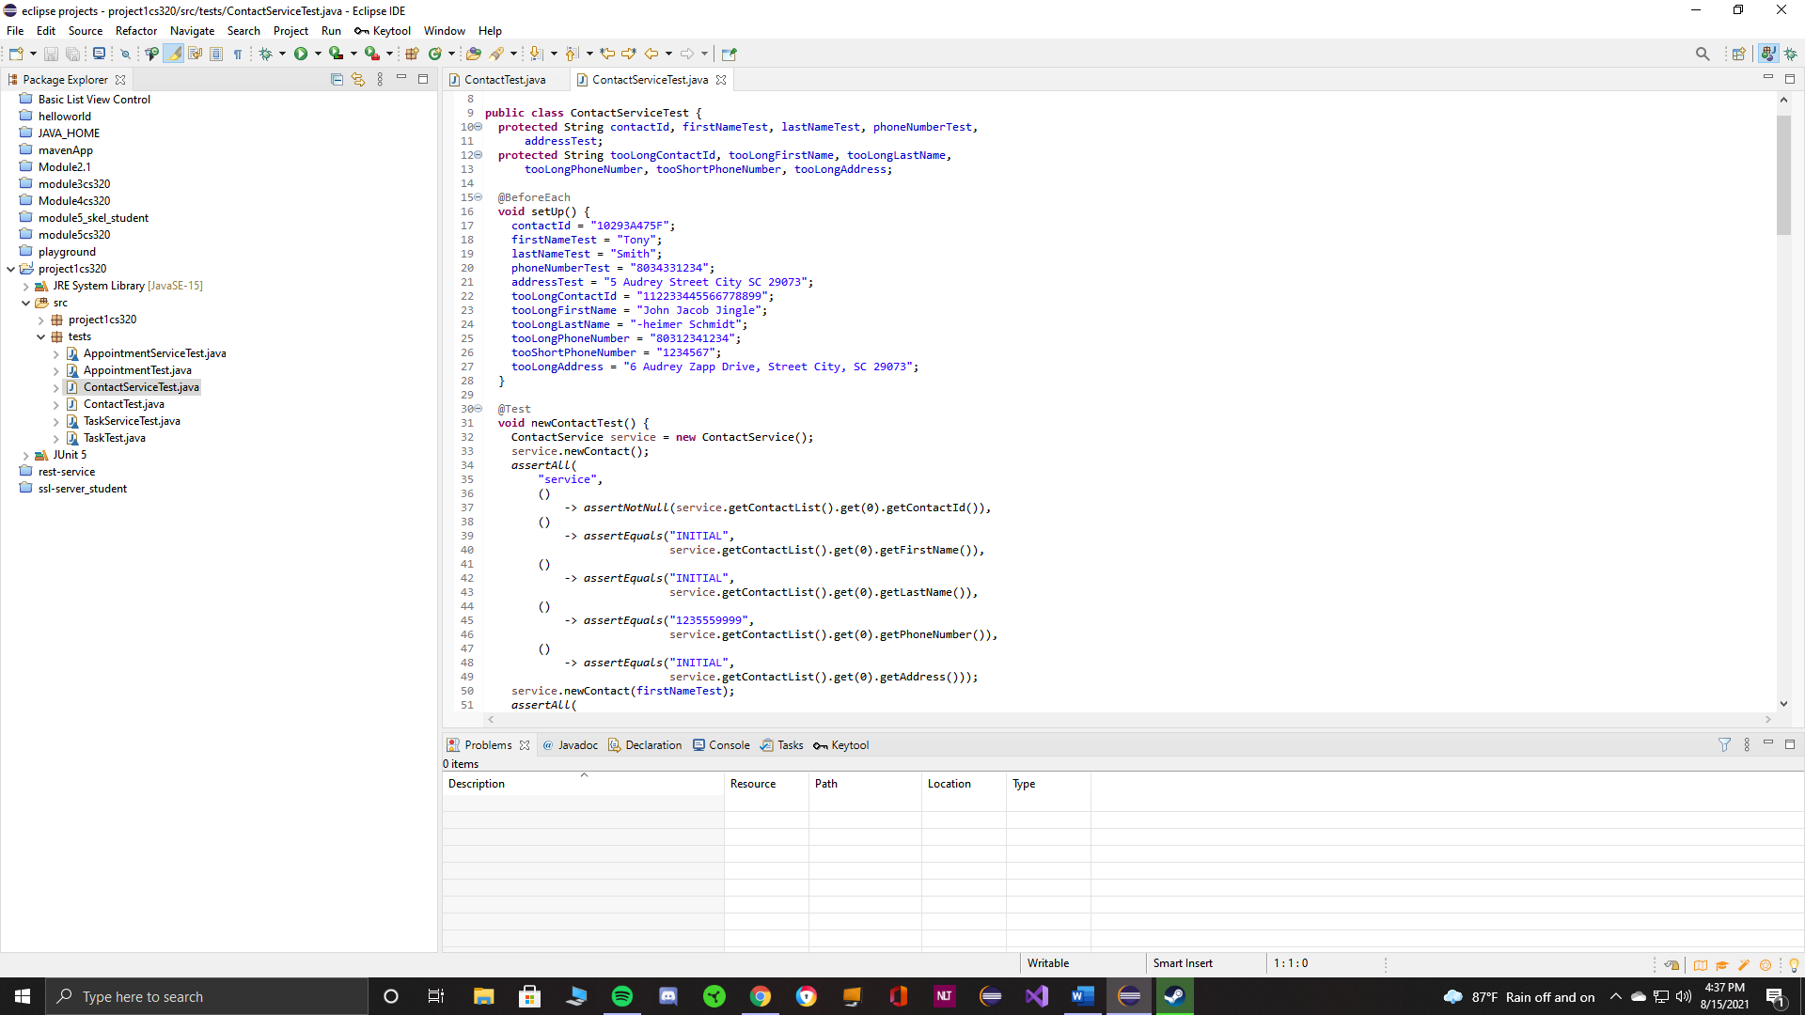
Above is a screenshot of my contactService test witch is checking the parameters for the contactService class. Technically sound and is following the software requirements.

Reflection
One of the software techniques that I uses was static testing. This is currently the technique that I am most familier and comforatable with. Static testing is a way of testing the code with out it executing. Another technique that I used was boundary testing. Basically boundary testing is setting a min and max value that the code needs to stay within. If the these set values are exceded then it will result in an error.
The mindset that I adopted while working on this project was to be effient and thurogh while testing. While completing this project I did learn how important it is that every function and line of code needs to be tested in order to asure that software is working as intended. It is important to appreciate the complexity and interrelationships of the code because each class object has requirements that need to be fulfilled to make sure that the code is working poperly. This requires that the person testing the code to understand what the code is doing or trying to do. When it comes to reviewing your own code, being biased can become a factor. Personally I think the best way is to keep an open mind and understand that we are all still learning. Also to rememeber there is no such thing as bad criticism.
When it come to being a software engineer discipline is extreamly important. You always need to strive to do the best that you can and not cut corners. The software your are making will be used by other people and depending on what it will be used for could put people in harms way both physically and finacially.

