Nashville Housing Analysis

**Introduction**

This analysis focuses on cleaning and visualizing the dataset collected from [GitHub](https://github.com/AlexTheAnalyst/PortfolioProjects/blob/main/Nashville%20Housing%20Data%20for%20Data%20Cleaning.xlsx), which contains roughly 56,000 rows of housing data in Nashville between 1/2/2013 and 12/13/2016. When looking at the dashboards created to be intuitive and informative, I chose to use median over average because the price in this dataset is largely skewed to the left, which made the median a more accurate representation of the central tendency with less influence from the outliers.

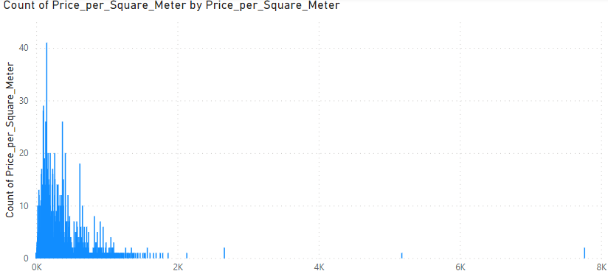

**Figure 1**

*The distribution of price per square meter.*

*Click* [*here*](https://github.com/FamilyGetCool/NashvilleHousing_Portfolio_Project) *for detail.*

**Technical Approach**

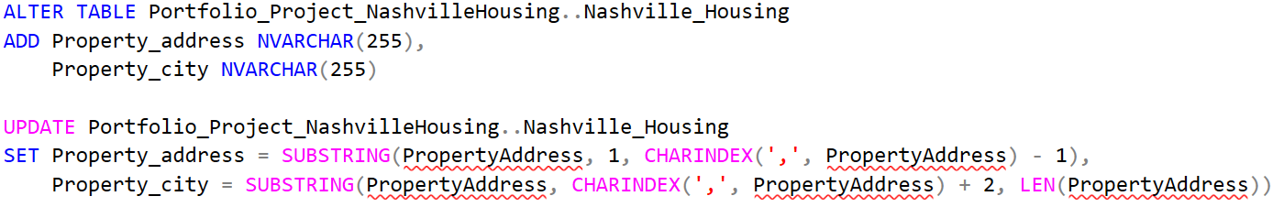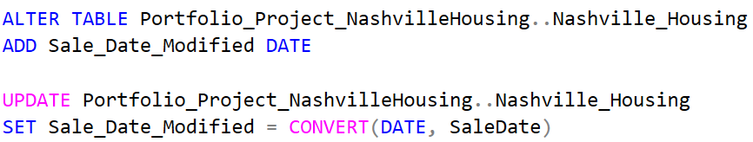Starting with the data cleaning using **MS SQL**, I standardized the sale dates by converting them into date values and separated the address and city from the property address column.

**Figure 3**

*One of the SQL queries that shows the process of slicing the property address. Click* [*here*](https://github.com/FamilyGetCool/NashvilleHousing_Portfolio_Project) *for detail.*

**Figure 2**

*One of the SQL queries that shows the process of datetime value conversion.*

*Click* [*here*](https://github.com/FamilyGetCool/NashvilleHousing_Portfolio_Project) *for detail.*

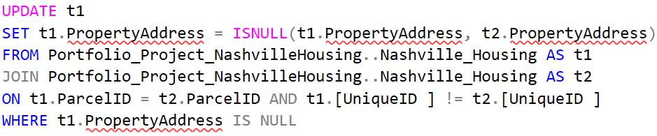Handling the missing property addresses by joining the table with itself and replace null values with the property address that shares identical parcel ID.

**Figure 2**

*Substituting the missing addresses with addresses that have same parcel ID using inner join.*

*Click* [*here*](https://github.com/FamilyGetCool/NashvilleHousing_Portfolio_Project) *for detail.*

Imported the data queried from SQL database and created the following dashboards.

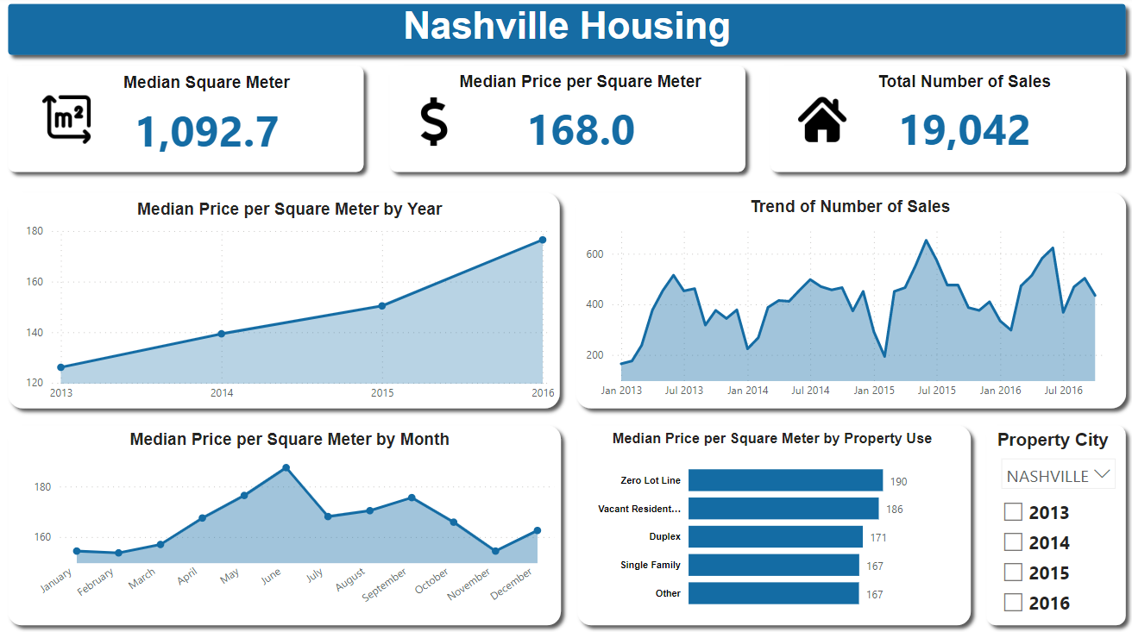 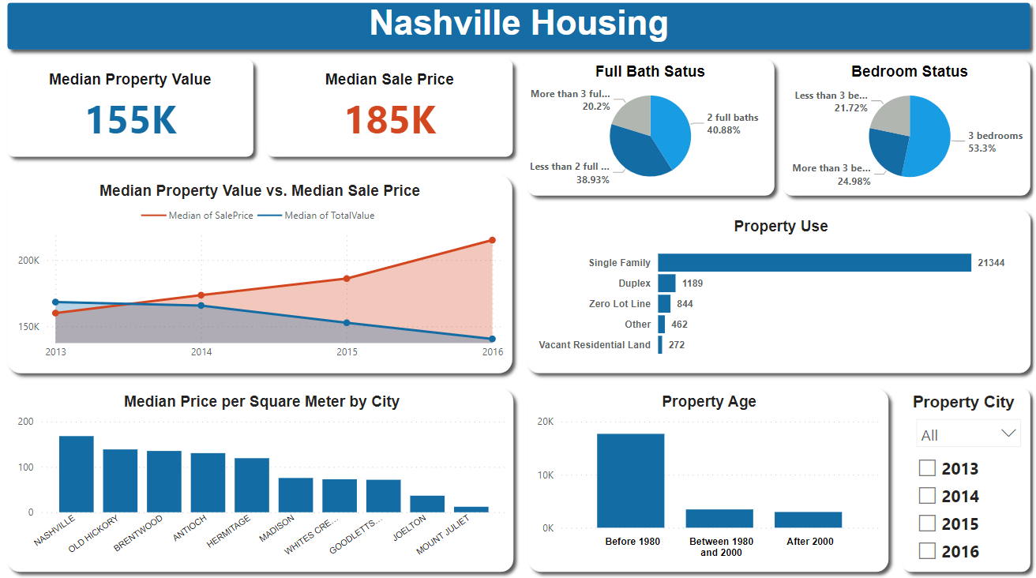

**Figure 3**

*A brief market overview that shows key housing information, such as price, number of sales, trends, etc.*

*Click* [*here*](https://github.com/FamilyGetCool/NashvilleHousing_Portfolio_Project) *for detail.*

**Figure 4**

*This dashboard includes more property details, such as property use and age, property value vs. sale price, etc.*

*Click* [*here*](https://github.com/FamilyGetCool/NashvilleHousing_Portfolio_Project) *for detail.*