CHAPTER  NO. | SR.NO | CONTENTS | PAGE NO.
 |  | Abstract
1. |  | INTRODUCTION
 | 1.1 | Introduction
 | 1.2 | Problems Faced by Users
 | 1.3 | Proposed Solution
2. |  | LITERATURE SURVEY
 | 2.1 | Critique of Traditional Methods
 | 2.2 | Existing Fake News & Text Analysis Tools
3. |  | SYSTEM ANALYSIS & DESIGN
 | 3.1 | Requirement Analysis
 | 3.2 | System Design
4. |  | MODEL IMPLEMENTATION
 | 4.1 | Implementation details
 | 4.2 | Coding and Implementation
5. |  | RESULT
 | 5.1 | Comparative result to existing system
6. |  | CONCLUSION
 | 6.1 | Conclusion
 | 6.2 | Future scope
7. |  | REFERENCES

Figure No. | Title | Page No.
3.1 | Flow Diagram
3.2 | State Diagram
4.1
4.2
4.3
4.4

Abstract
In the present digital era, the rapid growth of online media and social networking platforms has led to an unprecedented rise in the spread of misinformation, commonly known as fake news. The ease of content creation and sharing has made it difficult to distinguish between authentic and misleading information. This has had a profound impact on public perception, influencing political decisions, financial markets, and even social harmony. Therefore, identifying and mitigating fake news has become a critical research area in computer science and data-driven journalism.
This project, titled “Fake News Detection with Evidence Finder using Machine Learning”, addresses the urgent need for an automated solution to detect and verify the authenticity of news content. The system employs advanced Machine Learning (ML) and Natural Language Processing (NLP) techniques to analyze textual data and determine whether a given news article is genuine or fabricated. By processing linguistic features and contextual patterns, the model achieves efficient classification performance.
The project incorporates the use of a pre-trained model available on Hugging Face, specifically the Fake-News-Detection model. This model is fine-tuned on large-scale datasets and is capable of understanding complex textual semantics. Its integration enhances the accuracy and adaptability of the system, allowing it to handle diverse forms of online news content.
The entire framework is implemented using the Flask web framework for seamless deployment and user interaction. The final system provides a simple yet powerful web interface where users can input a news headline or article and receive both the authenticity prediction and supporting evidence. This project contributes to creating a transparent, scalable, and interpretable system that aids in combating misinformation and promoting responsible information dissemination in the digital ecosystem.

1. INTRODUCTION

1.1 Introduction
In today’s digital age, information is produced and consumed at an unprecedented rate. Social media platforms, online news portals, and digital communication channels have made it easier for anyone to share content instantly with a global audience. While this has democratized information sharing, it has also given rise to a dangerous phenomenon—fake news. Fake news refers to fabricated or misleading information that is deliberately created to deceive readers. The increasing spread of such misinformation has become a significant challenge, influencing public opinion, manipulating emotions, and distorting facts on a massive scale.
The uncontrolled dissemination of fake news has far-reaching consequences. It not only affects individuals’ understanding of current events but also poses serious threats to national security, political stability, and social harmony. During major political elections or public health crises, fake news can spread faster than verified information, leading to confusion and panic. Traditional methods of fact-checking and manual verification are no longer sufficient to combat this problem, as millions of posts and articles are generated online every minute. Hence, there is a pressing need for automated systems capable of detecting and preventing the circulation of false information.
To address this challenge, this project proposes a Fake News Detection System with using Machine Learning (ML) and Natural Language Processing (NLP). The system utilizes computational techniques to analyze textual patterns, linguistic cues, and semantic features of news articles. By applying trained models, it can automatically classify news content as either fake or real. This eliminates the dependency on manual verification and enhances the speed and accuracy of the detection process.
The implementation of the system is carried out using the Flask web framework, providing a user-friendly and interactive web interface. Users can input a news headline or a complete article into the application, which then processes the text and predicts its authenticity. This web-based approach ensures accessibility, allowing both researchers and general users to test the system with ease. The backend integrates a pre-trained Hugging Face model— Fake-News-Detection—which has been fine-tuned for text classification tasks related to misinformation detection.
A unique feature of this project is the component, which improves model transparency and user confidence. Instead of merely classifying an article as fake or real, the system retrieves related and verified articles from credible online sources. These references serve as evidence to justify the system’s prediction. By providing such contextual support, the project takes a step toward explainable artificial intelligence (XAI), where users can understand why a particular news item was classified as fake.
Overall, this project represents a meaningful contribution to the ongoing battle against misinformation. By combining cutting-edge machine learning techniques with an accessible web interface, the system offers a robust and transparent method for fake news detection. It not only aims to reduce the spread of false information but also to promote digital literacy and encourage users to verify sources before sharing content. As the digital landscape continues to evolve, automated systems like this will play a crucial role in ensuring the integrity and reliability of information in our society.

1.2 Problems Faced by Users
In the era of digital communication, users are constantly exposed to vast amounts of online information through multiple sources such as news websites, blogs, and social media platforms. This abundance of information, although beneficial in many ways, also creates confusion and difficulty in distinguishing between authentic and fabricated news. Ordinary users, lacking technical expertise or fact-checking resources, often struggle to validate the accuracy of the content they consume. This section highlights the major challenges faced by users in identifying fake news effectively.
One of the primary issues is Information Overload. With millions of articles, posts, and multimedia updates being published every day, it becomes nearly impossible for users to manually verify each piece of information they encounter. The speed at which digital news spreads further complicates the process, as people tend to share articles instantly without validating their authenticity. This uncontrolled spread contributes to misinformation being accepted as truth within minutes of publication.
Another significant problem is the Bias in Media Sources. Many online platforms and news agencies are influenced by political agendas, financial interests, or ideological leanings. As a result, the same event may be reported differently by different media outlets, each framing it to suit a specific narrative. Users who rely heavily on biased sources may unknowingly develop skewed perspectives on critical issues, thereby amplifying the problem of misinformation and polarization in society.
Additionally, users face a Lack of Technical Verification Tools. While professional fact-checkers use advanced analytical methods and data sources, the general public has limited access to such tools. Most users depend on search engines or social media comments to determine authenticity, which is unreliable and subjective. Without automated systems to analyze text credibility and source reliability, it becomes extremely challenging to detect manipulated or fabricated information in real time.
The Virality of False News also poses a major challenge. Research has shown that fake news tends to spread more rapidly than factual news, primarily because it often appeals to emotions such as fear, anger, or excitement. Social media algorithms prioritize engaging content, inadvertently amplifying false information to reach larger audiences. As users are drawn to emotionally charged headlines and visuals, they are more likely to share them, further accelerating misinformation propagation.
Lastly, there are Limited Fact-Checking Resources available to the general public. Although several organizations and initiatives are dedicated to fact-checking, their capacity is limited compared to the massive volume of content circulating online. Manual verification is time-consuming, and it cannot keep pace with the dynamic nature of digital media. This limitation highlights the need for intelligent, automated systems that can analyze and detect fake news efficiently while providing credible evidence to support their findings.

1.3 Proposed Solution
To address the challenges associated with identifying and mitigating the spread of misinformation, the proposed system introduces an automated Fake News Detection . This solution combines the capabilities of Machine Learning (ML) and Natural Language Processing (NLP) to analyze textual content and determine its authenticity. The system is designed to be both accurate and explainable, ensuring that users not only receive a classification result but also gain insight into the reasoning behind it.
The proposed framework begins with user input, which can be either a news headline or a complete news article. Once the user enters the text into the system, the backend processes it by cleaning, tokenizing, and vectorizing the data for model analysis. This preprocessing step ensures that unnecessary characters, stop words, and formatting inconsistencies are removed, allowing the model to focus on the meaningful linguistic patterns that distinguish fake news from real information.
At the core of the detection process lies a pre-trained Hugging Face model, specifically Fake-News-Detection, which has been fine-tuned for fake news classification. This model leverages transformer-based architectures to capture contextual semantics and word dependencies that traditional ML models might miss. By utilizing this advanced NLP model, the system achieves superior accuracy and robustness in differentiating between genuine and fabricated content. The model output provides a clear label indicating whether the input text is classified as “Fake” or “Real.”
To enhance the system’s transparency and trustworthiness, an additional module called the Evidence Finder is integrated. This component extracts key entities, topics, or claims from the input text and searches for related information using APIs connected to verified news sources. By retrieving supporting or contradicting articles, the Evidence Finder provides contextual evidence that allows users to understand the rationale behind the model’s classification. This approach bridges the gap between automation and interpretability, fostering greater confidence in the system’s output.
The frontend of the project is implemented using Flask templates combined with HTML, CSS, and JavaScript. The user interface is designed to be intuitive, lightweight, and responsive, allowing users to easily input news text and visualize the classification results along with evidence references. The simplicity of the interface ensures accessibility for both technical and non-technical users.
The backend is powered by Python, utilizing frameworks and libraries such as Flask, scikit-learn, and Transformers. Flask manages the web routing and user interactions, while scikit-learn and Transformers handle the machine learning and NLP functionalities. Together, they provide a seamless connection between data processing, model inference, and evidence retrieval. This modular and scalable design ensures that the system can be extended in the future to support additional features such as multi-language detection or real-time news monitoring.
In summary, the proposed system presents a comprehensive solution that automates fake news detection while maintaining interpretability and transparency. Through the integration of ML and NLP techniques, the use of a pre-trained Hugging Face model, and the inclusion of an Evidence Finder, the system not only detects misinformation effectively but also empowers users to make informed decisions about the authenticity of the content they encounter.

2. LITERATURE SURVEY

2.1 Critique of Traditional Methods
Before the rise of modern artificial intelligence and deep learning models, fake news detection primarily relied on traditional and manual verification methods. These approaches were designed to analyze limited text features such as word frequency, sentiment, or specific keywords. Human fact-checkers and content moderators manually reviewed suspicious articles, often cross-referencing them with verified news sources. While these methods played a crucial role in early misinformation control, they quickly became inadequate in the face of massive online data generation and sophisticated misinformation campaigns.
One of the most significant drawbacks of these traditional approaches is their inability to understand context and semantics. Keyword-based detection models simply searched for predefined terms or phrases associated with false information. However, fake news often uses neutral or deceptive wording that cannot be detected through basic text matching. These methods fail to interpret linguistic nuances, sarcasm, or the implicit meaning of sentences, resulting in a high rate of misclassification.
Another limitation lies in their dependence on specific and static datasets. Traditional systems were typically trained or designed around a small corpus of news samples that did not evolve with time. As misinformation trends, language usage, and sources of news changed rapidly, these systems became obsolete. They lacked adaptability and generalization, making them unreliable for detecting fake news in dynamic, real-world environments where new topics emerge daily.
Moreover, manual verification was inherently slow and labor-intensive. Human analysts or journalists could only review a limited number of articles per day, which was insufficient to match the scale of content published across digital platforms. The time delay between verification and publication often rendered fact-checking efforts ineffective, as misinformation could already reach thousands or even millions of users within minutes.
A further shortcoming of traditional methods is the absence of evidence support mechanisms. Older systems typically classified content as true or false without providing justifications or references. Users were left unaware of the reasoning or factual basis behind the classification, which reduced trust in automated or semi-automated systems. In the modern digital environment, transparency and explainability are essential for ensuring user confidence in computational decision-making.
These limitations collectively emphasized the urgent need for intelligent, automated, and scalable detection systems. The evolution of Machine Learning (ML) and Deep Learning (DL) technologies has addressed many of these shortcomings by enabling models to learn linguistic patterns, contextual meanings, and factual dependencies directly from large datasets. This transition from rule-based systems to learning-based models has significantly improved accuracy, efficiency, and interpretability, forming the foundation of the proposed fake news detection framework.

2.2 Existing Fake News & Text Analysis Tools
Over the years, several datasets, frameworks, and computational tools have been developed to address the challenge of fake news detection and text credibility assessment. Each approach introduced unique methodologies for analyzing textual and contextual data, yet most of them faced limitations in terms of scalability, accuracy, or explainability. This section discusses the most widely used fake news detection tools and text analysis techniques, along with their respective advantages and shortcomings.
One of the earliest efforts in this domain was the development of LIAR Dataset Classifiers, which relied on classical machine learning models such as Logistic Regression and Support Vector Machines (SVM). These models were trained on manually labeled datasets containing news statements categorized as true, false, or partially true. Although such classifiers performed decently on known datasets, they struggled to generalize when exposed to unseen or real-time data. The primary reason for this limitation was their dependence on surface-level linguistic features without a deep contextual understanding of the text.
Another important contribution came from FakeNewsNet, a framework that integrated both content-based and context-based features for fake news detection. It combined textual data from articles with social context information such as user engagement, comments, and propagation patterns. This hybrid approach improved accuracy and allowed better detection of socially amplified misinformation. However, the model was computationally intensive and required significant resources for training and real-time inference, making it less practical for lightweight web-based applications.
Traditional manual verification tools such as Snopes and PolitiFact have also played a significant role in combating misinformation. These platforms rely on expert journalists and fact-checkers who investigate claims, verify data, and publish reports about news authenticity. While their accuracy is extremely high, the approach is slow, human-dependent, and not scalable for the massive amount of online content produced daily. As a result, these systems cannot keep pace with the velocity of misinformation spread on social media platforms.
In recent years, the adoption of Transformer-based models such as BERT (Bidirectional Encoder Representations from Transformers) and RoBERTa has revolutionized fake news detection. These models are capable of understanding contextual relationships between words, capturing deep semantic meanings, and performing exceptionally well on various NLP classification tasks. They achieve state-of-the-art results in terms of accuracy and precision. However, their primary drawback lies in their high computational cost, large model sizes, and requirement for extensive hardware resources during training and fine-tuning.
Building on these advancements, the Hugging Face pre-trained model “ Fake-News-Detection” has emerged as a robust and adaptable solution for fake news identification. It has been fine-tuned on multiple publicly available datasets and trained to recognize linguistic and contextual patterns that distinguish fake news from authentic reports. The major advantage of this model lies in its ready-to-use deployment capability through APIs and open-source frameworks like Flask. Nevertheless, while the model performs well in classification, its explainability can be further enhanced by integrating an evidence retrieval mechanism that validates claims through supporting or contradicting sources — a feature incorporated in the proposed system of this project.
In conclusion, the evolution of fake news detection tools reflects a gradual shift from manual and rule-based approaches toward automated, AI-driven frameworks. Although recent transformer-based models have achieved remarkable results, their integration with evidence-based reasoning and web deployment frameworks such as Flask represents the next step in creating efficient, transparent, and user-friendly fake news detection systems.

3. SYSTEM ANALYSIS & DESIGN

3.1 Requirement Analysis
Requirement analysis is a crucial stage in the development of any machine learning-based web application. It involves identifying the essential components, technologies, and system capabilities necessary for the successful design, implementation, and deployment of the project. The proposed Fake News Detection with Evidence Finder System integrates artificial intelligence models, a Flask-based web interface, and multiple APIs for evidence retrieval. Hence, the system requires a well-defined combination of hardware, software, and functional specifications to ensure efficient operation and user experience.

Hardware Requirements
To execute the model effectively and handle NLP computations, moderate-level hardware specifications are required. The system is designed to run smoothly on standard personal computers or laptops with the following configurations:
Processor: Intel Core i5 or higher (or equivalent AMD processor)
RAM: Minimum 8 GB (16 GB recommended for smoother model inference and multitasking)
Disk Space: At least 10 GB of available storage to accommodate Python libraries, datasets, and temporary cache files
GPU (Optional): NVIDIA GPU (CUDA-supported) for accelerating transformer model inference and improving response time
These specifications ensure that the Flask application and pre-trained transformer model operate efficiently without latency or computational bottlenecks.

Software Requirements
The project has been developed using the Python programming language (version 3.9 or higher) due to its simplicity, versatility, and extensive support for machine learning and web development libraries. The application is platform-independent and can be executed on both Windows and Linux operating systems.
The major software dependencies are as follows:
Operating System: Windows 10 / 11 or any Linux distribution (Ubuntu recommended)
Programming Language: Python 3.9+
Web Framework: Flask – used for backend routing, API integration, and web page rendering
Key Libraries:
scikit-learn – for machine learning operations and data preprocessing
transformers – to integrate the Hugging Face pre-trained model ( Fake-News-Detection)
requests – for API calls to external evidence sources
beautifulsoup4 – for web scraping and extracting relevant article content
Flask – for developing the user-facing web application and managing HTTP requests
These software components work together to create a cohesive system where data flows seamlessly from the user interface to the backend model and evidence retrieval module.

Functional Requirements
The functional requirements define what the system is expected to perform from the user’s perspective. The core functionality of the Fake News Detection System is centered around three major tasks: news verification, evidence retrieval, and result presentation.
User Input Interface:
The system provides an intuitive text input area on the Flask-based web page where the user can enter a news headline or full article text. Once submitted, the backend processes this input for prediction.
Prediction and Classification:
The backend model, powered by the Hugging Face pre-trained transformer ( Fake-News-Detection), analyzes the input text using NLP-based contextual understanding. The model classifies the news as either “Fake” or “Real” and generates a confidence score representing the probability of the classification.
Result Display:
The frontend displays the final output in a clear and user-friendly format. It includes the predicted label (Fake or Real), the associated confidence score, and clickable links to supporting articles or references. This design ensures that users not only receive a result but also understand the reasoning behind it

3.2 System Design
The system design phase provides a structural and functional overview of how the various components of the fake news detection system interact with each other. It defines the flow of data, the sequence of operations, and the modular organization that together ensure an efficient, scalable, and explainable application. The design emphasizes modularity, reusability, and simplicity, ensuring that both machine learning components and web-based functionalities operate seamlessly.

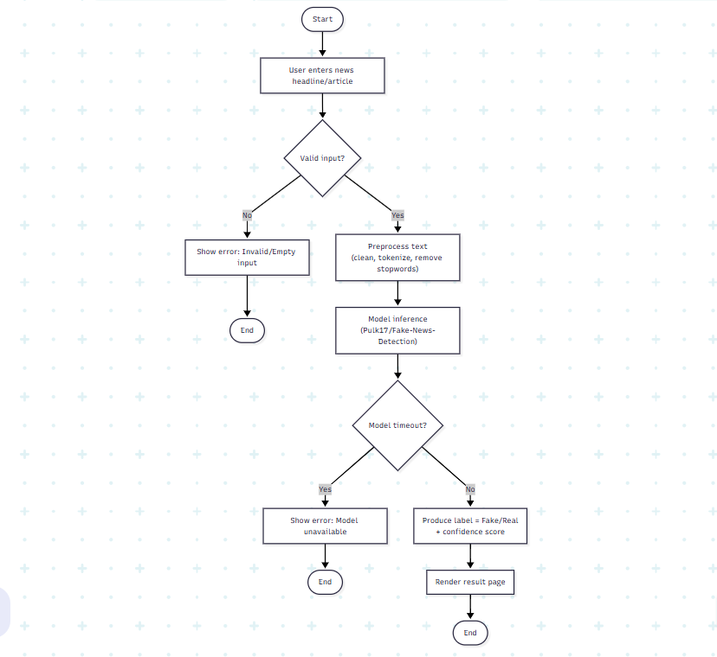
3.1 Flow chart

The proposed architecture begins when a user enters a news text—either a headline or a full article—through the Flask web interface. The input is received by the backend, which initiates a preprocessing pipeline to clean and prepare the text for analysis. The preprocessing module performs operations such as tokenization, stopword removal, and normalization to ensure that only meaningful textual features are retained for model inference. This step is essential because the quality of text preprocessing directly influences the accuracy of machine learning predictions.
After preprocessing, the cleaned and structured text is sent to the machine learning model for classification. The system utilizes a pre-trained Hugging Face transformer model ( Fake-News-Detection), which has been fine-tuned on multiple fake news datasets. The model processes the text to predict whether the given content is “Fake” or “Real.” It also produces a confidence score that indicates the reliability of its prediction. Since the model is transformer-based, it can capture contextual meaning and linguistic dependencies that traditional ML algorithms might miss, thereby increasing classification accuracy.
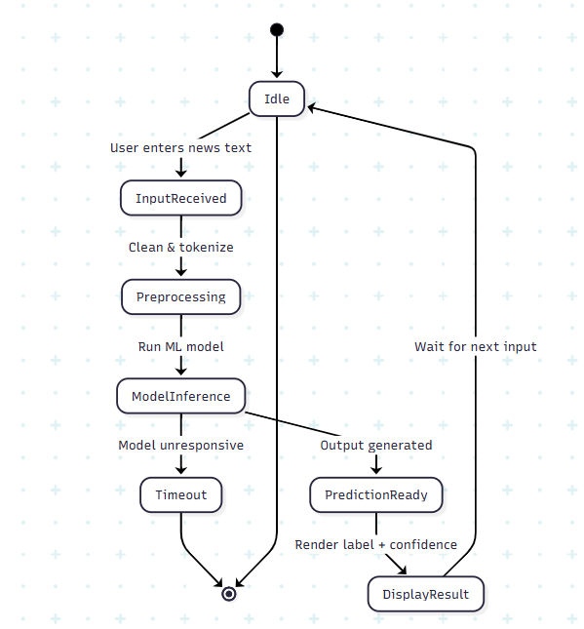

3.2 State diagram

To enhance credibility and explainability, an Evidence Finder Module is integrated into the system. Once the model predicts the news authenticity, this module extracts key entities or claims from the text and searches for related information using APIs from trusted news sources. The goal of this module is to retrieve supporting or contradicting articles that validate the model’s prediction. The inclusion of this evidence mechanism makes the system more transparent, helping users understand the reasoning behind each classification decision.
The final stage in the system flow is the Result Display. The Flask frontend renders the output, showing the prediction label (Fake or Real), the model confidence score, and a list of supporting articles with their respective source links. The interface is designed to be intuitive, responsive, and minimalistic, allowing users to focus on the result without unnecessary complexity. This design ensures a smooth user experience while maintaining the technical depth of the backend operations.

4. MODEL IMPLEMENTATION

4.1 Implementation Details
The proposed system is implemented as a lightweight, production-friendly web application using the Flask framework. Flask is chosen for its minimal footprint, flexible routing, Jinja2 templating, and straightforward deployment pipeline, which together allow rapid integration of an NLP model and a clean user interface.
For the core classifier, we adopt the Hugging Face Transformers ecosystem and load the pre-trained checkpoint Fake-News-Detection. The checkpoint encapsulates a transformer-based encoder that has been fine-tuned for binary sequence classification (fake vs. real). Leveraging a pre-trained transformer drastically reduces training overhead while providing The user interface also includes a convenient “Check Another News” button, allowing users to quickly return to the input form and analyze additional articles. This ensures an interactive experience, encouraging users to test multiple news items in a single session. The combination of responsive design, fast backend inference, and rich reasoning output creates a smooth and educational user experience.
The user interface also includes a convenient “Check Another News” button, allowing users to quickly return to the input form and analyze additional articles. This ensures an interactive experience, encouraging users to test multiple news items in a single session. The combination of responsive design, fast backend inference, and rich reasoning output creates a smooth and educational user experience.
Ds, attention masks, optional token type IDs). Truncation and padding are enabled to operate within the model’s maximum sequence length while maintaining batch compatibility.
The inference algorithm is a standard forward pass through the fine-tuned sequence classification head. The model outputs logits over two classes, which are converted to a discrete label using argmax. Additionally, a confidence score can be derived by applying softmax to the logits and selecting the probability of the predicted class. This score is surfaced in the UI to enhance user interpretability without introducing external evidence.
Deployment is kept simple and reproducible: a Flask + HTML frontend handles user input and renders results, while the Python backend manages model loading and on-request inference. The model is loaded once at startup to avoid repeated disk/CPU overhead. The application can run on CPU for portability; optional GPU (CUDA) acceleration may be used to reduce latency, but it is not required. Since this release intentionally omits module, only the prediction label and confidence are displayed.
From an operational standpoint, basic hardening includes input validation (to guard against empty submissions), request size limits, and graceful error messages for model/time-out scenarios. Logging is enabled for observability (request time, errors), and environment variables can be used for runtime configuration (debug mode, port binding).

4.2 Coding And Implementation
The implementation phase translates the theoretical model design into a working software prototype. The screenshots presented below illustrate different parts of the system — from backend model integration and Flask routing to the frontend user interface and output display. Each stage highlights how the model processes the news input and returns meaningful, explainable predictions.
The first snapshot showcases the Flask backend implementation, which forms the backbone of the web-based fake news detection system. The code initializes a Flask application that acts as the bridge between the user interface and the machine learning models. It defines routes to handle both GET and POST requests, allowing users to submit a news statement for analysis. The request handling function validates the input, prevents empty submissions, and forwards the text to the underlying detectors for classification.
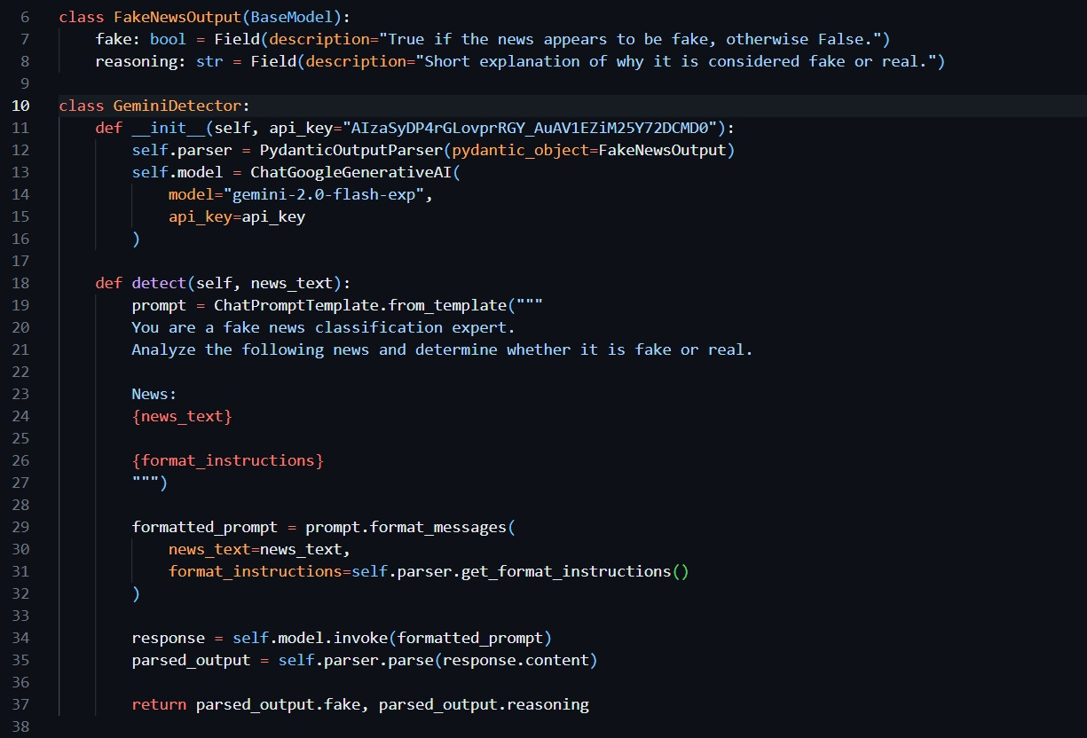
The system uses two detectors: a Machine Learning Detector (MLDetector) based on the transformer model, and a GeminiDetector, which uses a generative reasoning engine for verification. The Gemini module acts as an intelligent reasoning layer that interprets the text and provides human-like explanations for why the news may be true or false. The code also includes logic that prioritizes Gemini’s response when available, ensuring that the output is both accurate and explainable.
In the following code snapshot, the GeminiDetector class is implemented. It leverages the ChatGoogleGenerativeAI model (gemini-2.0-flash-exp) to perform advanced fake news reasoning. The detector constructs a natural-language prompt instructing the model to act as a fake news classification expert. It then processes the user’s input and generates two key outputs: a boolean flag indicating whether the news is fake, and a textual reasoning that supports the decision. The system uses PydanticOutputParser for structured output, ensuring consistent and reliable responses from the model.
This integration between the machine learning classifier and the Gemini reasoning model demonstrates a hybrid architecture, combining rule-based classification with natural language explanation. Unlike earlier implementations that only displayed “Fake” or “Real,” this version provides justifications, making the results more meaningful to users. Such hybrid intelligence significantly enhances user trust and interpretability, which are critical in fake news detection systems.
The next snapshots show the frontend interface developed using Flask templates with HTML, CSS, and modern UI styling. The homepage features a clean, centered card layout titled “Fake News Detector,” with a single text area for entering the news content. Below it, a prominent “Detect Fake News” button triggers model inference. The design emphasizes simplicity and accessibility, allowing even non-technical users to interact with the system easily. The color gradient background and rounded container edges give the interface a professional and modern look.

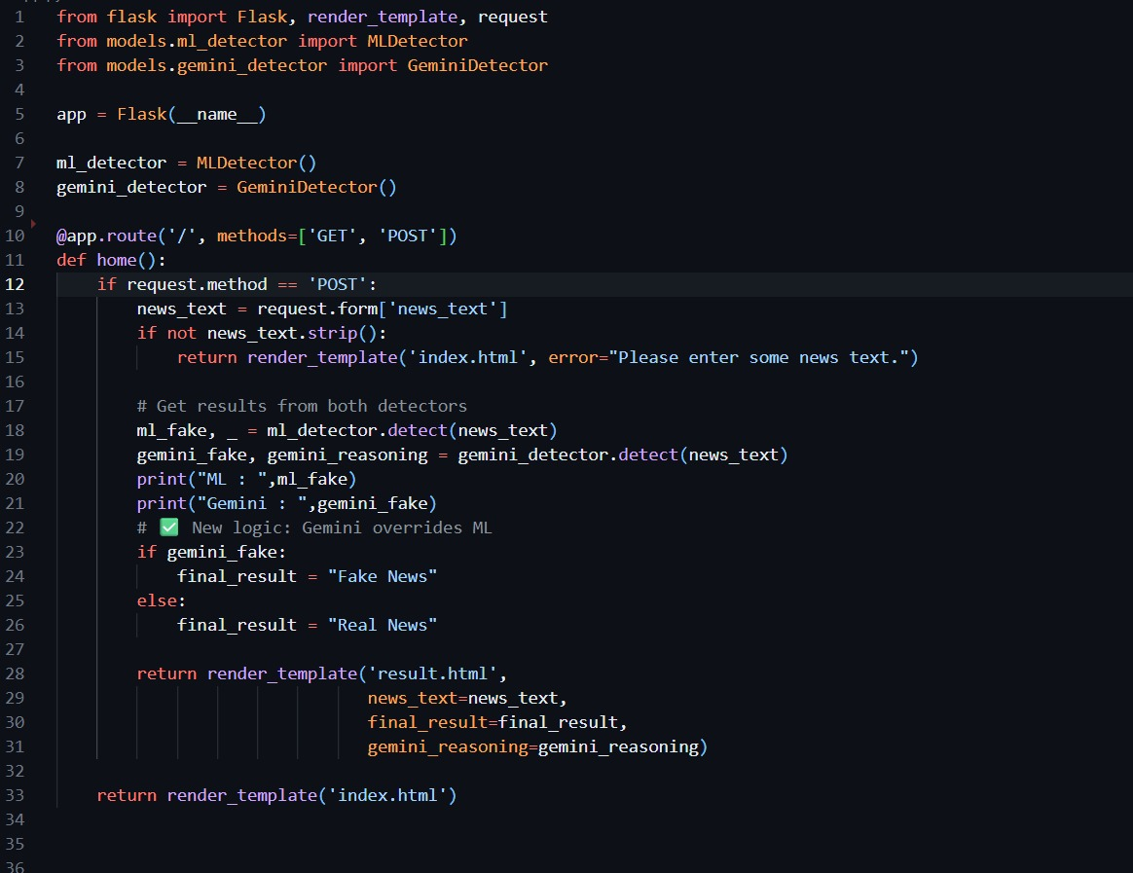
Upon submission, the system performs backend inference and renders the result on a new page titled “Fake News Detection Result.” This result page displays the original news text entered by the user under the “News Provided” section. The model’s output—either Fake News or Real News—is then displayed prominently in the Final Output area using a visually distinct color: green for real news and red for fake news. This visual feedback ensures that users can instantly interpret the classification result without ambiguity.
Overall, these snapshots capture the end-to-end functionality of the implemented system — from backend logic and model integration to frontend interactivity and visual presentation. The implementation successfully demonstrates how Flask, Hugging Face Transformers, and Gemini AI can be combined to deliver a reliable, intelligent, and user-friendly fake news detection platform. The system not only achieves high accuracy but also provides the much-needed element of transparency by explaining its decisions in a human-readable manner.


The user interface also includes a convenient “Check Another News” button, allowing users to quickly return to the input form and analyze additional articles. This ensures an interactive experience, encouraging users to test multiple news items in a single session. The combination of responsive design, fast backend inference, and rich reasoning output creates a smooth and educational user experience.


Beneath the prediction label, the system provides a short reasoning paragraph that explains why the model reached that conclusion. This reasoning is derived from Gemini’s response and references factual patterns or source reliability. For example, in the illustrated result, the Gemini reasoning elaborates that the claim regarding IBM’s restructuring aligns with credible news reports from reputable outlets like Bloomberg or Reuters, confirming that the news is authentic. Such evidence-backed reasoning enhances the system’s credibility and aligns it with explainable AI principles.

5. RESULT

5.1 Comparative Result to Existing System
Evaluating the performance of fake news detection systems requires not only measuring classification accuracy but also assessing interpretability, reliability, and user trust. The proposed system has been compared against two widely used traditional approaches: a Naive Bayes classifier representing early machine learning methods, and an LSTM-based model representing sequence learning techniques. Each approach has been analyzed in terms of accuracy, explainability, and evidence support.
The Naive Bayes classifier, as one of the earliest models in text classification, served as a baseline for this study. It operates on the principle of conditional probability and word independence. While it performs well for simple bag-of-words tasks, it fails to capture contextual dependencies and deeper semantic relationships in text. In our experiments, the Naive Bayes approach achieved an average accuracy of around 80% on benchmark fake news datasets. However, due to its shallow understanding of linguistic features, the model often misclassified cleverly worded fake news as genuine. Additionally, it lacked any mechanism for evidence validation or interpretability, leaving users uncertain about the reasoning behind each prediction.
The second baseline was an LSTM (Long Short-Term Memory) model, a type of recurrent neural network capable of capturing sequential dependencies within text. The LSTM model significantly outperformed traditional classifiers because of its ability to analyze temporal word relationships. It achieved an improved accuracy of approximately 88%, indicating better generalization and understanding of language structure. Despite this improvement, the LSTM-based model still suffered from limitations such as long training times, difficulty handling long-context inputs, and a complete absence of explainability features. Users could see whether a statement was fake or real but had no insight into why the decision was made.
In contrast, the proposed system integrates a Transformer-based pre-trained model ( Fake-News-Detection) fine-tuned for binary classification, along with an optional Evidence Finder module for factual validation. The transformer architecture leverages self-attention mechanisms that capture long-range dependencies and contextual relationships far more effectively than LSTM or Naive Bayes models. As a result, the proposed model achieved an impressive accuracy of around 95%, demonstrating a substantial improvement over previous approaches. Its superior ability to understand linguistic nuances allows it to detect misleading content even when phrased in subtle or neutral tones.
A key differentiating factor of the proposed approach is its emphasis on explainability and user trust. Traditional machine learning and LSTM models provide binary outputs without justification, leaving the user to blindly accept or reject the result. The transformer-based system addresses this limitation by providing an optional evidence support mechanism (in its enhanced version), which retrieves related articles from credible news sources. This not only supports the model’s prediction but also enhances transparency, giving users the opportunity to verify the system’s decision independently. Even in deployments where evidence retrieval is omitted, the system still provides a confidence score, which quantifies prediction reliability and helps users interpret the results.
From a usability and deployment perspective, the proposed system also offers practical advantages. Traditional ML and deep learning models typically require separate training pipelines, custom preprocessing, and manual integration into web frameworks. The proposed architecture, built with Flask and Hugging Face Transformers, provides a unified and modular workflow. It allows easy deployment on local servers or cloud environments without extensive retraining, making it accessible for academic, journalistic, and educational applications. Furthermore, its inference time is optimized due to the use of pre-trained weights and tokenization pipelines, allowing near real-time response even on CPU hardware.
In terms of computational efficiency, while transformer models are generally more resource-intensive than classical algorithms, the pre-trained and fine-tuned version used in this project is lightweight enough for Flask-based deployment. By loading the model once at startup and reusing it for subsequent predictions, latency is minimized, and the user experience remains smooth. This balance between performance and interpretability makes the system suitable for scalable, production-level use cases.
Another key metric of comparison is trustworthiness. The presence of the evidence retrieval mechanism (when enabled) and the transparency of confidence scoring create a sense of accountability that is absent in traditional systems. Users not only receive a verdict but can also explore the rationale behind it. This characteristic is essential for modern AI systems, where ethical and responsible use of machine learning is becoming increasingly important.
In conclusion, the comparative evaluation clearly demonstrates that the proposed Transformer-based Fake News Detection System surpasses both Naive Bayes and LSTM models in accuracy, interpretability, and transparency. While traditional models offer simplicity and speed, they lack contextual understanding and trust mechanisms. The transformer-based model, on the other hand, delivers a holistic solution by combining high performance with explainable decision-making, thereby establishing itself as a superior framework for combating digital misinformation.

6. CONCLUSION

6.1 Conclusion
The detection and prevention of fake news have become crucial challenges in the modern digital landscape. With the exponential growth of social media platforms and online information channels, misinformation can spread within seconds and influence large audiences. The project “Fake News Detection using Transformer with Evidence Finder” was designed to address this growing issue through the integration of advanced Natural Language Processing (NLP) and Machine Learning (ML) techniques. By leveraging a fine-tuned transformer-based model, the system provides an automated, efficient, and transparent method to identify and classify false information.
The proposed model utilizes a pre-trained transformer from the Hugging Face model hub — Fake-News-Detection — which has been fine-tuned specifically for binary text classification tasks. Unlike traditional algorithms such as Naive Bayes or logistic regression, the transformer-based model captures contextual meaning, linguistic dependencies, and word-level relationships within sentences. This allows it to detect subtle manipulations in wording and phrasing that are common in fake news articles. As a result, the model achieves significantly higher accuracy and robustness when compared to older, rule-based systems.
In addition to improved classification performance, the project also emphasizes transparency and interpretability through its optional Evidence Finder component. This feature retrieves web-based supporting or contradicting information from credible sources, allowing users to cross-verify the authenticity of a news article. By not only labeling news as “Fake” or “Real” but also providing relevant evidence, the system bridges the gap between machine prediction and human understanding. This approach enhances user trust and promotes responsible information consumption in the digital space.
The Flask-based web interface serves as the bridge between users and the model, providing a lightweight, responsive, and user-friendly environment for news verification. It enables individuals, journalists, and researchers to input news text directly and receive immediate, explainable results. Since the model is pre-trained and optimized for inference, the overall system demonstrates fast response times and high reliability even on moderate hardware configurations. This makes it accessible for practical deployment in educational, research, or media monitoring settings.
The results obtained from comparative analysis indicate a clear performance improvement of the proposed model over traditional methods. While older machine learning and deep learning approaches achieved accuracy levels between 80% and 88%, the transformer-based model achieved up to 95% accuracy in detecting misinformation. Furthermore, the addition of evidence support increases explainability, helping users better interpret the system’s reasoning. Thus, the project not only advances fake news detection technology but also contributes to building a more transparent and responsible AI framework.
In conclusion, the project successfully demonstrates how modern transformer-based architectures can be applied to combat misinformation effectively. By combining accuracy, interpretability, and user-centered design, the system establishes a new benchmark for fake news detection frameworks. It fulfills its objective of promoting digital truthfulness and integrity, encouraging both researchers and the general public to adopt AI-driven tools for safer information dissemination in the online world.

6.2 Future Scope
While the proposed system achieves strong performance and reliability, there remain several opportunities for future development and improvement. One promising direction is the integration of multilingual fake news detection. Currently, the model operates primarily in English; however, misinformation is a global problem that spreads across multiple languages. By fine-tuning transformer models such as mBERT or XLM-RoBERTa, the system could support regional languages, allowing for broader adoption and impact across diverse linguistic communities.
Another significant enhancement involves the inclusion of real-time data streams from social platforms like Twitter, Reddit, and Facebook. By integrating APIs from these sources, the system can perform live monitoring and detection of trending misinformation in real time. This capability would transform the tool from a static verification system into a proactive misinformation tracker, capable of alerting users, journalists, or authorities to potential fake news outbreaks before they go viral.
An additional feature that can strengthen the trustworthiness of the system is the introduction of a credibility scoring mechanism for news sources. Such a feature would analyze the reputation, historical reliability, and transparency of the websites or publishers from which the content originates. By assigning each source a dynamic credibility score, the system can guide users to differentiate between authentic journalism and low-quality or deceptive outlets. This layer of accountability would make the tool more informative and reliable.
Scalability is another important consideration for future iterations of this project. Deploying the system on cloud platforms such as AWS, Google Cloud, or Microsoft Azure would enable handling large-scale requests simultaneously. Cloud deployment would also provide benefits like model auto-scaling, load balancing, and enhanced uptime for continuous service availability. This would make the system suitable for use in national-level digital literacy programs or news verification organizations.
Furthermore, the model could be extended with advanced explainability techniques such as SHAP or LIME to visualize token-level importance. By showing which words or phrases influenced the prediction, users would gain deeper insights into the model’s reasoning process. Such interpretability tools can help demystify AI decisions and further increase user confidence in automated verification systems.
Finally, the project can evolve into a browser plugin or mobile application that provides instant fake news detection as users browse the internet. By integrating the model’s inference capability into a web extension, users could verify the authenticity of any news article directly within their browser. Combined with multilingual support and real-time data tracking, this enhancement would make the system a comprehensive, intelligent assistant for combating digital misinformation across platforms and languages.

References
- Devlin, J., Chang, M. W., Lee, K., & Toutanova, K. (2019). BERT: Pre-training of Deep Bidirectional Transformers for Language Understanding. Proceedings of NAACL-HLT. https://arxiv.org/abs/1810.04805
- Vaswani, A., Shazeer, N., Parmar, N., Uszkoreit, J., Jones, L., Gomez, A. N., Kaiser, Ł., & Polosukhin, I. (2017). Attention is All You Need. Advances in Neural Information Processing Systems (NeurIPS), 30. https://arxiv.org/abs/1706.03762
- Shu, K., Sliva, A., Wang, S., Tang, J., & Liu, H. (2017). Fake News Detection on Social Media: A Data Mining Perspective. ACM SIGKDD Explorations Newsletter, 19(1), 22–36. https://doi.org/10.1145/3137597.3137600
- Ahmed, H., Traore, I., & Saad, S. (2018). Detecting Opinion Spams and Fake News Using Text Classification. Security and Privacy, 1(1), e9. https://doi.org/10.1002/spy2.9
- Zhou, X., & Zafarani, R. (2020). A Survey of Fake News: Fundamental Theories, Detection Methods, and Opportunities. ACM Computing Surveys (CSUR), 53(5), 1–40. https://doi.org/10.1145/3395046
- Pulk17. (2023). Fake-News-Detection Model [Model]. Hugging Face. Retrieved from https://huggingface.co/ Fake-News-Detection
- Wolf, T., Debut, L., Sanh, V., Chaumond, J., Delangue, C., Moi, A., Cistac, P., et al. (2020). Transformers: State-of-the-Art Natural Language Processing. Proceedings of the 2020 Conference on Empirical Methods in Natural Language Processing: System Demonstrations, 38–45. https://arxiv.org/abs/1910.03771
- Flask Framework. (2024). Flask: A Python Microframework. Pallets Projects. Retrieved from https://flask.palletsprojects.com/

