Logo

**User**

**MANUAL**

*estimAADTion*

*An AADT Estimation Software*

**Clemson University**

July 2018

**Revision Sheet**

|  |  |  |
| --- | --- | --- |
| **Release No.** | **Date** | **Revision Description** |
| Rev. 0 |  |  |
| Rev. 1 |  |  |
| Rev. 2 |  |  |
| Rev. 3 |  |  |
|  |  |  |
|  |  |  |
|  |  |  |

**USER'S MANUAL**

**TABLE OF CONTENTS**

Page #

A. GENERAL INFORMATION A-1

1.1 System Overview A-1

1.2 Software and Hardware Requirements A-1

1.3 Acronyms and Abbreviations A-1

B. SYSTEM SUMMARY B-1

2.1 System Configuration B-1

2.2 User Interface B-1

C. PREPARING THE INPUT FILES C-1

3.1 Short-term Count File C-1

3.2 Functional Classification Factor File C-1

3.3 Model Parameter File C-1

3.4 ATR List File C-1

D. AADT ESTIMATION D-1

4.1 Start Menu D-1

4.2 Runtime Menu D-1

4.3 Output System D-1

E. ATR DATA COLLECTION E-1

5.1 Start Menu E-1

5.2 Runtime Menu E-1

5.3 Output System E-1

A. Appendix F-1

B. Appendix F-2

**1.0 GENERAL INFORMATION**

# GENERAL INFORMATION

## 1.1 Software Overview

estimAADTion is a software designed for SCDOT to estimate AADT from short-term counts. SCDOT collects short-term counts from different locations in the state. This software has been designed to use these short-term counts to estimate the AADT of those locations. The software uses an artificial intelligence based model in the background to estimate the AADT by utilizing data from permanent count stations (ATRs). SCDOT has 166 permanent count stations that collect hourly volume data from roads of different functional classes. The software also provides the capability of collecting the permanent count station data from the SCDOT website in an automated way for ease of use. The software has been implemented using C# in Visual Studio.

## 1.2 Software and Hardware Requirements

### 1.2.1 Hardware Requirements

The software can run on any basic hardware configuration. The minimum requirements are given below:

Processor: 1 GHz

RAM: 512 MB

Disk space (minimum): 5 GB

### 1.2.2 AADT Software Installation

The software will be provided to the users in a flash drive. If you enter the flash drive, you will see a zip file called “AADT.zip”. Copy the zip file to any location in your local machine and unzip it. After unzipping, you will find a folder called “AADT”. Enter the AADT folder, and you will find the software as “AADT.exe”. If you double click this file, the software will launch.

### 1.2.3 Software Requirements

In terms of the software, the first requirement is that the computer must have some version of the Windows operating system (Vista, 7, 8, or 10) to run the software. Moreover, the AADT software has some pre-requisite softwares that need to be installed before use. The following subsection below will provide the direction on how to install the pre-requisite softwares to run the AADT software.

### 1.2.3.1 .NET Framework

The installation guide for .NET framework can be found in the following link. The link contains the download link to the required package.

<https://docs.microsoft.com/en-us/dotnet/framework/install/>

At first, the user will select the version of Windows OS in the user’s computer. Below is the screenshot.

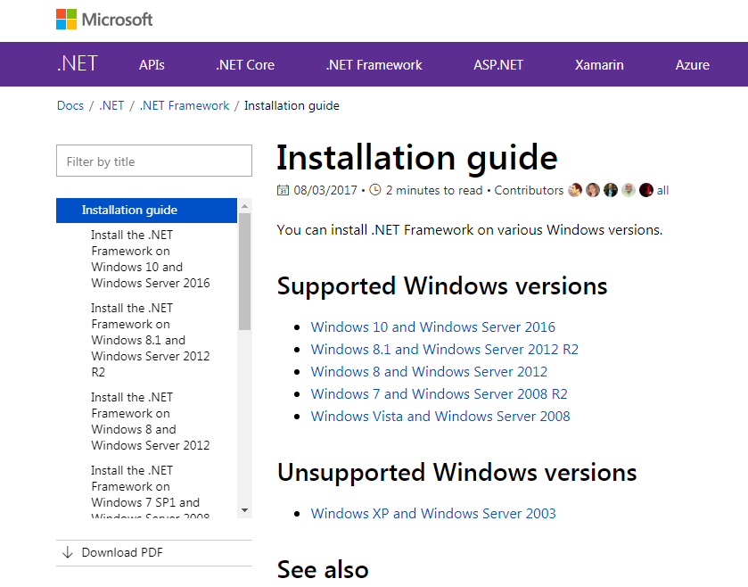

Then, the user will install the version 4.x (where x can be any number). Below is the screenshot of the screen the user will see if the user selects Windows 7. The user will click on “Download .NET Framework 4.7.2”.

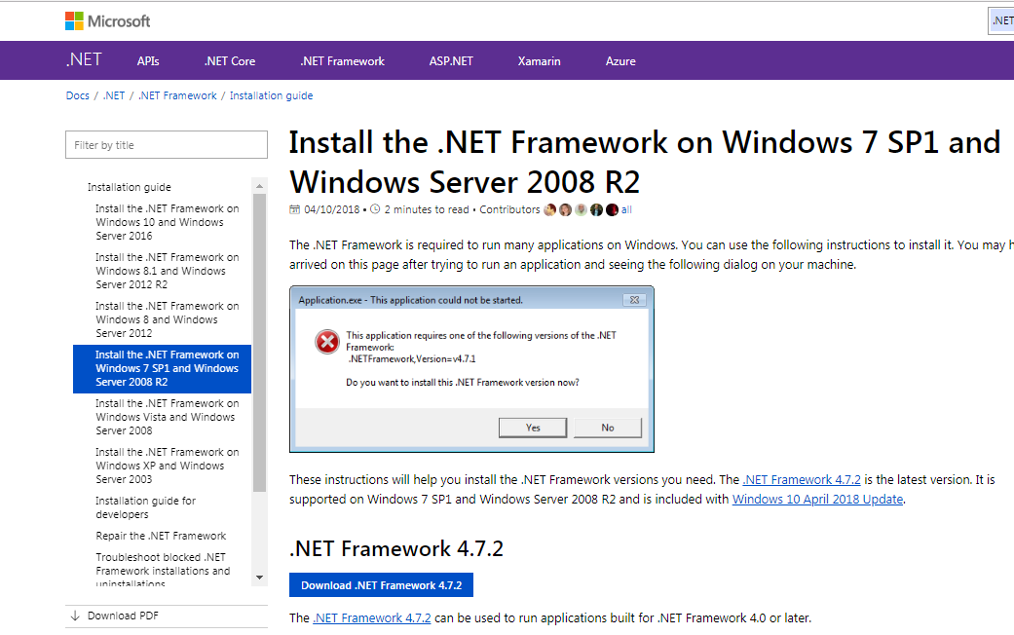

After downloading the installer, the user can install the software using the installer file. The installer will guide the user on how to install the software.

### 1.2.3.2 Web-browser and Webdriver

Step 1- For the ATR data collection, the software needs to have a web-browser and a webdriver installed on the machine. There are three options for the users.

1. Install Google Chrome and Chromedriver
2. Install Mozilla Firefox
3. Use Internet Explorer and IEdriver

Below are the installation guides for web-browsers. The links include the download links to the browsers.

Google Chrome- <https://support.google.com/chrome/answer/95346?co=GENIE.Platform=Desktop&hl=en>

Mozilla Firefox- <https://support.mozilla.org/en-US/kb/how-download-and-install-firefox-windows>

Internet Explorer- Already installed in any Windows machine

It is recommended to install the latest version of any browser that the user chooses to install. If the user chooses to use Internet Explorer, then the user is encouraged to update the Windows Explorer to the latest version.

Step 2- After installing the web-browser, the user will need to download the corresponding webdriver. Below are the download links to chromedriver and IEdriver.

Chromedriver- <http://chromedriver.chromium.org/downloads>

Firefoxdriver- The Firefox driver does not need to be installed, it is part of the Python package “Selenium” that we will install later.

IEdriver- <http://selenium-release.storage.googleapis.com/index.html>

The chromedriver and IEdriver comes in a zip file. If the user unzips the file, then the user will find an executable (*.exe) file. The user has to place this file in the C drive. Therefore, if the user chooses chromedriver, then the path to chromedriver.exe file will be “C:\chromedriver.exe”.

When the user chooses the script during ATR data collection, the user will need to select the script that corresponds to the user’s choice. For example, if the user chooses Internet Explorer as the preferred option, then the user will choose “SC_hv_ie.py”. If the user chooses Mozilla Firefox, then the user will choose “SC_hv_mf.py”. If it is neither and the choice is Google Chrome, then the user will choose “SC_hv.py”.

### 1.2.3.3 Python and Associated Packages

Step 1- At first, we need to install Python. The link to the installation guide for Python is given below.

<https://www.howtogeek.com/197947/how-to-install-python-on-windows/>

For our software, we will install Python 3. If you scroll down after opening the link, you will find a section titled “How to install Python 3”. Just follow the instructions and the installation will work. Below is a screenshot of the section.

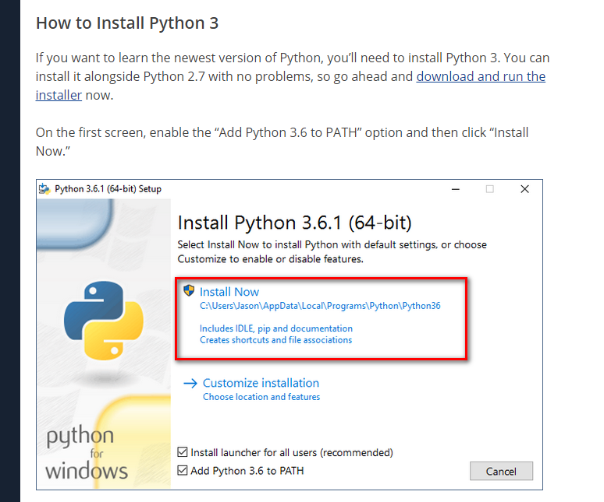

In terms of version, you can install any Python 3 version you like, but it is recommended to install the latest version of Python 3.

Step 2- The packages that need to be installed are- Selenium, and Pandas. These packages can only be installed after you have successfully installed Python in your machine. The steps are given below.

1. Go to start menu and search for “cmd”. You will find “cmd.exe”. Click on it.
2. After “cmd.exe” opens, type “pip install selenium” or “pip install pandas” based on whichever package you are installing. Then hit enter. This will automatically install the package in the background.
3. After installation is complete, you will see a message “success” at the bottom. That means that the packages installed successfully. Now you can exit cmd.

Below is a screenshot from the installation.

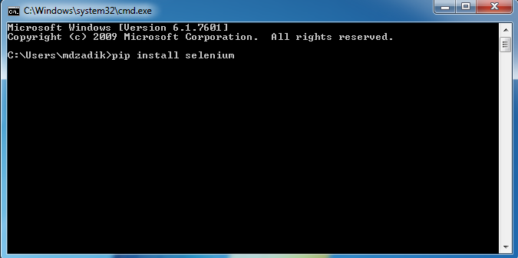

## 1.3 Acronyms and Abbreviations

List of the acronyms and abbreviations used in this document and the meaning of each.

**2.0 SYSTEM SUMMARY**

# SYSTEM SUMMARY

In this section, we will describe the software with further details.

## 2.1 System Configuration

The software is capable of performing two functions. The two functions are AADT estimation and ATR Data Collection.

### 2.1.1 AADT Estimation

This is the primary function of the software. The user needs to provide several inputs to the software. The inputs are-

1. List of ATRs and their functional classes
2. Short-term counts of any year
3. ATR Data of that year
4. Functional classification factors
5. Model Parameters

The software uses a machine learning based predictive model estimate the AADT from short-term counts. The machine-learning method used in the software is Support Vector Regression (SVR). The SVR model has been implemented using the LIBSVM library, which is an open source machine-learning library for implementing the SVR method. The SVR model uses the ATR data of that year to train the model and calculate the model parameters. After that, the model estimates the AADT from the short-term counts.

The list of ATRs and their functional class information are used to form three major groups; they are interstate, arterial and collector. The ATR data is segmented into three separate groups pertaining to these three groups. If the ATR data has been used previously, then the model uses the parameters input by the user. If the ATR data is new, then the software will create the models from scratch, recalculate the parameters and save them. The software creates three separate models for three major groups. After that, the short-term counts data is input to the appropriate model based on their functional classes to estimate the AADT of that location. The functional classification factors are used to calculate the AADT from seasonal and axle factors. This is the traditional factor method of AADT estimation. The output file provides both AADT values for the user.

### 2.1.2 ATR Data Collection

In order to perform AADT estimation, the user needs to input the ATR data (hourly volume data from all permanent count stations) to the model. The software provides the capability of ATR data collection also. For this function, the user also needs to provide several inputs to the software. The inputs are-

1. List of ATRs
2. Data Collection location
3. Year

A script has been developed using Python programming language that automatically collects all the ATR data from the SCDOT website. The script will be provided to the users with the software package. The script collects the hourly volumes for each ATR in a separate text file, which can be directly used by the AADT estimation part of the software. The user also needs to specify the year of data collection and the folder where all the data will be saved. This process is time consuming and it takes approximately 10-14 hours depending on data availability and connectivity. However, this will be done once per year, after downloading the data the user can reuse the data for the rest of the year.

## 2.2 User Interface

The user interface of the software has three separate tabs for different types of inputs. The three tabs are described below.

### 2.2.1 AADT Estimation

The first tab is designed for inputs related to the AADT estimation. Below is a screenshot of the first tab.

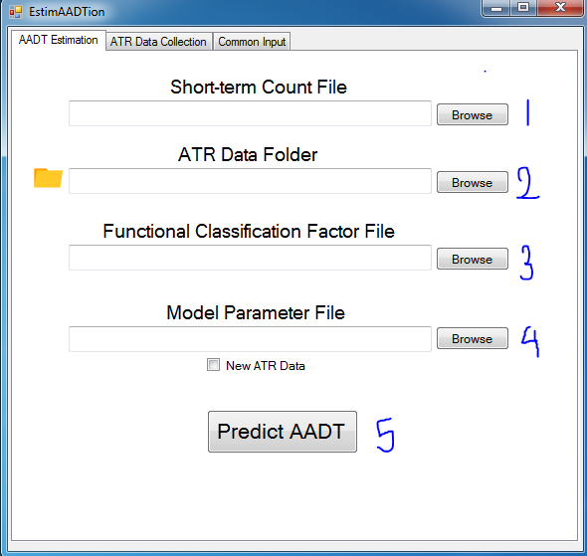

Input 1- The first input is the location to the short-term count file. The browse button can be used to browse to the location of the file. The file has to be in csv format. Specific instructions on how to construct the csv file will be described in subsequent sections. The user also has the option of copying and pasting the location of the file in the box.

Input 2- The second input is the location to the ATR data folder. The browse button can be used to browse to the location of the ATR data folder. The user also has the option of copying and pasting the location of the folder in the box.

Input 3- The third input is the location to the functional classification factor file. The browse button can be used to browse to the location of the file. The file has to be in csv format. Specific instructions on how to construct the csv file will be described in subsequent sections. The user also has the option of copying and pasting the location of the file in the box.

Input 4- The fourth input is the location to the model parameter file. The browse button can be used to browse to the location of the file. The user also has the option of copying and pasting the location of the file in the box. This file is also in csv format, but the user will not create this file. Instead, the software creates this file if we check the box “New ATR Data”. The software will take a long time to run. After running once with the checked box, the software will write the parameters to the csv file specified by the user. As such, the user gets an updated model parameter each time there is a new data. The next time the user wants to use the software with the same ATR data, the user can just select this file and uncheck the box. The software will run very fast and output the result.

Input 5- After providing all the input, the user can use the “Predict AADT” at the bottom and the software will run the program in the background and provide the output.

### 2.2.2 ATR Data Collection Input

The second tab is designed for inputs related to ATR data collection. Below is a screenshot of the second tab.

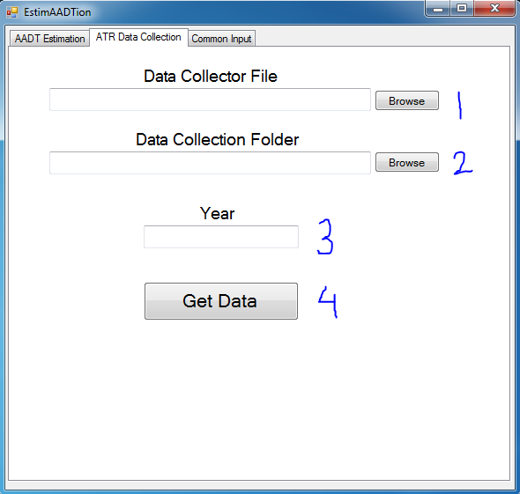

Input 1- The first input is the location of data collector script. The browse button can be used to browse to the location of the file. The script will be provided to the user with the software package, so the user is not required to do anything. It is a python script named “SC_hv.py”. The user also has the option of copying and pasting the location of the file in the box.

Input 2- The second input is the location to the data collection folder. The browse button can be used to browse to the folder where the user wants to store the data. The user also has the option of copying and pasting the location of the folder in the box.

Input 3- The third input is the year of ATR data collection. The user needs to input the year for which the ATR data will be collected.

Input 4- After providing all the input, the user can use the “Get Data” at the bottom and the software will run the program in the background.

### 2.2.3 ATR List

The software performs two operations and there are separate inputs for each operation. However, regardless of the operation, the software needs one input from the user, which is the updated list of ATRs. Therefore, the software has a third separate tab where the user can input the list of ATRs.

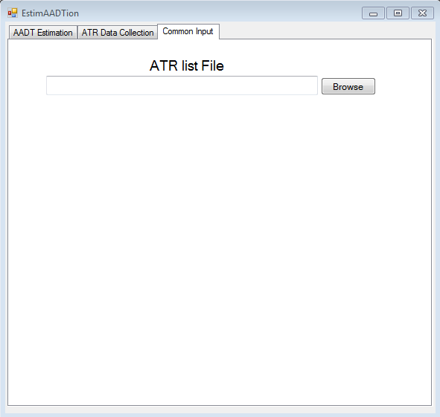

The list of ATRs is a file which the user must input. The browse button can be used to browse to the location of the file. The file has to be in csv format. Specific instructions on how to construct the csv file will be described in subsequent sections. The user also has the option of copying and pasting the location of the file in the box.

**3.0 PREPARING THE INPUT FILES**

# SUMMARY

In the previous section, we described the software and user interface. The software has several input files that need to be prepared by the user. Instructions on how to prepare those files are described below.

## 3.1 Short-term Count File

This csv file contains the short-term counts for AADT prediction. Below is a screenshot of the csv file.

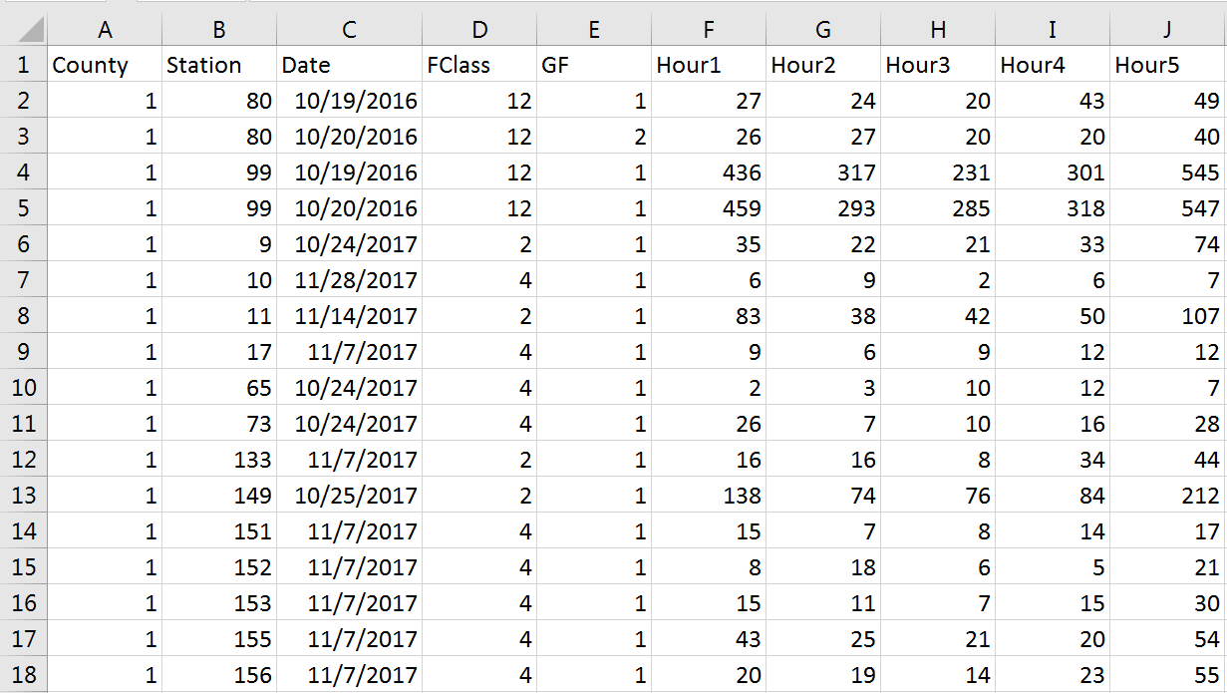

The first row must contain the labels. From column F towards the right, we will have the 24 hourly volumes in each column, although in the screenshot it is not visible. Each row after the first row represents one short-term count of 24 hours. Column A represents the county and Column B represents the station. This information is provided to keep the location information. Column C represents the date of the short-term count. The date is used to identify the day of the week and month of the year, which influence the hourly volumes. Column D represent the functional class of the road at which the short-term count was taken. This information is used to determine which model should be used for AADT prediction. Column E represents the growth factor. The user can input an old short-term count and specify a growth factor. The software uses the growth factor to project the hourly volume to the current year. For all other short-term counts that are up-to-date, the value should be 1 in this column. A blank column is equivalent to 0, so putting the 1 is mandatory. Column F to AC are the 24 hourly volumes.

## 3.2 Functional Classification Factor File

This csv file contains the functional classification factors. Below is a screenshot of the csv file.

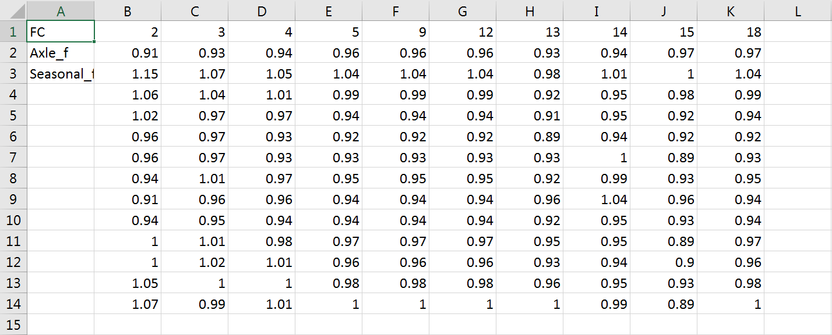

In this file, the labels are in Column A. Row 1 contains all possible functional classes. There are 10 possible functional classes, which are placed between Column B to Column K. Row 2 contains the Axle factors by functional class. Row 3 to Row 14 contain the seasonal factors by functional class. As we know, the seasonal factors are on a monthly basis and there are 12 months. So, Row 3 contains the seasonal factors for the month of January, Row 4 contains the seasonal factors for the month of February. This trend continues to Row 14. If a cell is left blank, it is interpreted as 0 by the software.

## 3.3 Model Parameter File

This csv file contains the parameters of the model. The software generates this file when new ATR data is used, but it can be used repeatedly as long as there is no update to the ATR data. Below is a screenshot of the csv file.

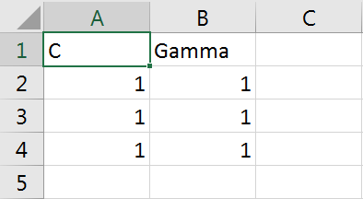

This is the simplest file of all the csv files. The model has two primary parameters, C and Gamma. There are three prediction models in the software, interstate model, arterial model and collector model. Column A and Column B contain the C and Gamma values. Row 2 contains the C and Gamma values for the interstate model, Row 3 contains the C and Gamma values for the arterial model and Row 2 contains the C and Gamma values for the collector model.

## 3.4 ATR List File

This csv file contains the functional classification factors. Below is a screenshot of the csv file.

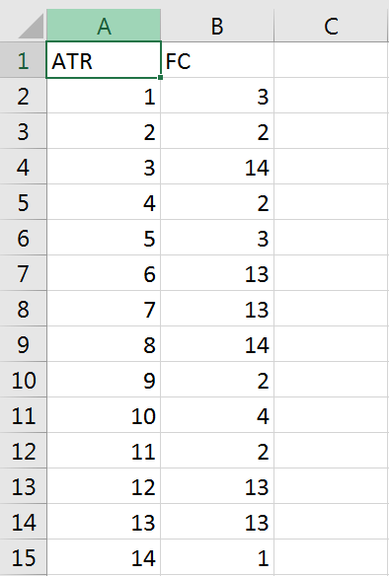

There are two columns in this file. Column A is the ATR number and Column B is the functional classification of the ATRs. Row 1 is the label. From Row 2, each row entry corresponds to one ATR. Therefore, if there are 100 ATRs in a state, then there will be 100 row entries in this file.

**4.0 AADT Estimation**

# SUMMARY

In this section, we will walk through the steps when the software is used to perform AADT estimation.

## 4.1 Start Menu

Step 1- First, we open the software and we stay at the “AADT Estimation” tab. At first, we click the “browse” button beside the “Short-term Count File” box and another window opens up as shown in the screenshot below. We select the file “Input.csv” in this example demonstration. The file has already been populated with all the data.

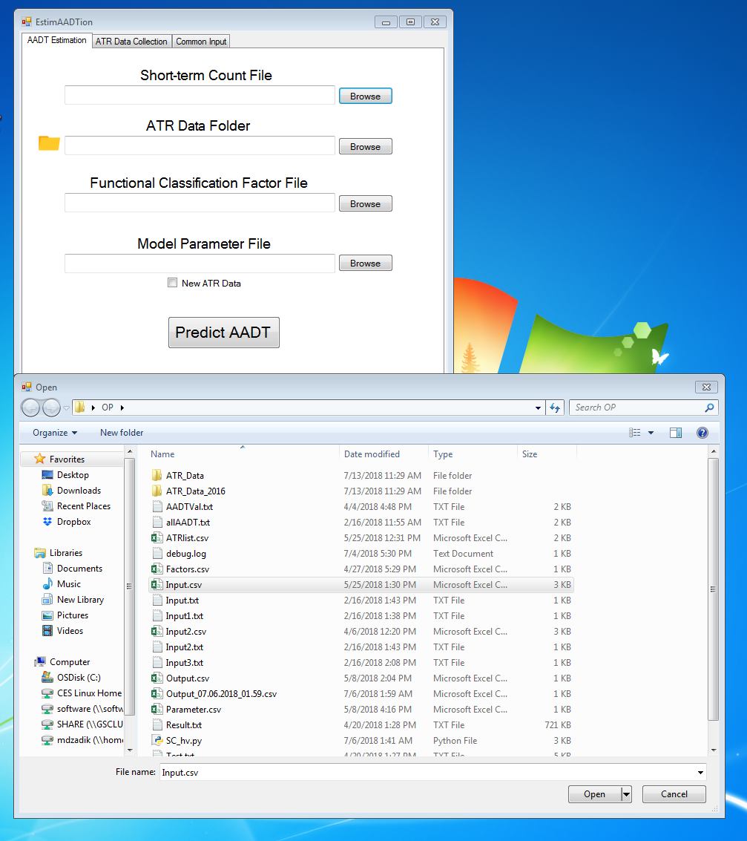

We select the file and the click open. This will populate the box with the path to the input file. Below is a screenshot of the software start menu after this action.

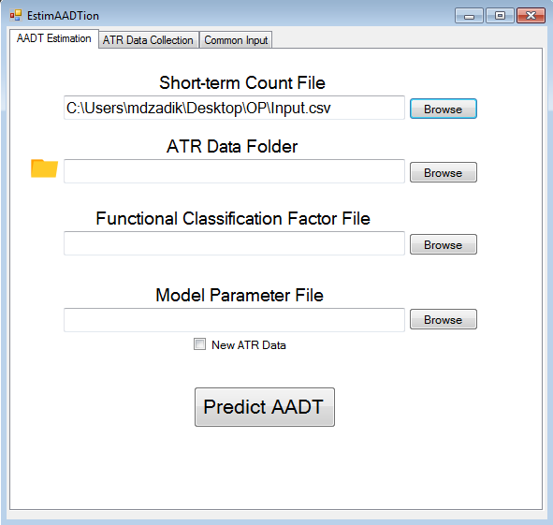

Step 2- We click browse button beside the ATR Data Folder box and different window opens. We browse to the folder where all the ATR data is located, select the folder and click ok. The empty box is populated with the path to the folder. The screenshots are given below.

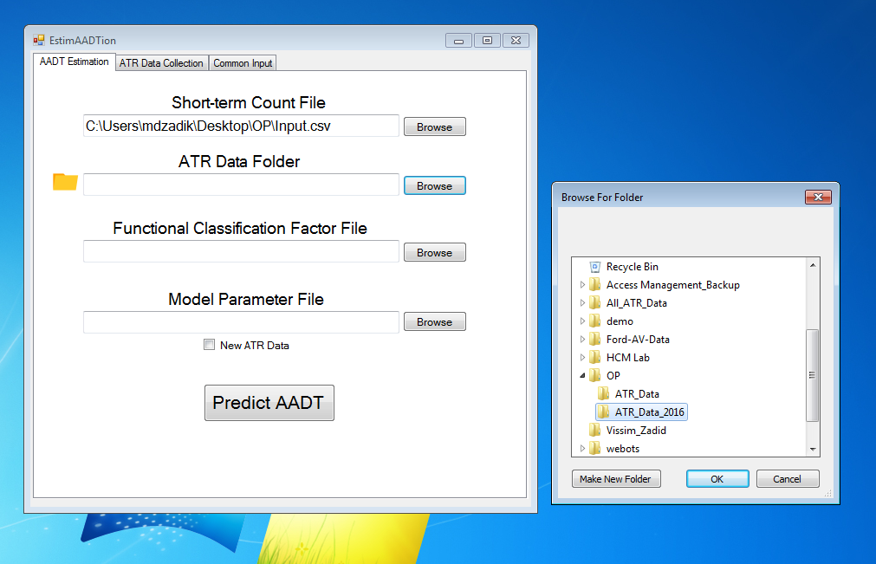

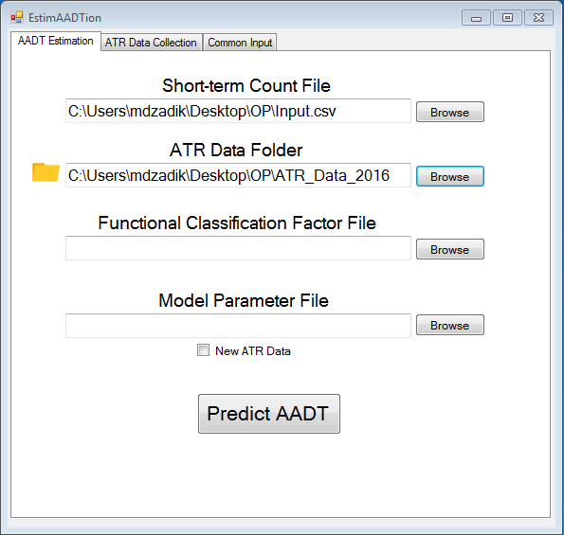

Step 3- The next two inputs are both csv files, so the process is the same as the first input. After selecting the appropriate files using the browse button, below is a screenshot of the software start menu.

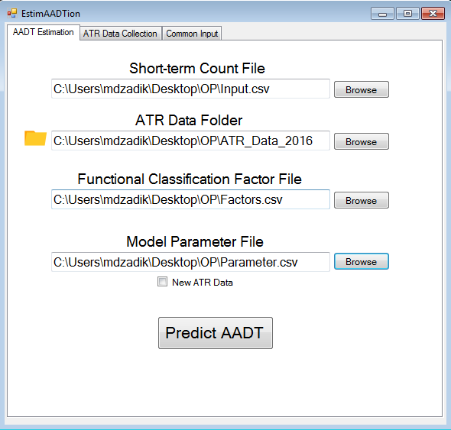

Step 4- There is a checkbox below the model parameter path, we will check it if we are using new ATR data. If the ATR data we are using has been used before, then we will leave it unchecked.

Step 5- Go to the “ATR List” tab and click on the browse button. The file browsing window will appear. The ATR list is stored in a csv file. We select the appropriate csv file. The path to the csv file appears in the box. The screenshot is given below.

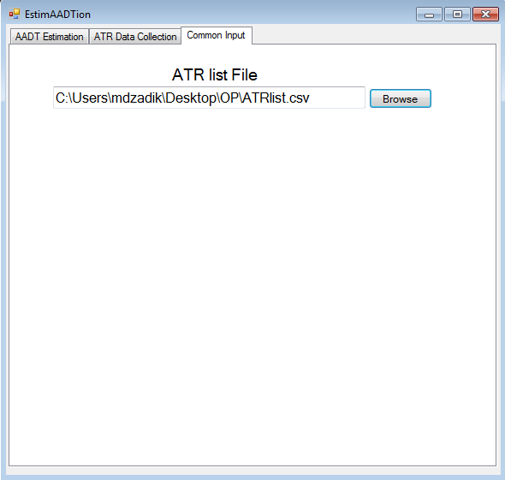

Step 6- We come back to the “AADT Estimation” tab and click on “Predict AADT” button.

## 4.2 Runtime Menu

While the software is running in the background, a progress bar will appear below the “Predict AADT” button that will show how much progress has been made. In addition, the progress percentage will appear on the top bar. Below is a screenshot of the software in runtime.

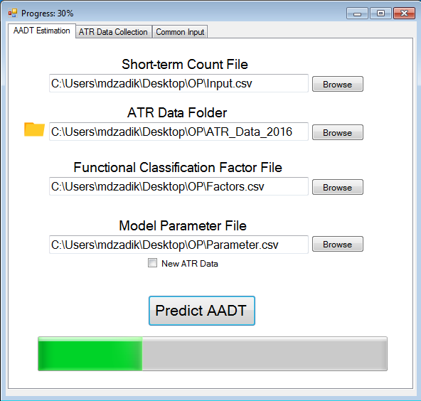

If the New ATR box is unchecked, the software takes about 2-5 minutes to run. However, if the New ATR box is checked, it will take hours for the software to run. The reason is, whenever new ATR data is provided, the software recreates the models and stores the parameters of the model in the csv file. If old ATR data is used, then the software uses the parameters stored from previous instances. However, the final output will be generated in the same way for both cases. Only the runtime increases for the new ATR data scenario.

## 4.3 Output Menu

After the software finishes, the progress bar will be full, and immediately the runtime menu will disappear and another window will appear. This is called the output menu. The screenshot of a sample output menu is given below.

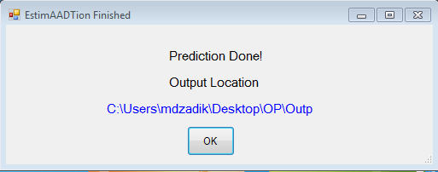

There is a link in the output menu; it contains the path to the output file. If we click on the link, it opens up the output csv file generated by the software. The output csv file can also be found in the same location as the input csv file. To recognize the output csv files, each output csv has a base filename of “Output” and it is appended by the date and time at which it was created. A sample output filename can be “Output_07.18.2018_14.45.csv”. This file was created on 18th July of 2018, at 2:45PM.

Below is a screenshot of the output csv.

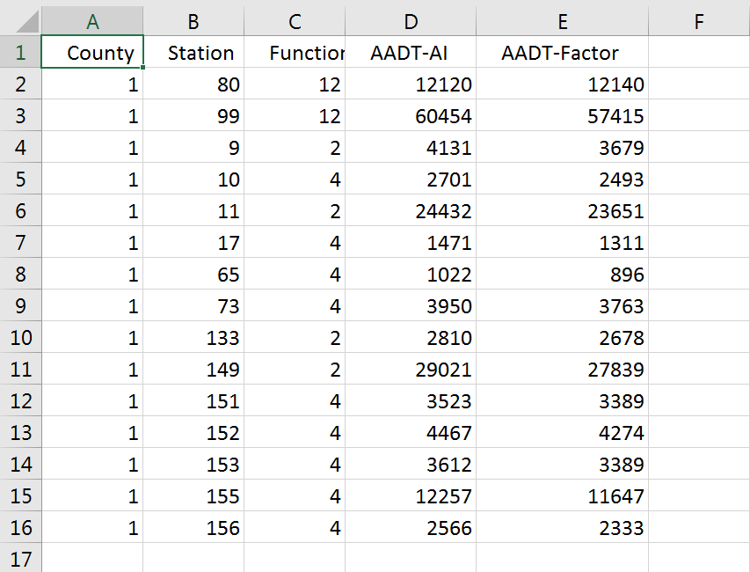

The output csv file will always contain five columns. As usual, Row 1 contains the labels. Each entry in the output file corresponds to a unique station. If there were multiple entries for one station in the input file, the software aggregates the outputs and provides one output.

Column A, B and C are unchanged from the input file. Column D and E are the new columns which have been generated by the software. Column D is the calculated AADT using the AI method, and Column E is the calculated AADT using the traditional factor method. The users can compare and check the values for

**5.0 ATR Data Collection**

# SUMMARY

In this section, we will walk through the step when the software is used to perform ATR data collection.

## 4.1 Start Menu

Step 1- First, we open the software and we go to the “ATR Data Collection” tab. At first, we click the “browse” button beside the “Data Collector File” box. Using this box, we need to select the Python script that has been provided with the software. The file will have an extension of “*.py”. In this demo, we select the file “SC_hv.py”. As mentioned in section 1.2.3.2, the user will select the script corresponding to the browser that the user will use. In this demo, we are using Google Chrome, so we select the script that corresponds to Google chrome. Below is a screenshot of the selection.

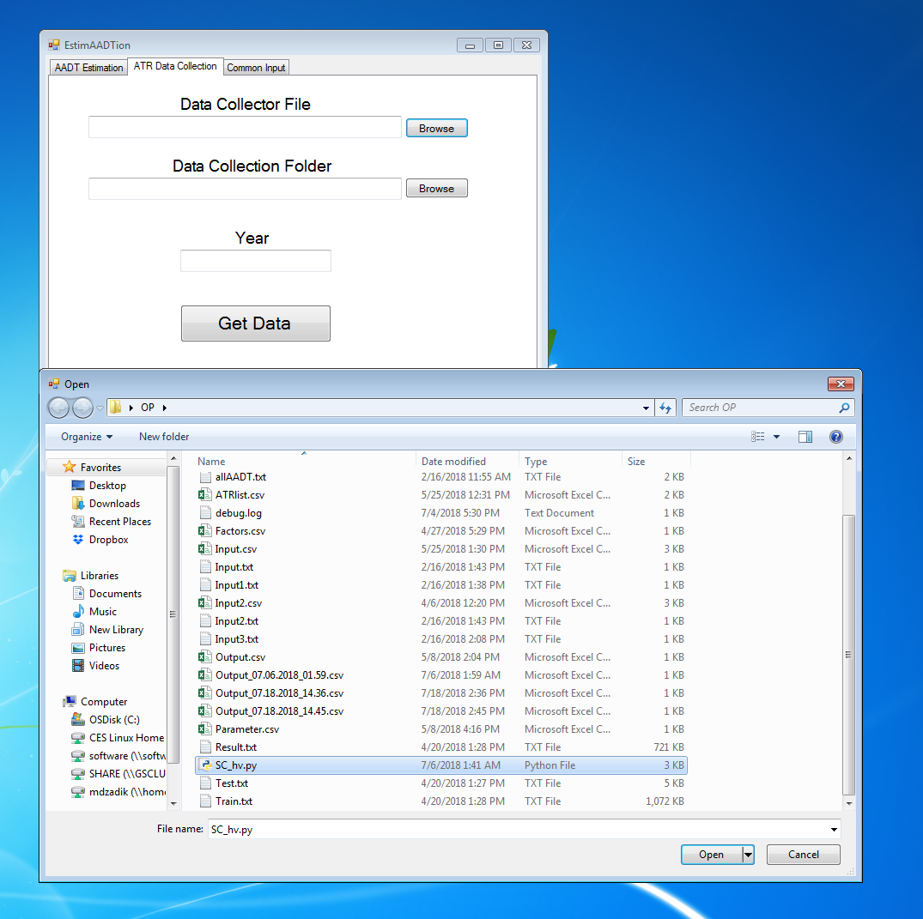

After the selection, the path to the file appears in the box. Below is the screenshot.

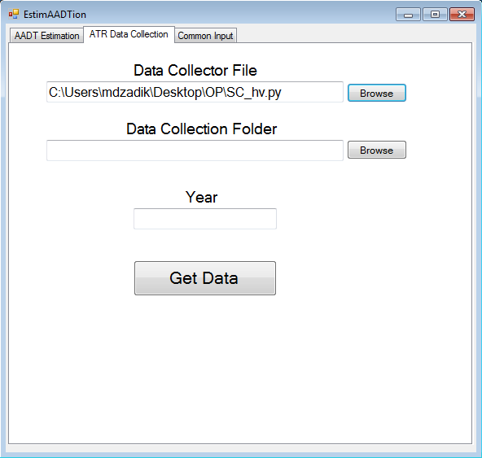

Step 2- We click browse button beside the “Data Collection Folder” box and the folder browse window opens. Using this window, we need to select the folder where we want to store the ATR data. In this demo, we are collecting the ATR data for 2016 and we have created an empty folder named “ATR_data” for data collection. We browse to the folder, select the folder and click ok. The empty box is populated with the path to the folder. The screenshots are given below.

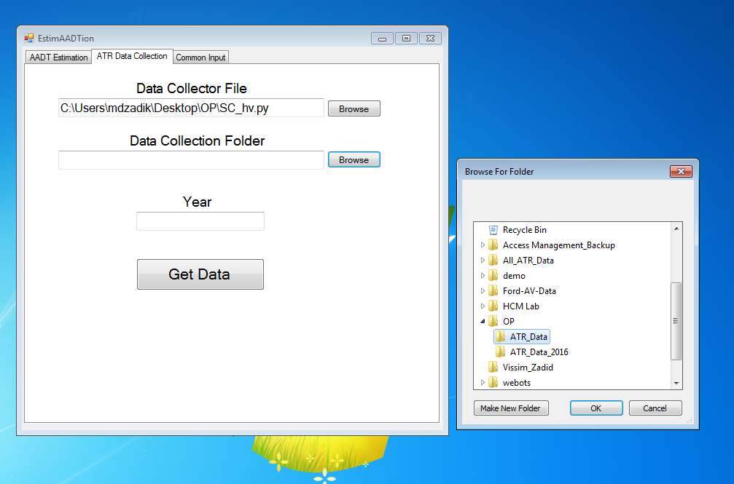

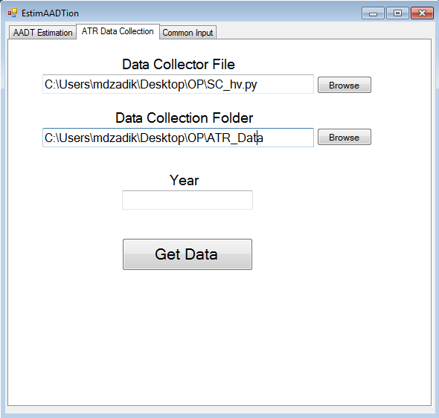

Step 3- The final input is the year. In this demo, we are collecting the ATR data for 2016. Therefore, we enter 2016 in the “Year” box. Below is the screenshot.

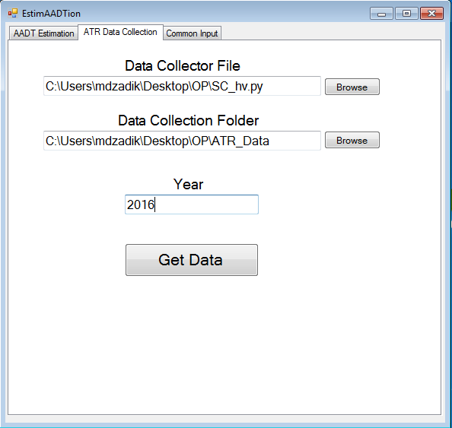

Step 4- Go to the “ATR List” tab and click on the browse button. The file browsing window will appear. The ATR list is stored in a csv file. We select the appropriate csv file. The path to the csv file appears in the box. The screenshot is given below.



Step 5- We come back to the “ATR Data Collection” tab and click on “Predict AADT” button.

## 4.2 Runtime Menu

In this demonstration, we are using the google chrome and chromedriver to collect the data. They have already been setup prior to the demo. When we click on “Get Data”, black window will appear as shown in the screenshot below. The software has started running in the background. But the data collection has not started yet.

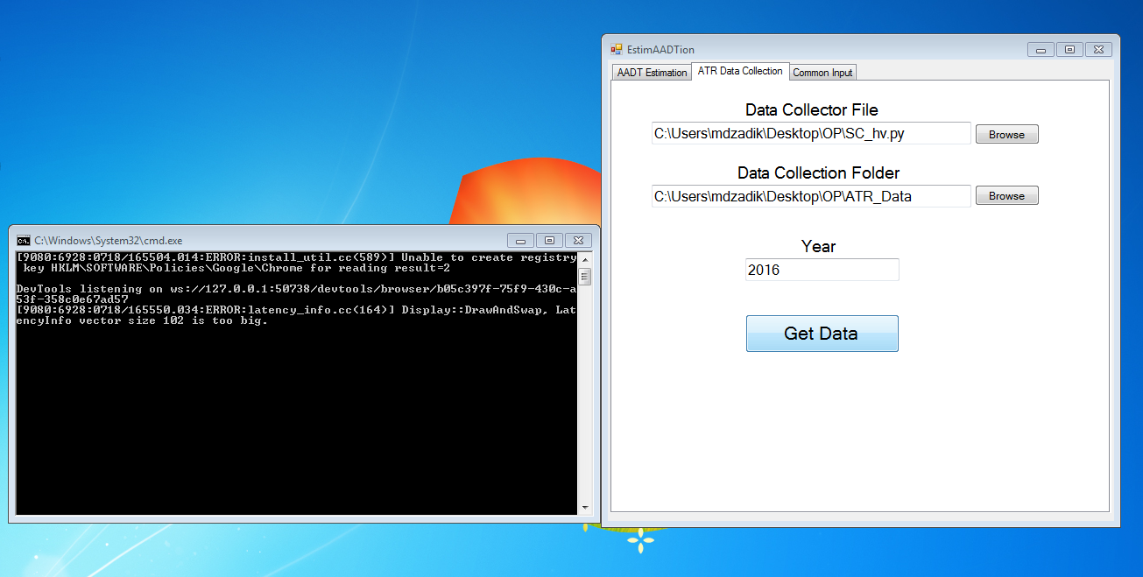

After 1-2 minutes, a new google chrome window will appear as can be seen in the screenshot below. This is the SCDOT website where all the ATR data is located. The software is now pulling data from the website one ATR at a time and one day at a time. This is a very lengthy process and it might take about 12-20 hours. The users can do other work while the data collection is happening in the background.

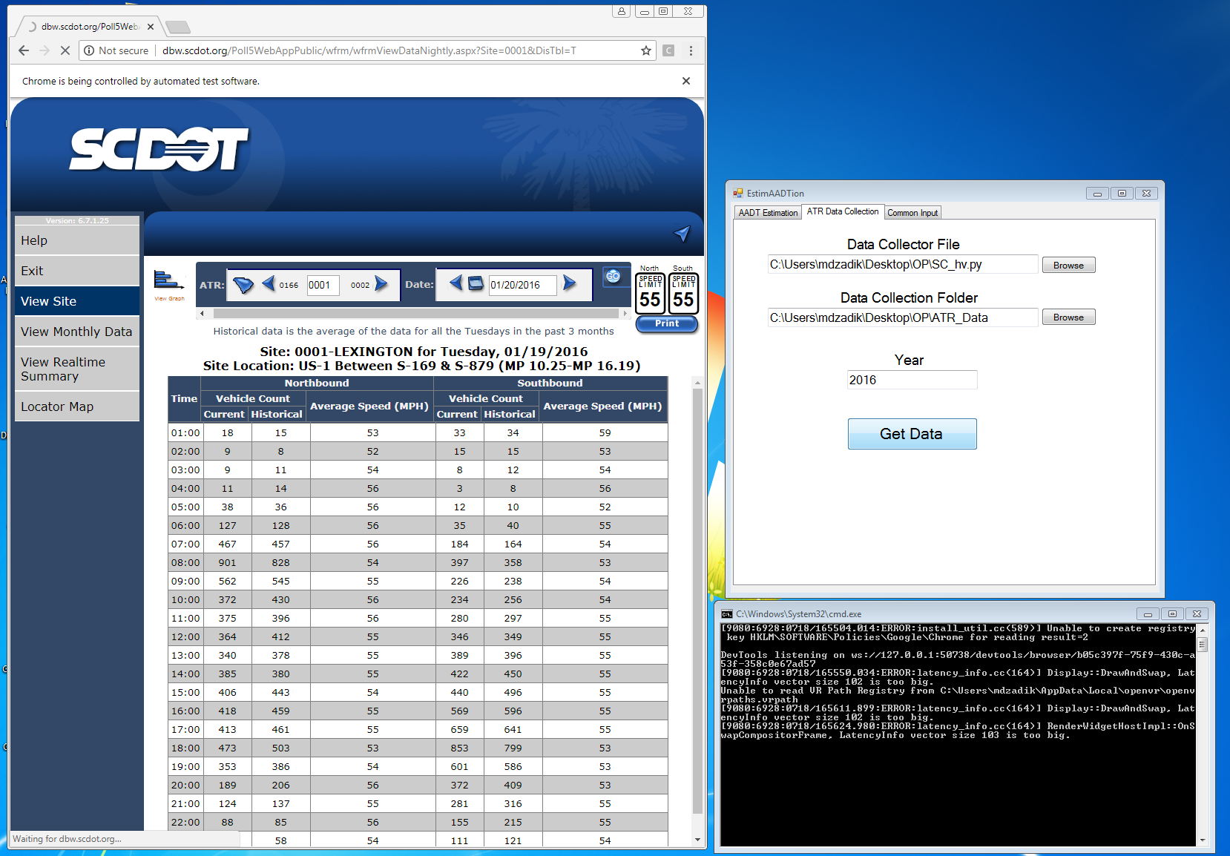

## 4.3 Exit Menu

After the data collection is done, the runtime menu, the black window and the google chrome browser page will disappear and another different window will appear. This is called the output menu. The screenshot of a sample output menu is given below

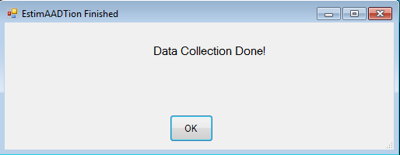

As the user already knows where the output data is, the output menu does not contain any information.

Now we go to the folder where the output data is stored. Below is a screenshot of the content of the folder after the data collection is finished.

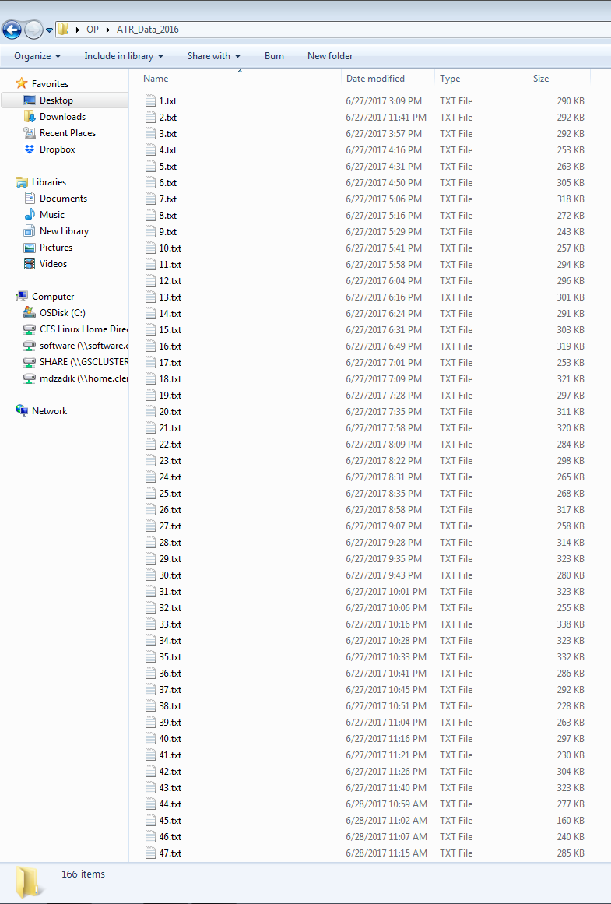

The folder contains one text file for each ATR, starting with ATR 1. The name of the files are in the format “(ATR_number).txt”. The user must make sure that the software has generated one text file for every ATR in the ATR list. In addition, the user must make sure that the text files are in the correct format. Below is a screenshot of the text file.

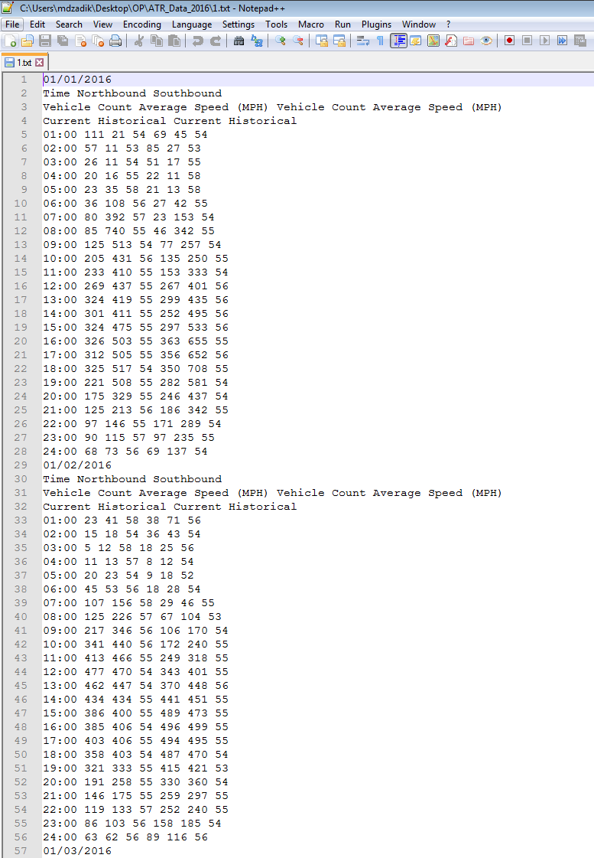

The text files should start with the first date of the year. Then the next 3 rows should the labels. From the fifth row, there should be 7 columns of data, where the first column should be the time. Immediately after the 24:00 time, there should be next date. Then the same pattern is repeated. Sometimes there could be a different pattern where the ATR data was not available. For example, the following two types of text files can be found. In these cases, the data was not available. However, if the data was available, then the text file should always have the above format.

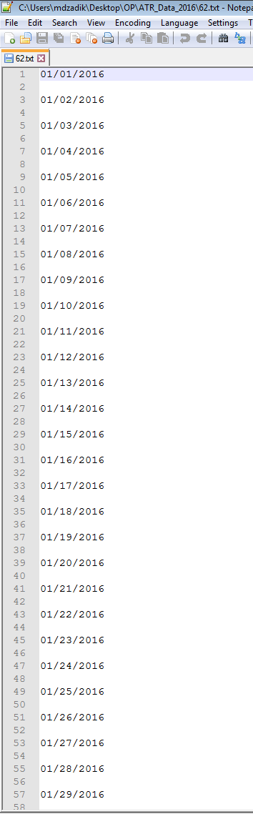 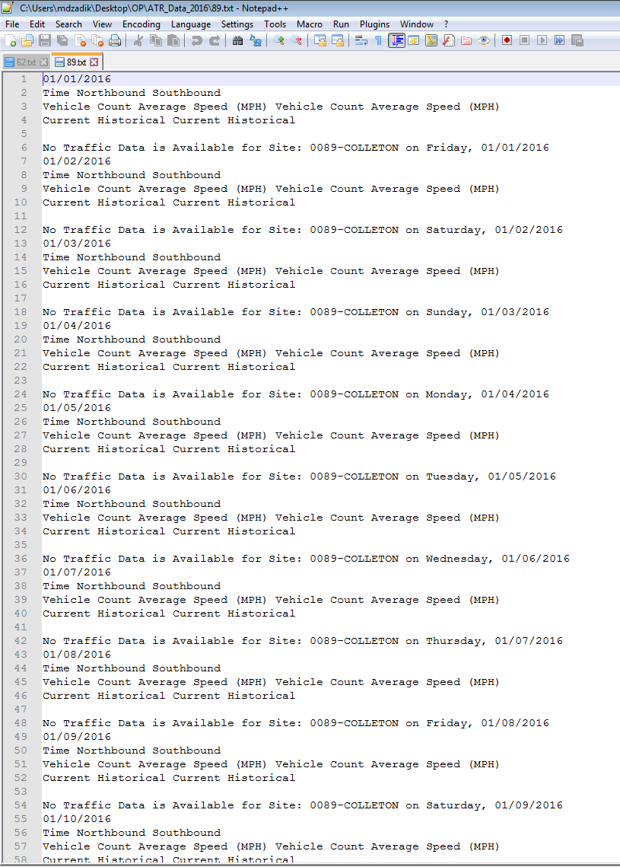

**6.0 APPENDIX**

# Appendix

Common errors