

**User MANUAL**

for

***estimAADTion***

***An AADT Estimation Software***

Prepared by

**Clemson University**

August 2018

**Revision Sheet**

|  |  |  |
| --- | --- | --- |
| **Release No.** | **Date** | **Revision Description** |
| Rev. 0 |  |  |
| Rev. 1 |  |  |
| Rev. 2 |  |  |
| Rev. 3 |  |  |
|  |  |  |
|  |  |  |
|  |  |  |

USER MANUAL

TABLE OF CONTENTS

Page #

1.0 ABOUT THE SOFTWARE 4

1.1 Software Overview 5

1.2 Software Functions 5

1.3 User Interface 6

2.0 INITIAL SETUP & INSTALLATIONS 10

2.1 Software and Hardware Requirements 11

2.2 Acronyms and Abbreviations 15

3.0 PREPARING THE INPUT FILES 16

3.1 Short-term Count File 17

3.2 Functional Classification Factor File 17

3.3 Model Parameter File 18

3.4 ATR List File 19

4.0 AADT ESTIMATION 20

4.1 Start Menu 21

4.2 Runtime Menu 24

4.3 Output Menu 25

5.0 ATR DATA COLLECTION 27

5.1 Start Menu 28

5.2 Runtime Menu 31

5.3 Output Menu 32

6.0 COMMON ERRORS 36

**1.0 ABOUT THE SOFTWARE**

## 1.1 Software Overview

EstimAADTion is a software designed for SCDOT to estimate Annual Average Daily Traffic (AADT) using short-term count data. SCDOT conducts short-term counts at different locations in the state periodically. This software has been designed to estimate the AADT at those locations from the short-term counts at those locations. The software uses a machine-learning (ML) model to estimate the AADT. In order to estimate AADT from short-term counts, the software uses data from permanent count stations (ATRs). The software provides the capability to collect the permanent count station data from the SCDOT website to facilitate the use of the permanent count stations. The software has been implemented using C# in Visual Studio.

## 1.2 Software Functions

This software is capable of performing two functions: AADT estimation and ATR Data Collection.

### 1.2.1 AADT Estimation

AADT Estimation is the primary function of the software. The user needs to provide several inputs to the software. The required inputs are:

1. List of ATRs and their functional classes
2. Short-term counts
3. ATR Data of that year
4. Functional classification factors
5. Model Parameters
6. Growth factor (to project short-term count to current year)

The software uses a machine-learning based predictive model to estimate the AADT from short-term counts. The machine-learning method used in the software is Support Vector Regression (SVR). The SVR model has been implemented using the open source LIBSVM library. The SVR model uses the ATR data of a specific year to train the model, determines the model parameters, and estimates the AADT using short-term counts as inputs.

The list of ATRs and functional class information are used to form three major road groups: interstate, arterial and collector (this group includes collectors and local roads). If the ATR data has been used previously in the model, then the model will use the parameters input by the user. If the ATR data is new, then the software will create new models and recalculate the parameters. The software creates three separate models for the three major road groups. After that, the short-term counts data is input to the appropriate model based on their functional classes to estimate the AADT of that location. The functional classification factors are used to calculate the AADT from seasonal and axle factors. This is the traditional factor method of AADT estimation. The output file contains two AADT values, AADT from factor method and SVR method.

### 1.2.2 ATR Data Collection

In order to perform AADT estimation, the user needs to input the ATR data (hourly volume data from all permanent count stations) to the model. The software provides the capability of ATR data collection also. For this function, the user also needs to provide several inputs to the software. The inputs are:

1. List of ATRs
2. Data collection location
3. Year

A script has been developed using Python programming language to automatically collect all the ATR data from the SCDOT website. The script will be provided to the users with the software package. The script collects the hourly volumes for each ATR in a separate text file, which can be directly used by the AADT estimation part of the software. The user will need to specify the year of data collection and the folder where all the data will be saved. Although the primary use of the software is to estimate AADT of current year, the year has been kept as an input so that users can choose to estimate AADT for a previous year also, if required. This process takes approximately 12 to 24 hours depending on data availability, connectivity and hardware specifications of the computer. However, in an ideal situation, this procedure will only need to be done once per year. After downloading the ATR data, the user can reuse the data for the rest of the year.

## 1.3 User Interface

The user interface of the software has three separate tabs for different types of inputs. The three tabs are described below.

### 1.3.1 AADT Estimation

The first tab at the top of the window is designed for inputs related to the AADT estimation. Below is a screenshot of the first tab.

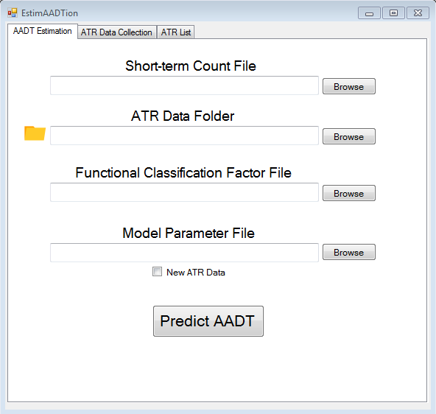

Step 1

Step 2

Step 3

Step 4

Step 5

Each step is described below.

**Step 1:** Input the location of the short-term count file using the browse button. The file must be in .csv format. Instructions for constructing a csv file is described in section 3. You may also copy and paste the location of the file into the text box if you prefer.

**Step 2:** Input the location of the ATR data, which will be a folder produced by the script from step 2.1.2. You can use the browse button to locate this folder or copy and paste the folder location if you prefer.

**Step 3:** Input the location of the functional classification factor file. You can do this using the browse button or copying and pasting the folder location into the text box. This file must also be in .csv format.

**Step 4:** Input the model parameter file, which can be found using the browse button or the copy and paste method. The software will create a new model parameter file if you check the box “New ATR Data.” The procedure will take a while to complete (12 to 20 hours) as mentioned above, but this step should only be performed when inputting new ATR Data. The model parameters will get updated each time there is a new data. The next time the user wants to use the software with the same ATR data, the user can just select this file and leave the “New ATR Data” box unchecked.

**Step 5:** After providing all the inputs, the user can click the “Predict AADT” button at the bottom and the software will run the program. While the program runs in the background, a progress bar will show the progress of the software. After the run is completed, the software will provide the predicted AADT output in an excel file with the current date and time, so the users can identify it easily.

### 1.3.2 ATR Data Collection

The second tab at the top of the window is designed for inputs related to ATR data collection. Below is a screenshot of it and the steps to input the appropriate files.

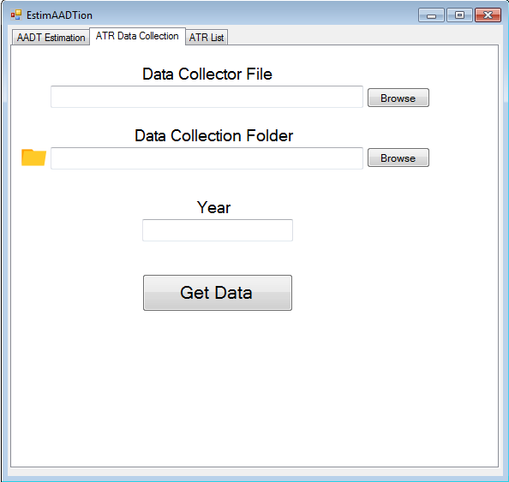

Step 1

Step 2

Step 3

Step 4

Each step is described below.

**Step 1:** Input the location of the data collector script using the browse button or copy and paste method. The script will be provided to the user with the software package, so the user is not required to write this script. Recall from section 1.2.3.2 the python script named “SC_hv.py.”

**Step 2:** Input the location to the data collection folder. The browse button can be used to browse to the folder where the user has selected to store the data. The user also has the option of copying and pasting the location of the folder in the box.

**Step 3:** Input the year of ATR data collection by typing in the format YYYY (i.e.- 2017, 2018).

**Step 4:** After providing all the inputs, click “Get Data” at the bottom and the software will run the program in the background.

### 1.3.3 ATR List

Regardless of the whether the user is using the software to estimate AADT or collect ATR data, the software requires the list of ATRs entered on the third tab. ATRs can get added or removed for various reasons. So, the ATR list needs to be updated accordingly in an excel file (.csv file) and it should be uploaded whenever we use the software

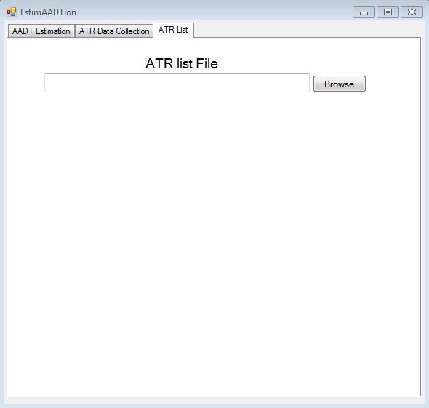

The browse button can be used to browse the location of the ATR list csv file. This file has to be in csv format. The user also has the option to copy and paste the location of the file in the box.

## 2.0 INITIAL SETUP & INSTALLATION

## 2.1 Software and Hardware Requirements

### 2.1.1 Hardware Requirements

The software can run on any basic hardware configuration. The minimum requirements are given below:

Processor: 1 GHz

RAM: 512 MB

Disk space: 5 GB

### 2.1.2 Software Requirements

In terms of the software, the first requirement is that the computer must have some version of the Windows operating system (Vista, 7, 8, or 10) to run the software. The AADT software has some pre-requisite software that need to be installed before use. The following subsection below will provide the direction on how to install the pre-requisite software to run the AADT software.

### 2.1.2.1 .NET Framework

The installation guide for .NET framework can be found in the following link. The link contains the download link to the required package.

<https://docs.microsoft.com/en-us/dotnet/framework/install/>

Select the version of Windows OS in the user’s computer. Below is the screenshot of the webpage when you open the link. The rectangular box shows the options of operating system (OS) for the user.

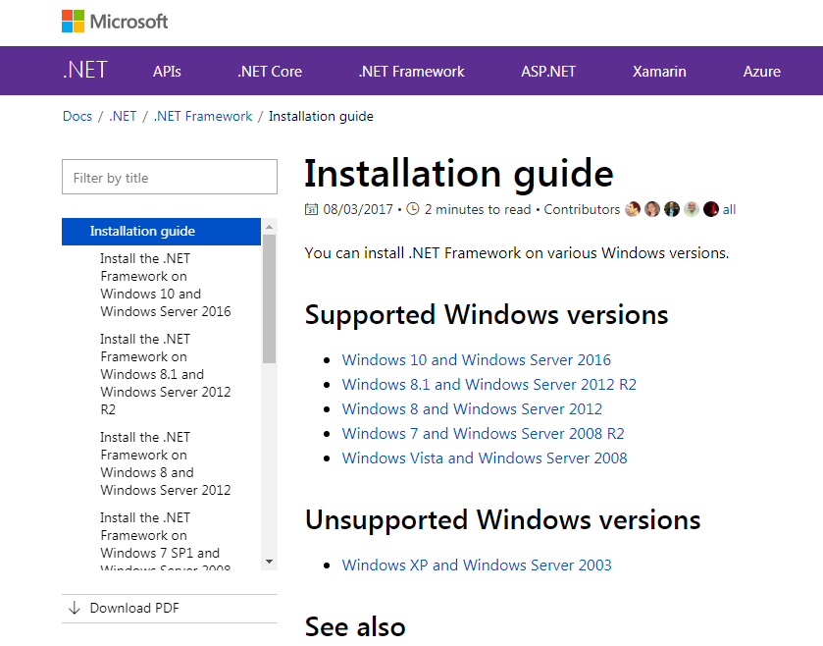

After selecting the appropriate OS, Install any of the version 4 options of .NET Framework. Below is the screenshot of the screen you will see if you select Windows 7. Click on “Download .NET Framework 4.7.2” (marked using rectangular box).

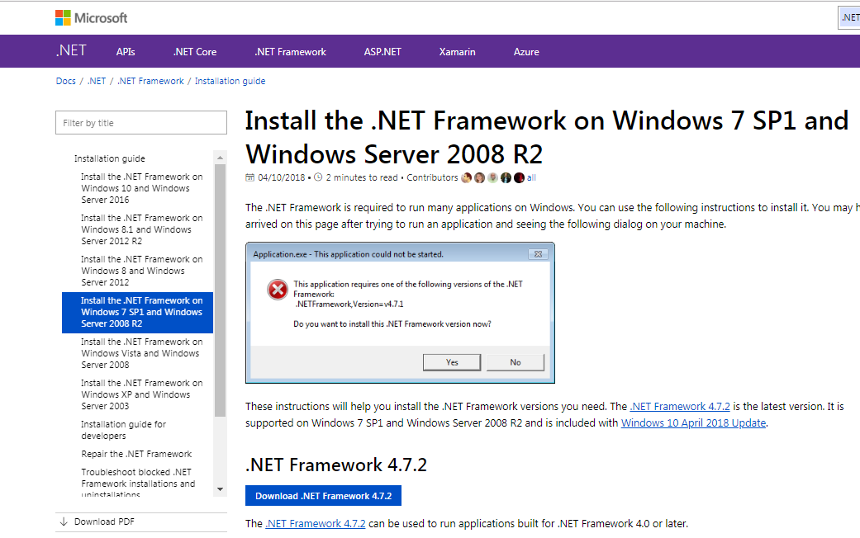

After downloading the installer, install the software using the installer file. The installer will guide you through software installation.

### 2.1.2.2 Web-browser and Webdriver

To download ATR data from the SCDOT website, the software needs to have a web-browser and a webdriver installed on the machine. Any one of the following will work:

1. Google Chrome and Chromedriver
2. Mozilla Firefox
3. Internet Explorer and IEdriver

The links below provide the installation guides and download links for web-browsers.

Google Chrome- <https://support.google.com/chrome/answer/95346?co=GENIE.Platform=Desktop&hl=en>

Mozilla Firefox- <https://support.mozilla.org/en-US/kb/how-download-and-install-firefox-windows>

Internet Explorer – Preinstalled on all Windows computers

It is recommended that users update their browser to the latest version. After installing the web-browser, the user will need to download the corresponding webdriver. Below are the download links to all webdrivers.

Chromedriver- <http://chromedriver.chromium.org/downloads>

Firefoxdriver- Firefox driver does not need to be installed, it is part of the Python package “Selenium” that we will install later.

IEdriver- <http://selenium-release.storage.googleapis.com/index.html>

The chromedriver and IEdriver comes in a zip file. If you unzip the file, then you will find an executable (*.exe) file. Place this file in the C drive. For example, if you have selected chromedriver, the path to chromedriver.exe file will be “C:\chromedriver.exe”.

During ATR data collection, the user will need to select the script that corresponds to the user’s choice. Each browser’s script is found below:

* Internet Explorer : “SC_hv_ie.py”
* Mozilla Firefox: “SC_hv_mf.py”
* Google Chrome: “SC_hv_gc.py”

### 2.1.2.3 Python and Associated Packages

Install Python according to the installation guide below.

<https://www.howtogeek.com/197947/how-to-install-python-on-windows/>

For the AADT software, the users will install Python 3. After opening the link, scroll down until you find a section titled “How to install Python 3”. Click on “download and run the installer” (rectangular box), which will take you to the Python website.

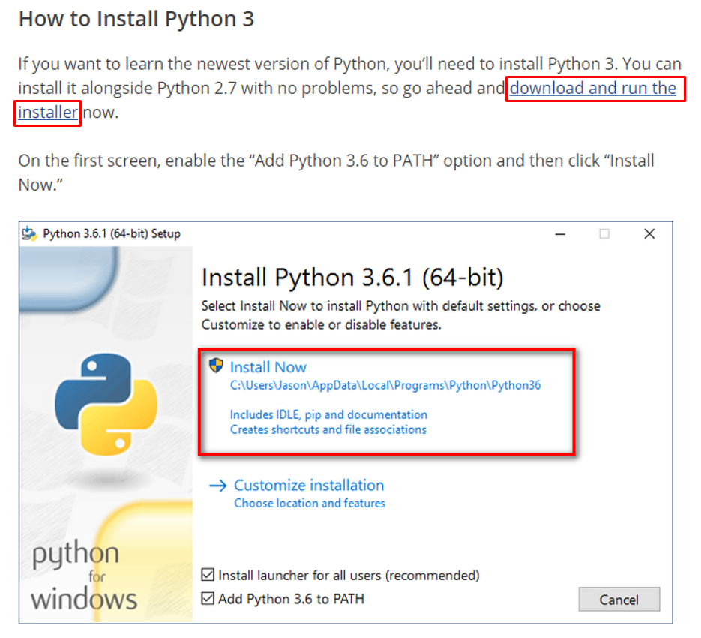

Select the “Latest Python 3 Release” to download the executable installer. You will see a screen similar to the screen below in the screenshot.

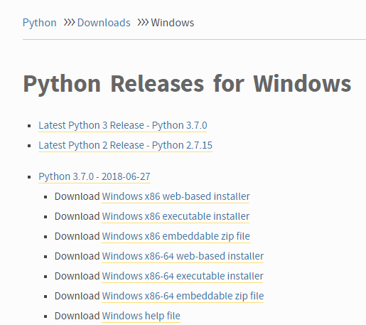

After downloading the installer, go back to the previous webpage and follow the instructions provided under “How to install Python 3”. The webpage contains all the instructions with screenshots.

After installing Python, the packages that need to be installed are Selenium and Pandas. These packages can only be installed after you have successfully installed Python in your machine. Steps to install a package are given below.

**Step 1:** In Windows 7, go to start menu (bottom left corner) and in the “search programs and files” search bar, type “cmd.exe” You will find a program titled “cmd.exe”. Open the program. In Windows 8 and 10, the search bar is already there at the bottom left corner, use it to search for “cmd.exe”.

**Step 2:** After “cmd.exe” opens, type “pip install selenium” and press enter. This command will install Selenium.

**Step 3:** In the same window, type “pip install pandas” and press enter. This command will install the Pandas package.

**Step 4:** After installation of both is complete, you will see a message “success” at the bottom. Exit the cmd window by typing “exit” and press Enter.

Below is a screenshot of “cmd.exe”.

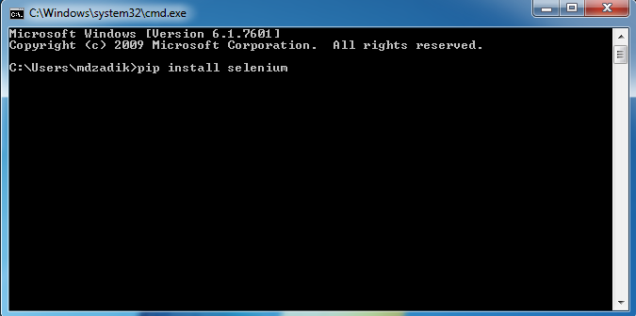

### 2.1.3 AADT Software Installation

The software will be provided to the users in a zip file called “estimAADTion.zip.” Copy / save the zip file to any location in your local machine and unzip it. After unzipping, you will find a folder called “AADT.” Open the AADT folder and you will find “AADT .exe” along with several other files. If you double click “AADT.exe”, the software will launch. Below is a screenshot of the list of files you will see when you open the AADT folder.

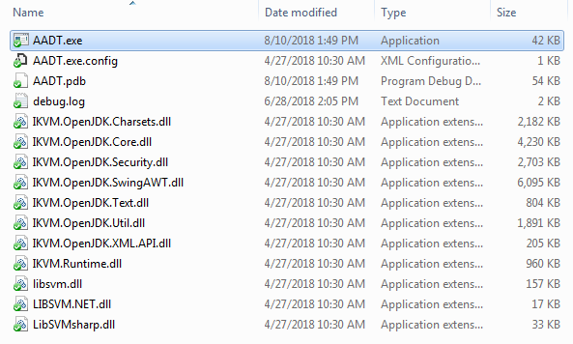

## 2.2 Acronyms and Abbreviations

AADT = Average Annual Daily Traffic

OS = Operating System

ML = Machine Learning

SCDOT = South Carolina Department of Transportation

ATR = Automatic Traffic Recorder

SVR = Support Vector Regression

CSV = Comma Separated Values

**3.0 PREPARING THE INPUT FILES**

## 3.1 Short-term Count File

This .csv file contains the short-term counts for AADT prediction. Below is a screenshot of the csv file.

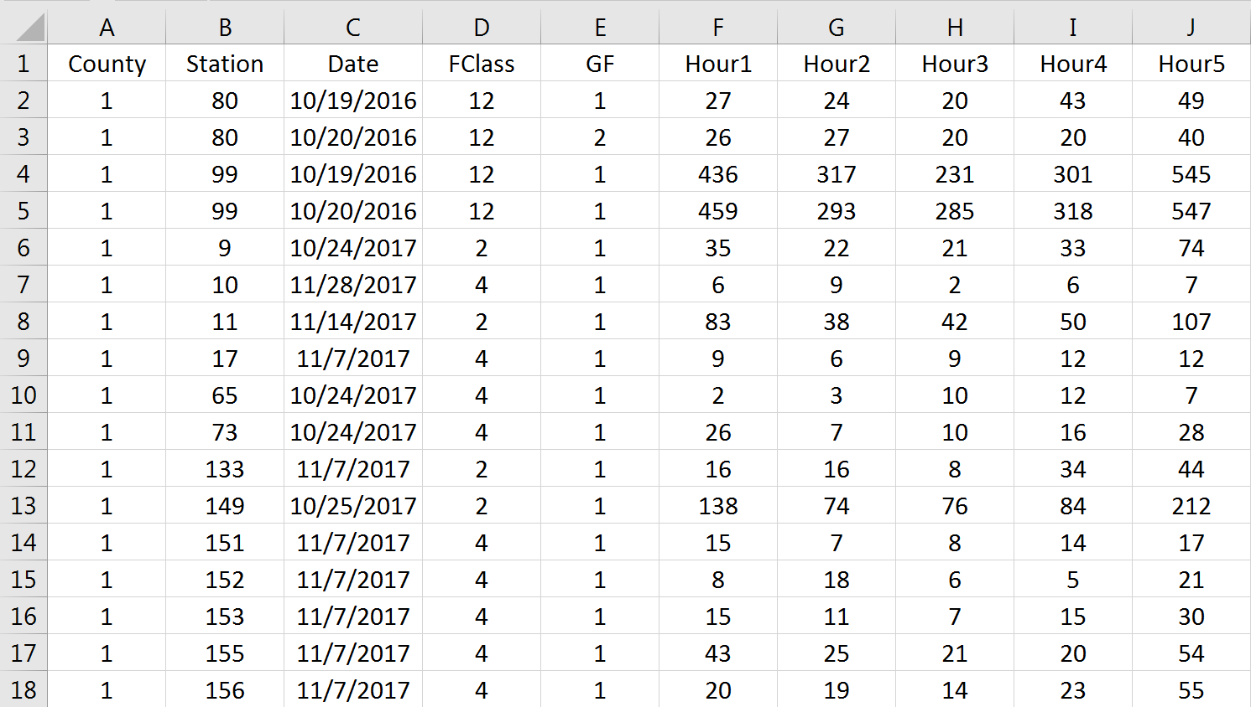

Row 1 must contain the headings for each column. Column A contains the county and Column B contains the station number/ID. This information is provided to keep the location information. Column C contains the date of the short-term count. The date is used to identify the day of the week and month of the year, which influence the hourly volumes. Column D contains the functional class of the road at which the short-term count was taken. This information is used to determine which model should be used for AADT prediction. Column E contains the growth factor. The user can input an old short-term count and specify a growth factor. The software will use the growth factor to project the hourly volume to the current year. For all other short-term counts that are up-to-date, the value should be 1 in this column. A blank column is equivalent to 0, so inputting the value of 1 is mandatory. Starting in column F and for each subsequent column to its right, each column contains one hour volume for each of the 24 hourly volumes. The screenshot above only shows the hourly volume for up to hour 5.

## 3.2 Functional Classification Factor File

The Functional Classification Factor csv file contains the functional classification factors. Below is a screenshot.

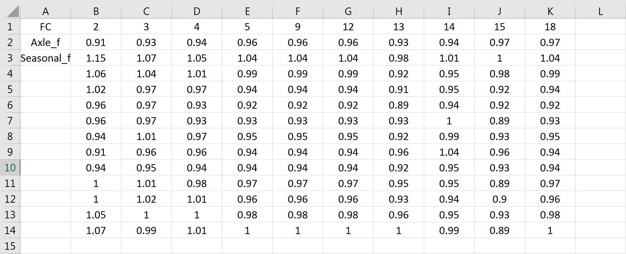

Column A contains the labels. Row 1 contains all possible functional classes. There are 10 possible functional classes, which are placed in Columns B through K. Row 2 contains the Axle factors by functional class. Rows 3 through 14 contain the seasonal factors by functional class. As we know, the seasonal factors are on a monthly basis and there are 12 months. So, Row 3 contains the seasonal factors for the month of January, Row 4 contains the seasonal factors for the month of February. This trend continues to Row 14. If a cell is left blank, it is interpreted as 0 by the software.

## 3.3 Model Parameter File

The Model Parameter csv file is generated by the software when new ATR data is added. This CSV file will remain unchanged as long as there is no update to the ATR data. Below is a screenshot of the csv file. .

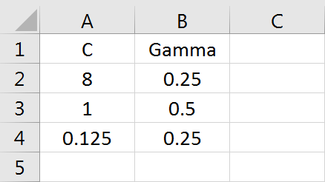

The model has two primary parameters, C and Gamma. Each row (2-4) correspond to one of the three prediction models in the software, interstate model, arterial model and collector model. Row 2 contains the C and Gamma values for the interstate model, Row 3 contains the C and Gamma values for the arterial model and Row 4 contains the C and Gamma values for the collector model.

## 3.4 ATR List File

The ATR List csv file contains the functional classification factors. Below is a screenshot of the csv file.

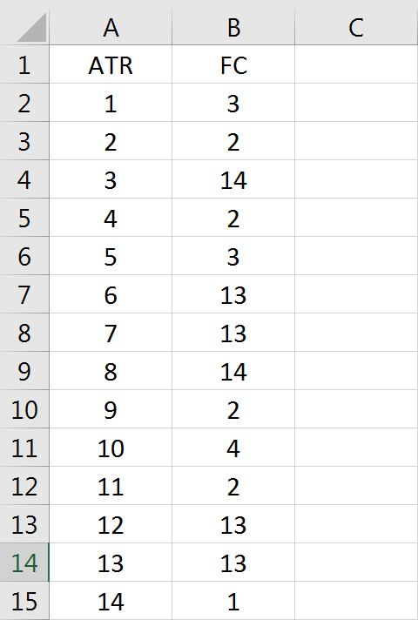

There are two columns in this file. Column A is the ATR number and Column B is the functional classification of the corresponding ATR. Row 1 is the heading. From Row 2, each row entry corresponds to an ATR. Therefore, if there are 100 ATRs in the state, then there should be 100 rows of entries in this file.

**4.0 AADT ESTIMATION**

## 4.1 Start Menu

Below are the steps to be followed by the user.

**Step 1:** Open the software using “AADT.exe” and make sure the “AADT Estimation” tab is selected.

**Step 2:** Click the “browse” button beside the “Short-term Count File” box and another window will open, as shown in the screenshot below.

**Step 3:** Select the appropriate csv file which you have created based on the instructions in Section 3 of this manual. In this example demonstration, it is “Input.csv”, which has already been populated with the corresponding data.



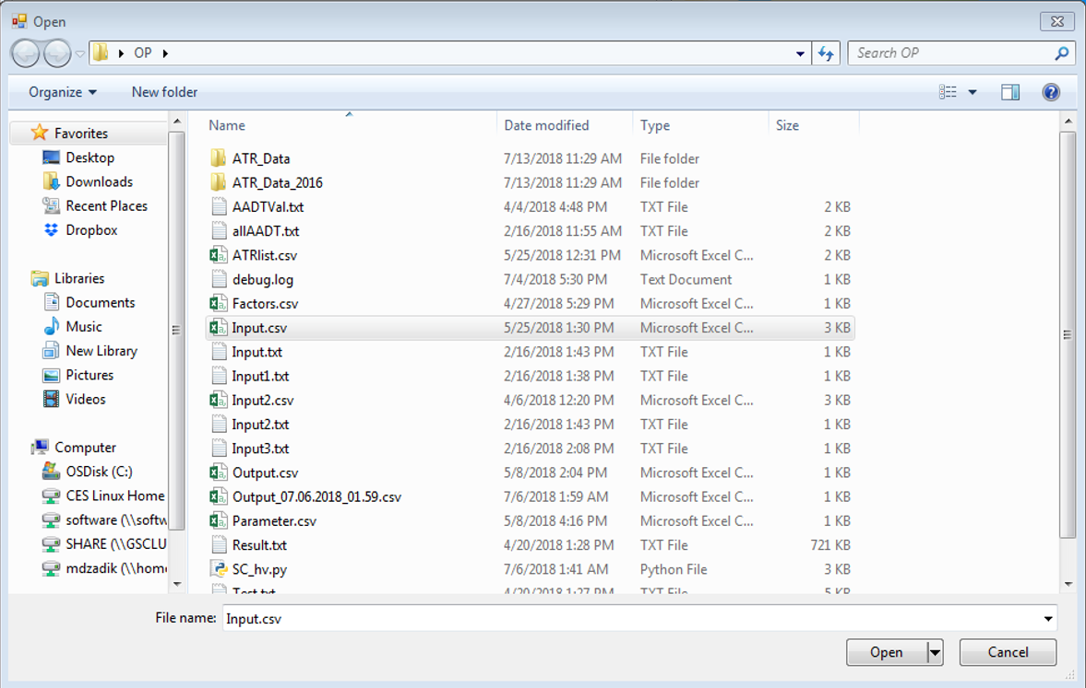

**Step 4:** Select the file and the click open. This will populate the box with the path to the input file. Below is a screenshot of the software start menu that appears after the action.

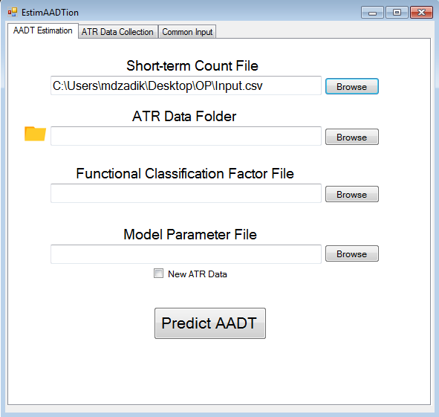

**Step 5:** Click the browse button beside the ATR Data Folder box and a new window will open.

**Step 6:** Browse to the folder where all the ATR data is located, select the folder and click ok. The empty box is populated with the path to the folder, as shown in the following screenshot.

 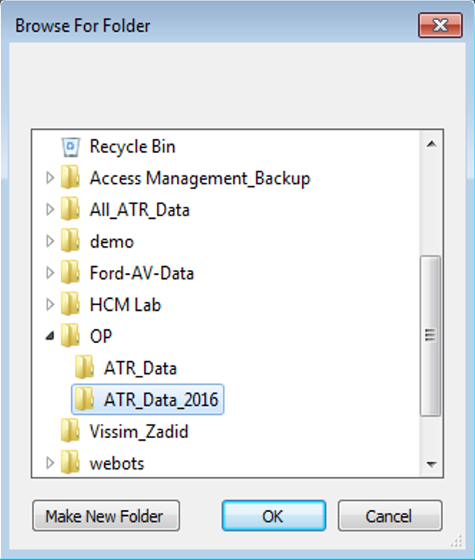

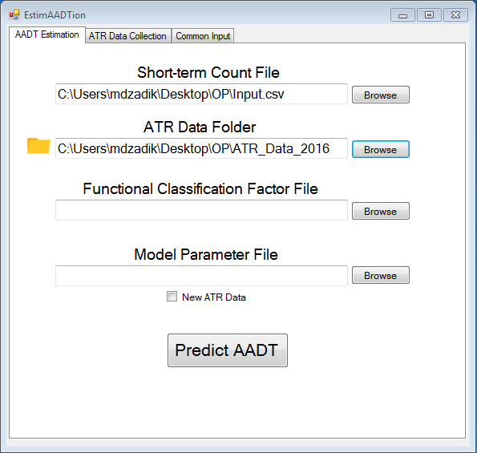

**Step 7:** The next two inputs are both .csv files, so repeat the steps 2-4 in this workflow with the appropriate csv file. After selecting the appropriate files, the following screenshot will appear from the software start menu.

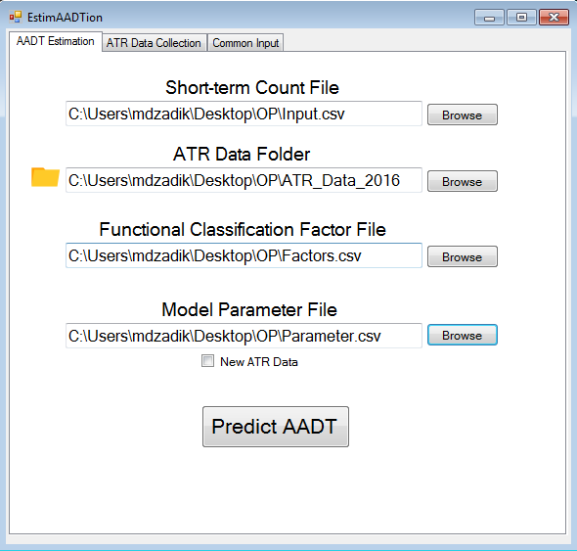

**Step 8:** There is a checkbox below the model parameter path, check it if you are using new ATR data. If the ATR data you are using has been used before, then leave it unchecked.

**Step 9:** Go to the “ATR List” tab and repeat steps 2-4 for this section too. Select the appropriate csv file where all the ATRs are listed. The path to the csv file appears in the box as shown below.

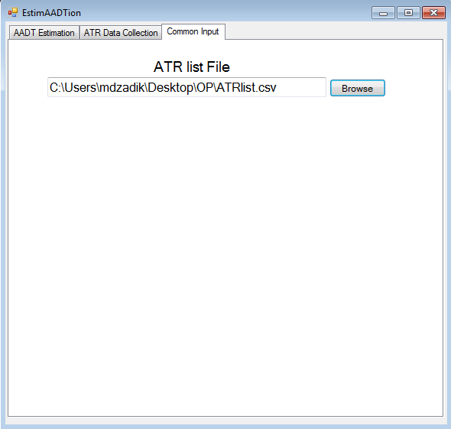

**Step 10:** Navigate back to the “AADT Estimation” tab and click on the “Predict AADT” button.

## 4.2 Runtime Menu

While the software is running in the background, a progress bar will appear below the “Predict AADT” button that will show the progress of the software. In addition, the progress percentage will appear on the top bar. Below is a screenshot of a sample runtime window.

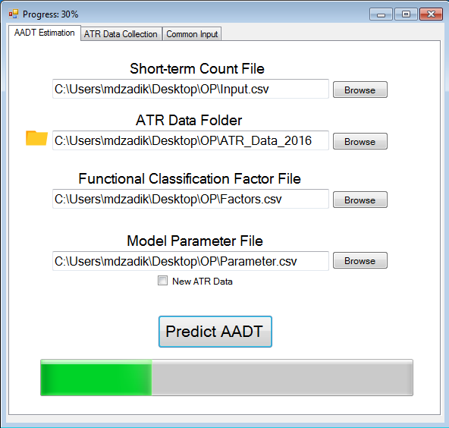

If the New ATR box is unchecked, the software takes about 2-5 minutes to run. However, when “New ATR” box is checked, it can take 3-6 hours for the software to run because the software recreates the models and stores the parameters of the model in the csv file. During this time, you can leave the software running in the background and attend other work. However, do not turn off the computer during this time.

## 4.3 Output Menu

After the software finishes, the progress bar will be full, the runtime menu will disappear and the output menu window will appear, as shown below.

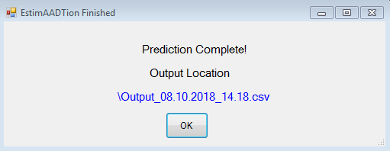

This pop-up window includes a hyperlinked file path to the output file. Clicking on the link will open the output file generated by the software. The output csv file can also be found in the same folder as the input csv file. To recognize the output csv files, each output csv has a base filename of “Output” appended by the date and time at which it was created. A sample output filename can be “Output_07.18.2018_14.45.csv.” This file was created on 18th July of 2018, at 2:45PM.

Below is a screenshot of the output csv.

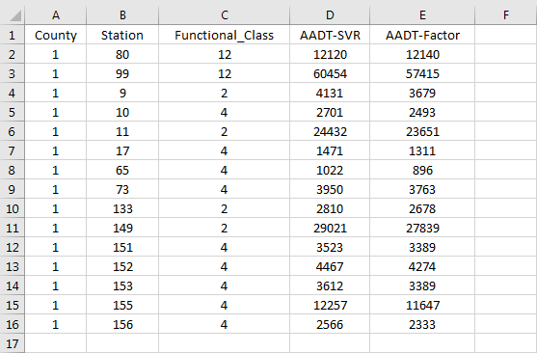

The output csv file will always contain five columns. Row 1 contains the labels. Each entry in the output file corresponds to a unique short-term count. If there were multiple entries for one ATR station in the input file, the software aggregates the outputs and provides one output.

Column A, B and C are unchanged from the input file. Column D and E are the new columns which have been generated by the software. Column D is the calculated AADT using the AI method, and Column E is the calculated AADT from the traditionally used factor method. The output from the factor method has been included so that users can have a reference for comparison.

## 5.0 ATR DATA COLLECTION

## 5.1 Start Menu

Below are the steps to be followed by the user.

**Step 1:** Open the software and navigate to the “ATR Data Collection” tab.

**Step 2:** Click the “browse” button beside the “Data Collector File” box.

**Step 3:** Using this box, select the appropriate Python script for your setup. The file will have an extension of “*.py.” Select the file “SC_hv.py”.

**Step 4:** As mentioned in section 1.2.3.2, select the script corresponding to the browser you have selected. In this example, we have selected Google Chrome, so we choose the script that corresponds to Google chrome. Below is a screenshot of the selection.



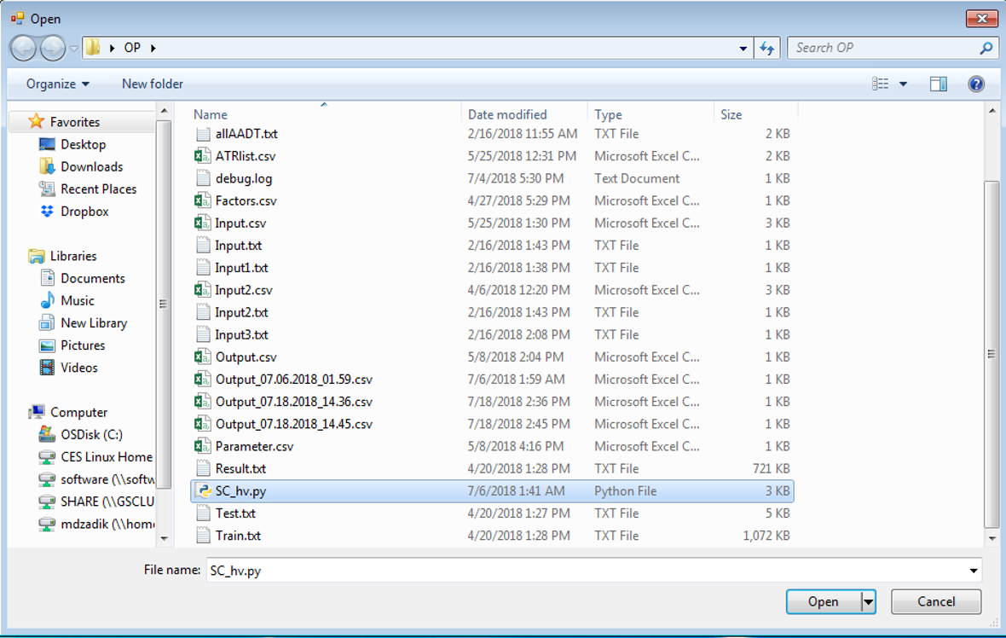

After the selection, the path to the file appears in the box. Below is the screenshot.

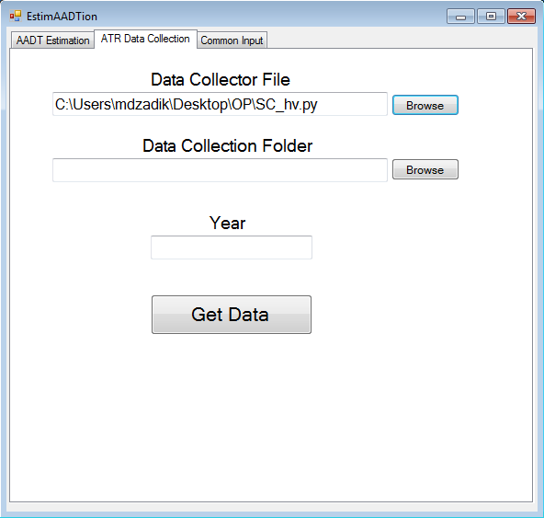

**Step 5:** Click the browse button beside the “Data Collection Folder” box and the folder browse window opens.

**Step 6:** Using this window, select the folder where you want to store the ATR data. In this example, the ATR data has been collected for 2016 and an empty folder named “ATR_data” has been created for data collection.

**Step 7:** Browse to the folder where you stored your ATR data, select the folder and click ok. The empty box is populated with the path to the folder.

 

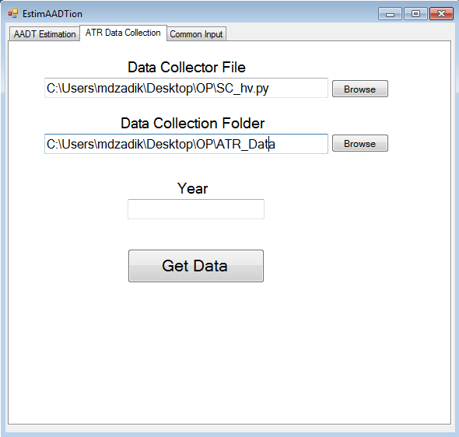

**Step 8:** The final input is the year. In this example, we are collecting the ATR data for 2016. Therefore, we enter 2016 in the “Year” box. Below is the screenshot.

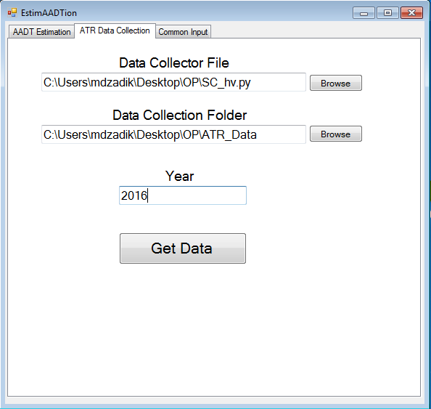

**Step 9:** Go to the “ATR List” tab and click on the browse button. The file browsing window will appear. The ATR list is stored in a csv file. Select the appropriate csv file. The path to the csv file appears in the box. The screenshot is given below.



**Step 10:** Select the “ATR Data Collection” tab and click the “Predict AADT” button.

## 5.2 Runtime Menu

In this example, we used Google Chrome and chromedriver to collect the data. The steps are given below.

Step 1: Click on “Get Data” and a black window will appear as shown in the screenshot below. This is “cmd.exe” launched from the software. This indicates that the software has started running in the background. Below is a sample window.

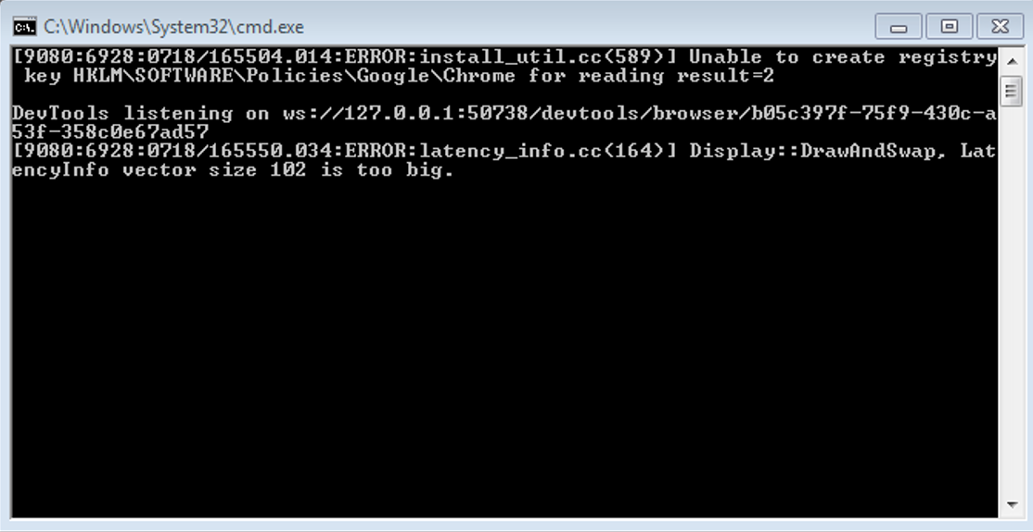

Step 2: After 1-2 minutes, a new google chrome window will appear as can be seen in the screenshot below. This is the SCDOT website where all the ATR data is located. This window indicates that the software has started pulling data from the website one ATR at a time and one day at a time. This is a very lengthy process and it might take about 12-24 hours. You may proceed with other work on your computer as long as you do not close the windows. Below is a screenshot of google chrome browser while data is collected.

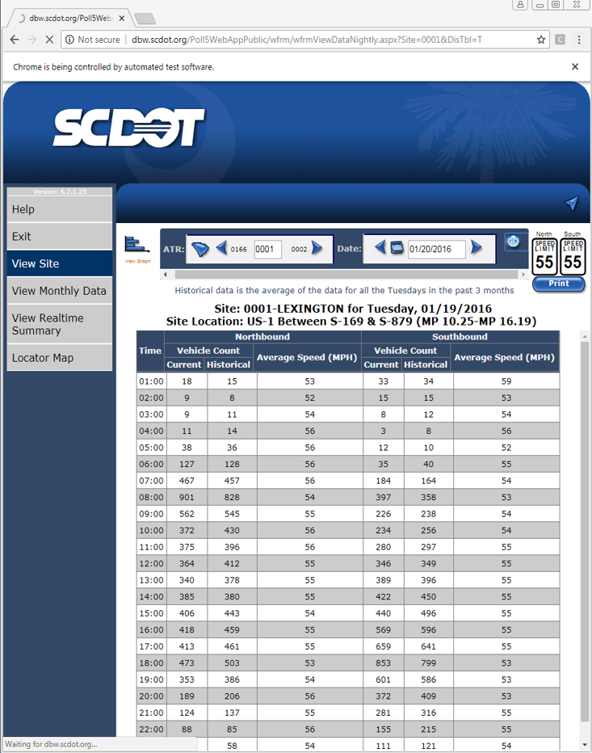

## 5.3 Output Menu

After the data collection is complete, the runtime menu, “cmd.exe” and the google chrome window will disappear and a new output menu window will appear. The screenshot of a sample output menu is given below

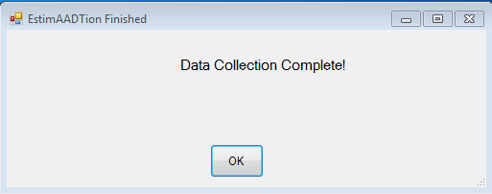

Navigate to the folder where the output data is stored. Below is a screenshot of the content of the folder after the data collection is finished.

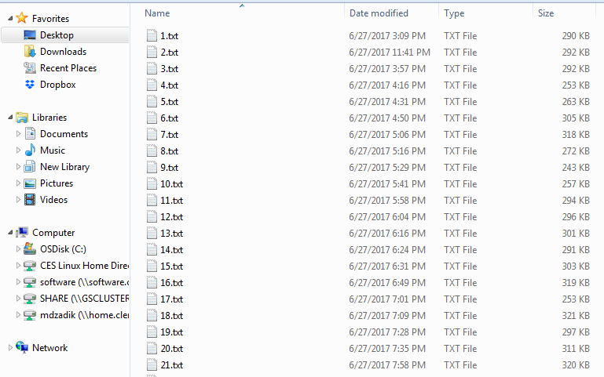

The folder contains one text file for each ATR, starting with ATR 1. The name of the files are in the format “(ATR_number).txt.” Check to make sure that the software has generated one text file for every ATR in your ATR list. In addition, double check that the text files are in the correct format. Below is a screenshot of an ideal text file. The text files should start with the first date of the year. Then the next three rows should contain the labels. From the fifth row, there should be seven columns of data, where the first column should be the time, in hh:00 format (i.e.- 2PM will be 14:00). Immediately after the time, there should be numeric data in each of the six columns. Columns 2, 3 and 4 contain the current volume, historical volume and average speed (mph) for one direction. Columns 5, 6 and 7 contain the current volume, historical volume and average speed (mph) for the other direction. There are 24 rows for each day, corresponding to each hour of the day. Then the same pattern is repeated for each day. Below is a screenshot of a sample input.

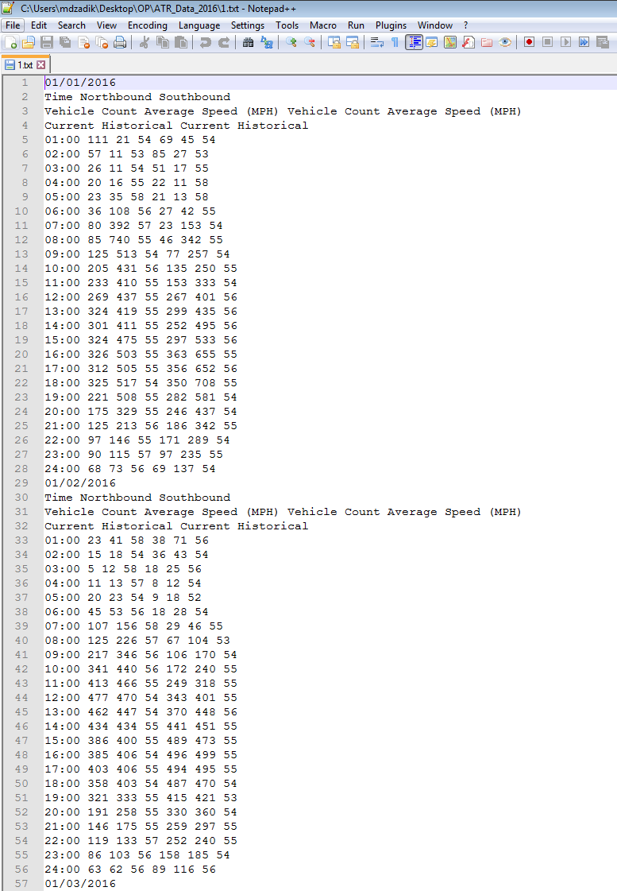

You might see a different pattern if the ATR data was not available. For example, the following two types of text files can be found. In these cases, the data was not available.

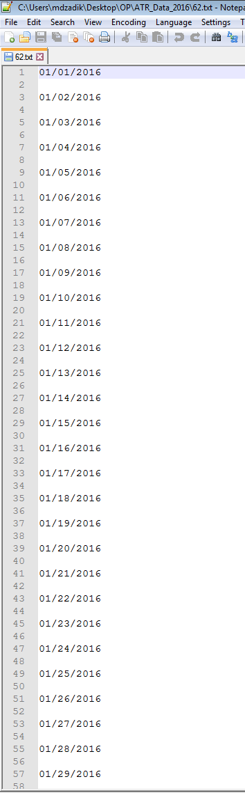 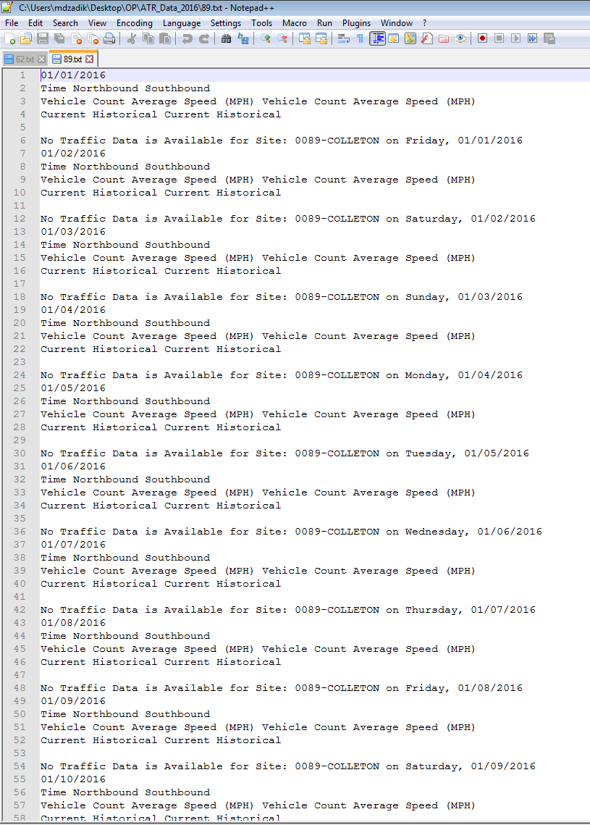

For the file on the left, there is no data between the dates, only a blank line. For the file on the right, the labels are present but there is no data under the label. In both cases, data is absent.

**6.0 COMMON ERRORS**

## 6.1 Leaving input file open in excel

The most common error while using the software is keeping the input csv files open in excel and trying to run the software. The software needs to access the csv files and extract the data in the csv file. Keeping the file open in excel stops the software from accessing the file.

## 6.2 Mistakes in csv file formatting

The user should be careful while creating the csv files. If the csv files are not created with the exact specific format described in Section 3, then the software will not be able to run. For example, in the short-term count csv file, if we leave the growth factor column blank, then it will be interpreted as zero and all AADT results will be zero.

## 6.3 Closing the computer/browser while software runs in the background

In the case of AADT estimation with new ATR data, or ATR data collection, the software will continue to run in the background. While you may continue with other work, you should not close the browser window or the computer itself while the software runs in the background.

## 6.4 Discrepancies in input data

The user should be careful with the input data to the software. For example, the user may have short-term counts for 2017, but uses the ATR data from a previous year (i.e.- 2015). This will result in inaccurate AADT estimation. If the short-term count data is from a previous year and the ATR data is for the current year, the user must specify a growth factor so that the short-term count can be mapped to the current year. If no growth factor is specified or the cell is left blank in the csv file, then the estimation will be inaccurate.