**Software Overview**

*EstimAADTion* is a software designed for SCDOT to estimate Annual Average Daily Traffic (AADT) using short-term count data. SCDOT conducts short-term counts at different locations in the state periodically. This software has been designed to estimate the AADT at those locations from the short-term counts at those locations. The software uses a machine-learning (ML) model to estimate the AADT. In order to estimate AADT from short-term counts, the software uses data from permanent count stations (ATRs). The software provides the capability to collect the permanent count station data from the SCDOT website to facilitate the use of the permanent count stations. The software has been implemented using C# in Visual Studio.

## Software Functions

This software is capable of performing two functions: AADT estimation and ATR Data Collection.

### *AADT Estimation*

AADT Estimation is the primary function of the software. The user needs to provide several inputs to the software. The required inputs are:

1. List of ATRs and their functional classes
2. Short-term counts
3. ATR Data of that year
4. Functional classification factors
5. Model Parameters
6. Growth factor (to project short-term count to current year)

The software uses a machine-learning based predictive model to estimate the AADT from short-term counts. The machine-learning method used in the software is Support Vector Regression (SVR). The SVR model has been implemented using the open source LIBSVM library. The SVR model uses the ATR data of a specific year to train the model, determines the model parameters, and estimates the AADT using short-term counts as inputs.

The list of ATRs and functional class information are used to form three major road groups: interstate, arterial and collector (this group includes collectors and local roads). If the ATR data has been used previously in the model, then the model will use the parameters input by the user. If the ATR data is new, then the software will create new models and recalculate the parameters. The software creates three separate models for the three major road groups. After that, the short-term counts data is input to the appropriate model based on their functional classes to estimate the AADT of that location. The functional classification factors are used to calculate the AADT from seasonal and axle factors. This is the traditional factor method of AADT estimation. The output file contains two AADT values, AADT from factor method and SVR method.

### *ATR Data Collection*

In order to perform AADT estimation, the user needs to input the ATR data (hourly volume data from all permanent count stations) to the model. The software provides the capability of ATR data collection also. For this function, the user also needs to provide several inputs to the software. The inputs are:

1. List of ATRs
2. Data collection location
3. Year

A script has been developed using Python programming language to automatically collect all the ATR data from the SCDOT website. The script will be provided to the users with the software package. The script collects the hourly volumes for each ATR in a separate text file, which can be directly used by the AADT estimation part of the software. The user will need to specify the year of data collection and the folder where all the data will be saved. Although the primary use of the software is to estimate AADT of current year, the year has been kept as an input so that users can choose to estimate AADT for a previous year also, if required. This process takes approximately 12 to 24 hours depending on data availability, connectivity and hardware specifications of the computer. However, in an ideal situation, this procedure will only need to be done once per year. After downloading the ATR data, the user can reuse the data for the rest of the year.

## User Interface

The user interface of the software has three separate tabs for different types of inputs. It should be mentioned here that, the details about constructing the input files will be discussed in Appendix D of this report. In Appendix D, there is a separate section on how to construct the input files for the software. The three tabs are described briefly below.

### *AADT Estimation*

The first tab at the top of the window is designed for inputs related to the AADT estimation. Below is a screenshot of the first tab.

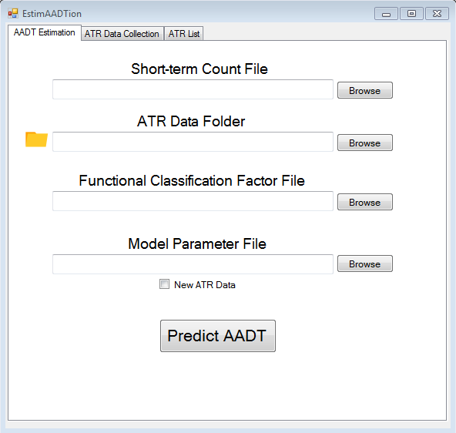

Step 1

Step 2

Step 3

Step 4

Step 5

Each step is described below.

**Step 1:** Input the location of the short-term count file using the browse button. The file must be in .csv format. You may also copy and paste the location of the file into the text box if you prefer.

**Step 2:** Input the location of the ATR data, which will be a folder produced by the script from step 2.1.2. You can use the browse button to locate this folder or copy and paste the folder location if you prefer.

**Step 3:** Input the location of the functional classification factor file. You can do this using the browse button or copying and pasting the folder location into the text box. This file must also be in .csv format.

**Step 4:** Input the model parameter file, which can be found using the browse button or the copy and paste method. The software will create a new model parameter file if you check the box “New ATR Data.” The procedure will take a while to complete (12 to 20 hours) as mentioned above, but this step should only be performed when inputting new ATR Data. The model parameters will get updated each time there is a new data. The next time the user wants to use the software with the same ATR data, the user can just select this file and leave the “New ATR Data” box unchecked.

**Step 5:** After providing all the inputs, the user can click the “Predict AADT” button at the bottom and the software will run the program. While the program runs in the background, a progress bar will show the progress of the software. After the run is completed, the software will provide the predicted AADT output in an excel file with the current date and time, so the users can identify it easily.

### *ATR Data Collection*

The second tab at the top of the window is designed for inputs related to ATR data collection. Below is a screenshot of it and the steps to input the appropriate files.

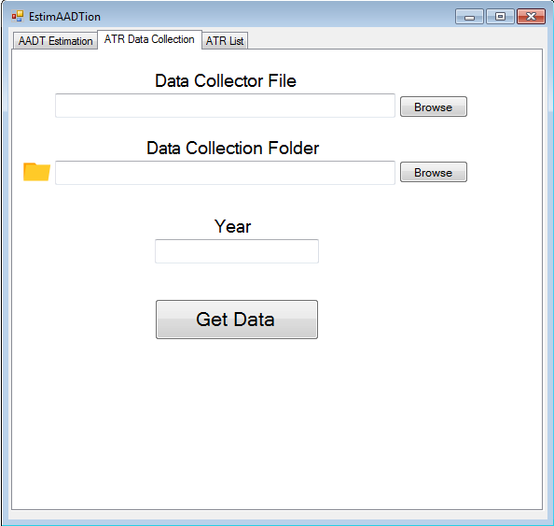

Step 1

Step 2

Step 3

Step 4

Each step is described below.

**Step 1:** Input the location of the data collector script using the browse button or copy and paste method. The script will be provided to the user with the software package, so the user is not required to write this script.

**Step 2:** Input the location to the data collection folder. The browse button can be used to browse to the folder where the user has selected to store the data. The user also has the option of copying and pasting the location of the folder in the box.

**Step 3:** Input the year of ATR data collection by typing in the format YYYY (i.e.- 2017, 2018).

**Step 4:** After providing all the inputs, click “Get Data” at the bottom and the software will run the program in the background.

### *ATR List*

Regardless of the whether the user is using the software to estimate AADT or collect ATR data, the software requires the list of ATRs entered on the third tab. ATRs can get added or removed for various reasons. So, the ATR list needs to be updated accordingly in an excel file (.csv file) and it should be uploaded whenever we use the software

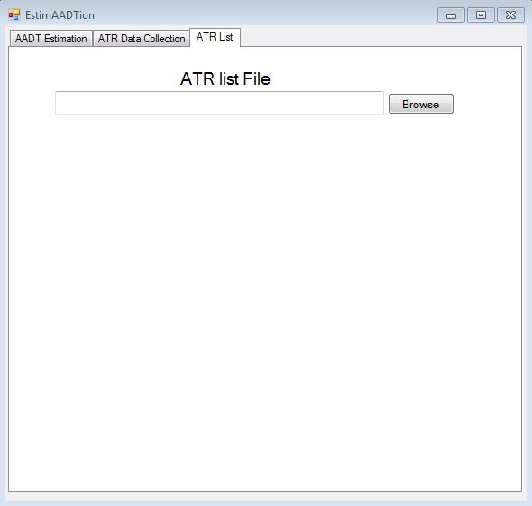

The browse button can be used to browse the location of the ATR list csv file. This file has to be in csv format. The user also has the option to copy and paste the location of the file in the box.