

User Manual

Ryan Evans
Barry Chapman
Sam Williams
Devin Coger
SoftEng06
www.radford.edu/~softeng06
12/10/2009

USER'S MANUAL
TABLE OF CONTENTS
Page #
1.0 GENERAL INFORMATION 1
1.1 System Overview 1
1.2 Project References 1
1.3 Points of Contact 1
1.3.1 Help Desk 1
1.4 Organization of the Manual 2
1.5 Acronyms and Abbreviations 2
2.0 SYSTEM SUMMARY 3
2.1 System Configuration 3
2.2 Data Flows 3
2.3 Contingencies and Alternate Modes of Operation 3
3.1 System Menu 4
3.1.1 Main Interface 4
3.1.2 New Customer 5
3.1.3 New Items 6
3.1.4 New Bids 7
3.1.5 New Donor 7
3.1.6 Search Customer 8
3.1.7 Search Item 9
3.1.8 Search Bids 10
3.1.9 Search Donors 11
3.1.10 Delete Customer by Customer ID 11
3.1.11 Exporting Data to Excel 12
3.2 Exit System 12
4.0 QUERYING 13
4.1 Querying 13
4.2 Query Capabilities 13
4.3 Query Procedures 14
5.0 REPORTING 15
5.1 Reporting 15
5.2 Report Capabilities 15
5.3 Report Procedures 15

1.0 GENERAL INFORMATION

GENERAL INFORMATION

1.1 System Overview

The system is designed to allow the user to seamlessly enter in data about a particular auction item (Such as minimum bid, price, name, etc.) using pre-programmed, easy-to-use forms. The information entered into the forms is then warehoused in a database. Users are then capable of generating a number of various reports based on the information in the database. The system is also capable of using Microsoft Excel to efficiently import and export data.

The system is designed to be run with Microsoft Access 2007, and was developed in the fall 2009 semester by the Shock Force Software team at Radford University. It is classified as a Major application, with a straightforward GUI.

1.2 Project References

The following is a list of the references that were used during development of the system:

- Microsoft Access 2007
- Microsoft Word 2007
- Microsoft Excel 2007
- Microsoft PowerPoint 2007
- Dr. Tracy Lewis
- Sheila Roop
- Barbara Greenberg

1.3 Points of Contact

1.3.1 Help Desk

In the event of a question pertaining to the operation of the program, users should contact the office of Dr. Tracy Lewis at (540) 831-5358, or via email tlewis32@radford.edu.

1.4 Organization of the Manual

This manual is divided into 5 major sections, listed and defined below.

- – General Information: Contains basic information about the program, such as functions performed and a description of the program.

- – System Summary: This section provides a general overview of the system.

- – Getting Started: This section provides a general walk-through guide to the system, from beginning to exit.

- – Querying: This section describes the query and retrieval capabilities of the system.

- – Reporting: This section describes the various reports that can be generated by the system.

1.5 Acronyms and Abbreviations

GUI – Graphical User Interface

SYSTEM SUMMARY

2.1 System Configuration

Users are provided with a GUI to interact with the database to complete tasks such as data insertion, data deletion, data modification, along with various queries and reports.

2.2 Data Flows

Users are presented with an interface from which they can select a variety of forms. The system then prompts the user to input specific data, which is then stored in the database. This data is able to be retrieved by the user through use of straightforward forms and reports, as well as export capabilities to Microsoft Excel.

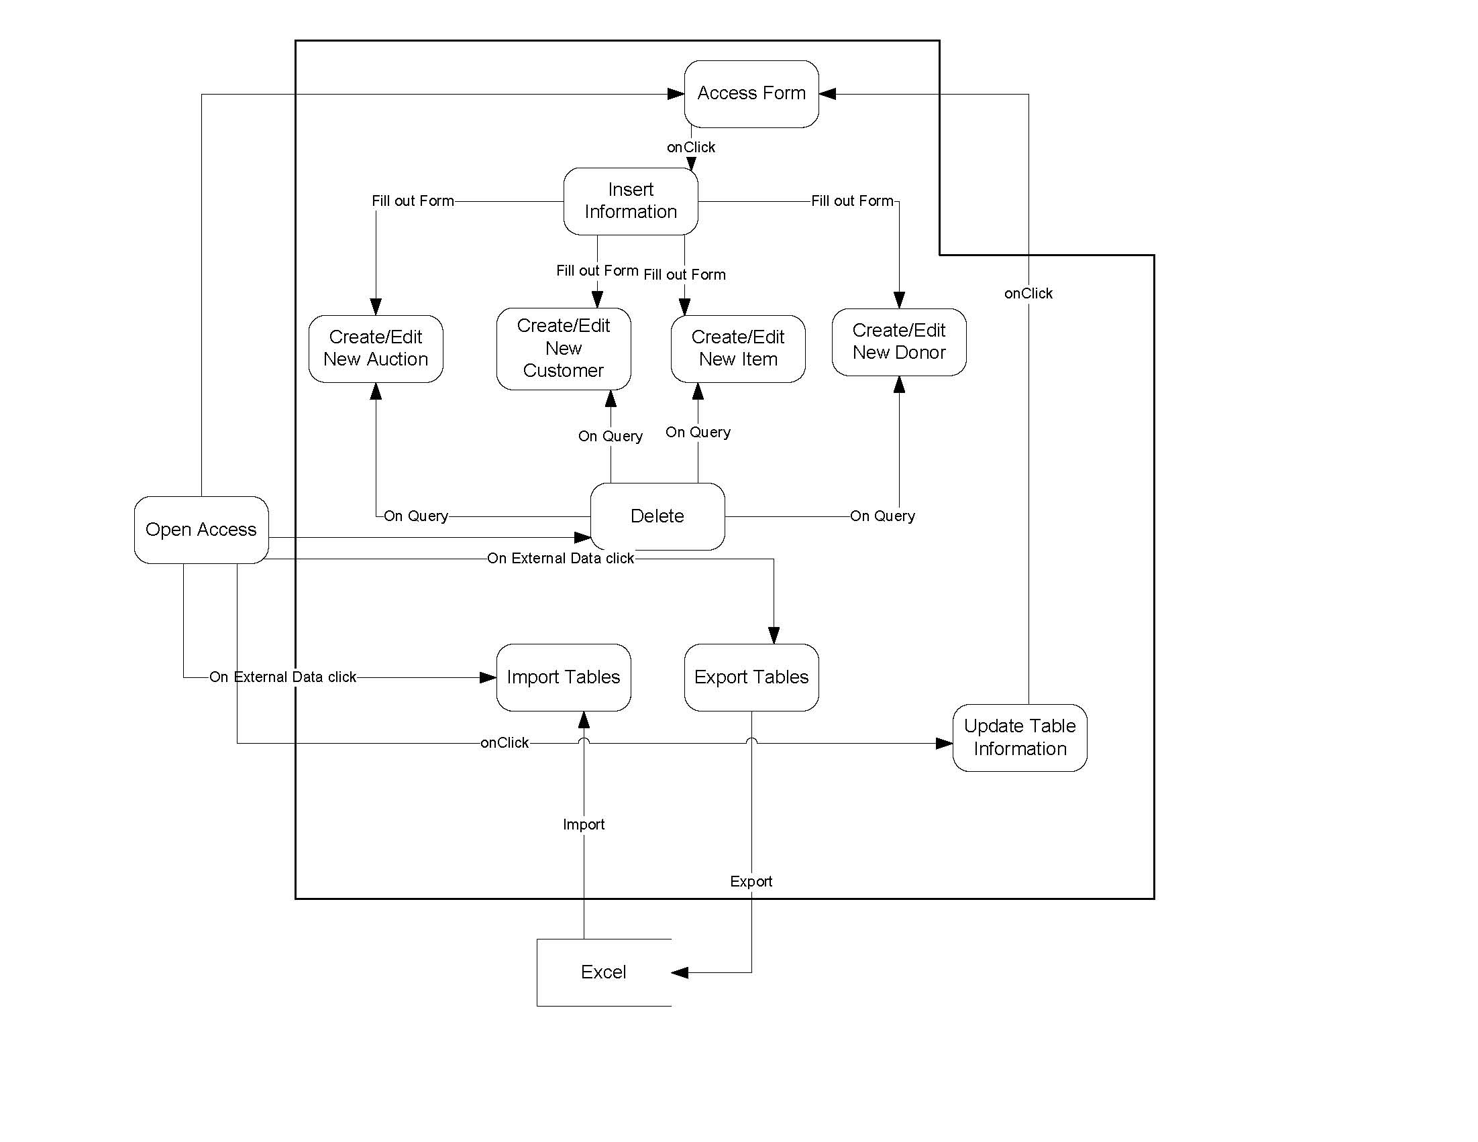

2.3 Contingencies and Alternate Modes of Operation

Regular backups should be performed, due to the fact that in the event of an emergency and/or accident, stored data could become lost.

3.0 GETTING STARTED

3.1 System Menu

3.1.1 Main Interface
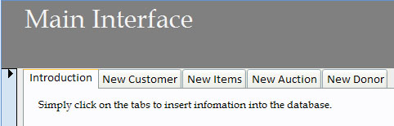

Upon launching the system, users are presented with the main interface (pictured above). By clicking the labeled tabs, users are capable of performing the following actions:

- New Customer
- New Items
- New Auction
- New Donor

3.1.2 New Customer

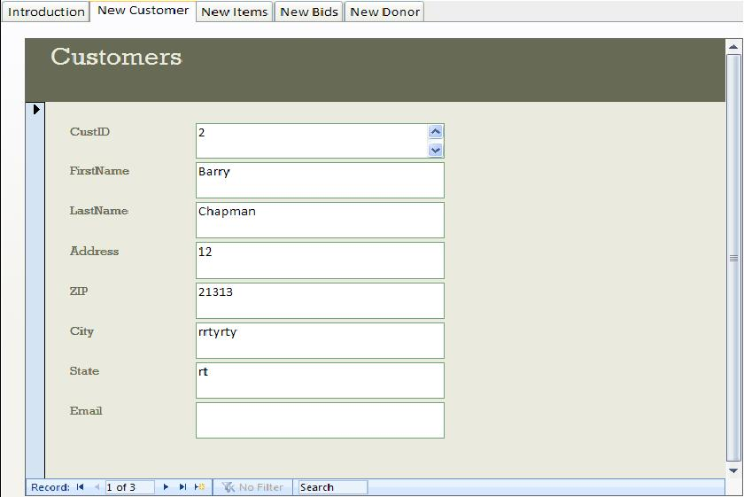

By clicking on the New Customer tab, users are able to easily create a record of a new customer. Users simply click the “New Record” icon,, located on the bottom panel and enter the requested information (CustID, First Name, Last Name, etc) into the form, and the customer is stored in the database.

3.1.3 New Items
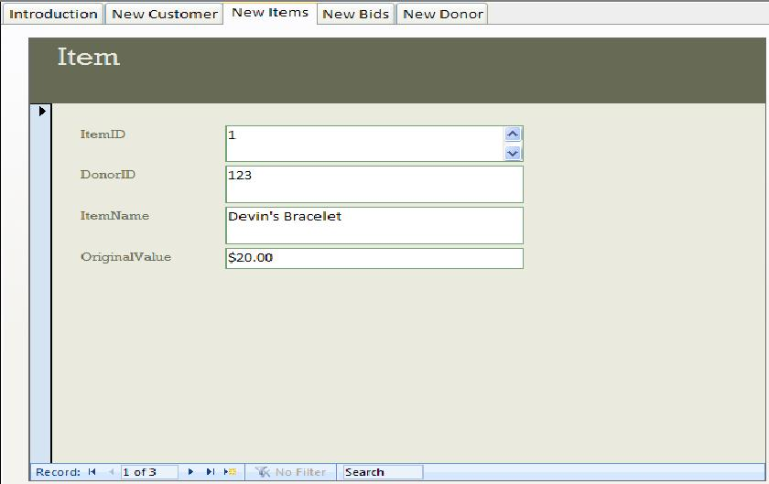

By clicking on the New Items tab, users are able to easily create a record of a new item. Users simply click the “New Record” icon,, located on the bottom panel and enter the requested information (ItemID, DonorID, Item Name, etc) into the form, and the item is stored in the database.

3.1.4 New Bids

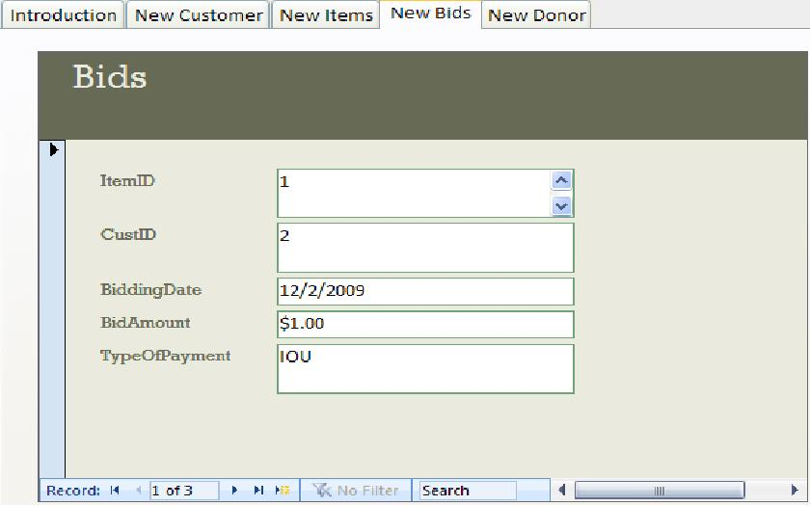

By clicking on the New Bids tab, users are able to easily create a record of a new bid. Users simply click the “New Record” icon,, located on the bottom panel and enter the requested information (ItemID, CustID, Bid Amount, etc) into the form, and the bid is stored in the database.

3.1.5 New Donor

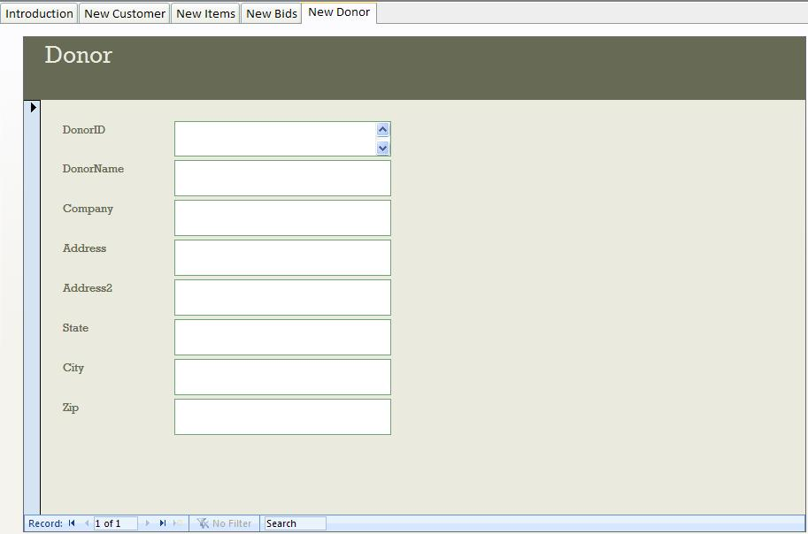

By clicking on the New Donor tab, users are able to easily create a record of a new donor. Users simply click the “New Record” icon, , located on the bottom panel and enter the requested information (Donor ID, Donor Name, Company etc) into the form, and the donor is stored in the database.

3.1.6 Search Customer

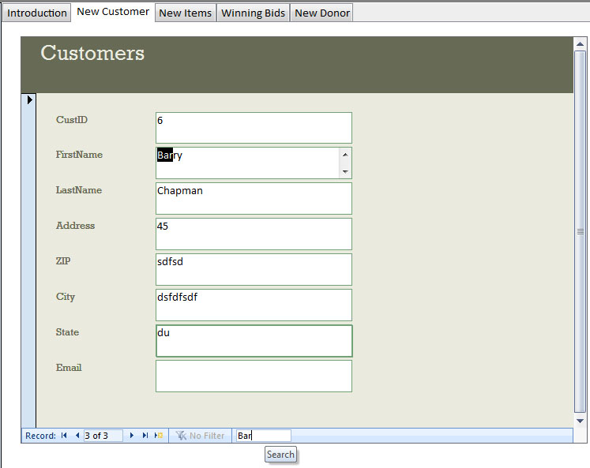

Users can search for a particular customer by clicking on the Customer tab, and then entering text into the search box located at the bottom of the panel. As the keyword is entered, the database searches for the word throughout the stored list of customers.

3.1.7 Search Item

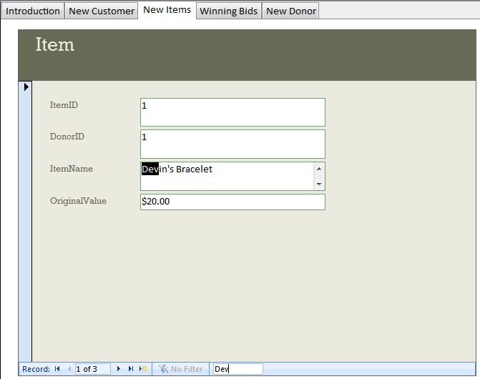

Users can search for a particular item by clicking on the Item tab, and then entering text into the search box located at the bottom of the panel. As the keyword is entered, the database searches for the word throughout the stored list of items.

3.1.8 Search Bids
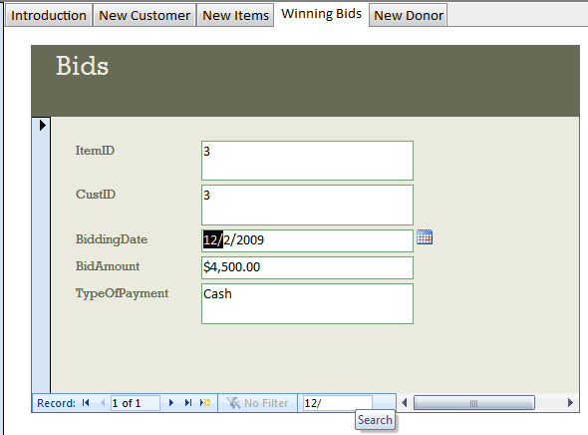

Users can search for a particular bid by clicking on the Bids tab, and then entering text into the search box located at the bottom of the panel. As the keyword is entered, the database searches for the word throughout the stored list of bids.

3.1.9 Search Donors
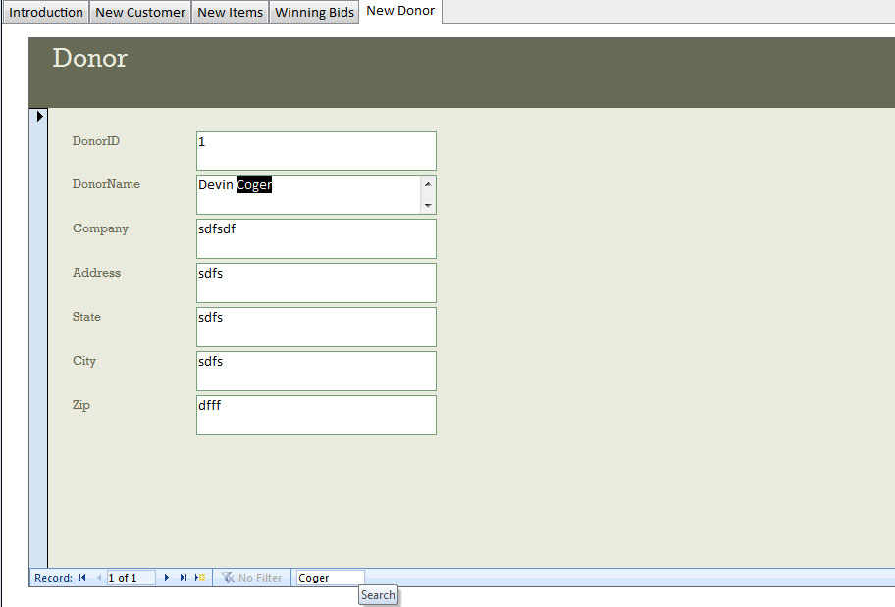

Users can search for a particular donor by clicking on the Donor tab, and then entering text into the search box located at the bottom of the panel. As the keyword is entered, the database searches for the word throughout the stored list of donors.

3.1.10 Delete Customer by Customer ID

Users are able to permanently remove a customer from the database by clicking on the option on the left-side of the screen labeled “Delete Customer by Customer ID”. Following this, they are shown a warning message to help prevent accidental deletion. Finally, the user is able to type in a Customer ID and remove their information from the database.

3.1.11 Exporting Data to Excel

Exporting to Microsoft Excel is achieved by first opening up the table which contains the desired information. Following this, users click the tab located at the top of the screen labeled “External Data” and are presented with the following screen:

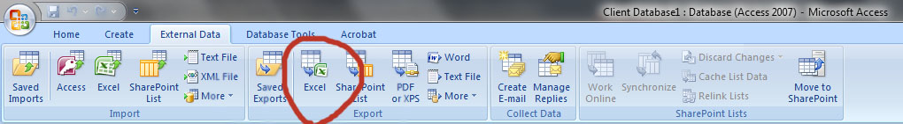

By clicking Excel in the “Export” Category, users can export their data to excel.

3.2 Exit System

Users should ensure that all of their changes and input have been saved in the database. Once their information has been saved, the user can either click the Microsoft ribbon, followed by Exit Access.

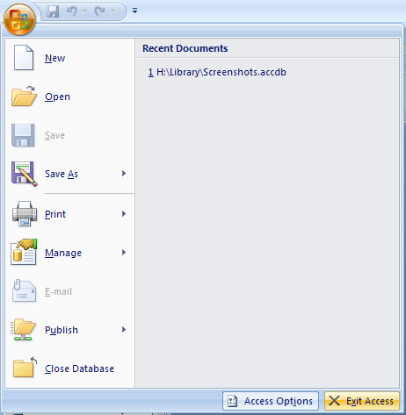
A secondary exit method available to the user is the x button located in the top right of the screen.

4.0 QUERYING

4.1 Querying

This section describes the query and retrieval capabilities of the system. The instructions necessary for recognition, preparation, and processing of a query applicable to a database shall be explained in detail.

4.2 Query Capabilities

There are various query capabilities pre-programmed into the system, available to the user by a variety of easy-to-use buttons on the left-hand side of the screen. These queries are accessible by clicking on sentences following the Query Icon ()

Search Customer: Allows the user to input a first and last name, and then provides all relevant information about the customer.

Items by Donor: Allows the user to input a donor’s first and last name and then displays all items donated by that particular donor.

Search Auctions by Customer: Allows the user to input a customer’s first and last name, and then displays the bids made by that customer, as well as additional information such as the date of the bid and what item they were bidding on.

4.3 Query Procedures

Users can access particular queries by clicking on the desired query, denoted by the Query Icon (), and then following the prompts that follow.

For example, to perform a Search Customer query: Users would click , which would generate a prompt asking for the customer’s first name.
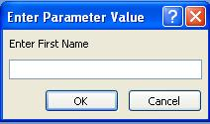
This would be followed by a prompt asking for the customer’s last name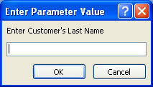. Then, all results found in the database will be displayed for the user.

5.0 REPORTING

5.1 Reporting

This section describes and depicts all standard reports that can be generated by the system or internal to the user.

5.2 Report Capabilities

The user is capable of generating various reports, such as:

Viewing a list of all customers in the database
Report of all auctions where a particular customer bid on items
Report of total profits of a particular auction.

These are available on the left-hand side of the window, marked by the Report icon ()

5.3 Report Procedures

In order to access these reports, double-click on the desired report, and then follow the prompts that follow.

For example, to run a report showing the total profits of a particular auction, users would first double-click on the report marked “Total Profits by Auction Date”.
Then, a prompt asking for the desired date appears: 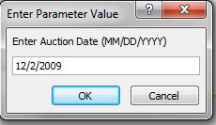
Finally, the report is generated and displayed to the user:
