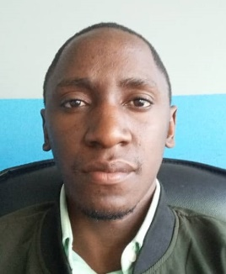Mr. Ngobi is a software developer who holds a BSc. in Software Engineering from Makerere University. Mr. Ngobi has over five years working experience in designing and developing Information systems, financial applications and Mobile applications for businesses and utilities in Uganda and Nigeria. The MIS he has developed include but not limited to: Billing, Payments collection, E-procurement to mention but a few. His most credible experience is the development of an in- house E-Procurement system for Lagos Water Corporation (LWC).  He was among the development team for the Osun billing system.  He developed the asset management system, billing system and human resource management system for state of Borno in Nigeria.

Mr. Ngobi Daniel has developed financial system for different banks in Uganda under Pegasus technologies. The Financial systems he has developed include Bulk Payment system for Ministry of Finance Uganda, Flexipay school fees platform for Stanbic bank Uganda. Mr. Ngobi was a backend developer for Stanbic bank Uganda agency banking and his main role was to integrate agency banking with all utility companies that allow payments through Stanbic bank Uganda. Mr. Ngobi was able to integrate Stanbic bank Uganda Teller payment platform to different utilities, which include Flexipay school fees, School pay, Chap Chap, Buganda Land board, Umeme, N.W.C. He was also the technical support engineer to Stanbic bank Uganda deployed by Pegasus technologies Uganda.

Mr. Ngobi has was the technical support engineer for Pegasus technology and his main role was to provide, and develop systems for the clients which include MTN Uganda, Wave (U.S.A), Airtel Uganda, NC bank, Postbank Uganda , Top Finance Uganda and many more clients.

He was a senior engineer for Swipe It Ltd and was able to develop the mobile money payment module for Apay Uganda. He integrated Startimes, Africel money, Africel airtime, Airtel money to Apay. He is also the developer for top finance bank Agency banking for both carded and non-carded customers.

Mr. Ngobi has been able to accumulate a lot of experience in development of Unstructured Supplementary Service Data (USSD) as he has designed and implemented USSD system for Liquid telecom and top finance bank.

MTN Uganda awarded him for having developed the best mobile application in the MTN App challenge of 2017. He has participated in different competitions, which include WAZIHUB for internet of things (IoT), Intel developer completion, Microsoft Imagine Cup and many other completions.