**Create the IAM user**

* Go to the Root User of your AWS account.
* Go to IAM
* Created the user and made sure I granted the user admin access. I also ensured that I saved the AccessKey ID and Secret Access Key for the user.

**Configure User**

To configure the user, I made use of Git Bash

* The command to configure user: aws configure



* For the input request for the AWS Access Key ID, I entered the access id generated when I created the user.
* For the input request for the AWS Shared Access Key, I entered the access key generated when I created the user
* For the input request for the Default region name, I used “us-east-1” because this was the region where my user was created.
* For the input request for Default output format [json], I used json.

**Requirements to create the EC2 instance**

**VPC ID:**

* Go to the AWS console, search VPC. There should be a default VPC available in the account if you have not created one. I used the default VPC.
* Copy the VPC id as seen on the console for later use

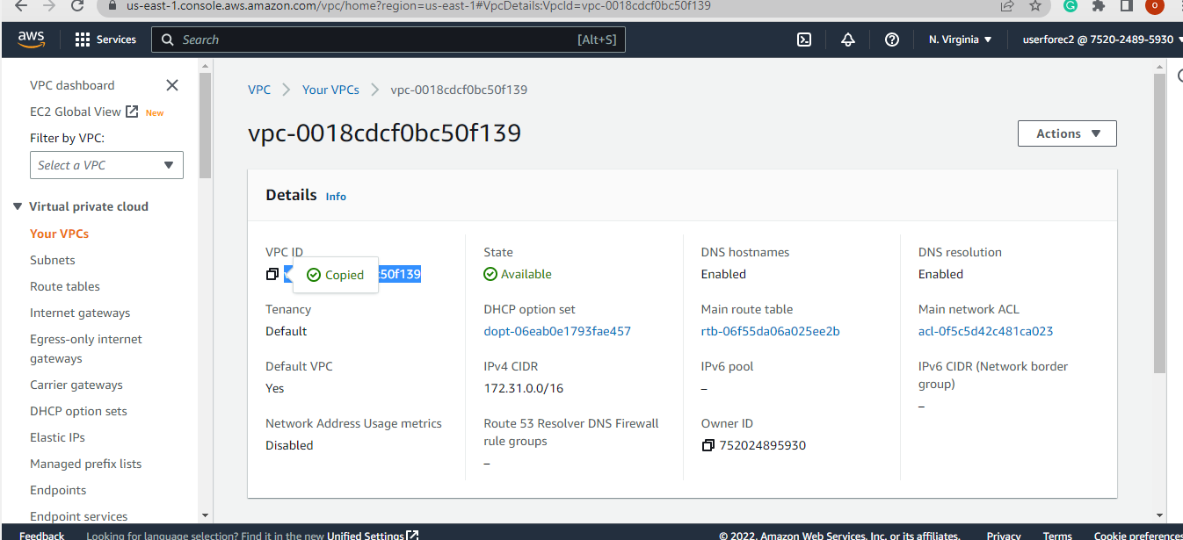

Subnet ID:

* Under the VPC dashboard, I clicked on Subnets

* I selected one of the subnets that is has the VPC id that has been copied
* I also Copied the Subnet Id for later use

**AMI ID:**

* Go to the AWS console, search EC2. Scroll down the EC2 dashboard and select AMI catalog.

* Scroll down the AMI Catalog and copy the ami id for the service you want to use. For me, I made use of the Ubuntu Server 22.04 LTS (HVM), SSD Volume Type with ami id: ami-0574da719dca65348. Copy the ami Id for later use

Key Pair

* Create the Key Pair that would be used to ssh into the server after creating the Ec2 instance
* Command line: aws ec2 create-key-pair --key-name MyEc2-key --query 'KeyMaterial' --output text > MyEc2-key.pem



* The pem file was saved to the directory named MyEc2-key.pem

Security Group  
 The security group is also needed as a requirement to create the Ec2 instance.

* To create the security group, I used the vpc-id which is optionally.



* Then add the inbound rules

**Run EC2 instance**

With all the requirements that has been created, I ran the EC2 instance as seen below

* Command: aws ec2 run-instances --image-id ami-0574da719dca65348 --count 1 --instance-type t2.micro --subnet-id subnet-012b198803eebfe8d --security-group-ids sg-0d2c73c0ac91bdc4f --key-name MyEc2-key

Here is the EC2 instance in Console

* Click on connect at the top of the EC2 instance
* Click on EC2 Instance Connect

* Click Connect, you should get to the page where the server is available to make use of.

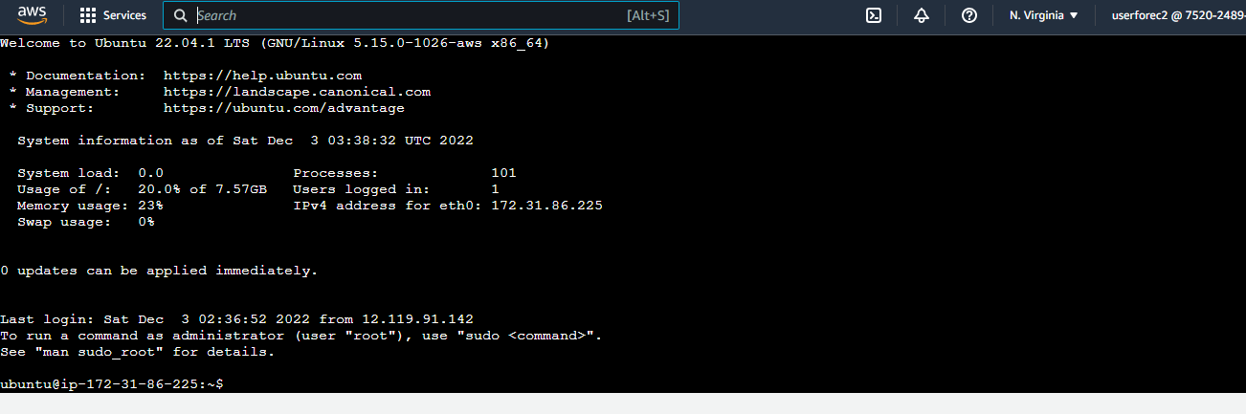

**SSH into the EC2 instance**

* Used the key Pair created to SSH into the EC2 instance and created some directory

* After that I created some folders in the Server to test its functionality
* Then I went back to the server through the Console to check if the folders are there with the ls command.

