Diving into Model Training with Teachable

Machine

Zaeema Rabeet

(BSEM-F16-160)

Superior University

Lahore,Pakistan

[BSEM-F16-160@superior.edu.pk](mailto:BSEM-F16-160@superior.edu.pk)

***Abstract--- This Document explain the DS (Data Science) Project. Project (Dividing into Model Training with Teachable Machine) is based three process i.e. 1) is Data Gathering, 2) Data Training and 3) Data Exporting. Project has four classes and per class has specific field. The further discussion are given.***

1. **INTRODUCTION**

The project is a audio project ***recognizing the bird sound Project***. This project has four classes, one base class and three process. The first class is ***sparrow continuous*** and in this class, Record all the sound samples of the sparrow sound. Second class is peacock. This class has the recorded sound samples of peacock. The third class is blackbird. This class also have audio data of blackbird the fourth one is Starling. This class stores the enough data needed to proceed with the training of model. Three process in this project based on three process the first is data gathering, the second one is training, and the third one is exporting the information of output.

1. **CLASSES.**
   1. Sparrow

### SONGS

The Song Sparrow sings a loud, clanking song of 2–6 phrases that typically starts with abrupt, well-spaced notes and finishes with a buzz or trill. In between, the singer may add other trills with different tempo and quality. The song usually lasts 2-4 seconds.

Patterns of songs vary over the species’ enormous range, so the Song Sparrows you hear when traveling may not sound quite like those from your hometown.

### CALLS

Song Sparrows have a sharp chip note to indicate alarm or anxiety; both sexes make it when excited or if predators approach a nest. Females make a harsh chatter at their mates during nest-building, or at a female intruding on the territory. Young or subordinate birds make a softer, *tsip* note.

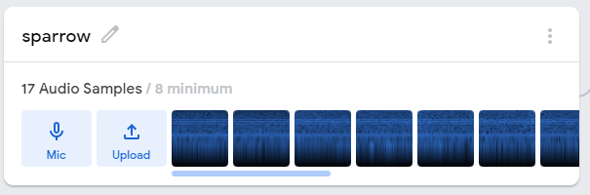

## peacock

Indian blue peafowl are known best for their exquisite train and plumage. If the length of the tail and wing span is included, the peafowl is considered one of the largest flying birds. They weigh in between 2.7-6 kg and have a wingspan of 1.4-1.6 m. They vary widely in length from 0.86-2.12 m. This species has long, strong, grayish-brown legs equipped for running away into brush for safety. Both sexes are equipped with spurs that are around 2.5 cm long; males will use them during the breeding season to ward off other competing males. Females are brown, grey, and cream-colored. Chicks are usually a light yellow to brown color. The males have a long train, about 1.2 m in length on average, from June to December. The train is discarded in January, but is grown again at a rapid pace when breeding season approaches. Their necks and breasts are a bright blue, golden feathers line their sides and backs, and their trains are an iridescent arrangement of multiple colors featuring ocelli (eye-spots). When displayed, the male’s train spreads out in a wide fan, showing off gold, brown, green, and black feathers. Around 30 to 40 of the ocelli around the outer edges of the fan are not round but v-shaped. This complicated pattern is thought to be an advantage in mating, and even though it might seem like this bright pattern would make peafowl stand out, they can very easily disappear into foliage, making it extremely hard to spot

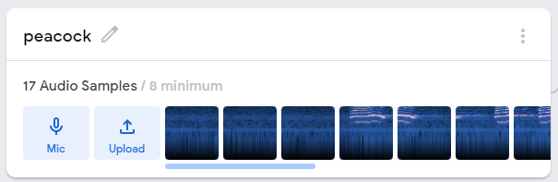

## Black Bird

### SONGS

Both males and females sing two kinds of rather rudimentary songs. The first is a shrill, rising squee that lasts about 0.8 second, with a metallic sound. It’s reminiscent of the ree part of the Red-winged Blackbird’s conk-la-ree call. The second song is a nonmusical rushing gurgle, also lasting less than a second.

### CALLS

Brewer’s Blackbirds often make a tchup or chuk similar to the calls of other blackbirds, and used in a manner scientists have called “conversational in nature.” A more intense, slightly higher pitched version of this call is used as an alarm, to chase off intruders, and when carrying food for young. Males make a clear, descending whistle, about 0.5 second long, when they sight hawks or large birds. Quarreling females chatter at each other with a kit-tit-tit-tit call

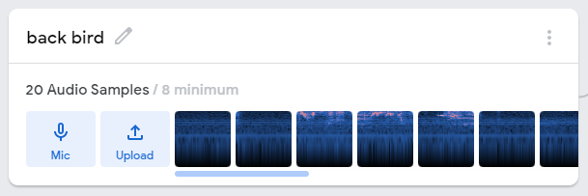

## Starling Bird

### SONGS

Starlings are relatives of the mynah birds, and like them they have impressive vocal abilities and a gift for mimicry. They can warble, whistle, chatter, make smooth liquid sounds, harsh trills and rattles, and imitate meadowlarks, jays, and hawks. The songs tend to consist of either loud whistles or softer, jumbled warbling. Whistled songs are a few seconds long, often used between males. Warbled songs can go on for more than a minute, and seem mainly directed at females. Males sing several varieties of each of these two classes of songs. Females also sing, particularly in the fall. Songs often include imitations of other birds, including Eastern Wood-Pewee, Killdeer, meadowlarks, Northern Bobwhite, Brown-headed Cowbird, Northern Flicker, and others.

### CALLS

Male and female starlings use about 10 kinds of calls to communicate about where they are, whether there’s danger around, and how aggressive or agitated they feel. Among these are a purr-like call given as the bird takes flight, and a rattle that starlings make as they join a flock on the ground. Two types of screamlike calls indicate aggression and are often accompanied by flapping wings: one is a chattering call (described as *chackerchackerchacker*); the other is a high-pitched trill. Starlings also make metallic chip notes to other flock members and when harassing or mobbing predators.

### OTHER SOUNDS

Male starlings sometimes clack or rattle their bills as part of their warbled song

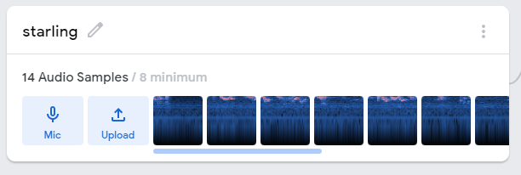

## Background noise

You’ll always need a background noise class, to detect when no noise is happening at all. And because background noise in a forest is different than in an office (or anywhere else,) you should give that class audio samples for anywhere you foresee using your model.

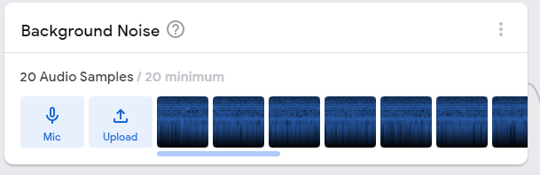

1. **Training**

After all the classes to be in the queue we are ready to train the model. This software is automated software that train the model it self when you ready just press the button train model and automatically model will be trained

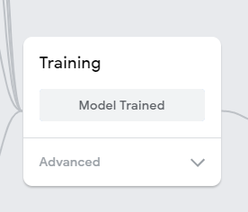

1. **Preview/Output**

Preview/output is the phase where we can check out model as it works perfectly or not. Just need to give audio to the model and it will tell from what class it belongs

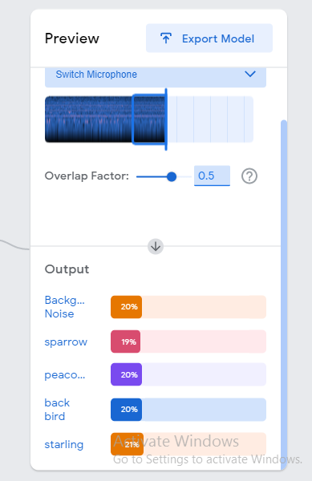

## PROCECC.

## *A.* Data Gathering.

In this process get app the information about classes inform of pics, inform of voice, or inform of recording the data in this stage is a non-trainable data or dirty data. It is just an information, which used in project and get all information related to classes.

## B. Training.

In this process, the getting data start training process all the data who get in Data Gathering process. This process realized the difference between classes and then this training data will use to realize the input information are related which class.

## C. Exporting.

Exporting process use to get the output data after gathering and training and this output will be use in different, other process like check the quantity of the classes etc.

# CONCLUSION

Dividing into model training in this training project get the all information about classes and after this training use the information in different process for realized input information belongs which class.

# Links

### Github link:

<https://github.com/zaeema434/teachablemachine-community-snippets-markdown-audio-tensorflowjs-javascript.md/tree/master>

### Youtube link:

<https://youtu.be/sqohVEjA9rU>

### teachable machine audio project’s preview

https://teachablemachine.withgoogle.com/models/BvPESrNy5/