**Problem # 1:** π can be calculated using the following infinite series:

$$π=4- \frac{4}{3}+ \frac{4}{5}- \frac{4}{7}+ \frac{4}{9}- \frac{4}{11}+ …$$

Write a code that prints the value of π after the first 100 terms, 200 terms and 300 terms (in the same code).

**Problem # 2:** Write a program which takes number of lines of patterns and print following patterns (Sample output for noOfLines = 6)

**\***

**\*\***

**\*\*\***

**\*\*\*\***

**\*\*\*\*\***

**\*\*\*\*\*\***

**\*\*\*\*\*\***

**\*\*\*\*\***

**\*\*\*\***

**\*\*\***

**\*\***

**\***

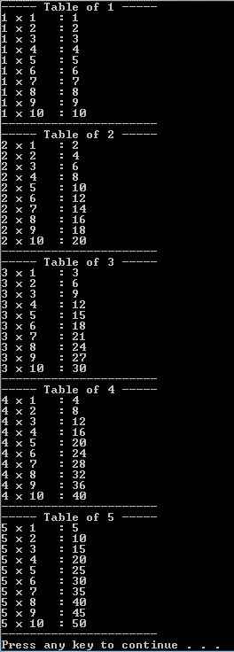**Problem # 3:** Write a program

that uses nested for – loops to print first 10 entries of tables of x to y. For example:

If user enters the value of x “1” and value of y “5” then the following output should be displayed.