**Selection Sort**

Selection sort is a simple sorting algorithm. This sorting algorithm is an in-place comparison-based algorithm in which the list is divided into two parts, the sorted part at the left end and the unsorted part at the right end. Initially, the sorted part is empty and the unsorted part is the entire list.

The smallest element is selected from the unsorted array and swapped with the leftmost element, and that element becomes a part of the sorted array. This process continues moving unsorted array boundary by one element to the right.

**How Selection Sort Works?**

Consider the following depicted array as an example.

Unsorted Array

For the first position in the sorted list, the whole list is scanned sequentially. The first position where 14 is stored presently, we search the whole list and find that 10 is the lowest value.

Selection Sort

So we replace 14 with 10. After one iteration 10, which happens to be the minimum value in the list, appears in the first position of the sorted list.

Selection Sort

For the second position, where 33 is residing, we start scanning the rest of the list in a linear manner.

Selection Sort

We find that 14 is the second lowest value in the list and it should appear at the second place. We swap these values.

Selection Sort

After two iterations, two least values are positioned at the beginning in a sorted manner.

Selection Sort

The same process is applied to the rest of the items in the array.

Following is a pictorial depiction of the entire sorting process −

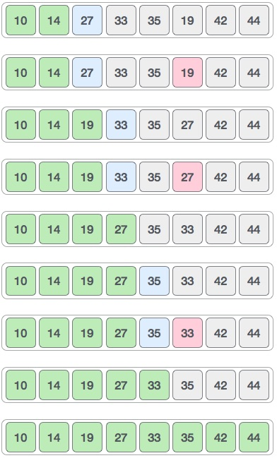

**Binary Search**

Search a sorted array by repeatedly dividing the search interval in half. Begin with an interval covering the whole array. If the value of the search key is less than the item in the middle of the interval, narrow the interval to the lower half. Otherwise narrow it to the upper half. Repeatedly check until the value is found or the interval is empty.

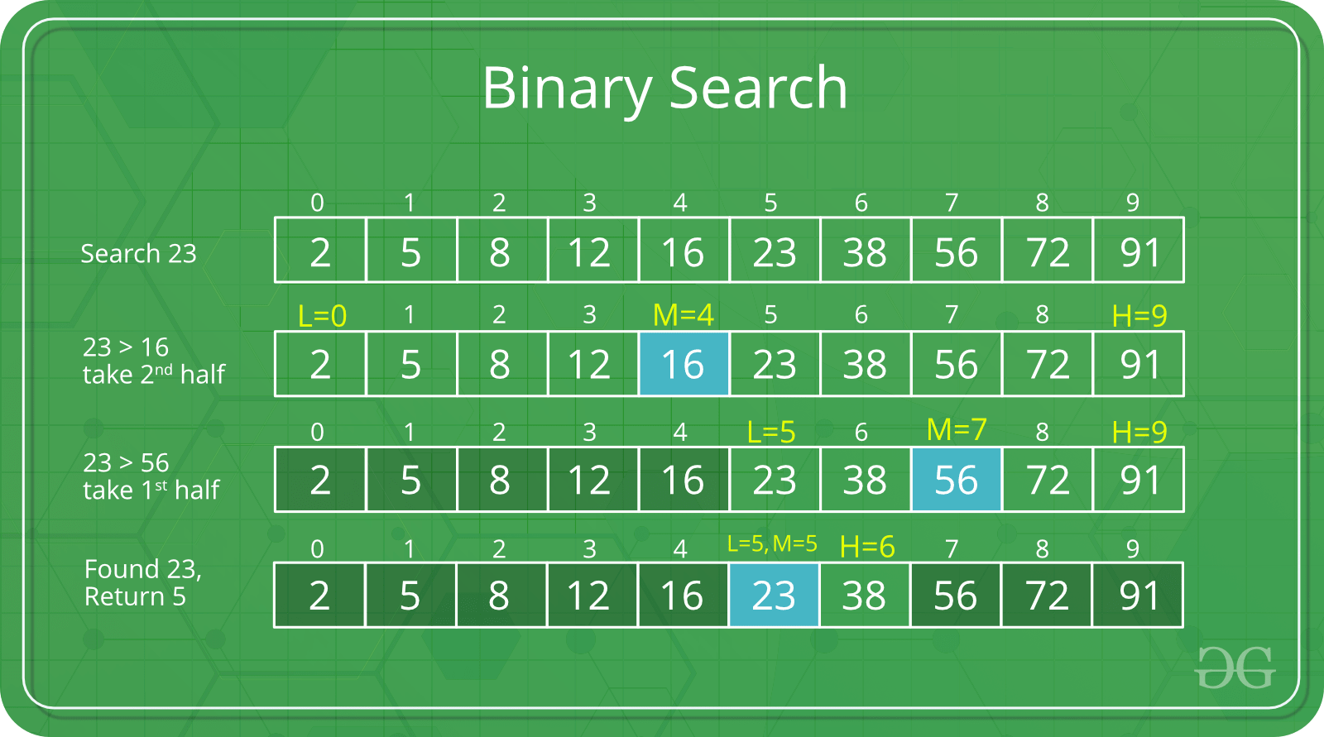

Reference:

<https://www.tutorialspoint.com/data_structures_algorithms/selection_sort_algorithm.htm>

<https://www.geeksforgeeks.org/binary-search/>