**COAL Project – Atari Breakout**

**Phase I - Display**

**Deadline: Saturday 21st November, 2020**

**Important Note: Students will implement the project individually. Best implement the programming and other practices.**

You are required to display four rows of bricks, one blue bar in the last row and any character (consuming one cell) that we will use as ball.

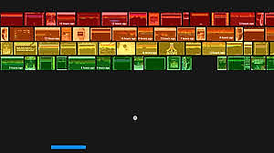

**Phase II & III - Welcome Screen and Ball Movement**

**Deadline: Monday 7th December, 2020**

**Welcome Screen Requirements**

1- Display user friendly Welcome/Introduction Screen that will tell user about the rules and other important information (if any) about the game.

2- Ask user to press Enter to Continue and Esc to exit

3- Implement all the functionality of part (a) using BIOS/DOS Services.

**Ball Movement**

You have to implement the ball movement according to the online game. It includes breaking the bricks, handling lives and score. Also you have to properly show the score at the end of game.

**Requirements Update:** Our ball will be moving at the angles of 90 and 45 degrees only.

**Phase IV - Sliding Bar and Notifications**

**Deadline: Monday 14th December, 2020**

1- Slide the Blue Bar if the user presses Right or Left Arrow Key using Keyboard Interrupt.

2- Add notification tones according to the online game.