Contents

About Jenkin WebHook 1

GitHub Configuration 2

Git Hub PAT (Personal Access Token) 3

Add Secrets in Jenkins 5

Connect Jenkins With GitHub Api 5

Webhook Pipeline 6

Terraform Build AWS VM From Jenkins 8

Run Deployment on Aws VM 8

# About Jenkin Webhook

# GitHub Configuration

1. Login to you github account
2. Brows your Github repo
3. Click on Settings
4. Click on WebHooks

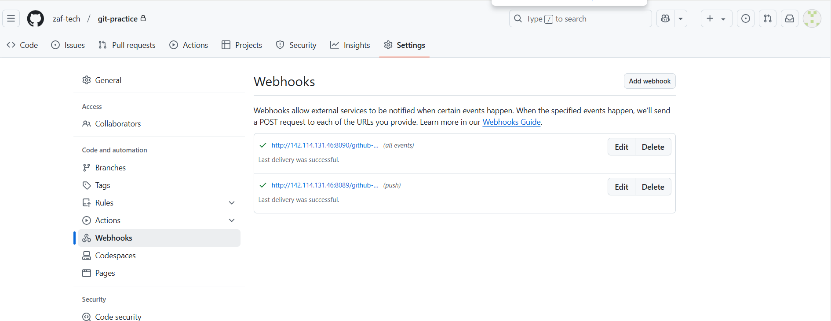

1. Payload URL is your Jenkins URL (Make sure your Jenkins URL must be accessible from internet ) **Click Save**

# Git Hub PAT (Personal Access Token)

1. Click on your github user Settings on the right top corner of the github page.

1. Click on Setting
2. On the left bottom side of the page click on Developer Settings

1. Click on Personal Access Token

1. Select Token (Classic)

1. Click on Generate token and select the following permissions.

admin:repo_hook –

for managing hooks (read, write and delete old ones)

# Add Secrets in Jenkins

Manage Jenkins 🡺 Credentials 🡪 System – Global Credentials

Click Add Credentials

Secret value we obtain from Step 1 “Git PAT” and click create.

# Connect Jenkins With GitHub Api

Manage Jenkins 🡪 System 🡪 “Search for Github”

# Webhook Pipeline

Let’s create a pipeline that trigger when code change in github

1. Click On New Item, name Webhook and select Pipeline

1. Check “GitHub Hook Trigger for GITcm polling”
2. Go to definition, Select Git , Repository provide Git repo credentials branch “main or aster” and “Jenkins_file”

1. Click “Save and Apply”
2. Let’s commit something in git branch and see if Job automatically triggers on Jenkins

# Terraform Build AWS VM From Jenkins

1. Add new credentials in Jenkins for aws secret keys

AWS Secret Key

AWS Secret access Key

# Run Deployment on Aws VM

Let’s run automatic deployment on aws linux machine from Jenkins right after VM deployed from AWS.

Jenkins plugin required for this “SSH-Agent”