**University of Central Punjab**

**Department of Computer Science**

**Project Report – Semester Spring 2024**

**Project Title: BuildiumPro**

**Submitted By:**

**M Zafar Ul Haq**

**Abstract**

BuildiumPro is a comprehensive software solution aimed at streamlining the management and operations of building projects through effective use of MySQL for data storage and retrieval. The system enhances efficiency, improves communication, and ensures accurate project tracking and resource management. By leveraging database technology, BuildiumPro provides a robust platform for managing various aspects of construction management, such as project planning, scheduling, budgeting, and documentation.

**Introduction**

The construction industry often faces challenges related to inefficiencies and communication breakdowns, resulting in project delays and increased costs. BuildiumPro addresses these issues by offering a centralized platform that facilitates seamless collaboration and real-time information sharing among all project stakeholders, from project managers to subcontractors.

**Objectives:**

1. Develop a user-friendly database schema for project management.

2. Implement robust features for scheduling and resource allocation using MySQL.

3. Ensure real-time tracking and reporting capabilities through SQL queries.

4. Enhance communication among team members and stakeholders using database tools.

5. Integrate financial management tools to monitor budgets and expenses using MySQL.

**System Design**

**Architecture:**

BuildiumPro employs a multi-tier architecture consisting of a user interface layer, an application logic layer, and a data storage layer using MySQL. This design ensures scalability, maintainability, and ease of integration with other syste**ms.**

**Modules:**

**1. Project Management:** Tools for creating, updating, and tracking project milestones and tasks using MySQL.

**2. Resource Management:** Allocation and monitoring of resources, including labor, materials, and equipment using MySQL.

**3. Scheduling:** Tools for planning and adjusting project timelines using MySQL.

**4. Financial Management:** Budget tracking, expense monitoring, and financial reporting using MySQL.

**5. Communication:** Tools for storing and managing messages and notifications to keep all team members informed using MySQL.

**Methodology**

The development of BuildiumPro followed the Agile methodology, allowing for iterative progress and continuous feedback from stakeholders. This approach ensured that the final product closely aligned with user needs and industry requirements.

**Development Tools:**

**Database:** MySQL

**Design:** Entity-Relationship Diagram (ERD)

### Features

**Database Schema:**  
BuildiumPro features a well-structured and normalized database schema, ensuring efficient data storage and retrieval. The ERD provides a clear visualization of the database structure, facilitating easy maintenance and scalability.

**Scheduling and Planning:**  
The system includes SQL queries that allow project managers to create detailed project plans, assign tasks, and adjust timelines as needed. The schema supports storing project progress and dependencies.

**Resource Management:**  
Resource allocation is simplified through a dedicated database schema that tracks the availability and utilization of materials, labor, and equipment. Alerts can be generated using SQL queries when resources are over-allocated or under-utilized.

**Financial Management:**  
BuildiumPro includes comprehensive financial management tools that enable users to create budgets, track expenses, and generate financial reports using MySQL. This ensures that projects remain within budget and financial health is continuously monitored.

**Communication:**  
The platform supports robust communication features through a database schema that stores messages, email notifications, and document sharing information. This ensures that all stakeholders are kept informed and can collaborate effectively.

### Implementation

The implementation phase involved rigorous testing to ensure the system's reliability and performance. User acceptance testing (UAT) was conducted with a select group of industry professionals to gather feedback and make necessary adjustments.

**Deployment:**  
BuildiumPro is deployed on a cloud-based infrastructure, providing scalability and accessibility. Regular updates and maintenance are scheduled to ensure the system remains up-to-date with the latest features and security patches.

### Conclusion

BuildiumPro represents a significant advancement in construction project management, offering a comprehensive and user-friendly platform that addresses the industry's most pressing challenges. The system's robust features and seamless integration capabilities make it an invaluable tool for project managers and stakeholders.

### Future Work:

Future enhancements will focus on incorporating web-based interfaces to improve user accessibility and interaction. Additionally, advanced analytics and machine learning will be integrated to provide predictive insights and further optimize project management processes.

**PROJECT 2 INSERTION AND JOINS**

CREATE DATABASE RealEstateManagementSystem;

USE RealEstateManagementSystem;

CREATE TABLE Clients (

ClientID INT AUTO_INCREMENT PRIMARY KEY,

FirstName VARCHAR(100),

LastName VARCHAR(100),

Email VARCHAR(255),

Phone VARCHAR(20)

);

CREATE TABLE Landlords (

LandlordID INT AUTO_INCREMENT PRIMARY KEY,

FirstName VARCHAR(100),

LastName VARCHAR(100),

Email VARCHAR(255),

Phone VARCHAR(20)

);

CREATE TABLE Properties (

PropertyID INT AUTO_INCREMENT PRIMARY KEY,

Address VARCHAR(255),

City VARCHAR(100),

State VARCHAR(100),

PostalCode VARCHAR(20),

Country VARCHAR(100),

OwnerID INT,

FOREIGN KEY (OwnerID) REFERENCES Landlords(LandlordID)

);

CREATE TABLE Listings (

ListingID INT AUTO_INCREMENT PRIMARY KEY,

PropertyID INT,

ListingType ENUM('Sale', 'Rent'),

Price DECIMAL(10, 2),

ListingDate DATE,

Status ENUM('Available', 'Sold', 'Rented'),

FOREIGN KEY (PropertyID) REFERENCES Properties(PropertyID)

);

CREATE TABLE Sales (

SaleID INT AUTO_INCREMENT PRIMARY KEY,

ListingID INT,

ClientID INT,

SaleDate DATE,

SalePrice DECIMAL(10, 2),

FOREIGN KEY (ListingID) REFERENCES Listings(ListingID),

FOREIGN KEY (ClientID) REFERENCES Clients(ClientID)

);

CREATE TABLE Rents (

RentID INT AUTO_INCREMENT PRIMARY KEY,

ListingID INT,

ClientID INT,

StartDate DATE,

EndDate DATE,

RentAmount DECIMAL(10, 2),

FOREIGN KEY (ListingID) REFERENCES Listings(ListingID),

FOREIGN KEY (ClientID) REFERENCES Clients(ClientID)

);

CREATE TABLE Payments (

PaymentID INT AUTO_INCREMENT PRIMARY KEY,

ClientID INT,

RentID INT,

Amount DECIMAL(10, 2),

PaymentDate DATE,

PaymentMethod VARCHAR(100),

FOREIGN KEY (ClientID) REFERENCES Clients(ClientID),

FOREIGN KEY (RentID) REFERENCES Rents(RentID)

);

CREATE TABLE MaintenanceRequests (

RequestID INT AUTO_INCREMENT PRIMARY KEY,

PropertyID INT,

ClientID INT,

Description TEXT,

RequestDate DATE,

Status ENUM('Pending', 'In Progress', 'Completed'),

FOREIGN KEY (PropertyID) REFERENCES Properties(PropertyID),

FOREIGN KEY (ClientID) REFERENCES Clients(ClientID)

);

**INSERTION**

-- Inserting data into Landlords

INSERT INTO Landlords (FirstName, LastName, Email, Phone)

VALUES

('Ahmed', 'Khan', 'ahmed.khan@example.com', '+923001234567'),

('Fatima', 'Malik', 'fatima.malik@example.com', '+923006543210'),

('Sajid', 'Butt', 'sajid.butt@example.com', '+923212345678'),

('Zainab', 'Hussain', 'zainab.hussain@example.com', '+923213456789'),

('Bilal', 'Ahmed', 'bilal.ahmed@example.com', '+923314567890'),

('Imran', 'Sheikh', 'imran.sheikh@example.com', '+923325678901'),

('Maria', 'Akhtar', 'maria.akhtar@example.com', '+923336789012'),

('Kamran', 'Javed', 'kamran.javed@example.com', '+923347890123'),

('Ayesha', 'Aslam', 'ayesha.aslam@example.com', '+923358901234'),

('Tariq', 'Riaz', 'tariq.riaz@example.com', '+923369012345'),

('Nazia', 'Iqbal', 'nazia.iqbal@example.com', '+923379123456'),

('Yasir', 'Ali', 'yasir.ali@example.com', '+923389234567'),

('Saima', 'Hassan', 'saima.hassan@example.com', '+923399345678'),

('Jamal', 'Ansari', 'jamal.ansari@example.com', '+923409456789'),

('Noman', 'Qureshi', 'noman.qureshi@example.com', '+923419567890'),

('Hina', 'Latif', 'hina.latif@example.com', '+923429678901'),

('Shahzad', 'Mirza', 'shahzad.mirza@example.com', '+923439789012'),

('Asif', 'Bhatti', 'asif.bhatti@example.com', '+923449890123'),

('Rubina', 'Gill', 'rubina.gill@example.com', '+923459901234'),

('Kashif', 'Nawaz', 'kashif.nawaz@example.com', '+923460012345'),

('Sumaira', 'Chaudhry', 'sumaira.chaudhry@example.com', '+923471234567'),

('Waqas', 'Mansoor', 'waqas.mansoor@example.com', '+923482345678'),

('Farah', 'Tanveer', 'farah.tanveer@example.com', '+923493456789'),

('Omar', 'Naeem', 'omar.naeem@example.com', '+923504567890'),

('Saira', 'Adeel', 'saira.adeel@example.com', '+923515678901'),

('Anwar', 'Shafi', 'anwar.shafi@example.com', '+923526789012'),

('Hamza', 'Shah', 'hamza.shah@example.com', '+923537890123'),

('Nadia', 'Rashid', 'nadia.rashid@example.com', '+923548901234'),

('Raza', 'Kamal', 'raza.kamal@example.com', '+923559012345'),

('Zubair', 'Nasir', 'zubair.nasir@example.com', '+923560123456');

-- Inserting data into Properties

INSERT INTO Properties (Address, City, State, PostalCode, Country, OwnerID)

VALUES

('123 Gulberg St', 'Lahore', 'Punjab', '54000', 'Pakistan', 1),

('45 DHA Phase 5', 'Karachi', 'Sindh', '75500', 'Pakistan', 2),

('78 Mall Road', 'Islamabad', 'Capital Territory', '44000', 'Pakistan', 1),

('10 Bahria Town', 'Rawalpindi', 'Punjab', '46000', 'Pakistan', 3),

('12 Gulshan Block', 'Lahore', 'Punjab', '54000', 'Pakistan', 4),

('15 Clifton', 'Karachi', 'Sindh', '75500', 'Pakistan', 5),

('23 Blue Area', 'Islamabad', 'Capital Territory', '44000', 'Pakistan', 1),

('18 G-10', 'Islamabad', 'Capital Territory', '44000', 'Pakistan', 2),

('9 Faisal Town', 'Lahore', 'Punjab', '54000', 'Pakistan', 3),

('22 Cantt', 'Lahore', 'Punjab', '54000', 'Pakistan', 4),

('40 DHA Phase 6', 'Karachi', 'Sindh', '75500', 'Pakistan', 6),

('30 F-7', 'Islamabad', 'Capital Territory', '44000', 'Pakistan', 7),

('55 Gulistan-e-Johar', 'Karachi', 'Sindh', '75290', 'Pakistan', 8),

('88 Main Boulevard', 'Lahore', 'Punjab', '54000', 'Pakistan', 9),

('66 PWD Colony', 'Islamabad', 'Capital Territory', '44000', 'Pakistan', 10),

('14 Johar Town', 'Lahore', 'Punjab', '54000', 'Pakistan', 11),

('29 Model Town', 'Lahore', 'Punjab', '54000', 'Pakistan', 12),

('56 F-10', 'Islamabad', 'Capital Territory', '44000', 'Pakistan', 13),

('17 Clifton Block 9', 'Karachi', 'Sindh', '75500', 'Pakistan', 14),

('67 I-8', 'Islamabad', 'Capital Territory', '44000', 'Pakistan', 15),

('100 DHA Phase 2', 'Islamabad', 'Capital Territory', '44000', 'Pakistan', 16),

('77 DHA Phase 3', 'Lahore', 'Punjab', '54000', 'Pakistan', 17),

('81 Askari 10', 'Rawalpindi', 'Punjab', '46000', 'Pakistan', 18),

('95 Gulshan-e-Iqbal', 'Karachi', 'Sindh', '75290', 'Pakistan', 19),

('38 DHA Phase 5', 'Karachi', 'Sindh', '75500', 'Pakistan', 20),

('48 Gulshan Block 7', 'Lahore', 'Punjab', '54000', 'Pakistan', 21),

('62 Blue Area', 'Islamabad', 'Capital Territory', '44000', 'Pakistan', 22),

('21 Garden Town', 'Lahore', 'Punjab', '54000', 'Pakistan', 23),

('33 Model Town Ext', 'Lahore', 'Punjab', '54000', 'Pakistan', 24),

('44 Gulberg 3', 'Lahore', 'Punjab', '54000', 'Pakistan', 25);

-- Inserting data into Clients

INSERT INTO Clients (FirstName, LastName, Email, Phone)

VALUES

('Ali', 'Raza', 'ali.raza@example.com', '+923111234567'),

('Ayesha', 'Saeed', 'ayesha.saeed@example.com', '+923117654321'),

('Asim', 'Bashir', 'asim.bashir@example.com', '+923212345678'),

('Nadia', 'Iqbal', 'nadia.iqbal@example.com', '+923223456789'),

('Hassan', 'Sadiq', 'hassan.sadiq@example.com', '+923234567890'),

('Sara', 'Rashid', 'sara.rashid@example.com', '+923245678901'),

('Musa', 'Khalid', 'musa.khalid@example.com', '+923256789012'),

('Amna', 'Zahid', 'amna.zahid@example.com', '+923267890123'),

('Usman', 'Farooq', 'usman.farooq@example.com', '+923278901234'),

('Fahad', 'Ali', 'fahad.ali@example.com', '+923289012345'),

('Zara', 'Mehmood', 'zara.mehmood@example.com', '+923299123456'),

('Talha', 'Asif', 'talha.asif@example.com', '+923301234567'),

('Nida', 'Riaz', 'nida.riaz@example.com', '+923312345678'),

('Haris', 'Mumtaz', 'haris.mumtaz@example.com', '+923323456789'),

('Tuba', 'Jamal', 'tuba.jamal@example.com', '+923334567890'),

('Sohail', 'Awan', 'sohail.awan@example.com', '+923345678901'),

('Arfa', 'Latif', 'arfa.latif@example.com', '+923356789012'),

('Bilal', 'Iqbal', 'bilal.iqbal@example.com', '+923367890123'),

('Mariam', 'Nadeem', 'mariam.nadeem@example.com', '+923378901234'),

('Farhan', 'Raza', 'farhan.raza@example.com', '+923389012345'),

('Kiran', 'Zafar', 'kiran.zafar@example.com', '+923390123456'),

('Rameez', 'Akram', 'rameez.akram@example.com', '+923401234567'),

('Uzma', 'Siddiqui', 'uzma.siddiqui@example.com', '+923412345678'),

('Danish', 'Babar', 'danish.babar@example.com', '+923423456789'),

('Sadia', 'Naseer', 'sadia.naseer@example.com', '+923434567890'),

('Noman', 'Hussain', 'noman.hussain@example.com', '+923445678901'),

('Erum', 'Ahmed', 'erum.ahmed@example.com', '+923456789012'),

('Taimoor', 'Javed', 'taimoor.javed@example.com', '+923467890123'),

('Mehwish', 'Sultan', 'mehwish.sultan@example.com', '+923478901234'),

('Saad', 'Ali', 'saad.ali@example.com', '+923489012345');

-- Inserting data into Listings

INSERT INTO Listings (PropertyID, ListingType, Price, ListingDate, Status)

VALUES

(1, 'Sale', 15000000.00, '2024-01-10', 'Available'),

(2, 'Rent', 50000.00, '2024-01-15', 'Available'),

(3, 'Sale', 20000000.00, '2024-02-20', 'Sold'),

(2, 'Rent', 55000.00, '2024-03-01', 'Rented'),

(4, 'Sale', 25000000.00, '2024-03-15', 'Available'),

(5, 'Rent', 60000.00, '2024-04-01', 'Available'),

(6, 'Sale', 30000000.00, '2024-04-10', 'Available'),

(7, 'Rent', 75000.00, '2024-04-20', 'Rented'),

(8, 'Sale', 35000000.00, '2024-05-05', 'Sold'),

(9, 'Rent', 45000.00, '2024-05-10', 'Available'),

(10, 'Sale', 40000000.00, '2024-05-15', 'Available'),

(11, 'Rent', 70000.00, '2024-05-20', 'Rented'),

(12, 'Sale', 55000000.00, '2024-06-01', 'Available'),

(13, 'Rent', 80000.00, '2024-06-10', 'Rented'),

(14, 'Sale', 15000000.00, '2024-06-15', 'Available'),

(15, 'Rent', 65000.00, '2024-06-20', 'Available'),

(16, 'Sale', 25000000.00, '2024-07-01', 'Available'),

(17, 'Rent', 85000.00, '2024-07-05', 'Available'),

(18, 'Sale', 45000000.00, '2024-07-10', 'Available'),

(19, 'Rent', 75000.00, '2024-07-15', 'Available'),

(20, 'Sale', 55000000.00, '2024-07-20', 'Sold'),

(21, 'Rent', 50000.00, '2024-07-25', 'Available'),

(22, 'Sale', 60000000.00, '2024-08-01', 'Available'),

(23, 'Rent', 90000.00, '2024-08-05', 'Available'),

(24, 'Sale', 30000000.00, '2024-08-10', 'Available'),

(25, 'Rent', 65000.00, '2024-08-15', 'Available'),

(26, 'Sale', 45000000.00, '2024-08-20', 'Available'),

(27, 'Rent', 55000.00, '2024-08-25', 'Available'),

(28, 'Sale', 50000000.00, '2024-09-01', 'Available'),

(29, 'Rent', 75000.00, '2024-09-05', 'Available'),

(30, 'Sale', 65000000.00, '2024-09-10', 'Available');

-- Inserting data into Sales

INSERT INTO Sales (ListingID, ClientID, SaleDate, SalePrice)

VALUES

(3, 1, '2024-04-10', 19500000.00),

(8, 3, '2024-05-25', 34000000.00),

(10, 5, '2024-06-10', 39500000.00),

(14, 6, '2024-07-05', 15000000.00),

(18, 7, '2024-07-15', 45000000.00),

(20, 8, '2024-07-25', 55000000.00),

(22, 9, '2024-08-05', 60000000.00),

(24, 10, '2024-08-15', 30000000.00),

(26, 11, '2024-08-25', 45000000.00),

(28, 12, '2024-09-05', 50000000.00);

-- Inserting data into Rents

INSERT INTO Rents (ListingID, ClientID, StartDate, EndDate, RentAmount)

VALUES

(4, 2, '2024-03-15', '2025-03-15', 55000.00),

(7, 4, '2024-05-01', '2024-12-31', 75000.00),

(11, 5, '2024-05-20', '2025-05-20', 70000.00),

(13, 6, '2024-06-10', '2025-06-10', 80000.00),

(15, 7, '2024-06-20', '2025-06-20', 65000.00),

(17, 8, '2024-07-05', '2025-07-05', 85000.00),

(19, 9, '2024-07-15', '2025-07-15', 75000.00),

(21, 10, '2024-07-25', '2025-07-25', 50000.00),

(23, 11, '2024-08-05', '2025-08-05', 90000.00),

(25, 12, '2024-08-15', '2025-08-15', 65000.00),

(27, 13, '2024-08-25', '2025-08-25', 55000.00),

(29, 14, '2024-09-05', '2025-09-05', 75000.00),

(9, 15, '2024-09-10', '2025-09-10', 45000.00),

(6, 16, '2024-09-15', '2025-09-15', 70000.00),

(10, 17, '2024-09-20', '2025-09-20', 80000.00),

(28, 18, '2024-09-25', '2025-09-25', 75000.00),

(3, 19, '2024-09-30', '2025-09-30', 65000.00),

(12, 20, '2024-10-05', '2025-10-05', 60000.00),

(5, 21, '2024-10-10', '2025-10-10', 55000.00),

(2, 22, '2024-10-15', '2025-10-15', 50000.00);

-- Inserting data into Payments

INSERT INTO Payments (ClientID, RentID, Amount, PaymentDate, PaymentMethod)

VALUES

(2, 1, 55000.00, '2024-04-01', 'Bank Transfer'),

(2, 1, 55000.00, '2024-05-01', 'Cash'),

(4, 2, 75000.00, '2024-06-01', 'Credit Card'),

(4, 2, 75000.00, '2024-07-01', 'Bank Transfer'),

(5, 3, 70000.00, '2024-08-01', 'Cash'),

(5, 3, 70000.00, '2024-09-01', 'Credit Card'),

(6, 4, 80000.00, '2024-07-10', 'Bank Transfer'),

(6, 4, 80000.00, '2024-08-10', 'Cash'),

(7, 5, 65000.00, '2024-07-20', 'Bank Transfer'),

(7, 5, 65000.00, '2024-08-20', 'Credit Card'),

(8, 6, 85000.00, '2024-08-05', 'Bank Transfer'),

(8, 6, 85000.00, '2024-09-05', 'Cash'),

(9, 7, 75000.00, '2024-08-15', 'Credit Card'),

(9, 7, 75000.00, '2024-09-15', 'Bank Transfer'),

(10, 8, 50000.00, '2024-08-25', 'Cash'),

(10, 8, 50000.00, '2024-09-25', 'Credit Card'),

(11, 9, 90000.00, '2024-09-05', 'Bank Transfer'),

(11, 9, 90000.00, '2024-10-05', 'Cash'),

(12, 10, 65000.00, '2024-09-15', 'Credit Card'),

(12, 10, 65000.00, '2024-10-15', 'Bank Transfer'),

(13, 11, 55000.00, '2024-09-25', 'Cash'),

(13, 11, 55000.00, '2024-10-25', 'Credit Card'),

(14, 12, 75000.00, '2024-10-05', 'Bank Transfer'),

(14, 12, 75000.00, '2024-11-05', 'Cash'),

(15, 13, 45000.00, '2024-10-10', 'Credit Card'),

(15, 13, 45000.00, '2024-11-10', 'Bank Transfer'),

(16, 14, 70000.00, '2024-10-15', 'Cash'),

(16, 14, 70000.00, '2024-11-15', 'Credit Card'),

(17, 15, 80000.00, '2024-10-20', 'Bank Transfer'),

(17, 15, 80000.00, '2024-11-20', 'Cash'),

(18, 16, 75000.00, '2024-10-25', 'Credit Card'),

(18, 16, 75000.00, '2024-11-25', 'Bank Transfer');

-- Inserting 30 rows into MaintenanceRequests table

INSERT INTO MaintenanceRequests (PropertyID, ClientID, Description, RequestDate, Status)

VALUES

(1, 1, 'Water leakage in the kitchen', '2024-01-10', 'Pending'),

(2, 2, 'Broken window in the living room', '2024-01-12', 'In Progress'),

(3, 3, 'Electrical wiring issue in the bedroom', '2024-01-15', 'Completed'),

(4, 4, 'Pest control needed in the basement', '2024-01-20', 'Pending'),

(5, 5, 'Plumbing issue in the bathroom', '2024-01-25', 'In Progress'),

(6, 6, 'Air conditioning not working', '2024-01-30', 'Completed'),

(7, 7, 'Heater malfunctioning in the winter', '2024-02-05', 'Pending'),

(8, 8, 'Roof leakage during rain', '2024-02-10', 'In Progress'),

(9, 9, 'Paint peeling in the hallway', '2024-02-15', 'Completed'),

(10, 10, 'Door lock broken', '2024-02-20', 'Pending'),

(11, 11, 'Clogged drainage system', '2024-02-25', 'In Progress'),

(12, 12, 'Gas leakage detected in the kitchen', '2024-03-01', 'Completed'),

(13, 13, 'Garage door not functioning', '2024-03-05', 'Pending'),

(14, 14, 'Water heater issue', '2024-03-10', 'In Progress'),

(15, 15, 'Faucet leak in the bathroom', '2024-03-15', 'Completed'),

(16, 16, 'Mold growth in the bathroom', '2024-03-20', 'Pending'),

(17, 17, 'Wall crack in the living room', '2024-03-25', 'In Progress'),

(18, 18, 'Floor tiles are coming off', '2024-03-30', 'Completed'),

(19, 19, 'Window jam in the bedroom', '2024-04-05', 'Pending'),

(20, 20, 'Noise issue with HVAC system', '2024-04-10', 'In Progress'),

(21, 21, 'Bathroom exhaust fan not working', '2024-04-15', 'Completed'),

(22, 22, 'Gate remote control malfunctioning', '2024-04-20', 'Pending'),

(23, 23, 'Leaking faucet in the kitchen', '2024-04-25', 'In Progress'),

(24, 24, 'Power outage in certain areas', '2024-04-30', 'Completed'),

(25, 25, 'Sliding door stuck', '2024-05-05', 'Pending'),

(26, 26, 'Water pump not working', '2024-05-10', 'In Progress'),

(27, 27, 'Security camera offline', '2024-05-15', 'Completed'),

(28, 28, 'Garden sprinkler malfunctioning', '2024-05-20', 'Pending'),

(29, 29, 'Basement flooding issue', '2024-05-25', 'In Progress'),

(30, 30, 'Insulation problem in the attic', '2024-05-30', 'Completed');

**JOINS**

**-- 1. List Properties with Their Landlords**

SELECT

Properties.PropertyID,

Properties.Address,

Properties.City,

Properties.State,

Properties.PostalCode,

Properties.Country,

Landlords.FirstName AS LandlordFirstName,

Landlords.LastName AS LandlordLastName,

Landlords.Email AS LandlordEmail,

Landlords.Phone AS LandlordPhone

FROM Properties

JOIN Landlords ON Properties.OwnerID = Landlords.LandlordID;

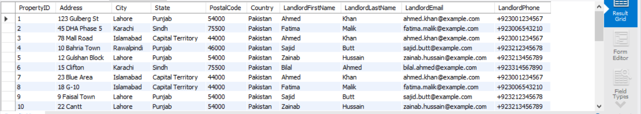

**-- 2. List All Listings with Their Property Details and Status**

SELECT

Listings.ListingID,

Properties.Address,

Properties.City,

Properties.State,

Properties.PostalCode,

Listings.ListingType,

Listings.Price,

Listings.ListingDate,

Listings.Status

FROM Listings

JOIN Properties ON Listings.PropertyID = Properties.PropertyID;

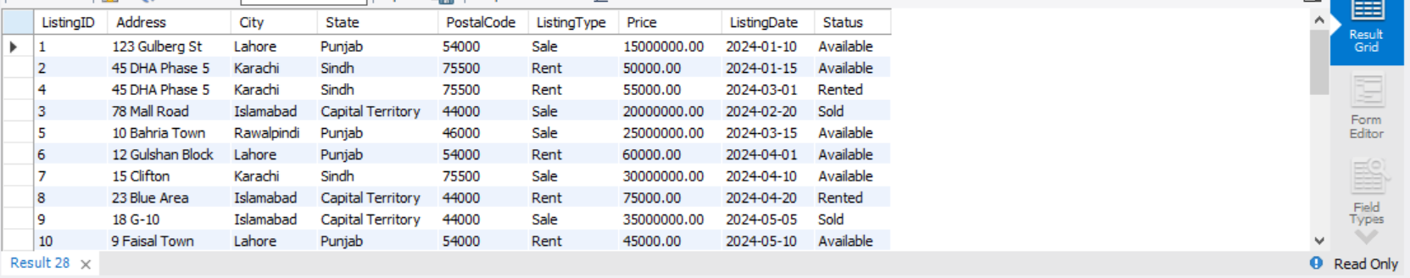

**-- 3. List of Clients Who Purchased Properties**

SELECT

Sales.SaleID,

Clients.FirstName AS ClientFirstName,

Clients.LastName AS ClientLastName,

Clients.Email AS ClientEmail,

Properties.Address,

Properties.City,

Properties.State,

Properties.PostalCode,

Sales.SaleDate,

Sales.SalePrice

FROM Sales

JOIN Clients ON Sales.ClientID = Clients.ClientID

JOIN Listings ON Sales.ListingID = Listings.ListingID

JOIN Properties ON Listings.PropertyID = Properties.PropertyID;

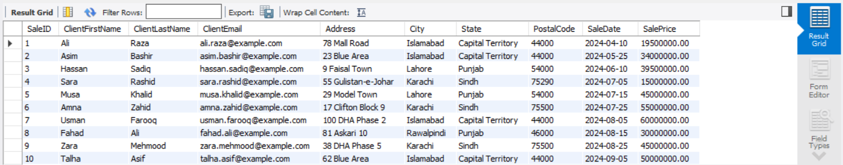

**-- 4. List of Clients Who Are Renting Properties**

SELECT

Rents.RentID,

Clients.FirstName AS ClientFirstName,

Clients.LastName AS ClientLastName,

Clients.Email AS ClientEmail,

Properties.Address,

Properties.City,

Properties.State,

Properties.PostalCode,

Rents.StartDate,

Rents.EndDate,

Rents.RentAmount

FROM Rents

JOIN Clients ON Rents.ClientID = Clients.ClientID

JOIN Listings ON Rents.ListingID = Listings.ListingID

JOIN Properties ON Listings.PropertyID = Properties.PropertyID;

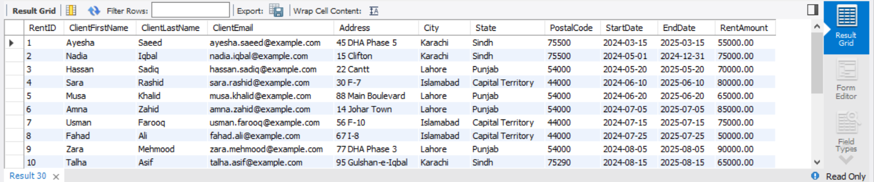

**-- 5. List of Payments Made by Clients**

SELECT

Payments.PaymentID,

Clients.FirstName AS ClientFirstName,

Clients.LastName AS ClientLastName,

Payments.Amount,

Payments.PaymentDate,

Payments.PaymentMethod,

Properties.Address AS PropertyAddress,

Rents.StartDate,

Rents.EndDate

FROM Payments

JOIN Clients ON Payments.ClientID = Clients.ClientID

JOIN Rents ON Payments.RentID = Rents.RentID

JOIN Listings ON Rents.ListingID = Listings.ListingID

JOIN Properties ON Listings.PropertyID = Properties.PropertyID;

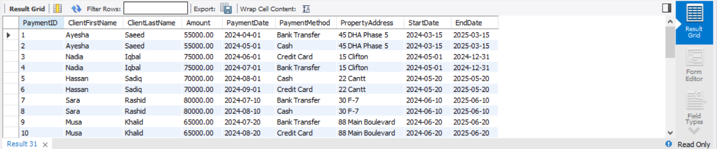

**-- 6. List of Maintenance Requests by Clients**

SELECT

DISTINCT MaintenanceRequests.RequestID,

Clients.FirstName AS ClientFirstName,

Clients.LastName AS ClientLastName,

Properties.Address,

MaintenanceRequests.Description,

MaintenanceRequests.RequestDate,

MaintenanceRequests.Status

FROM MaintenanceRequests

JOIN Clients ON MaintenanceRequests.ClientID = Clients.ClientID

JOIN Properties ON MaintenanceRequests.PropertyID = Properties.PropertyID;

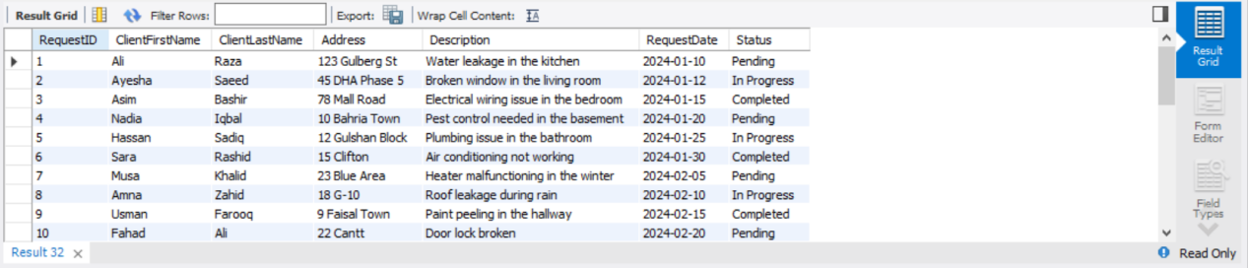

**-- 7. List Properties That Are Currently Rented Out**

SELECT

Properties.PropertyID,

Properties.Address,

Properties.City,

Properties.State,

Properties.PostalCode,

Clients.FirstName AS ClientFirstName,

Clients.LastName AS ClientLastName,

Rents.StartDate,

Rents.EndDate,

Rents.RentAmount

FROM Properties

JOIN Listings ON Properties.PropertyID = Listings.PropertyID

JOIN Rents ON Listings.ListingID = Rents.ListingID

JOIN Clients ON Rents.ClientID = Clients.ClientID

WHERE Listings.ListingType = 'Rent' AND Listings.Status = 'Rented';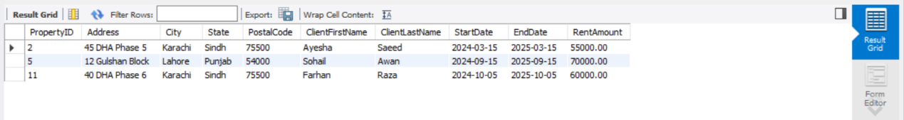

**-- 8. List of Available Properties for Sale**

SELECT

Properties.PropertyID,

Properties.Address,

Properties.City,

Properties.State,

Properties.PostalCode,

Listings.Price,

Listings.ListingDate

FROM Properties

JOIN Listings ON Properties.PropertyID = Listings.PropertyID

WHERE Listings.ListingType = 'Sale' AND Listings.Status = 'Available';

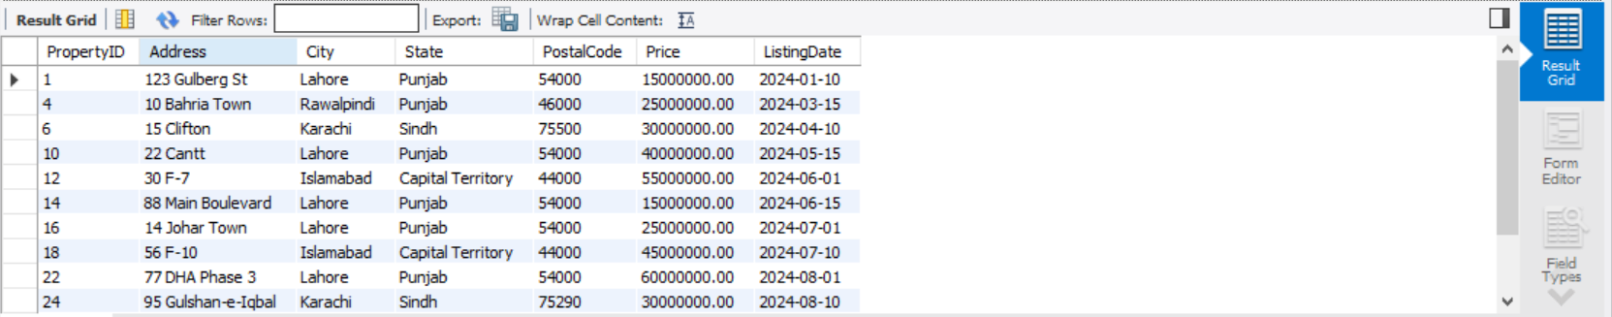

**-- 9. List All Properties With Their Rental Status**

SELECT

Properties.PropertyID,

Properties.Address,

Properties.City,

Properties.State,

Properties.PostalCode,

Listings.Status AS RentalStatus

FROM Properties

JOIN Listings ON Properties.PropertyID = Listings.PropertyID

WHERE Listings.ListingType = 'Rent';

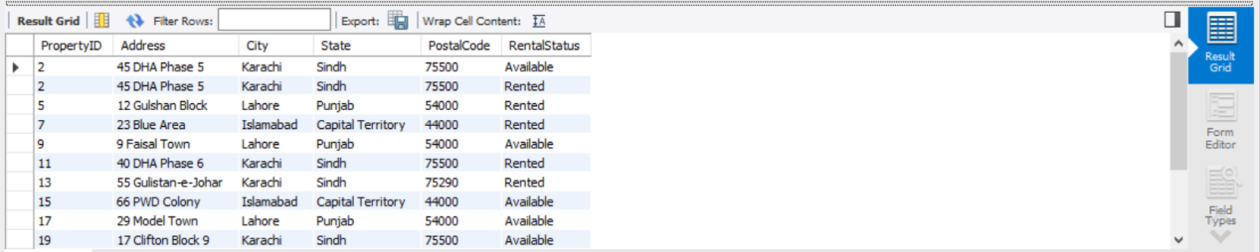

**-- 10. List Properties With Pending Maintenance Requests**

SELECT

Properties.PropertyID,

Properties.Address,

Properties.City,

Properties.State,

Properties.PostalCode,

MaintenanceRequests.Description,

MaintenanceRequests.RequestDate

FROM Properties

JOIN MaintenanceRequests ON Properties.PropertyID = MaintenanceRequests.PropertyID

WHERE MaintenanceRequests.Status = 'Pending';

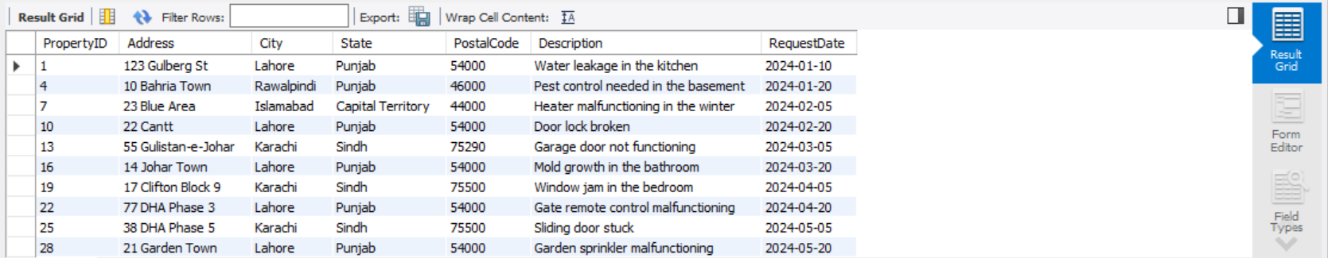

-- Nested Queries

-- 1 Find the clients who have made payments using multiple methods:

SELECT c.ClientID, c.FirstName, c.LastName

FROM Clients c

WHERE EXISTS (

SELECT *

FROM Payments p1

JOIN Payments p2 ON p1.ClientID = p2.ClientID AND p1.PaymentMethod <> p2.PaymentMethod

WHERE c.ClientID = p1.ClientID

);

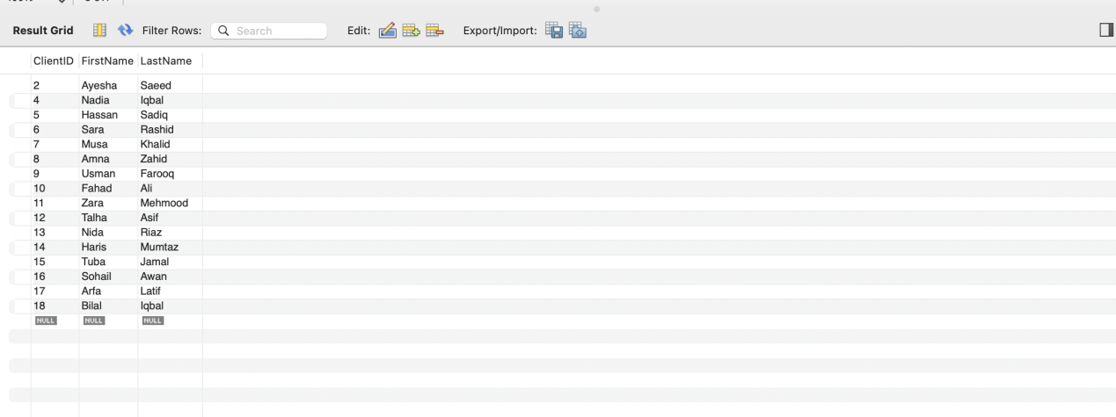

-- 2 List the landlords who own properties in more than one city:

SELECT l.LandlordID, l.FirstName, l.LastName

FROM Landlords l

WHERE EXISTS (

SELECT *

FROM Properties p1

JOIN Properties p2 ON p1.OwnerID = p2.OwnerID AND p1.City <> p2.City

WHERE l.LandlordID = p1.OwnerID

);

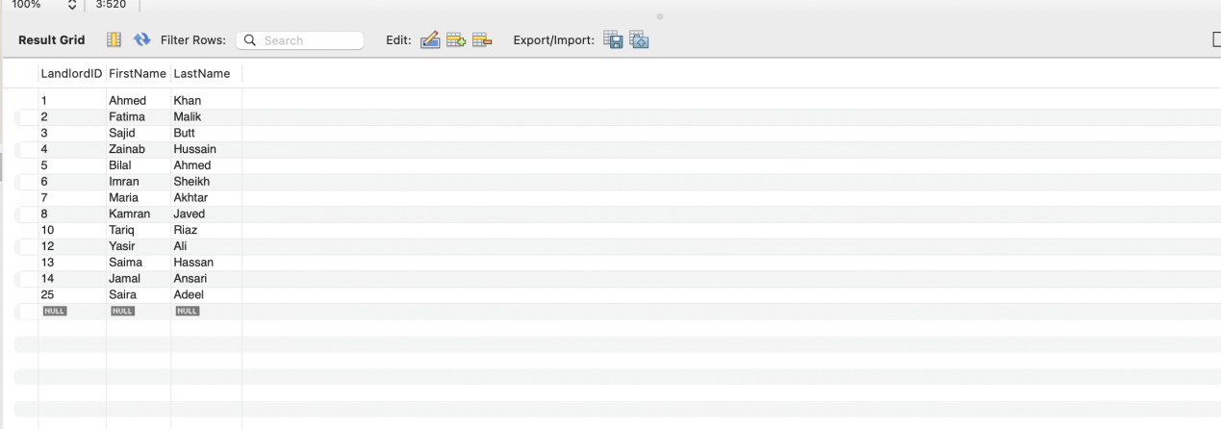

-- 3 Find properties that are either for sale or rent and have had maintenance requests:

SELECT p.PropertyID, p.Address

FROM Properties p

WHERE EXISTS (

SELECT *

FROM Listings l

WHERE p.PropertyID = l.PropertyID AND (l.Status = 'Available' OR l.Status = 'Rented')

) AND EXISTS (

SELECT 1

FROM MaintenanceRequests mr

WHERE p.PropertyID = mr.PropertyID

);

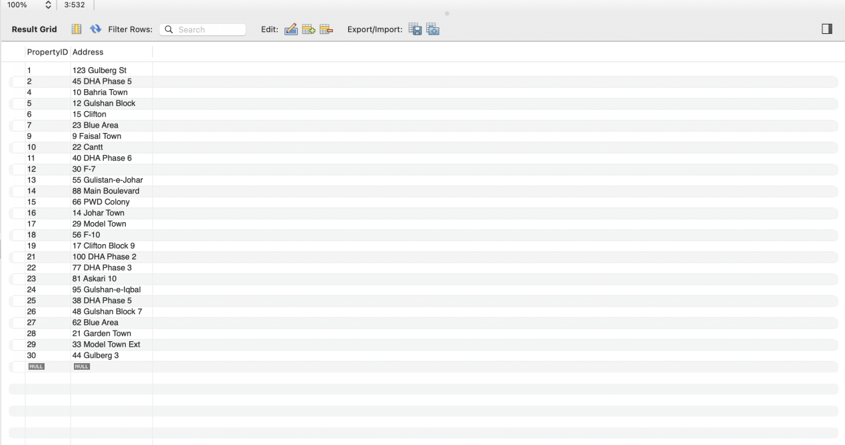

-- 4 List clients who have purchased a property and have a pending maintenance request for that property:

SELECT c.ClientID, c.FirstName, c.LastName

FROM Clients c

WHERE EXISTS (

SELECT *

FROM Sales s

JOIN MaintenanceRequests mr ON s.ListingID = mr.PropertyID

WHERE c.ClientID = s.ClientID AND mr.Status = 'Pending'

);

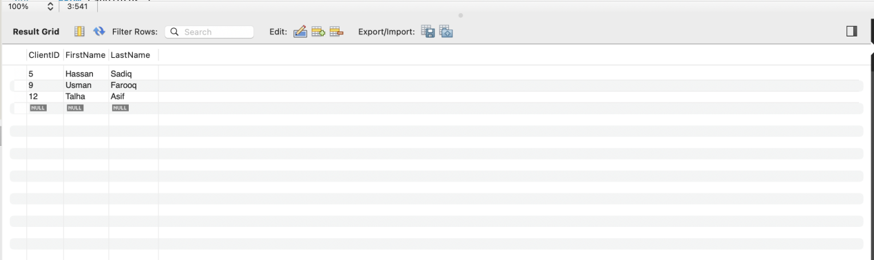

-- 5 Find landlords whose properties have been rented out and have received payments:

SELECT l.LandlordID, l.FirstName, l.LastName

FROM Landlords l

WHERE EXISTS (

SELECT *

FROM Properties p

JOIN Listings li ON p.PropertyID = li.PropertyID

JOIN Rents r ON li.ListingID = r.ListingID

JOIN Payments pay ON r.RentID = pay.RentID

WHERE l.LandlordID = p.OwnerID

);

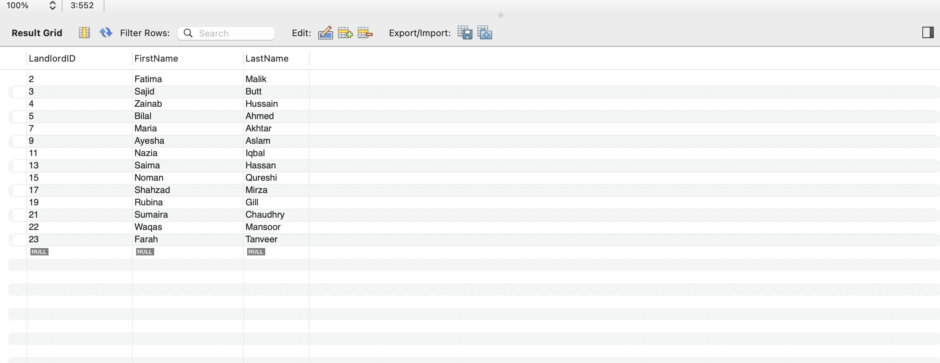



-- 6 List properties that have been sold to clients who also have rented properties:

SELECT p.PropertyID, p.Address

FROM Properties p

WHERE EXISTS (

SELECT 1

FROM Sales s

WHERE p.PropertyID = s.ListingID

AND EXISTS (

SELECT 1

FROM Rents r

WHERE r.ClientID = s.ClientID

)

);

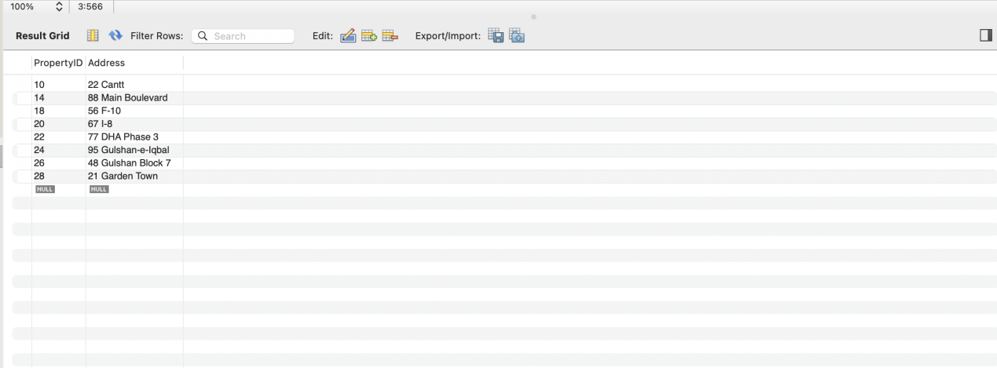

-- 7 Find the total amount of rent paid by each client for properties they have rented:

SELECT c.ClientID, c.FirstName, c.LastName, (

SELECT SUM(p.Amount)

FROM Payments p

JOIN Rents r ON p.RentID = r.RentID

WHERE p.ClientID = c.ClientID

) AS TotalRentPaid

FROM Clients c;

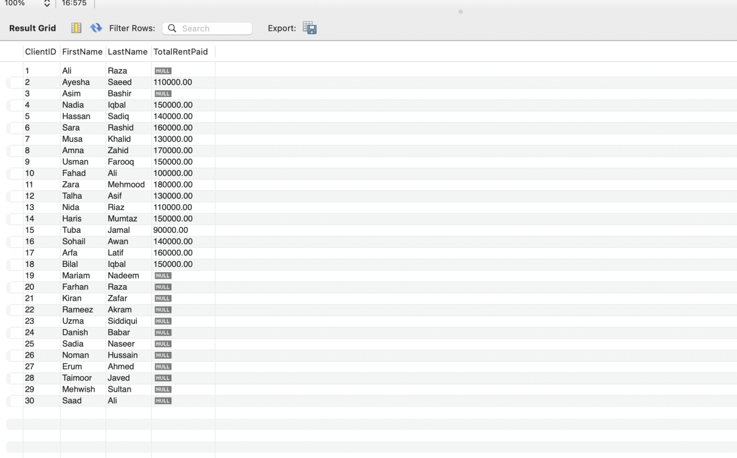

-- 8 Retrieve landlords whose properties have been both sold and rented:

SELECT l.LandlordID, l.FirstName, l.LastName

FROM Landlords l

WHERE EXISTS (

SELECT 1

FROM Properties p

JOIN Listings ls ON p.PropertyID = ls.PropertyID

WHERE l.LandlordID = p.OwnerID AND ls.Status = 'Sold'

) AND EXISTS (

SELECT 1

FROM Properties p

JOIN Listings ls ON p.PropertyID = ls.PropertyID

WHERE l.LandlordID = p.OwnerID AND ls.Status = 'Rented'

);

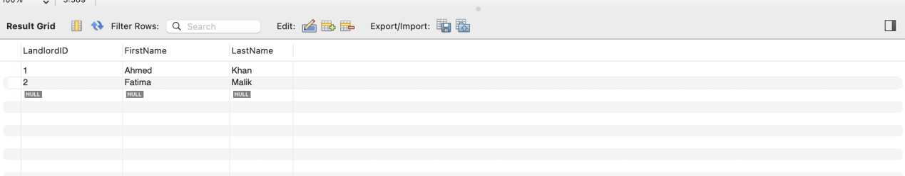

-- 9 List all maintenance requests for properties that are currently rented:

SELECT mr.RequestID, mr.Description, p.Address

FROM MaintenanceRequests mr

JOIN Properties p ON mr.PropertyID = p.PropertyID

WHERE EXISTS (

SELECT 1

FROM Listings l

JOIN Rents r ON l.ListingID = r.ListingID

WHERE l.PropertyID = p.PropertyID AND l.Status = 'Rented'

);

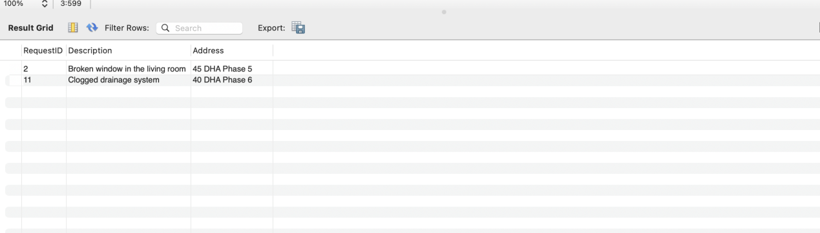

-- 10 Find properties that have never had a maintenance request:

SELECT p.PropertyID, p.Address

FROM Properties p

WHERE NOT EXISTS (

SELECT 1

FROM MaintenanceRequests mr

WHERE p.PropertyID = mr.PropertyID

);

