Assignment-1

Consider the following environment of a university. There are academic departments. Each department has a chairperson. Each department offers a set of courses. Some courses are currently offered. Some courses need prerequisites. An offering of a course is called a class or class section. A class is taught by a professor. It meets at a particular location. A course may have several sections with different meeting times. Some classes are scheduled in computer lab rooms. University staff are in charge of lab management. Not all departments offer the summer courses. Each faculty member is assigned to a single department and has a rank. Each student has an academic status (undergraduate, graduate, non-degree). Each student is currently enrolled in a number of classes. Undergraduate students are allowed to have double majors. Some students are performing better because they are hard working. Students' financial aids depend on their academic performance measured by GPA. Graduate students can have individual faculty as their advisor in writing research thesis. Students may join various campus organizations (clubs or societies) to enrich their academic experiences and campus life. Each organization has a name, email, etc listed at the organization’s website. (1a) Create an ER model for the information in this environment. Hint: this model should include a weak entity, a supertype-subtype entity and a recursive relationship. (It is strongly recommended that you use a computer-diagramming tool to draw this model). Note YOU MUST follow the drawing convention shown in my ppt presentation.
ER Model: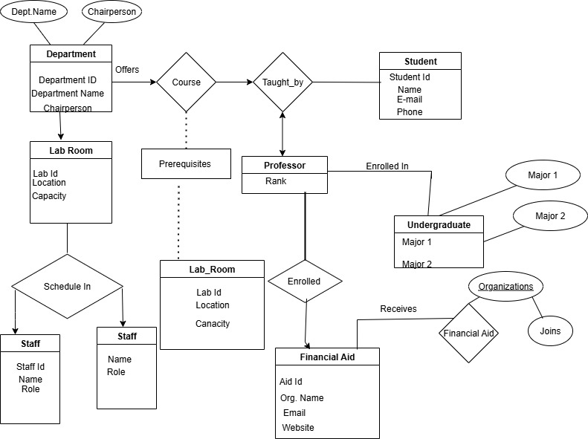

(1b) Which part of the above narrative that you cannot model using the ER diagram.

Although ER diagrams are excellent for showing structural links, they are not very good at capturing behavioral, subjective, or conditional elements.
These are difficult or impossible to directly model based on narrative:
Qualitative performance reasons: Some students are doing better because they are working hard (motivation and effort are not data attributes; they are subjective).
Conditional offerings: Not all departments offer summer courses, it is an example of a conditional offering; we can raise an objection, but the rule is a business restriction rather than a fundamental one.
Dependency on GPA for financial aid: The formula or policy that relates GPA to aid amount is a commercial norm, not a structural component of the ER.

2a. EAR INFECTION State the functional dependencies. (Assume that different patients can have the same zip code - PatZip)
Functional Dependencies:
From the data and the narrative:
VisitNo → VisitDate, PatID, ProvNo, Diagnosis (Each visit number is unique and determines the date, patient, provider, and diagnosis.)
PatID → PatName, PatAge, PatZip (A patient’s ID determines their name, age, and zip code.)
PatZip → PatCity (A zip code determines the city — even though multiple patients can share the same zip.)
ProvNo → ProvSpecialty (A provider number determines their specialty.)

2b. Transform this table into one or more tables in BCNF. State the primary keys, candidate keys, foreign keys, and referential integrity constraints.
Table Name | Primary Key | Attributes | Foreign Keys | Notes
PATIENT | PatID | PatName, PatAge, PatZip | PatZip → ZIPCODE.PatZip | Stores patient demographic details
ZIPCODE | PatZip | PatCity | — | Maps ZIP codes to cities
PROVIDER | ProvNo | ProvSpecialty | — | Stores provider details
VISIT | VisitNo | VisitDate, PatID, ProvNo, Diagnosis | PatID → PATIENT.PatID; ProvNo → PROVIDER.ProvNo | Stores visit details; links to patient and provider

Keys & Candidate Keys
PATIENT:
PK: PatID
Candidate Keys: PatID
ZIPCODE:
PK: PatZip
Candidate Keys: PatZip
PROVIDER:
PK: ProvNo
Candidate Keys: ProvNo
VISIT:
PK: VisitNo
Candidate Keys: VisitNo
Foreign Keys & Referential Integrity Constraints
PATIENT.PatZip → ZIPCODE.PatZip
VISIT.PatID → PATIENT.PatID
VISIT.ProvNo → PROVIDER.ProvNo

3a) Problems with Customer Table:
Issue: It appears to be fine in terms of BCNF — CustomerName → CustomerPhone, CustomerAddress is a single‑valued dependency on the key (Customer#).
However, if CustomerName is being used as the key instead of a unique Customer#, you risk partial dependency or update anomalies (e.g., if a customer changes their phone number or address, you’d have to update multiple rows).
Issue 1: Repeating groups — Multiple items for the same order are stored in the same row or as multiple rows with duplicated order data. This violates 1NF (atomicity) and leads to redundancy.
Issue 2: Functional dependency violations — In BCNF, every determinant must be a candidate key. Here:
OrderID → Customer#, OrderDate
But Item# → ItemDescription, ItemPrice (non‑key attribute determining other attributes) — this violates BCNF.
Issue 3: Update anomalies — Changing an item’s price means updating multiple rows; inserting a new item without an order is impossible; deleting the last order for an item loses the item’s details.

3b) Fixes to Comply with BCNF
Step 1: Identify proper keys
Customer Table: Use Customer# as the primary key.
Order Table: The natural key is (OrderID, Item#) for line items.
Step 2: Decompose into BCNF‑compliant tables

Customer Table
Customer# (PK)
CustomerName
CustomerPhone
CustomerAddress

Order Table
OrderID (PK)
Customer# (FK)
OrderDate
OrderLine
OrderID (FK)
Item# (FK)
LineItem (PK with OrderID)

ItemQty
ItemTotalAmount
Item
Item# (PK)
ItemDescription
ItemPrice

(4a) List a set of functional dependencies based on your analysis on the information in the above table.

Functional dependencies for APPOINTMENT:
Staff number determines dentist name:
staffNo → dentistName
Patient number determines patient details:patientNo → patientName, patientInsurance
Zip FD not applicable here; procedure code is atomic. (No FD from surgeryNo alone given the sheet; it’s just a code.)
Co-pay depends on patient and procedure (via primary insurance):
patientNo, surgeryNo → coPay
Note: Since patientNo → patientInsurance, the dependency patientNo, patientInsurance, surgeryNo → coPay reduces to patientNo, surgeryNo → coPay.
Key (whole-row) dependency (for completeness):
staffNo, patientNo, AppointmentDateTime, surgeryNo → dentistName, patientName, patientInsurance, coPay

(4b) Based on your answer to 4a, define the key of the table APPOINTMENT (StaffNo, DentistName, patientNo, patientName, AppointmentDate/time, SurgeryNo, PatientInsurance, Co-pay)
Key of APPOINTMENT
Candidate key: (AppointmentDateTime, patientNo, staffNo, surgeryNo)
Why minimal:
DentistName is determined by staffNo (staffNo → dentistName), so it’s not needed in the key.PatientName and PatientInsurance are determined by patientNo (patientNo → patientName, PatientInsurance), so they’re not needed in the key.
Co-pay is determined by patientNo and surgeryNo (patientNo, surgeryNo → Co-pay), so it’s not needed in the key.
To uniquely identify a row (an appointment instance for a specific patient, with a specific provider, for a specific procedure, at a specific time), you need all four: AppointmentDateTime, patientNo, staffNo, and surgeryNo.
Superkeys (examples):
Any superset of the candidate key (e.g., including dentistName or PatientInsurance) is a superkey but not minimal.

(4c) What normal form above table is in and WHY? (Note you need to correctly answer questions 4a and 4b in order to answer this question correctly)
Why it is in 1NF
All attributes are atomic — no repeating groups or multi-valued fields. Each row represents a single appointment instance.
Why it is NOT in 2NF
The primary key (from 4b) is:(AppointmentDateTime,patientNo,staffNo,surgeryNo)
There are partial dependencies:
staffNo → dentistName (dentistName depends only on part of the key, staffNo)
patientNo → patientName, patientInsurance (patient details depend only on part of the key, patientNo)
patientNo, surgeryNo → coPay (co-pay depends on part of the key — patientNo and surgeryNo — not the whole key)
Partial dependencies violate 2NF.
Why it is NOT in BCNF
BCNF requires every determinant to be a candidate key.
Here, determinants like staffNo, patientNo, and (patientNo, surgeryNo) are not candidate keys for the whole table, so BCNF is violated.
Conclusion: The table is in 1NF only — it fails 2NF (and therefore also 3NF and BCNF) because of partial dependencies between non-key attributes and parts of the composite key.

(4d) What modification anomalies this table suffers (be as specific as possible, refer to the textbook’s examples)
Modification Anomalies in the APPOINTMENT Table
1. Update Anomalies
Dentist name change problem: If Tony Smith changes his name or title, we must update it in every row where staffNo = 1011. Missing one row leads to inconsistent data.
Patient insurance change problem: If Jill Bell changes her primary insurance, we must update it in all rows where patientNo = P105. Missing one row causes conflicting insurance information.
Co-pay change problem: If the co-pay for P100 with surgery S10 changes, it must be updated in every appointment row for that patient–procedure combination.
2. Insertion Anomalies
Cannot add a new dentist without an appointment: If a new dentist joins the clinic but has no scheduled appointments yet, we cannot insert their staffNo and dentistName without creating a fake appointment row.
Cannot add a new patient without an appointment: Similarly, we cannot record a new patient’s details until they have an appointment.
Cannot add a new co-pay rule without an appointment: If a new patient–procedure co-pay is set, it cannot be stored unless there’s an actual appointment row for it.
3. Deletion Anomalies
Loss of dentist information: If we delete the last appointment for Helen Pearson, we lose all record of her staffNo and dentistName.
Loss of patient information: If we delete all appointments for Ian Mackay, we lose his patientNo, patientName, and PatientInsurance.
Loss of co-pay policy: If we delete the last appointment for P100 with surgery S10, we lose the co-pay amount for that patient–procedure combination.
Summary: Because this table mixes appointment facts with dentist details, patient details, and co-pay rules, it suffers from update, insertion, and deletion anomalies — exactly the kinds of problems normalization to BCNF is designed to eliminate.

BCNF-Compliant Tables
Table Name | Primary Key | Attributes | Foreign Keys | Notes
STAFF | staffNo | dentistName | — | Each staff number identifies exactly one dentist
PATIENT | patientNo | patientName, patientInsurance | — | Each patient has one primary insurance
SURGERY | surgeryNo | — | Stores treatment/procedure codes
INSURANCE_COPAY | patientNo, surgeryNo | coPay | patientNo → PATIENT.patientNo; surgeryNo → SURGERY.surgeryNo | Co-pay depends on patient and procedure
APPOINTMENT | AppointmentDateTime, patientNo, staffNo, surgeryNo | — | patientNo → PATIENT.patientNo; staffNo → STAFF.staffNo; surgeryNo → SURGERY.surgeryNo | Links a patient, dentist, and procedure at a specific time

Keys & Candidate Keys
STAFF: PK = staffNo
PATIENT: PK = patientNo
SURGERY: PK = surgeryNo
INSURANCE_COPAY: PK = (patientNo, surgeryNo)
APPOINTMENT: PK = (AppointmentDateTime, patientNo, staffNo, surgeryNo)

Foreign Keys & Referential Integrity Constraints
APPOINTMENT.patientNo → PATIENT.patientNo
APPOINTMENT.staffNo → STAFF.staffNo
APPOINTMENT.surgeryNo → SURGERY.surgeryNo
INSURANCE_COPAY.patientNo → PATIENT.patientNo
INSURANCE_COPAY.surgeryNo → SURGERY.surgeryNo

Why This Meets BCNF
Every determinant is a candidate key in its own table.Dentist name, patient details, and co-pay rules are stored once in their respective tables.Eliminates update anomalies (e.g., changing a dentist’s name in one place), insertion anomalies (can add a new patient without an appointment), and deletion anomalies (removing an appointment won’t erase dentist or patient records).

