Assignment 2 – part 1 1. Consider the following situation: A bus company owns a number of buses and has a contract with a town's Board of Education. Each bus may be assigned to one or more routes. Each route has a unique label/ID, mileage, and passes through a number of stops. A stop is identified by its code-name and street address, and can be on multiple routes. A route connects to a school. A school's students may come from different routes every day. The Board of Education needs to keep track of students’ information such as name, and grade as well as the stop and route she/he is on. Each school has a name, phone number of contact and an address. The company needs to keep track of estimated numbers of students to be picked up/dropped off at each stop and updates these numbers each year based on the information given by the Board of Education. One or more drivers are signed to a route. A driver's license and their cell phone number are important information for the company. There are a few garage(s) where buses are kept. The company needs to keep track of the location and the contact of each garage. Each bus is identified by its registration number and has different capacity of passengers. The information about a bus also includes its model and year. Each bus may be driven by different drivers so a daily log of driving is necessary to keep track who drives which bus on which date and time period as well as the routes. The log also records any incidence or note of the day if there is any. 1.1 Create an ER model for the above scenario. (Follow requirements of ER modeling posted in(Module 1)

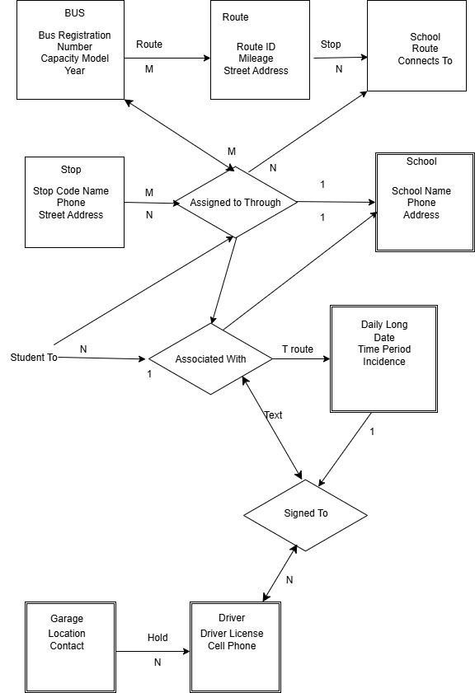

1.2 Transform the ER model in (1.1) into a set of tables in the format as TableName (Attribute1, Attribute2 …). Clearly indicate keys (underline them) and foreign keys (italicize them). Refer to the “Rules of converting ER model into tables'' presented in Module

Based on the ER model for the bus company scenario, here is the transformation into a set of tables with keys (underlined) and foreign keys (italicized):
- BUS (RegistrationNumber, Capacity, Model, Year, GarageID)
- GARAGE (GarageID, Location, Contact)
- ROUTE (RouteID, Mileage, SchoolID)
- SCHOOL (SchoolID, Name, Phone, Address)
- STOP (StopCodeName, StreetAddress)
- ROUTE_STOP (RouteID, StopCodeName, EstimatedStudents)
  - Composite key to capture stops on each route and estimated students at each stop
- STUDENT (StudentID, Name, Grade, StopCodeName, RouteID)
  - Links students to their stop and route
- DRIVER (DriverID, LicenseNumber, CellPhone)
- ROUTE_DRIVER (RouteID, DriverID)

Many-to-many between routes and drivers
- DAILY_LOG (LogID, Date, TimePeriod, DriverID, BusRegistrationNumber, RouteID, IncidenceNote)
Tracks who drove which bus on which route, when, and notes on incidents
This table design follows these rules:
- Each entity becomes a table with a primary key underlined.
- For 1:M relationships, foreign keys are placed in the "many" side table (italicized).
- For M:N relationships, an associative table is created with foreign keys (italicized) for both entities.
- Multi-valued attributes, such as estimated students per stop per route, are placed in their own table (ROUTE_STOP).
- The daily log is also an associative table with additional attributes.
This reflects all the entities, relationships, and attributes specified in the ER model, adhering to the database design transformation principles from the module.

