EXTENDED ABSTRACT TITLE
(TIMES NEW ROMAN, 14 FONT SIZE, BOLD, ALL CAPS, CENTERED)

Author’s Name and Surname¹, Author’s Name and Surname² (10 font size)
¹Affiliation
E-mail
²Affiliation
E-mail

ABSTRACT (11 Font Size, bold, all caps, centered)- Abstract should be written in 200 words and with 10 font size, Times New Roman, justified, single line spacing. Objectives, methods and findings are summarized in this section.

Keywords: Keywords regarding the work are stated in this section. Said section should contain maximum 5 words that are written with 10 font size and separated with semi-colon.

INTRODUCTION (Title Times New Roman, 12 font size, bold)

Extended abstracts should be written according to underlying structure of the structured abstract and in a form that is shorter than the full text. Subtitles of the extended abstract should be composed from the sections of abstract and keywords, introduction, methods, results/findings and conclusion and suggestions. Extended abstract of the full paper shall be written with Times New Roman font, single line spacing and 11 font size. Extended abstracts can contain figures, tables, formulations or images. Extended abstracts should be in a structure that explains the content of the declaration therefore the preparation phase of the said work. Page margins are formed regarding the A4 page size and are 2.5 cm wide from the right, left, top and bottom. End of the lines should be aligned to the right and there should be no syllable segmentation. Extended abstracts should be between 2 to 4 pages including the references and pages should not be numbered.

Current literature regarding the work subject should be examined and the differences of the said work from the past, similar works should be presented clearly in the introduction section.

MATERIALS AND METHODS

All materials and methods that have been used in the work must be stated clearly and subtitles should be used when necessary.

Subtitle

First degree titles (2.) should be written left aligned, all caps and bold. Second and 3rd degree subtitles (2.1, 2.1.1) should be written left aligned, bold and with title case. A blank line should be placed between the paragraphs and there should not be any paragraph indentation.

RESULTS / FINDINGS

The results and discussion of the work should be explicitly described and illustrated. Supporting figures, tables and images of the results (no more than two figures and two tables) may be included in the extended abstract.

Subtitle

All of the tables, images and figures should be centered. Figures and images should be numbered together (Figure 2) and figure definitions should be placed under the figure or image; as for the tables, they should also be numbered (Table 2) and the table header should be placed at the top of the chart. Table, image and figure headers should be written with upper case initial letters, bold and should be centered. References (if any) of the tables, figures and images should be presented just under the tables, figures and images in the form of author surname and publication date.

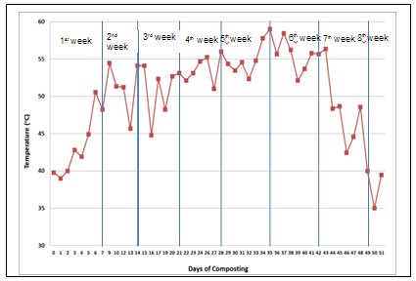
Figure 2. Figure Header (10 font size)

Subtitle

Table 2. Table Header (10 font size)
Factor | Unit | Low | High
Final temperatures | °C | 200 | 600
Heating rate | °C/min | 1 | 10
Holding time | Min | 0 | 60
N2 flow rate | L/min | 0.2 | 1.0
Condensing temperature | °C | 0 | 10
Reference: author surname and publication date (eg: George, 2009) (8 font size)

CONCLUSION

Please conclude your work incorporating your most important finding as well as future works and suggestions (3-4 lines).

ACKNOWLEDGEMENT

Please acknowledge your research grant, organization, scholarship (where relevant)

REFERENCES

Total no. of references must not exceed 15. Resources that have been presented inside [ ] in the text with numbers should be listed according to their order in the text. References that have been presented in the references list should be prepared in a format according to the reference type shown below:

[1] Smith, T., Jones, M.: 'The title of the paper', Hum. Fact., 2017, 1, (8), pp. 1–7
[2] Smith, T., Jones, M.: 'The title of the paper', IET Syst. Biol., 2007, 1, (2), pp. 1–7
[3] Borwn, L., Thomas, H., James, C., et al.:'The title of the paper, IET Communications, 2012, 6, (5), pp 125-138

