

3/23/2018

**Skin Disease Prediction Using Deep Neural Network**

CSE4097 / PSD Document

Ahmet Görünücü, Emre Dindar, Zafer Emre Ocak

sUPERVISED BY ASSOS. PROF. DR. ALI FUAT ALKAYA

**Contents**

**1. Problem Statement** 2

**2. Problem Description and Motivation** 2

**3. Aims of the Project** 3

3.1. Main Aims 3

3.2. Indirect Aims 4

**4. Related Work** 5

**5. Scope of the Project** 6

5.1 Phases 6

5.1.1. Obtaining the Data 6

5.1.2. Implementation 6

5.1.3. Adjustment 6

5.1.4. Creating an Android App 7

5.2. Constraints 7

5.3. Assumptions 7

**6. Success Factors and Benefits** 8

6.1. Measurability / Measuring Success 8

6.2. Benefits / Implications 8

**7. Methodology and Technical Approach** 9

**8. Professional Considerations** 12

8.1. Methodological Considerations / Engineering Standarts 12

8.2. Societal / Ethical Considerations 12

8.2.1. Economical 12

8.2.3. Ethical 12

8.2.3. Sustainability 13

8.3. Legal Considerations 13

**9. Management Plan** 14

9.1. Phases 14

9.2. Division of Responsibilities 15

9.3. TimeLine 15

9.4 Risk Management 15

**References** 16

# **1. Problem Statement**

Today, one of the most important problems of the healthcare industry is that medical doctors (especially the general practitioners) are expected to diagnose on the diseases that they have little experience on. This causes many diseases to be misdiagnosed which inherently leads to malpractices. In addition, preliminary misdiagnosis also cause time and money loss. With this project, we aim to transfer the knowledge and experiences of doctors who are experts in the field to the doctors who are inexperienced through our application which has learned the decisions made by the experts and to support them in decisions made by inexperienced doctors. In this graduation project, specific focus will be on dermatologic diseases.

On the other hand, the fact that the patients who have a dermatologic disease and consult directly to the hospital in the first stage leads to excessive intensity in our hospitals which run under limited resources. This situation significantly reduces the quality of health care provided. In our project, the patients are firstly examined by general practitioners and the doctor who uses our application will be directed by the doctor to the related departments of the hospital according to the preliminary diagnosis. We will focus on solving such problems by using the application.

# **2. Problem Description and Motivation**

Due to today's changing environmental conditions, the spectrum of dermatological diseases has increased greatly. A disease that is defined as redness in the past, can be defined in many ways such as cancer, measles, flower disease, melanoma in today's conditions. As a result of this diversity of diseases, the process of diagnosis is becoming increasingly difficult. The problem of solving this by raising number of doctors is a costly and time consuming process.

Early diagnosis plays a very important role in the treatment process. The late diagnosis of deadly diseases such as cancer can completely invalidate the treatment. The important factor which makes our project important, is to shorten the diagnosis process significantly. Thus, the possibility of treating many diseases with early diagnosis will increase considerably.

Our alternative solution is to create an information repository from the past diagnoses of experienced doctors, and it is an application that supports less-experienced doctors in the decision-making stage with the help of knowledge of diseases that are difficult to diagnose. In addition, another benefit of this continuously growing pool of information is; the decisions to be made are more up-to-date and correct.

The reason for us to make this project is to help our doctors to make decisions, to know that we will touch every life that will be saved, and to fulfill our duty as software developers.

# **3. Aims of the Project**

## 3.1. Main Aims

* **Increase the reliability of the diagnosis**

At present, 66% accuracy rate among dermatologists [1] is increased to 72% accuracy rate with the neural network. The recognition to be created has the advantage that it is compared with past deliveries, not only with an expert, and more accurate recognition is made. In the first phase, our aim is to reach this 66% accuracy. On later phases, our new aim will be 72% accuracy.

* **Creating a Diagnostic Repository**

Today, the number of photos in a total of 25,000 [2] in 19 labeled disease classes will be tried to be raised to 28,000 labeled photos per year. To ensure this, every new diagnosis made is planned to be added to the existing repository to make a diagnostic contribution in the future.

* **Reducing diagnostic cost**

At present, the average money spent on diagnosis and treatment of dermatological diseases is ₺926 [3]. We aim to prevent unnecessary money spending by avoiding the misdiagnosis resulting in erroneous treatments.

* **Evaluation from current diagnostic perspective**

 Be able to respond quickly (1 sec approx.) and effectively (72%) through easy learning of the mutations during the illnesses.

* **Increase the speed of diagnosis**

Utilizing visual data to ensure quick results from existing diagnostic procedures. To ensure that the doctor dedicates extra time to the examination by the help we provide, by reducing diagnosis time. (6 mins approx.)

## 3.2. Indirect Aims

* **Reducing density of hospitals**

Remove the necessity for patients to go to large hospitals for diagnosis and make them to go to alternative institutions where they can be diagnosed.

* **Determining approximate risk of diagnosis**

To determine the risk of the practitioner's reputation to support doctors in their decisions.

* **Exchanging experience between doctors**

Using the diagnoses of experienced doctors to help other doctors to make decisions.

* **Determining the parameters used in disease detection**

The surface area, color, surface characteristics (rough or not)

* **Determine the importance coefficient of these parameters**
* **Increase patient / doctor rate**

Due to the rapidity of the preliminary diagnosis, the doctor can spend more time with the patient

* **Informing the patient about the risks**
* **Informing doctors about possible treatment methods**

# **4. Related Work**

Along with the increase in the processing power of the machines and the data sets available, companies have begun to work on this problem in recent years. However, since it has an aspect of business dimension, it is not available for us to reach the contents. Some of the work done in the same field with us is as follows:

1. **Codella:** They are trying to diagnose Melanoma, the deadliest kind of skin cancer, by taking advantage of image processing. They make inferences using a pre-trained Neural Network. They use the Image Large Scale Visual Recognition Challenge (ILSVRC) 2012 as the dataset. The dataset contains 900 training images and 379 test images. They keep working on ImageNet dataset which we will use later. They state that they have achieved an accuracy rate of 70.5% in their last published articles. [4]
2. **Barata:** The approach proposed by Barata et al. [5] utilizes two different methods for the detection of melanoma in dermoscopy images based on global and local features. The global method uses segmentation and wavelets, Laplacian pyramids or linear filters followed by a gradient histogram are used to extract features such as texture, shape, and colour from the entire lesion. After that, a binary classifier is trained from the data. The second method of local features uses a Bag of Features (BoF) classifier for image processing tasks (i.e. object recognition).
3. **Kawahara:** A previously trained convolution neural network was used. They have practiced on International Skin Imaging Collaboration (ISIC) 2017 dataset. There are 2000 labelled images on 10 dermatological diseases in this dataset. It also contains 150 test images. Likewise, we are going to do as well, they carried out performance tests on AlexNet, VGG16, ResNet50, and ResNet101 frameworks. [6]

# **5. Scope of the Project**

Our project is aimed at creating a preliminary diagnosis of dermatological diseases in the human body by using image processing methods of photographs taken with the help of phone camera. To achieve this goal, we are going to use Convolution Neural Networks, then alter weights in convolution layers in the direction of our purpose, and finally we will try to reach 72% of the highest accuracy level currently reached. In case of success, we would like to obtain a higher level of accuracy than current accuracy. We will design a user interface so that the result of the calculations that will be made by the network we create, will be clear to the doctor. We foresee our project phases as follows:

1. Obtaining the data
2. Implementation and training of Neural Network
3. Making Convolutional Neural Network structure suitable (adjusting weights)
4. Creating an Android application for easier understanding of results

## 5.1 Phases

### 5.1.1. Obtaining the Data

In the initial phase of our project, we aim to provide different datasets from different institutions. The data sets that we will use are the DermNET [23000] dataset and the OLE [1300] dataset, which is the archive of the Dermofit Laboratory of Edinburg, where the ISIC Dermoscopic Archive is available.

### 5.1.2. Implementation

We plan to implement the Neural Network Implementation once we have provided the data sets. We will use Python language and libraries in the implementation part of our project. We will train our neural network with the datasets we have obtained when we have completed our implementation.

### 5.1.3. Adjustment

According to the top-5 accuracy values we have obtained from our neural network we have trained with datasets, we will try to improve the accuracy parameters by using the weight values of our network for disease parameters that we have obtained from specialists.

### 5.1.4. Creating an Android App

In the final phase of our project, we will implement an Android application so that users can use the system more easily. Thus, we will show the predictive result of the convolutional neural network running on the background to be more understandable to the users.

## 5.2. Constraints

* Limited Dataset (Dermnet [23000], Ole [1300])
* Time Constraint (Efficiency Constraint of Learning Algorithm)
* The application will only be based on Android
* Putting photographs in a specific standard (U-Net6)
* Working with a doctor with experience to supervise the result of the testing state (Validation)

## 5.3. Assumptions

* The doctor could use the application
* The application has enough memory for the photos taken (Maximum photo size)
* The phone’s camera is capable of taking high quality photos
* The patient’s consent to upload the photos taken to the application

# **6. Success Factors and Benefits**

## 6.1. Measurability / Measuring Success

Such learning algorithms are not 100% accurate. This is because the number of input and output related parameters is too large and the importance coefficients of these parameters can not be determined precisely. Established learning systems will try to estimate these coefficients and we expect the accuracy of the algorithm to increase day by day as it increases the likelihood of correct results in the parameter coefficients as the number of inputs increases.

In the case of photographs, it is proven that the trained systems (72%) are superior to the decisions made by the dermatologists (66%) [1]. However, we would like to draw attention to the fact that these systems can not be a decision maker in their own right. We aim to capture at least as accurate as these systems in the project. If the decisions made by the systems on the cases are at the level of 50% accuracy, they should be completely ignored and acted according to the doctor's knowledge or direction.

## 6.2. Benefits / Implications

In the present system, if a patient is injured in their skin, they have to make an appointment from one of the central hospitals and be examined there. If we present it to the system, it will be at all doctors who have access to the diagnostic or preliminary capacity of central hospitals. This will create a faster diagnosis / treatment opportunity for the patient.

Moreover, thanks to the data collected in the system repository, new diseases or different symptoms of known diseases will always be up to date. This will prevent from possible misdiagnosis or treatment and prevent from disease and waste of material and spiritual resources.

Finally, we aim to facilitate decision-making by informing doctors who are not experienced about the symptom, about similar symptoms and results.

# **7. Methodology and Technical Approach**

The core component of our system is artificial neural network. The purpose of artificial neural networks is to develop new models in order to make computers faster than human mind in a variety of ways, to develop new models and to use the processing power efficiently. It is also called "Artificial Neural Network" because it is a discipline that imitates and mimics the human brain. We can visualize the structure in the following way:

In fact, artificial neural networks are systems based on biological neural networks. You can analyse comparison of this with the following table:

|  |  |
| --- | --- |
| Biological Neural Networks | Artificial Neural Networks |
| Neuron | Node |
| Dendrite | Weights |
| Cell Body | Transfer and Activation Functions |
| Axon | Output |
| Synapse | Making Output to Input of Other Nodes |

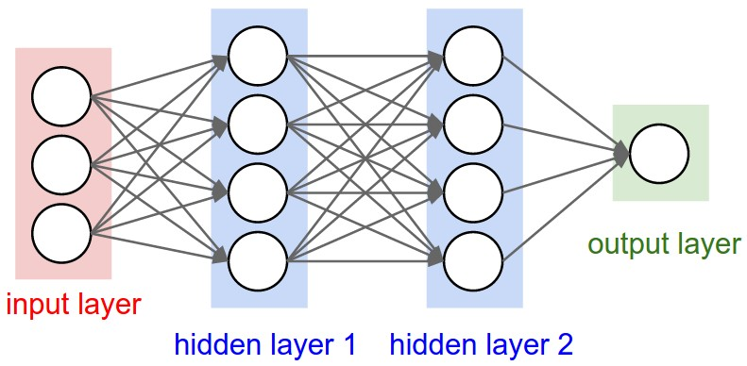 Artificial neural networks are a very appropriate system for learning algorithms used in Deep Learning.

***Figure 10:*** *Artificial Neural Network Layers* **[8]**

One of the most useful and common methods of deep learning to process images is the Convolution Neural Network. This system consists of multiple convolution layers. Each layer in the system includes an abstraction of the input data at a higher level. The output of one layer is the input of another layer associated with it. Up to 1000 convolutions with a minimum 5 can be found between layers.

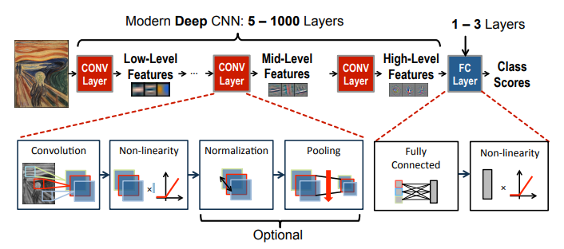 Convolutional Neural Networks [9]

Inputs to the layers are calculated by the activation functions and transferred to the other layer. Some of the activation functions are: Linear Function, Symmetric Hard Limit, Sigmoid Function, etc.

We will use several Deep Neural Network (DNN) models in our project. We will perform a performance test among these models and work with the model which gives the optimum result. We will fine tune on a pre-trained network instead of training randomly so that we will work towards our targets. Hence, we will do Transfer Learning using a deep learning framework such as ImageNet [10] or Caffe [11] for this. We have considered planning to use LeNet, VGG16, and GoogleNet as previously prepared models.

1. **LeNet:** This model contains 2 convolution layers and 2 fully connected layers. In the first convolutional layer, there are 6 filters and in the second one, there are 16 filters. These filters are 5x5 sizes. They use “Sigmoid Functions” as activation functions.
2. **VGG16:** There are a total of 16 layers, including 13 convolution layers and 3 fully connected layers. Each layer contains 3x3 filter images. In this model, the input layer requires 224x224 input images.
3. **GoogleNet:** This model goes deeper with 22 layers. There are parallel connections between the layers. You can apply filters in different dimensions to parallel connected layers (1x1, 3x3, 5x5, 7x7 etc.) The biggest advantage of filtering in different sizes in each layer is that input can be processed with multiple scales and provides better results. It provides 3 convolution layers and 9 inception layers between the 22 layers.

The most important challenge in this project is the variety of datasets. Today we still cannot find the desired level of labelled disease pictures to train these networks. Yet we can reach the enough number of photos to get the projects to good levels.

There are two datasets to use in our project:

1. 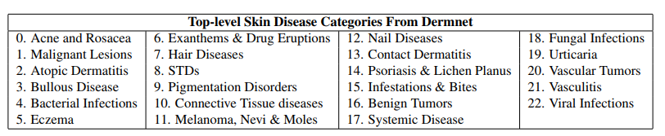**DERMNET:** This data set is provided by the Edinburgh Dermofit Labs database examines more than 23000 dermatological skin images in two different taxonomies available which are, bottom-level and high-level taxonomy. In bottom level, there are more than 600 different “Fine Grained Granularity” skin diseases. On the other hand, there are 23 different kinds of skin disease at the top-level.

The 23 top-level categories of the Dermnet taxonomy [2]

1. **OLE:** This dataset is provided by the New York State health department. It contains over 1300 images of skin disease. It divides skin diseases into 19 classes.

In the first place, we plan to start by training our VGG16 model in accordance with our goal. We need to make some changes on VGG16 for this. We only need to rebuild the top layers with dataset and start the model. We will fine tune the weights by training the top layers with back propagation. We plan to freeze bottom-level layer, because these layers own more general properties. Layers that provide specific properties are top-layers.

The libraries we can use in our project are:

1. TensorFlow
2. Keras
3. Theano

As a result of our research, we have decided Keras library is more meritorious as comparison with other libraries. Namely:

1. Users can create their networks by following a linear sequence.
2. The functions in the library allow the user to easily create and change network layers.
3. The user works in an environment that gives the freedom to use additional python dependencies such as SciPy and PIL.

# **8. Professional Considerations**

## 8.1. Methodological Considerations / Engineering Standarts

Since the libraries of Convolution Neural Network (CNN) algorithms are now available for the Python language, we will use python in our project. We are considering to use one of the most common Convolution Neural Network libraries which are TensorFlow, Theano or Keras. At the moment we can not make a definite decision because we do not have test cases to compare these libraries yet. We will create test cases for these libraries and decide what will be the best library for us based on the results of these test cases. After this step we will make adjustments on our neural network and adapt our target. We will make the neural network to work with the android application which is to be carried out in the next phases of the project.

We will go through a plan using UML diagrams to make our algorithms more effective. We will use the Agile Development Methods to stay within the plan. Since we have a software team of three people in the project phases, we are planning to follow up each other with Trello Application to make project follow-up easier. We also plan to work through a private repository on GitHub to prevent possible data loss in the development phase.

## 8.2. Societal / Ethical Considerations

### 8.2.1. Economical

Once the patient is diagnosed, the treatment process begins. This process is costly and can lead to negative results in the long term as well as misdiagnosis. With this project we aim to reduce incorrect preliminary diagnosis as much as possible at the initial phase between the patient and the doctor. In this way, we plan to prevent the wrong treatment costs and getting the wrong drugs.

### 8.2.3. Ethical

For the algorithm to work, patients need to share the image of the wound and its surrounding area with the application. In this regard, the application is not in any communication with any server, so there is no storage on the server side. In addition, the photographs that used to train the algorithm will be taken from the patients by giving information about the situation and requesting permission. Doctors who will use the application will be assured that the photographs to be used in preliminary diagnosis are taken in the application and these photographs should not be shared at any time and anywhere.

### 8.2.3. Sustainability

In order to continuously increase the accuracy of the algorithm that used in the application, it is necessary to continuously grow the input dataset. In this context, the new input sets are taught at intervals and the final state of the algorithm is sent as an update to all user doctors.

## 8.3. Legal Considerations

Doctors need to accept contracts and rules before using practice. The contract contains several items such as the use of photographs of the illness, social media sharing, accepting the fact that the recognition is not certain, and the application used can not be reproduced and sold to other persons etc.

# **9. Management Plan**

## 9.1. Phases

Phase **1**: Getting general information about Deep Learning and Neural Network.

Phase **2**: Taking courses on Standford University about DL and NN.

Phase **3**: Getting deep information from writings.

Phase **4**: Creating new code standards for implementation.

Phase **5**: Learning Python programming language

Phase **6**: Analysing and making decision about libraries for DL (Tensorflow, Keras, Theano etc.)

Phase **7**: Examinating examples for the library.

Phase **8**: Downloading Datasets

Phase **9**: Implementing the python source code

Phase **10**: Creating Test Cases and calculating top-five accurancy

Phase **11**: Identifing sensitivity and specificity

Phase **12**: Making decision about the Process Model

Phase **13**: Creating Android Application Design

Phase **14**: Research about integration of Android and Python

Phase **15**: Implementing Android Application

Phase **16**: Application Unit Test

Phase **17**: Integration of Python Code and General System Testing

Phase **18**: Prepearing Application for distribution

## 9.2. Division of Responsibilities

|  |  |  |  |  |  |  |  |  |  |  |  |  |  |  |  |  |  |  |
| --- | --- | --- | --- | --- | --- | --- | --- | --- | --- | --- | --- | --- | --- | --- | --- | --- | --- | --- |
| Phases | **1** | **2** | **3** | **4** | **5** | **6** | **7** | **8** | **9** | **10** | **11** | **12** | **13** | **14** | **15** | **16** | **17** | **18** |
| **Ahmet G.** | ✓ |  | ✓ | ✓ | ✓ | ✓ | ✓ |  | ✓ | ✓ |  | ✓ |  | ✓ | ✓ |  | ✓ | ✓ |
| **Emre D.** | ✓ | ✓ |  | ✓ | ✓ | ✓ | ✓ |  | ✓ | ✓ |  | ✓ | ✓ |  | ✓ |  | ✓ | ✓ |
| **Zafer O.** | ✓ | ✓ |  |  | ✓ |  | ✓ | ✓ | ✓ |  | ✓ |  | ✓ | ✓ | ✓ | ✓ | ✓ |  |

## 9.3. TimeLine

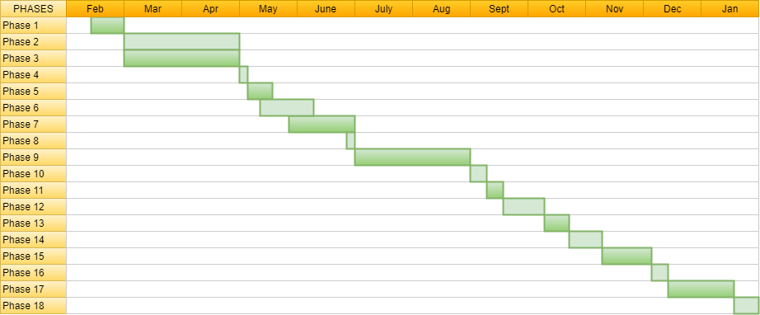

## 9.4 Risk Management

There is a risk about the computation power. Our personel computer may not have enough memory or CPU power. In this case we may use computers which are at the university laboratuary. If the problem still continues, we are thinking of using Google Compute Engine Platforms.

If the phone has not enough memory or the CPU power to execute the algorithm, we may set up a server to proceed it. In this case, the photo taken from user would be sent to server and the server returns information about the disease.

# **References**

[1] Hao Chang, Skin cancer reorganization and classification with Deep Neural Network, Department of Genetics, Yale University School of Medicine, USA, 2017

[2] Haofu Liao, A Deep Learning Approach to Universal Skin Disease Classification, University of Rochester Department of Computer Science, USA, 2017

[3] Bilal SULA, Haydar UÇAK, Mustafa ARICA, Demographic and Clinical Characteristics of Hospitalized Patients in Dermatology Clinic, Dicle University Medical School, Dermatology Master Science, Diyarbakir, Turkey, 2015

[4] N. Codella, Q.-B. Nguyen, S. Pankanti, D. Gutman, B. Helba, A. Halpern, and J. R. Smith, “Deep learning ensembles for melanoma recognition in dermoscopy images”, 2016.

[5] C. Barata, M. Ruela, M. Francisco, T. Mendonc¸a, and J. S. Marques, “Two systems for the detection of melanomas in dermoscopy images using texture and color features,” IEEE Systems Journal, vol. 8, no. 3, pp. 965–979, 2014.

[6] J. Kawahara, A. BenTaieb, and G. Hamarneh, “Deep features to classify skin lesions” IEEE International Symposium on Biomedical Imaging (IEEE ISBI), pp. 1397–1400.

[7] Innoarchitech.com, Picture About Artifical Neuron Model

<http://www.innoarchitech.com/assets/images/ArtificialNeuronModel_english.png>

[8] Stanford CS231 Course Website, Picture About Convolutional Neural Networks

<http://cs231n.github.io/assets/nn1/neural_net2.jpeg>

[9] Vivienne Sze, Senior Member, IEEE, Yu-Hsin Chen, Student Member, IEEE, Tien-Ju Yang, Student Member, IEEE, “Joel Emer, Efficient Processing of Deep Neural Networks: A Tutorial and Survey”, 2017.

[10] O. Russakovsky, J. Deng, H. Su, J. Krause, S. Satheesh, S. Ma, Z. Huang, A. Karpathy, A. Khosla, M. Bernstein, A. C. Berg, and L. Fei-Fei. ImageNet Large Scale Visual Recognition Challenge. International Journal of Computer Vision (IJCV), 115(3):211–252, 2015.

[11] Y. Jia, E. Shelhamer, J. Donahue, S. Karayev, J. Long, R. Girshick, S. Guadarrama, and T. Darrell. “Convolutional architecture for fast feature embedding”, 2014.