**Lab Assignment 4**

**SSK3100 COMPUTER PROGRAMMING I**

**Semester 1 2020/2021**

***Chapter Coverage: Chapter 5***

**Learning Outcome:**

1. Construct program from the flowchart (C3, P4)
2. Construct program using control statement (C3, P4)
3. Analyze and solve programming problem (CTPS)

**INSTRUCTION: Answer all questions.**

**Dateline: 11 December 2020**

**Question 1**

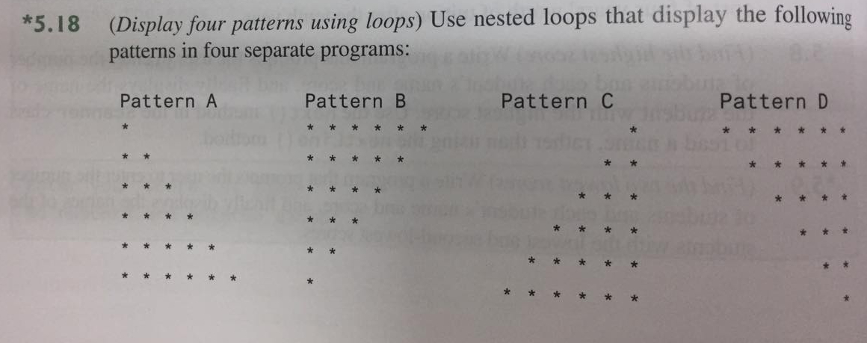

**Question 2**

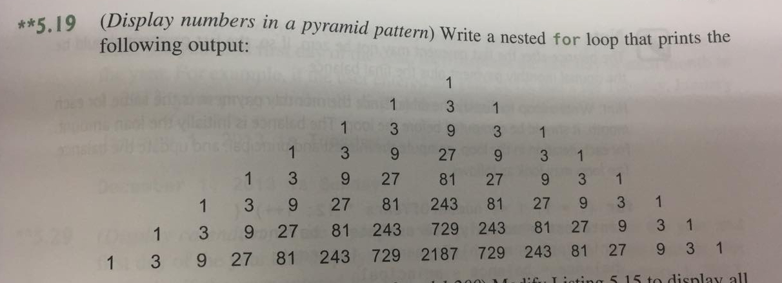

**Question 3**

