Preferences Management
TALEND
V0.3

Summary
1.1 Files import 3
1.1.1 Talend.epf : 3
1.1.2 talend-code-formatter.xml : 4
1.1.3 talend-code-templates.xml : 4
1.1.4 Checkstyle 5
1.2 How-to use the preferences files. 6
1. Preférences 6
1.2.1.1 Task Tags 6
1.2.1.2 Templates 6
1.2.2 Formatter 6
1.2.3 Templates 7
1.2.4 Checkstyle 7

Versioning follow-up

ID | Date | Observations | Author
0.1 | 24/05/06 | Creation | SML
0.2 | 06/06/06 | Adding checkstyle | SML
0.3 | 15/09/06 | English version | JCL
0.4 | 24/09/06 | Correction and Refactoring | CCA

Files import

Talend.epf :
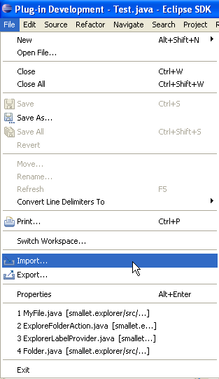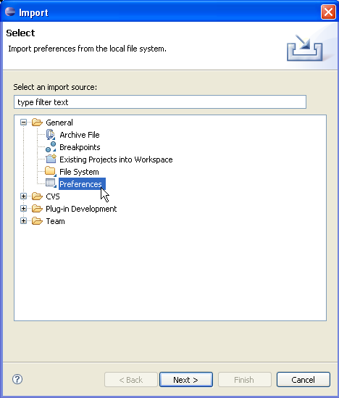
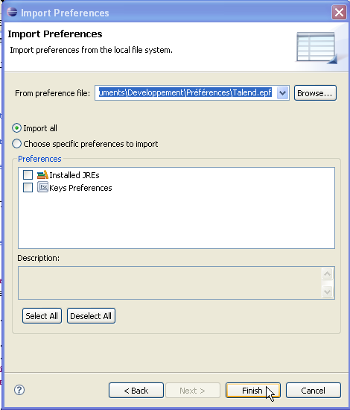

talend-code-formatter.xml :
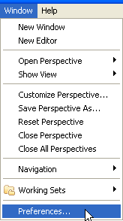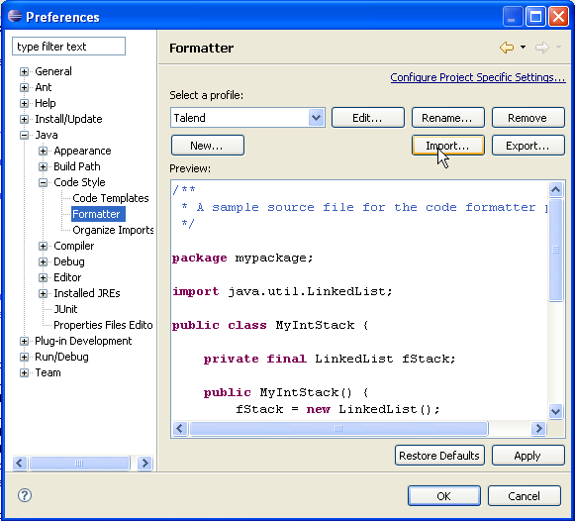

talend-code-templates.xml :
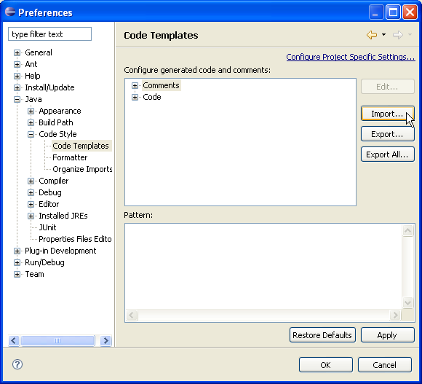

Checkstyle
You have to install the checkstyle plugin for eclipse.

Use « Software updates » in Eclipse with the URL « http://eclipse-cs.sourceforge.net/update »

Then the plugin is installed, import the file “Talend_Checks.xml”.

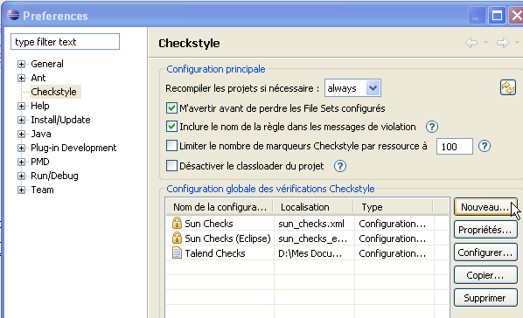

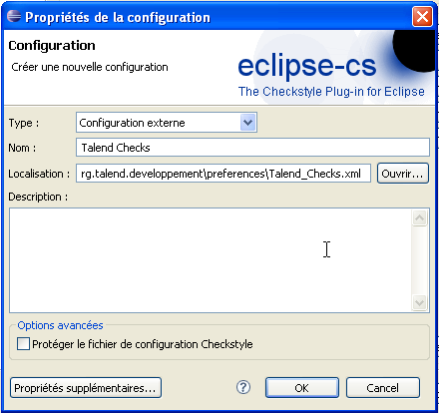

How-to use the preferences files.

Preférences

Task Tags
DOC : Indicate a portion of code which has to be commented

TSLT : Indicate a variable or a method to translate (All must be in english including remarks).

FIXME <USER>: For emergency actions.

PTODO <USER>: Personnal ToDo. Must be fixed by the developer (identified by his trigram). There’re not in the Maven reports. Sample : // PTODO MHE handle zoom and size

TODO : This tags is used for Global ToDo. It’s very important. Allow ToDo to appear in Maven reports.

Templates
You have the possibility to add your own templates for recurrent part of code.
Example :
nal => List<list_type> name = new ArrayList<list_type>();

Don’t hesitate to add your own templates and share them.

Formatter
Use the key combination “Ctrl+Shift+f” to indent the selected class or code before each saving.
This method avoids a lot of problems and conflicts without interest at the cvs synchronization time.

You may formulate any kind of suggestions to improve the quality of the code formatter.

Templates
The class documentation template is now final:

- Copyright in the files header
- Classes remarks with the cvs informations.

You may formulate any kind of suggestions to improve the quality of this template.

Checkstyle

Add errors, Warnings, Informations in the Eclipse « Problems » View.

If you find that certain rules are too restrictive, it’s possible to make some adjustments.

The purpose is to fix all Errors and Warning and take knowledge of all the Informations.

