**MUST**

**MIRPUR UNIVERSITY OF SCIENCE AND TECHNOLOGY**

**Academic Year 2021-25**

**Department: CS/IT**

**Name of Assignment: AI Dictionary**

**Full Name:** Syed Zafran Haider Kazmi

**Roll No.:** FA21-BIT-064

**Section:** “A”

**FIELD;BS IT**

**Semester 5th**

**Subject:** Programming in Python

Teacher Mam Iram;

**Date of Submission:**5/2/2024



**Q1.** **English AI dictionary. Here are some potential tasks students might undertake:**

1. **Designing the Dictionary Structure: Students could design the data structure to store words and their meanings, perhaps using key-value pairs or other data structures like trees or graphs.**
2. **Implementing Basic Operations: Students could implement basic operations such as adding new words, searching for words, updating meanings, and deleting entries.**
3. **Integrating AI Features: Students might explore integrating AI features such as natural language processing (NLP) for better search results, synonym suggestions, or even voice recognition for input.**

Screnshots

Main Dictionary

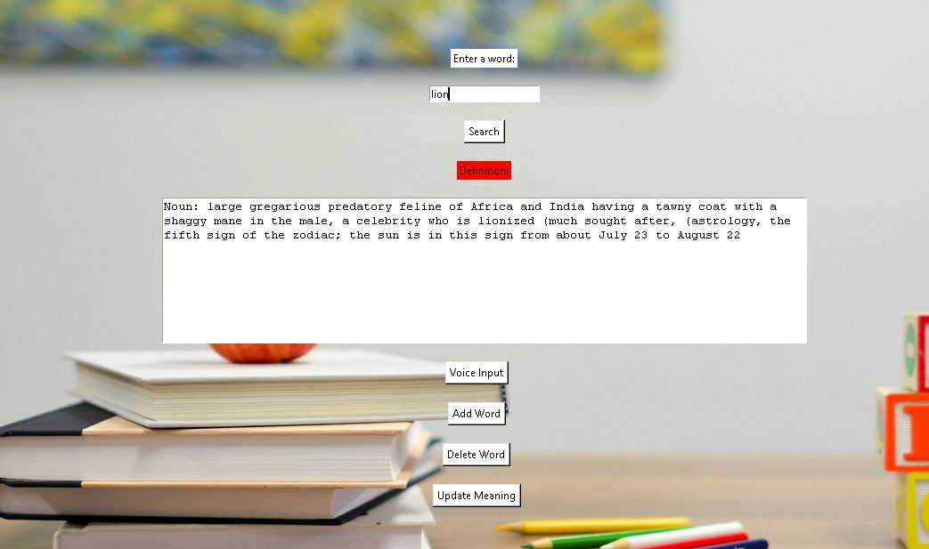

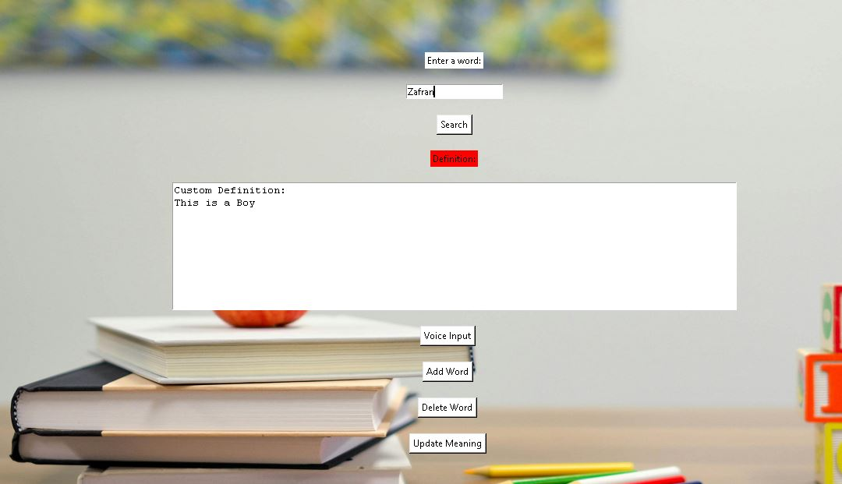

**Custom Added Name**

**Code**

import tkinter as tk

from tkinter import messagebox

import speech_recognition as sr

from PyDictionary import PyDictionary

class DictionaryApp:

    def __init__(self, master):

        self.master = master

        self.master.title("English AI Dictionary")

        # Set window size and center the window

        window_width = 1360

        window_height = 780

        screen_width = master.winfo_screenwidth()

        screen_height = master.winfo_screenheight()

        x_coordinate = (screen_width - window_width) // 2

        y_coordinate = (screen_height - window_height) // 2

        self.master.geometry(f"{window_width}x{window_height}+{x_coordinate}+{y_coordinate}")

        # Load background image

        self.background_image = tk.PhotoImage(file="back.png")  # Provide the path to your image

        self.background_label = tk.Label(master, image=self.background_image)

        self.background_label.place(relx=0.5, rely=0.5, anchor=tk.CENTER)

        self.dictionary = PyDictionary()

        # Initialize custom dictionary

        self.custom_dictionary = {}

        # Widgets for searching

        self.search_label = tk.Label(master, text="Enter a word:", bg="white")

        self.search_label.pack(pady=(100, 10))

        self.search_entry = tk.Entry(master)

        self.search_entry.pack(pady=10)

        self.search_button = tk.Button(master, text="Search", command=self.search_word, bg="white")

        self.search_button.pack(pady=10)

        # Widgets for displaying definition

        self.definition_label = tk.Label(master, text="Definition:", bg="red")

        self.definition_label.pack(pady=10)

        self.definition_text = tk.Text(master, height=10, width=90, wrap="word")

        self.definition_text.pack(pady=10)

        scrollbar = tk.Scrollbar(master, command=self.definition_text.yview)

        scrollbar.pack(side=tk.RIGHT, fill=tk.Y)

        self.definition_text.config(yscrollcommand=scrollbar.set)

        # Widgets for voice input

        self.voice_button = tk.Button(master, text="Voice Input", command=self.voice_input, bg="white")

        self.voice_button.pack(pady=10)

        # Widgets for adding words

        self.add_button = tk.Button(master, text="Add Word", command=self.create_add_word_window, bg="white")

        self.add_button.pack(pady=10)

        # Widget for deleting words

        self.delete_button = tk.Button(master, text="Delete Word", command=self.create_delete_word_window, bg="white")

        self.delete_button.pack(pady=10)

        # Widget for updating words

        self.update_button = tk.Button(master, text="Update Meaning", command=self.create_update_word_window, bg="white")

        self.update_button.pack(pady=10)

    def search_word(self):

        word = self.search_entry.get()

        definition = self.dictionary.meaning(word)

        if definition:

            self.definition_text.delete(1.0, tk.END)

            for pos, mean in definition.items():

                self.definition_text.insert(tk.END, f"{pos.capitalize()}: {', '.join(mean)}\n")

        elif word in self.custom_dictionary:

            self.definition_text.delete(1.0, tk.END)

            self.definition_text.insert(tk.END, f"Custom Definition:\n{', '.join(self.custom_dictionary[word])}")

        else:

            messagebox.showerror("Error", f"'{word}' not found in the dictionary.")

    def voice_input(self):

        r = sr.Recognizer()

        with sr.Microphone() as source:

            print("Speak:")

            try:

                audio = r.listen(source, timeout=5)

                word = r.recognize_google(audio)

                self.search_entry.delete(0, tk.END)

                self.search_entry.insert(0, word)

            except sr.WaitTimeoutError:

                messagebox.showerror("Error", "Timeout waiting for speech")

            except sr.UnknownValueError:

                messagebox.showerror("Error", "Could not understand audio")

            except sr.RequestError as e:

                messagebox.showerror("Error", f"Could not request results from Google Speech Recognition service; {e}")

    def add_word(self, word, meanings):

        # Add word and meanings to the custom dictionary

        self.custom_dictionary[word] = meanings

        messagebox.showinfo("Success", f"'{word}' added successfully.")

    def delete_word(self, word):

        # Delete word from the custom dictionary

        if word in self.custom_dictionary:

            del self.custom_dictionary[word]

            messagebox.showinfo("Success", f"'{word}' deleted successfully.")

        else:

            messagebox.showerror("Error", f"'{word}' not found in the custom dictionary.")

    def update_word(self, word, new_meanings):

        # Update meanings of a word in the custom dictionary

        if word in self.custom_dictionary:

            self.custom_dictionary[word] = new_meanings

            messagebox.showinfo("Success", f"Meanings of '{word}' updated successfully.")

        else:

            messagebox.showerror("Error", f"'{word}' not found in the custom dictionary.")

    def create_add_word_window(self):

        def add_word_to_dict():

            word = word_entry.get()

            meanings = meanings_entry.get("1.0", tk.END).strip().split('\n')

            self.add_word(word, meanings)

            add_word_window.destroy()

        add_word_window = tk.Toplevel(self.master)

        add_word_window.title("Add Word")

        add_word_window.geometry("400x300")

        word_label = tk.Label(add_word_window, text="Enter a word:")

        word_label.pack(pady=5)

        word_entry = tk.Entry(add_word_window)

        word_entry.pack(pady=5)

        meanings_label = tk.Label(add_word_window, text="Enter meanings (separated by new lines):")

        meanings_label.pack(pady=5)

        meanings_entry = tk.Text(add_word_window, height=10, width=30)

        meanings_entry.pack(pady=5)

        add_button = tk.Button(add_word_window, text="Add", command=add_word_to_dict)

        add_button.pack(pady=10)

    def create_delete_word_window(self):

        def delete_word_from_dict():

            word = word_entry.get()

            self.delete_word(word)

            delete_word_window.destroy()

        delete_word_window = tk.Toplevel(self.master)

        delete_word_window.title("Delete Word")

        delete_word_window.geometry("300x150")

        word_label = tk.Label(delete_word_window, text="Enter a word to delete:")

        word_label.pack(pady=5)

        word_entry = tk.Entry(delete_word_window)

        word_entry.pack(pady=5)

        delete_button = tk.Button(delete_word_window, text="Delete", command=delete_word_from_dict)

        delete_button.pack(pady=10)

    def create_update_word_window(self):

        def update_word_in_dict():

            word = word_entry.get()

            new_meanings = new_meanings_entry.get("1.0", tk.END).strip().split('\n')

            self.update_word(word, new_meanings)

            update_word_window.destroy()

        update_word_window = tk.Toplevel(self.master)

        update_word_window.title("Update Meaning")

        update_word_window.geometry("400x300")

        word_label = tk.Label(update_word_window, text="Enter a word to update:")

        word_label.pack(pady=5)

        word_entry = tk.Entry(update_word_window)

        word_entry.pack(pady=5)

        new_meanings_label = tk.Label(update_word_window, text="Enter new meanings (separated by new lines):")

        new_meanings_label.pack(pady=5)

        new_meanings_entry = tk.Text(update_word_window, height=10, width=30)

        new_meanings_entry.pack(pady=5)

        update_button = tk.Button(update_word_window, text="Update", command=update_word_in_dict)

        update_button.pack(pady=10)

def main():

    root = tk.Tk()

    app = DictionaryApp(root)

    root.mainloop()

if __name__ == "__main__":

    main()