**HOW TO INSTALL LINUX MINT:**

The Linux installation process has become much more streamlined over the years,and in some ways is even simplest than windows.See step I below to learn how to install and use Linux

**Step 01:**

**Preparing the installation DVD and backup data:**

If I am installing linux mint over my current operating system I will lose any data stored on the hard drive.Make sure that all of my important documents and fils are securely backed up before starting the installing process.

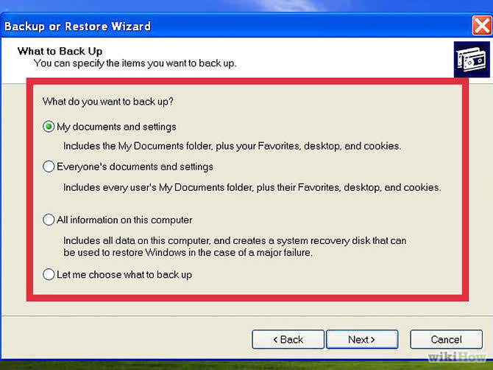

**Step 02:Download the Linux Mint ISO:-**

An ISO file is a disk image that I can burn to DVD .The ISO is available for free from the Linux Mint website ,through the download is on the large size.Depending on the speed of my connection .it may take a while for the download to complete.

i.There are several options when you visit the downloads page of the Linux Mint website.Most users will want to choose the version located at the top of the list.

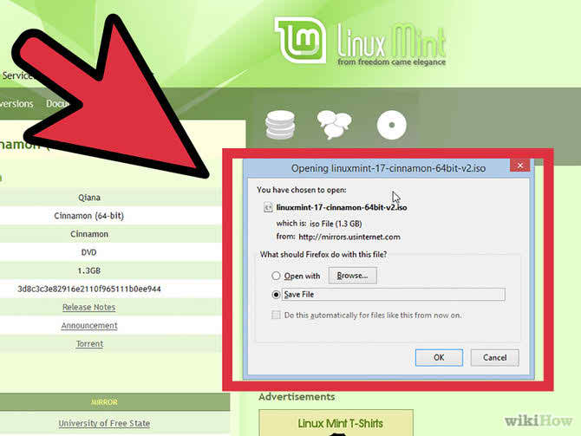

ii.you will need to ensure that I select the correct version for my system architecture 32 bit or 64 bit .

**Step 03:**

**Download an image burning programe:-**In order to copy the ISO file to a DVD I will need an image burning program.One of the more popular free options is imgburn,through there are a variety of either from campanions such as nero.

If I am running windows 7,I can use windows built in burning software .Right click on the ISO file and selecut burn disc image.

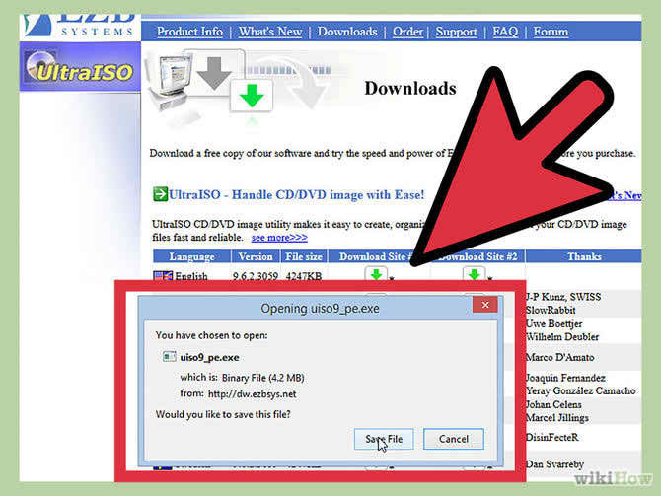

**Step 04:**

Burn the disc:-use my image burning software to select my DVD recorder drive with a blank DVD in it if necessary select the downloaded ISO file as the source file.Click the burn button to begin the burning process.This may take sevarel minute to complete.

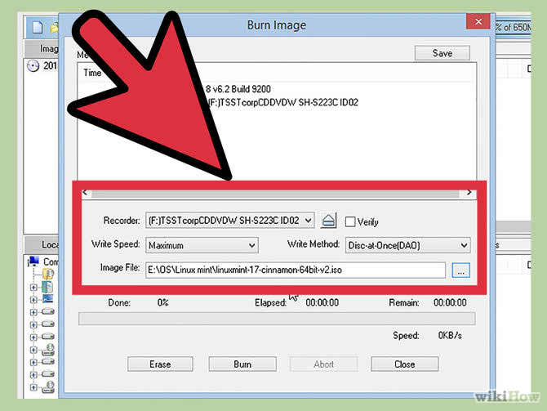

**Step:05**

In order to run the linux mint disc I will need to boot forom it instead of my hard drive.i can use my computers BIOS menu to change the boot order.

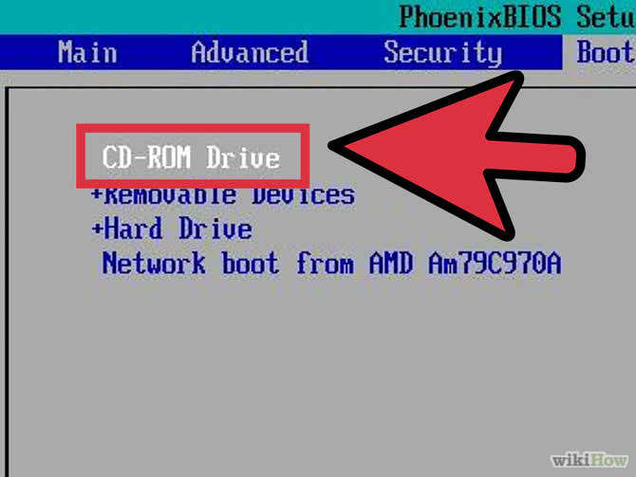

**Step 06:**

Start the Linux Mint:-when my computers boot from the Linux Mint DVD that my created,I will be greeted with a short list of option.Select “start Linux Mint”to boot the Linux Mint operating system from the DVD.

i.This doesnot install Linux Mint booting the operating system from the DVD allows you to test out Linux Mint.I will not able to change setting or delete or create files while in the pre vious mode.

ii.when tunning Mit from the DVD ,it will run slower than it was installed keep this.

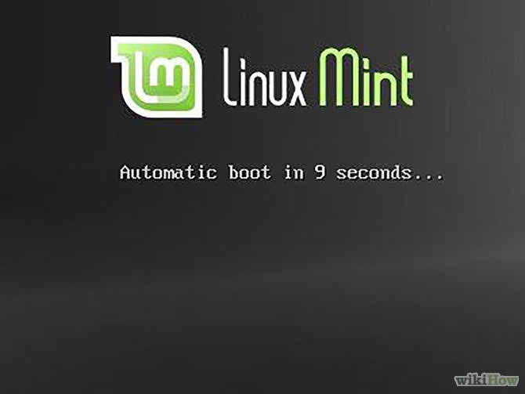

**Step 07:**

start the installation:-after I have taken some time to get familiar with the Linux Mint desktop I can begin the installation by double clicking the “install Linux Mint” located the desktop.select language and click continue.

**Step:08**In order to use the bundled installer,I will need to have at least 3.5 GB of free hard disk space as well as an active internet connection.if I am installing Mint on a laptop,ensure that it is connected to a power source during the installation.

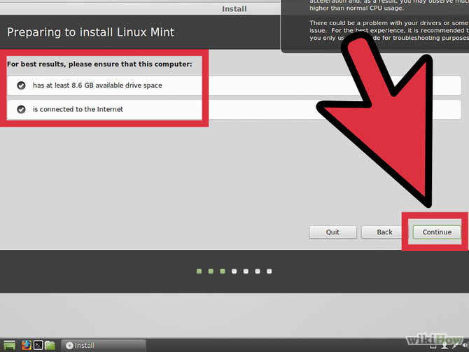

**Step:09:**

The next screen will allow me to choose what hard disk spare I would like allotted to my linux operating system.there are two main option to choose from.

i.erase disk and install Linux Mint this option will delete all of the data on the selected disk and install Linux Mint on it.Any existing operating systems or data will be deleted use this option if I want Linux mint to be the only operating system on my computer.

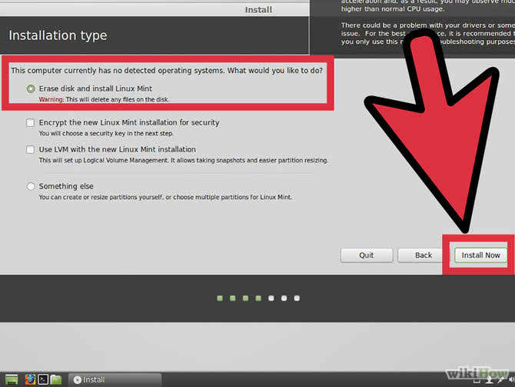

**Step 10:**

In the next screen use the drop down menu to choose which drive I want to install Linux to if I choose the “something else” option I will be able for use the silder to set the size of the Linux partition.

i.Linux Mint requires at least a 6 GB partition and the swap partition should be 15 times the amount of RAM I have installed.

ii.if I selected the first option for the install type the entire of the selected disk will be deleted during the installation process.

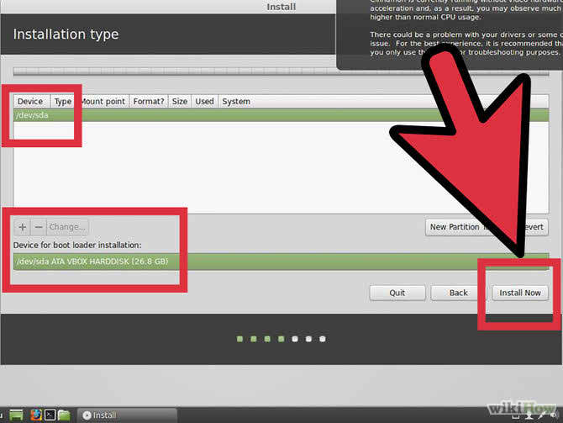

**Step 11:**

After the installation begins I will be askedto choose my timezone and keyboard.i can use the “detect keyboard layout”botton if I am ensure about my keyboard layout.

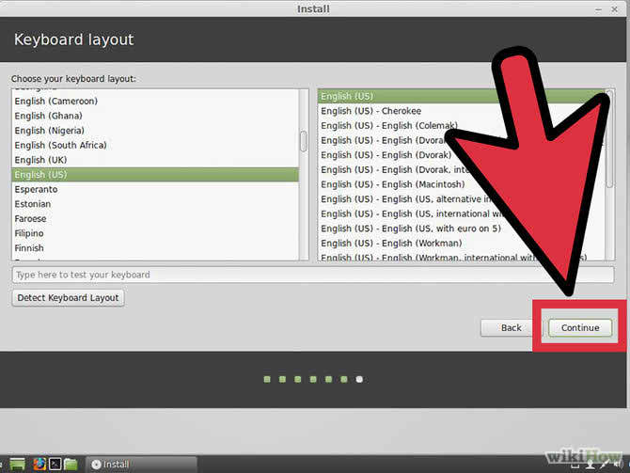

**Step 12:**After selecting my input preference I will be asked to enter my name and create users.when I enter my name,username and machine name will aoutomatically fill with my first name.i can change my username to whatever I would like.

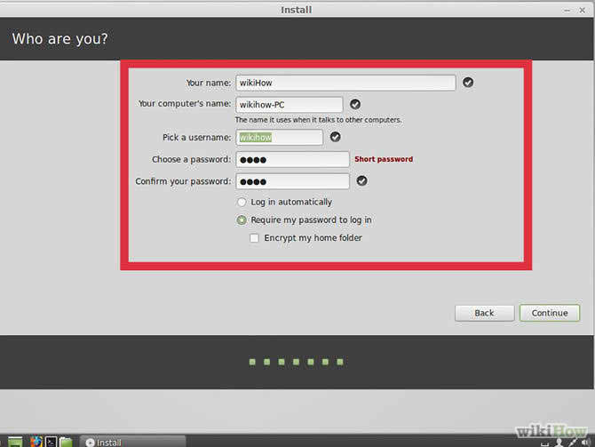

**Step 13:**

After entering in my information Linux Mint will begin copying fills.i can monitor the progress by looking at the at the bottom of the window.after the first are copied,installation will begin and my hardware will be configured.

